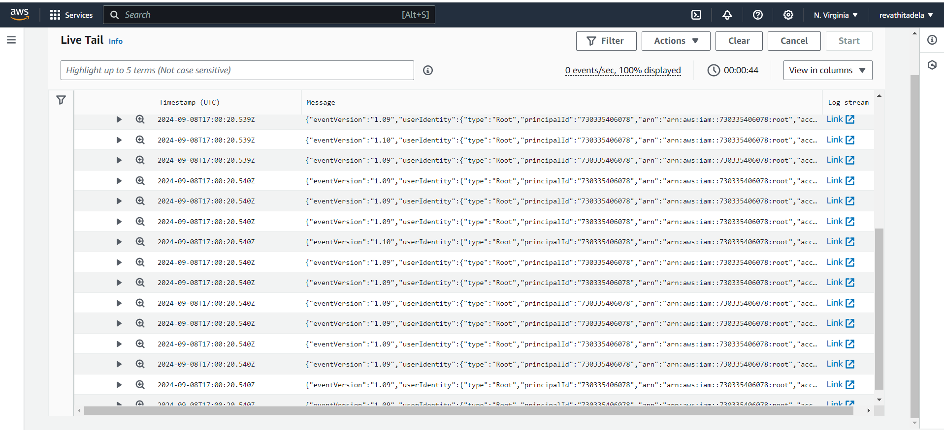

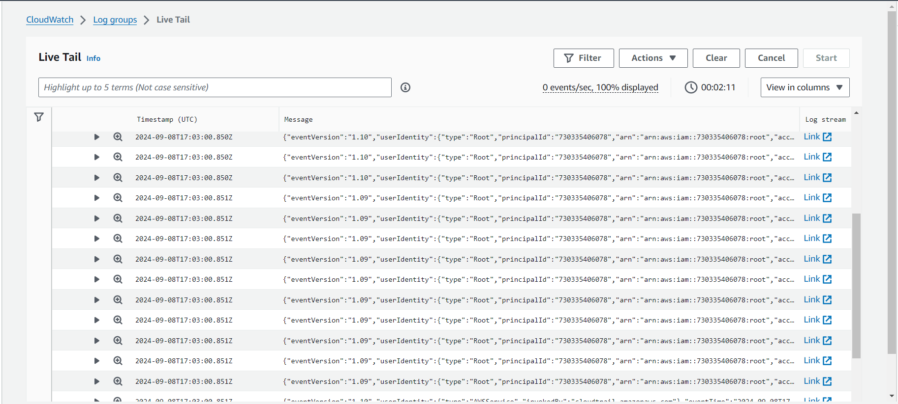

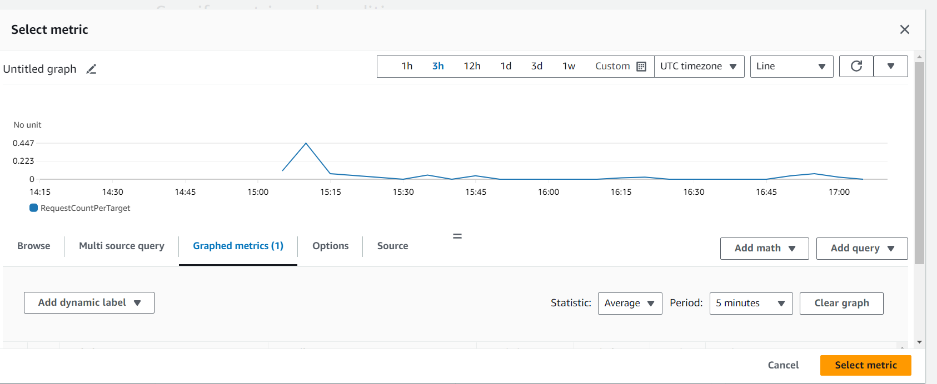

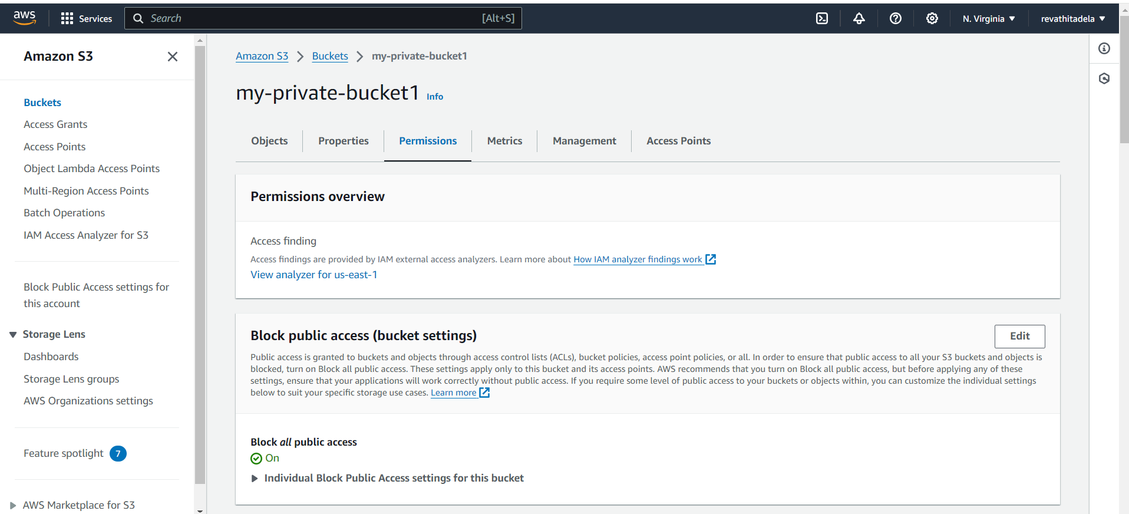

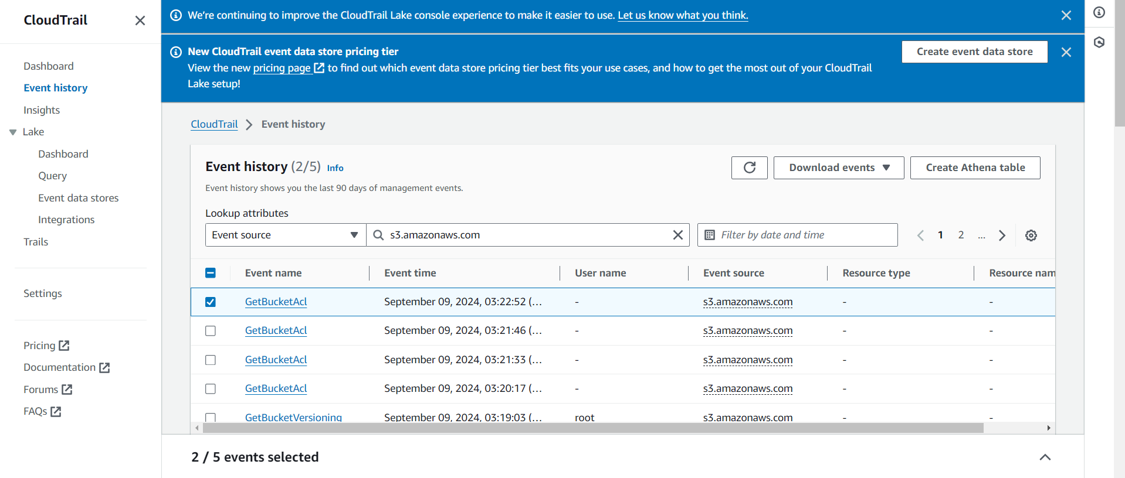

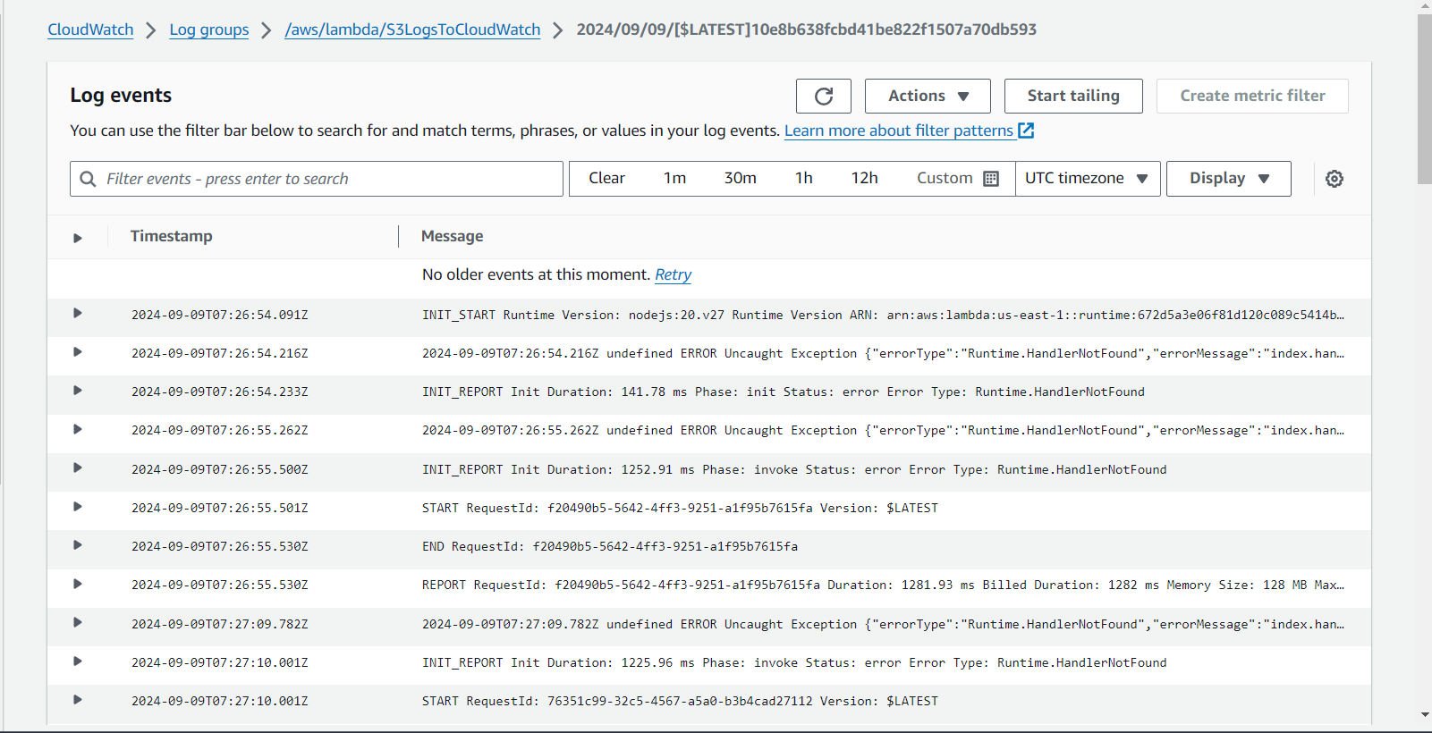

Output Log:

Here's a step-by-step guide to completing the task:

### **1. Create an S3 Bucket with No Public Access & Enable Logging**

1. **Create an S3 Bucket**:

- Go to the **S3 Console** in AWS.

- Click **Create bucket**.

- Enter the **Bucket name** (e.g., `my-private-bucket`).

- Uncheck the **Block all public access** option to prevent public access.

- Click **Create bucket**.

2. **Upload Files to the S3 Bucket**:

- Open your created bucket.

- Click **Upload** and select files to upload.

- Ensure no public access permissions are granted to the objects.

3. **Enable CloudWatch Logs for S3**:

To monitor uploads and track actions on the bucket using CloudWatch:

- In **S3**, select your bucket.

- Go to the **Properties** tab.

- Scroll down to **Server Access Logging**.

- Enable logging and select a destination S3 bucket for the logs.

- To view logs, set up CloudWatch:

1. Go to the **CloudWatch Console**.

2. Create a new log group or use an existing one.

3. Set up a log stream to view the S3 bucket logs.

### **2. Launch Two EC2 Instances**

1. **Launch EC2 Instances**:

- Go to the **EC2 Console**.

- Click **Launch Instance**.

- Choose the AMI (Amazon Linux 2 or Ubuntu).

- Select instance type (e.g., `t2.micro`).

- In **Network settings**, ensure both instances are in the same VPC and subnets.

- Configure **security groups** to allow traffic on HTTP/HTTPS (port 80/443).

- Launch the instances.

2. **Install Web Server on Both Instances**:

- After the instances are running, SSH into each instance.

- Install a web server (e.g., Apache or Nginx):

```bash

sudo yum install httpd -y # Amazon Linux 2

sudo systemctl start httpd

sudo systemctl enable httpd

```

3. **Test the Web Servers**:

- Confirm that the web server is running by accessing the instance's public IP.

### **3. Set Up an Application Load Balancer (ALB)**

1. **Create a Load Balancer**:

- Go to the **EC2 Console**.

- In the left-hand menu, select **Load Balancers**.

- Click **Create Load Balancer** and select **Application Load Balancer**.

- Choose **internet-facing**.

- Select the VPC where your EC2 instances are running.

- Choose **two public subnets**.

2. **Configure the Load Balancer**:

- For the security group, allow inbound traffic on HTTP (port 80).

- Create a new target group for your instances.

- Register both EC2 instances in this target group.

3. **Test Load Balancer**:

- Once the load balancer is active, use its **DNS name** to access your application.

- The traffic will be routed to your EC2 instances, and the **ALB's IP** will be seen as the source of the traffic.

### **4. Monitor with CloudWatch**

1. **Enable CloudWatch Metrics for ALB**:

- Go to the **CloudWatch Console**.

- Create an alarm or view metrics for the load balancer to monitor request rates, latency, and healthy host counts.

2. **View CloudWatch Logs for S3**:

- Go to **CloudWatch Logs**.

- Select the log group for your S3 bucket to view access and error logs.

By following these steps, you will have:

1. An S3 bucket with no public access.

2. Logs for file uploads available in CloudWatch.

3. Two EC2 instances connected to an Application Load Balancer.