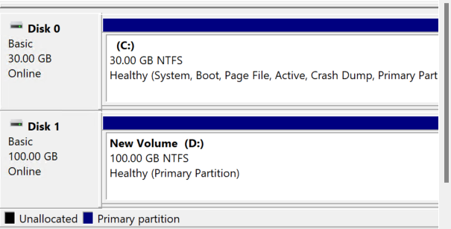

Created windows machine and attached to volume and then made it online

Same volume is attached to linux server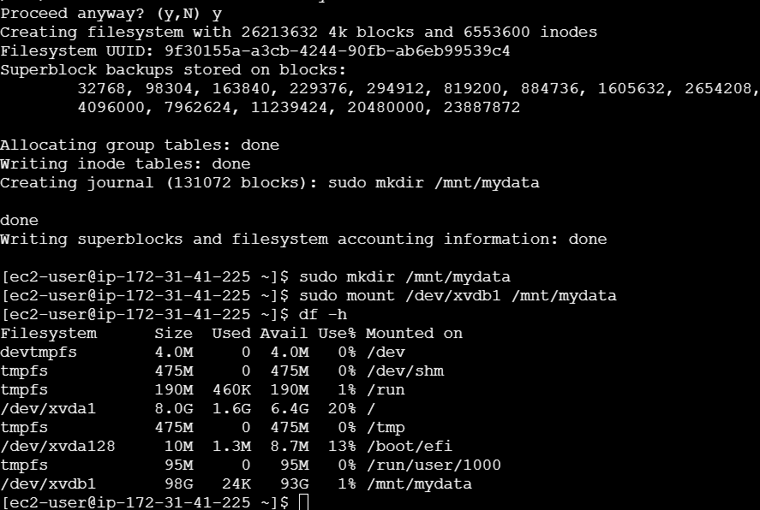

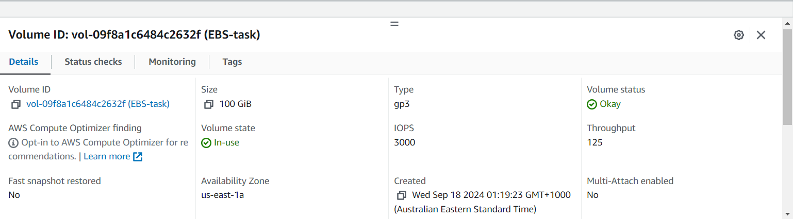

Volume created with snapshot

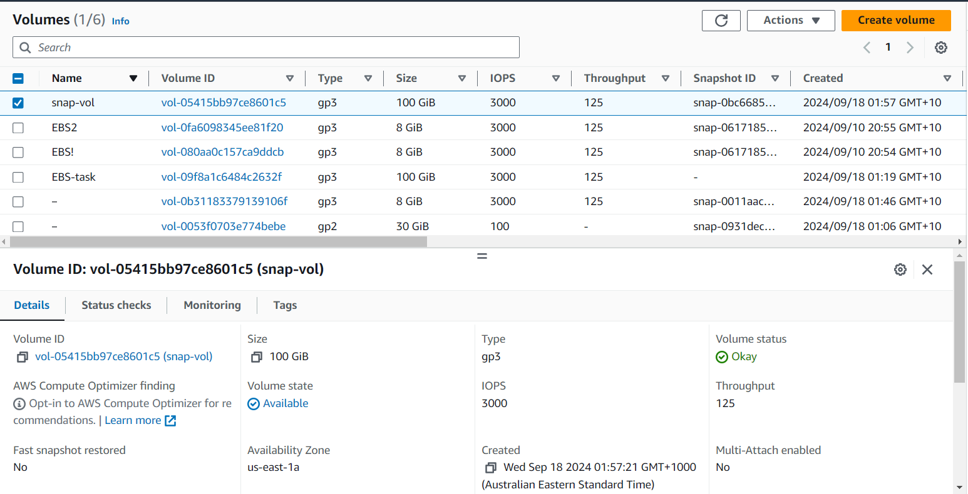

Attached volume created from snapshot to linux server

