Task Description#1
● Install and configure GitHub Copilot in VS Code. Take screenshots of each step.
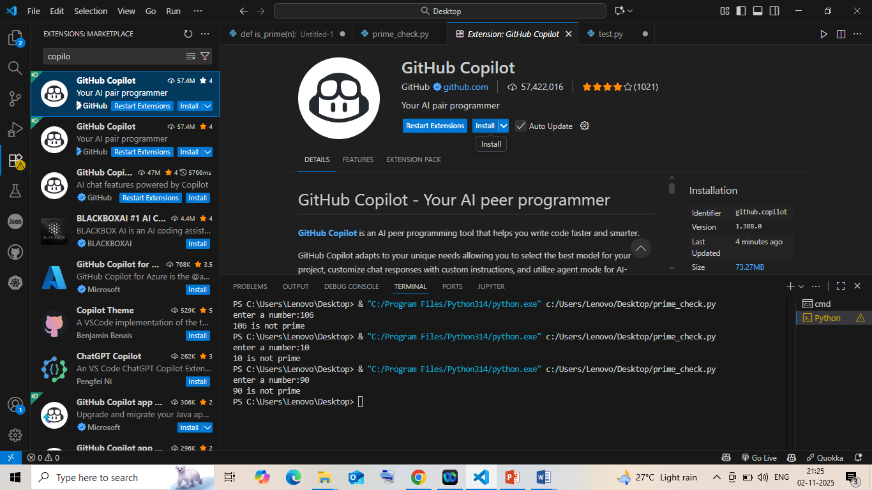
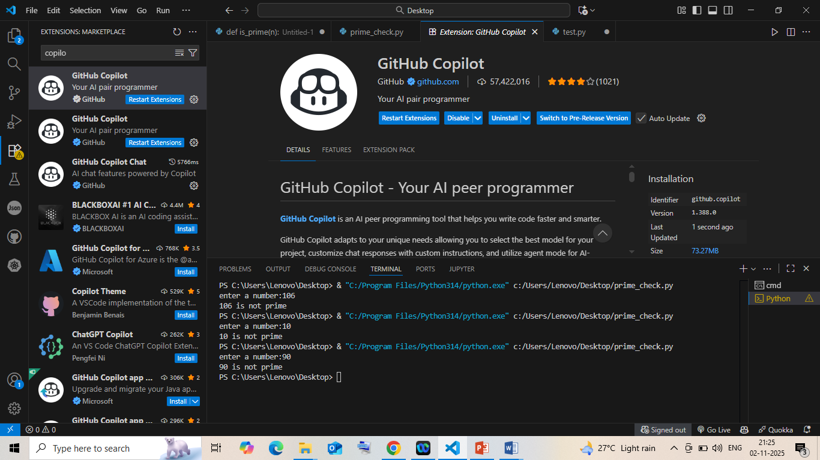
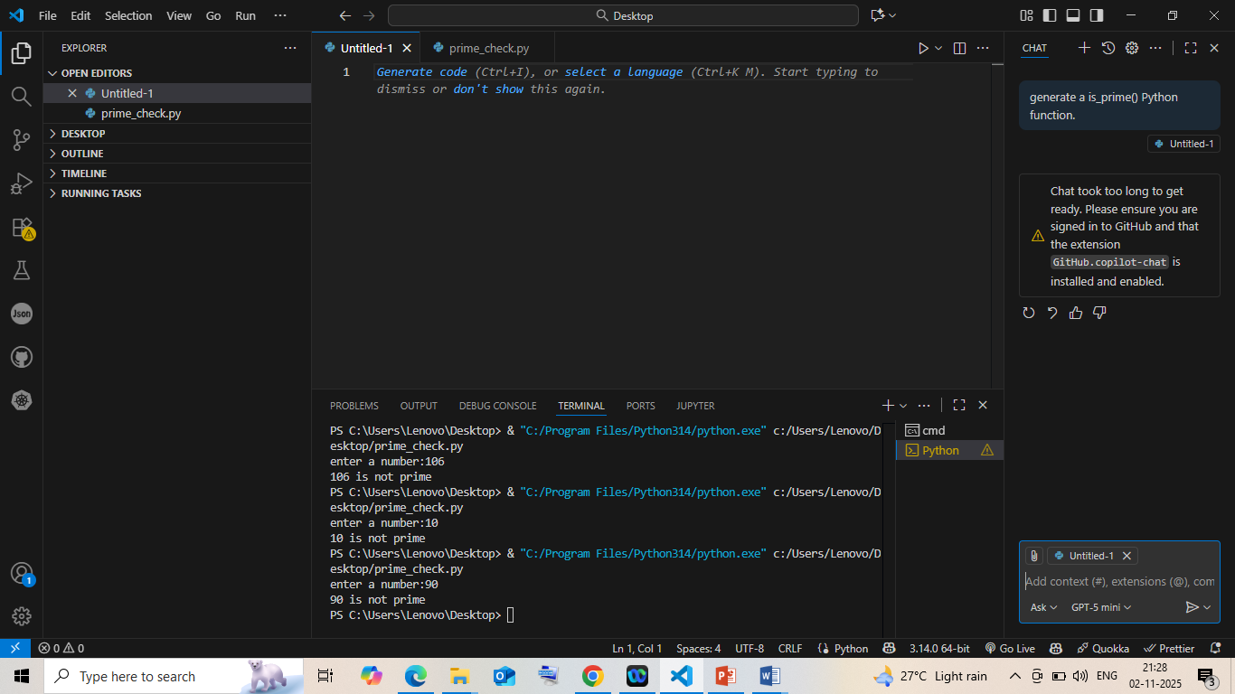
Task Description#2
● Use Copilot to generate a is_prime() Python function.
Expected Output#2
● Function to check primality with correct logic
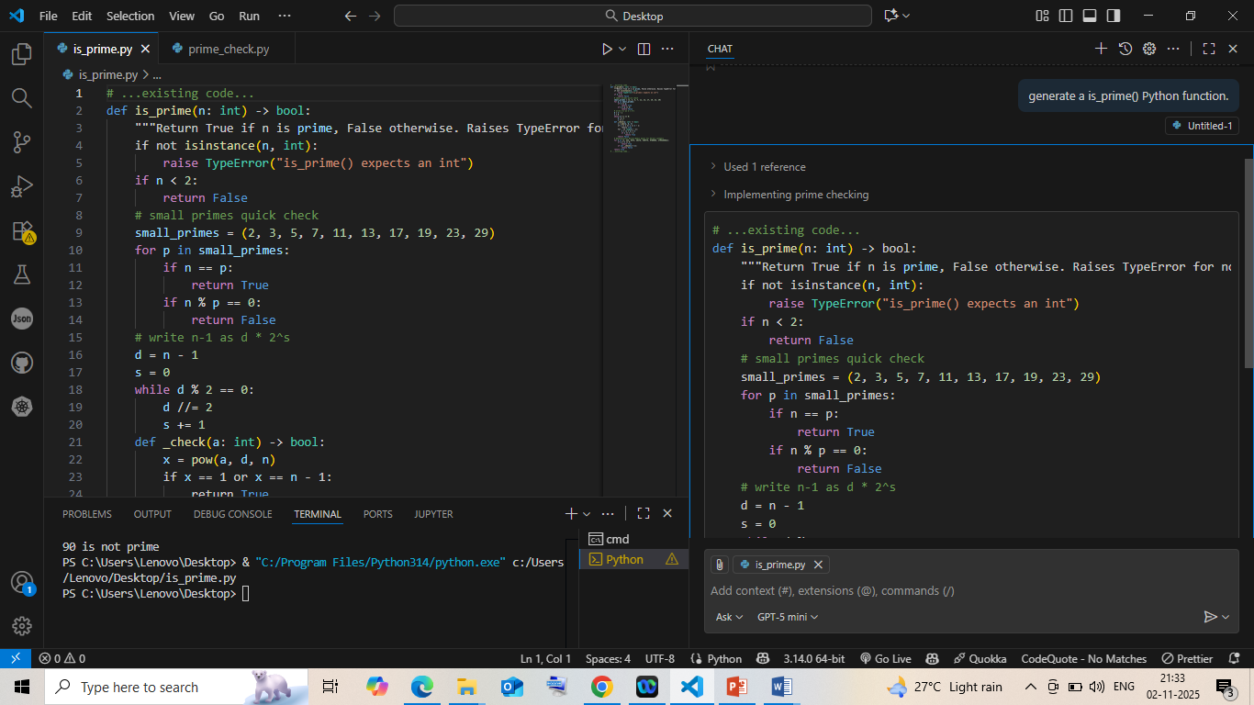

Task Description#3
● Write a comment like # Function to reverse a string and use Copilot to generate the
function.
Expected Output#3
● Auto-completed reverse function
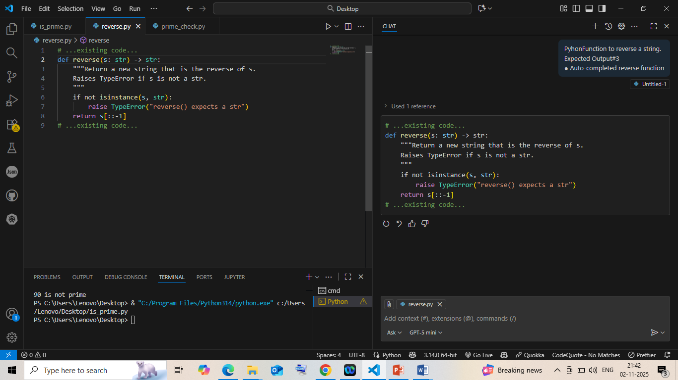

Task Description#4
● Generate both recursive and iterative versions of a factorial function using comments..
Expected Output#4
● Two working factorial implementations
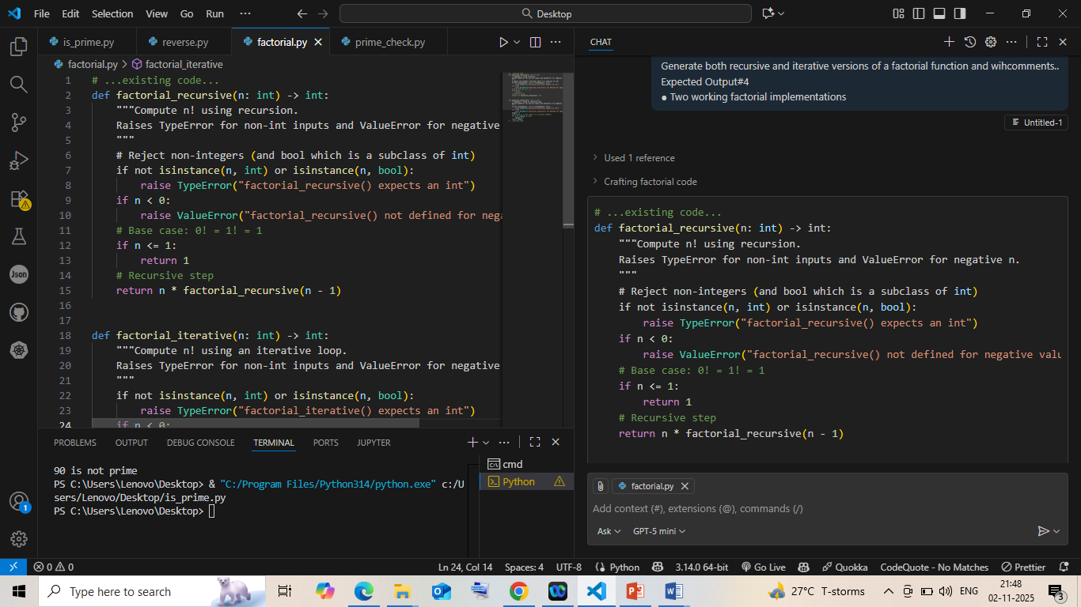
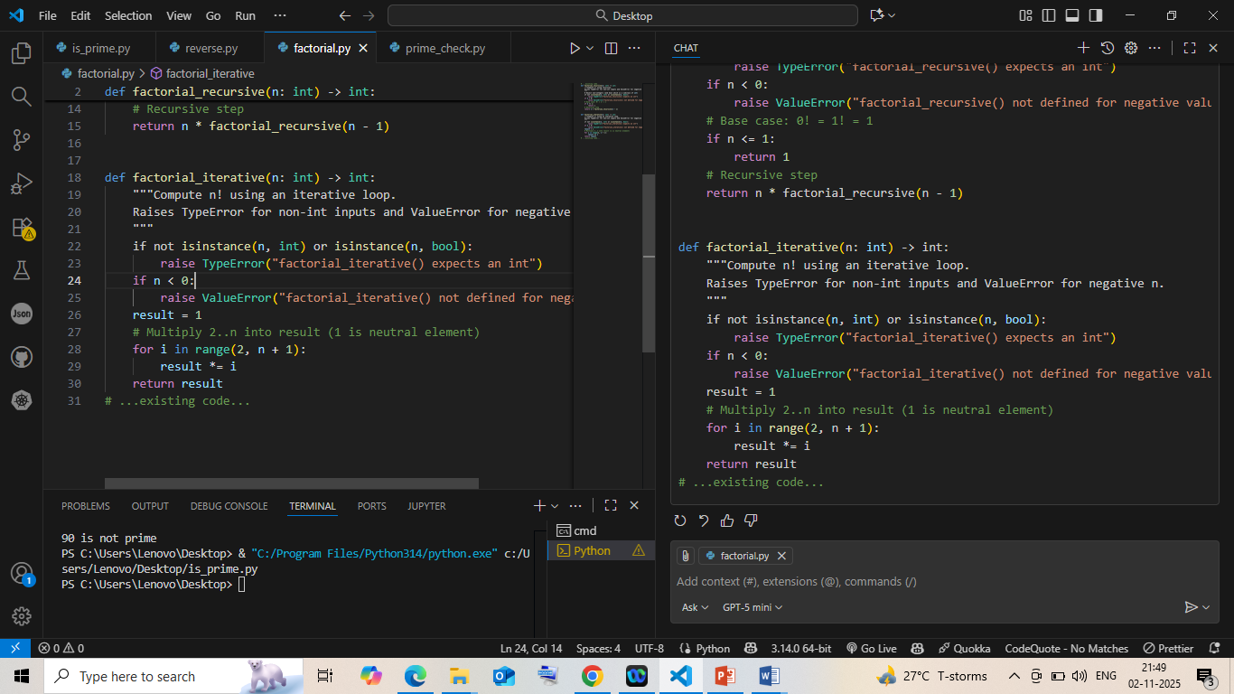

Task Description#5
● Use Copilot to find the largest number in a list. Assess code quality and efficiency.
Expected Output#5
● A valid function with your review

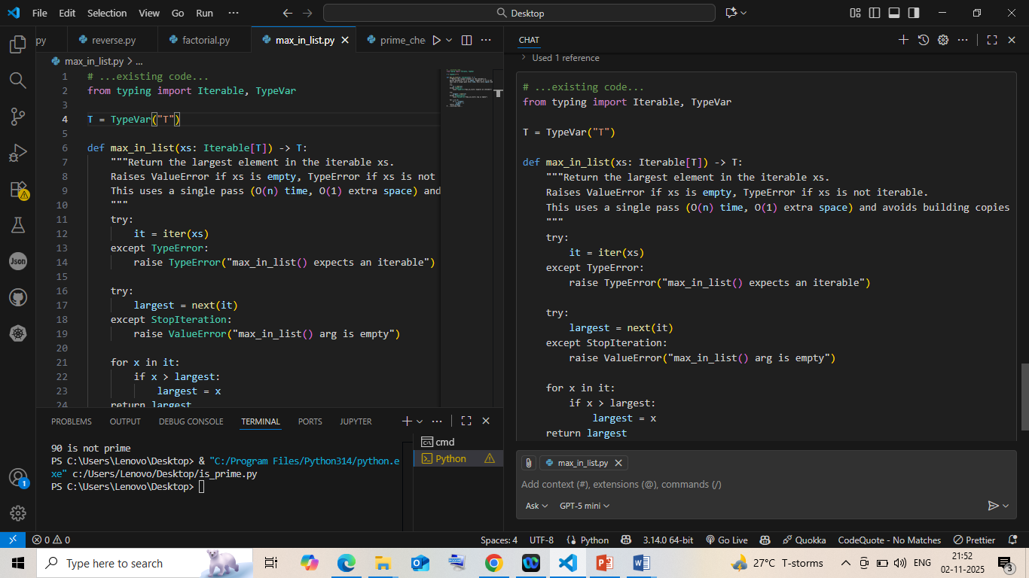0

Revathi-sru: generate a is_prime() Python function.

GitHub Copilot: Chat took too long to get ready. Please ensure you are signed in to GitHub and that the extension `GitHub.copilot-chat` is installed and enabled.

Revathi-sru: generate a is_prime() Python function.

GitHub Copilot: ````python
# ...existing code...
def is_prime(n: int) -> bool:
"""Return True if n is prime, False otherwise. Raises TypeError for non-ints."""
if not isinstance(n, int):
raise TypeError("is_prime() expects an int")
if n < 2:
return False
# small primes quick check
small_primes = (2, 3, 5, 7, 11, 13, 17, 19, 23, 29)
for p in small_primes:
if n == p:
return True
if n % p == 0:
return False
# write n-1 as d * 2^s
d = n - 1
s = 0
while d % 2 == 0:
d //= 2
s += 1
def _check(a: int) -> bool:
x = pow(a, d, n)
if x == 1 or x == n - 1:
return True
for _ in range(s - 1):
x = (x * x) % n
if x == n - 1:
return True
return False
# Deterministic Miller-Rabin bases for 64-bit integers
for a in (2, 325, 9375, 28178, 450775, 9780504, 1795265022):
if a % n == 0:
return True
if not _check(a % n):
return False
return True
# ...existing code...
````

Revathi-sru: PyhonFunction to reverse a string.
Expected Output#3
● Auto-completed reverse function

GitHub Copilot: ````python
# ...existing code...
def reverse(s: str) -> str:
"""Return a new string that is the reverse of s.
Raises TypeError if s is not a str.
"""
if not isinstance(s, str):
raise TypeError("reverse() expects a str")
return s[::-1]
# ...existing code...
````

Revathi-sru: Generate both recursive and iterative versions of a factorial function and wihcomments..
Expected Output#4
● Two working factorial implementations

GitHub Copilot: ````python
# ...existing code...
def factorial_recursive(n: int) -> int:
"""Compute n! using recursion.
Raises TypeError for non-int inputs and ValueError for negative n.
"""
# Reject non-integers (and bool which is a subclass of int)
if not isinstance(n, int) or isinstance(n, bool):
raise TypeError("factorial_recursive() expects an int")
if n < 0:
raise ValueError("factorial_recursive() not defined for negative values")
# Base case: 0! = 1! = 1
if n <= 1:
return 1
# Recursive step
return n * factorial_recursive(n - 1)

def factorial_iterative(n: int) -> int:
"""Compute n! using an iterative loop.
Raises TypeError for non-int inputs and ValueError for negative n.
"""
if not isinstance(n, int) or isinstance(n, bool):
raise TypeError("factorial_iterative() expects an int")
if n < 0:
raise ValueError("factorial_iterative() not defined for negative values")
result = 1
# Multiply 2..n into result (1 is neutral element)
for i in range(2, n + 1):
result *= i
return result
# ...existing code...
````

Revathi-sru: find the largest number in a list. Assess code quality and efficiency.
Expected Output#5
● A valid function with your review

GitHub Copilot: ````python
# ...existing code...
from typing import Iterable, TypeVar

T = TypeVar("T")

def max_in_list(xs: Iterable[T]) -> T:
"""Return the largest element in the iterable xs.
Raises ValueError if xs is empty, TypeError if xs is not iterable.
This uses a single pass (O(n) time, O(1) extra space) and avoids building copies.
"""
try:
it = iter(xs)
except TypeError:
raise TypeError("max_in_list() expects an iterable")

try:
largest = next(it)
except StopIteration:
raise ValueError("max_in_list() arg is empty")

for x in it:
if x > largest:
largest = x
return largest
# ...existing code...
````

Revathi-sru: commensplease

GitHub Copilot: ````python
# ...existing code...
from typing import Iterable, TypeVar

T = TypeVar("T")

def max_in_list(xs: Iterable[T]) -> T:
"""Return the largest element in the iterable xs.
Raises ValueError if xs is empty, TypeError if xs is not iterable or elements aren't comparable.
Single-pass O(n) time, O(1) extra space; works with generators.
"""
try:
it = iter(xs)
except TypeError:
raise TypeError("max_in_list() expects an iterable")

try:
largest = next(it)
except StopIteration:
raise ValueError("max_in_list() arg is empty")

for x in it:
try:
if x > largest:
largest = x
except TypeError as e:
# Re-raise with clearer message when elements cannot be compared
raise TypeError("Elements of iterable are not comparable") from e
return largest
# ...existing code...
````

