**Task Manager Front End**

**Hosted URL:**

* **UI - http://localhost:82/**
* **API - http://localhost:81/**

**SCM:**

* **UI -https://github.com/Revathi2608/Capsule_Angular**
* **API - https://github.com/Revathi2608/CapsuleService**

**Dev File path:**

* **UI - C:\Users\Admin\Desktop\Code\Angular**
* **API - C:\Users\Admin\Desktop\Code\Service\CapsuleWebService**

**Desktop View**

Add Task

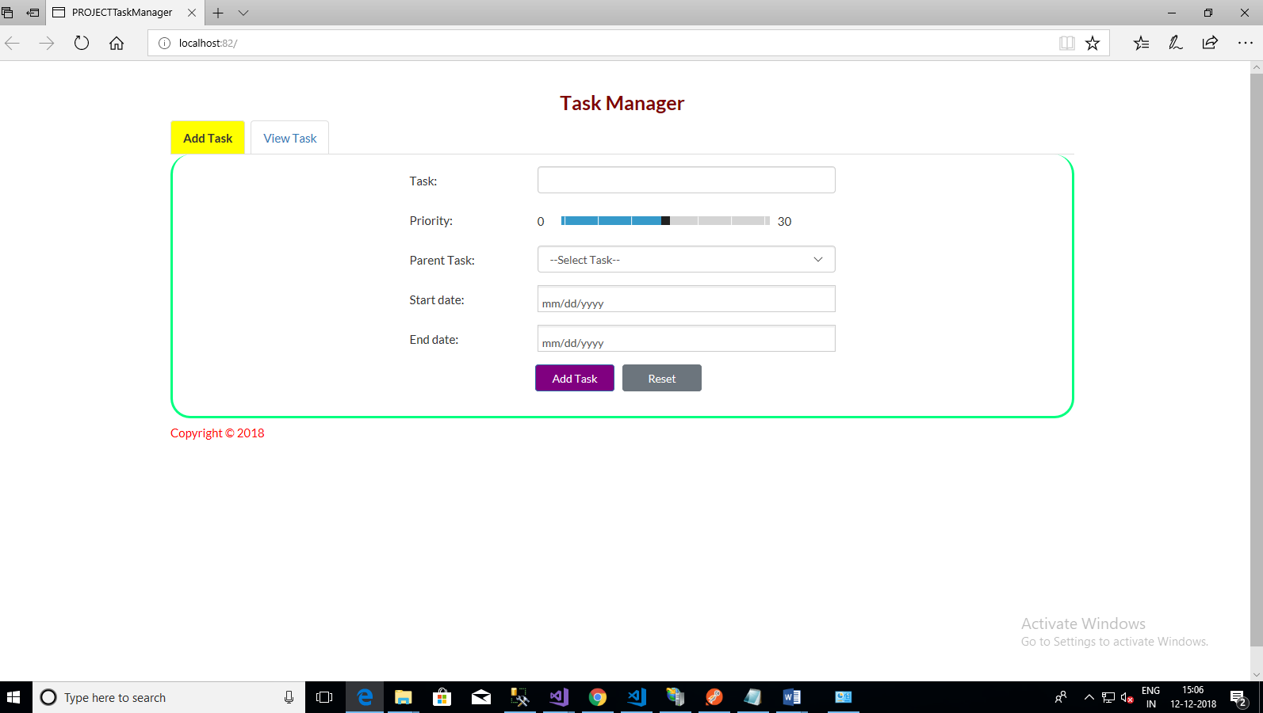

View Task

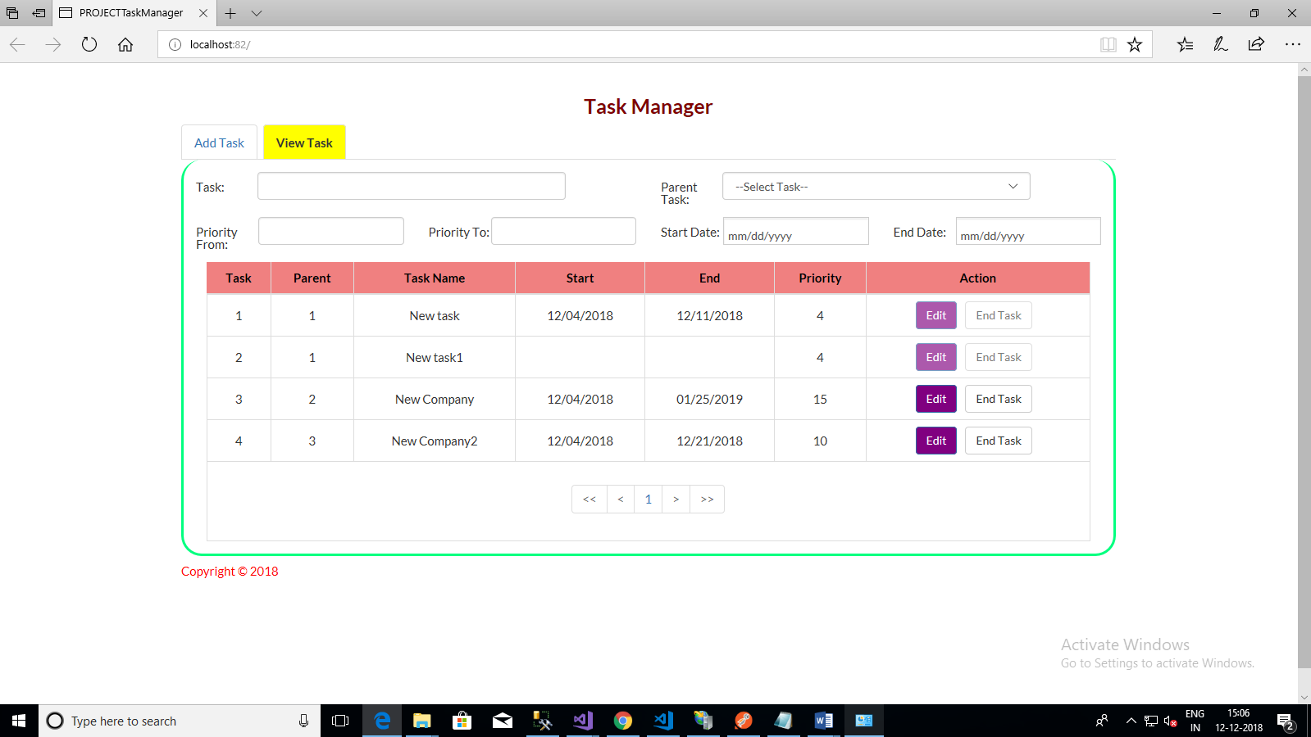

Update Task

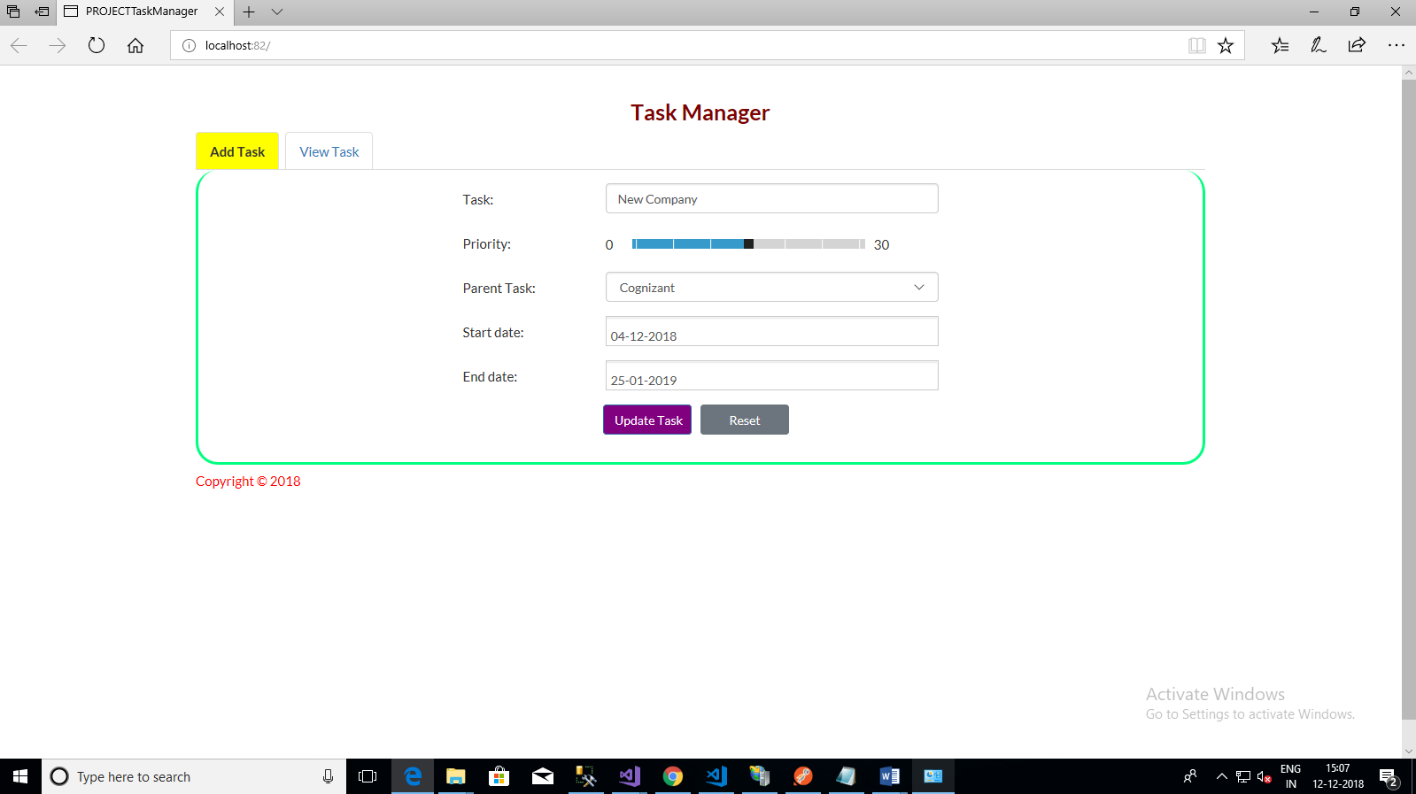

**Mobile**

Add Task

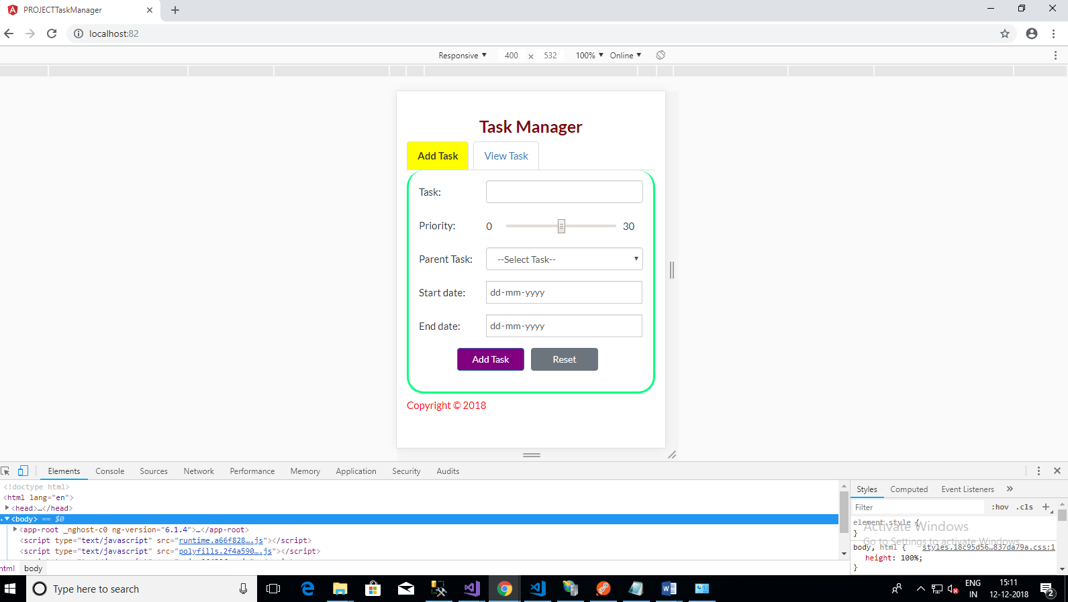

View Task

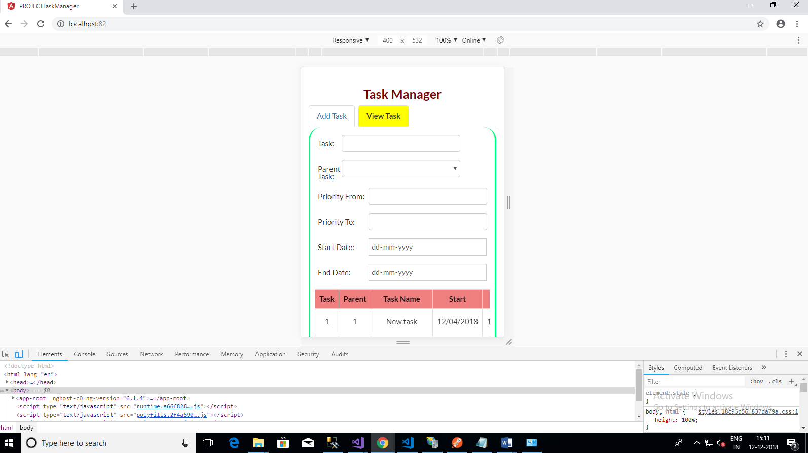

Update Task

