DATA ANALYTICS AND VISUALIZATION
MINI PROJECT REPORT
AIR QUALITY ANALYTICS &
POLLUTION PREDICTION
Environmental / Nature Domain
A web-based data analytics, visualization and machine-learning application

Project Details | Details
Student Name | Lenka Revathi
Roll Number | A24126510085
Department | Computer Science & Engineering
Academic Year | 2026–2027
Technology | Python, Streamlit
Dataset | Synthetic academic air-quality dataset — 3,000 records

Table of Contents

- Abstract
- Introduction
- Problem Statement
- Objectives
- Scope of the Project
- Dataset Description
- System Requirements and Technologies
- Methodology
- Data Preprocessing and Wrangling
- Exploratory Data Analysis
- Data Visualization
- Machine Learning Models
- Model Evaluation and Comparison
- Web Application Design and Modules
- Prediction Interface
- Testing
- Results and Discussion
- Limitations
- Future Enhancements
- Conclusion
- References

1. Abstract
Air pollution is a major environmental concern, and raw sensor measurements are difficult to interpret without systematic analysis. This project develops a web-based Air Quality Analytics and Pollution Prediction application for exploring pollutant and environmental measurements and demonstrating machine-learning-based prediction of carbon monoxide (CO). The application performs data preprocessing, missing-value handling, exploratory data analysis, descriptive visualization, model training, model comparison and interactive prediction.
The supplied academic dataset contains 3,000 records and follows the structure of an air-quality sensor dataset. After preprocessing, 2,964 records are usable. The cleaned data are divided into 2,371 training records and 593 testing records. Two regression approaches are implemented directly in the application: Linear Regression and KNN Regression. The models are evaluated using Mean Absolute Error (MAE), Root Mean Squared Error (RMSE) and R² score. In the demonstrated run, KNN Regression achieved the lower RMSE and higher R², making it the better model among the two for the supplied data.

2. Introduction
Environmental sensor datasets contain multiple measurements such as carbon monoxide, nitrogen oxides, benzene, temperature and humidity. A data analytics system can transform these measurements into summaries and relationships that are easier to interpret. Machine learning can additionally be used to estimate a target pollutant from related sensor and environmental variables.
The proposed application combines analytics and prediction in one Streamlit web interface. It is designed as an academic mini project demonstrating the complete workflow from raw CSV data to preprocessing, analysis, model comparison and prediction.

3. Problem Statement
Raw air-quality sensor data are difficult to analyze manually because they contain multiple pollutant measurements, environmental variables and missing-value markers. There is a need for a simple analytical application that can preprocess the data, present meaningful environmental insights and compare machine-learning models for predicting CO.

4. Objectives
- Load and inspect a structured air-quality dataset containing at least 1,000 records.
- Identify and handle missing sensor values represented by -200.
- Perform data preprocessing and basic data wrangling.
- Calculate descriptive statistics and explore relationships among pollution and environmental variables.
- Present meaningful analytical results through a user-friendly web interface.
- Implement two regression models for CO prediction.
- Compare the models using MAE, RMSE and R².
- Provide an interactive prediction interface for entering sensor/environment values.

5. Scope of the Project
- Environmental air-quality analytics.
- Pollution and environmental indicator summaries.
- Feature relationship analysis with the CO target.
- Regression-based CO prediction.
- Interactive Streamlit dashboard suitable for academic demonstration.
The current prototype is intended for educational demonstration and is not a certified environmental monitoring or public-health decision system.
6. Dataset Description
The included CSV contains 3,000 synthetically generated academic records. The generation script uses a fixed random seed and creates observations at three-hour intervals beginning on 01/01/2025. The synthetic data were designed to resemble the structure and variable types of an air-quality sensor dataset so that the complete analytics workflow can run immediately.
Important academic note: the included records are synthetic. They must not be presented as actual measured air-quality observations. If a supervisor requires a public measured dataset, the CSV should be replaced with the specified public dataset and the report should be updated accordingly.
Variable | Description / Role
Date | Observation date
Time | Observation time
CO(GT) | Target variable: Carbon Monoxide
PT08.S1(CO) | CO sensor response
NMHC(GT) | Non-Methane Hydrocarbons
C6H6(GT) | Benzene concentration
NOx(GT) | Nitrogen Oxides
NO2(GT) | Nitrogen Dioxide
T | Temperature
RH | Relative Humidity
AH | Absolute Humidity
Dataset summary:
Item | Value
Total records | 3,000
Usable records after preprocessing | 2,964
Training records | 2,371
Testing records | 593
Missing-value marker | -200
Train/test split | 80% / 20%
Target | CO(GT)

7. System Requirements and Technologies
Component | Technology / Tool
Programming language | Python 3.12.10
Web framework | Streamlit
Data source | CSV
Application logic | Python standard library
Machine learning | Custom Linear Regression and KNN Regression implementations
Development environment | Visual Studio Code
Browser | Microsoft Edge / Google Chrome
Operating system used | Windows

The final Windows-compatible application intentionally avoids importing compiled scientific Python libraries in app.py because the development machine was enforcing a Windows Application Control policy that blocked some compiled DLLs. The final application therefore performs the required analytics and two regression methods using Python's standard library.

8. Methodology
The complete workflow used in the project is:
CSV Dataset → Preprocessing → EDA → Visualization → Train/Test Split → ML Models → Evaluation → Prediction
- Load the CSV file and parse its rows.
- Convert numeric fields to floating-point values and interpret -200 as a missing value.
- Remove records where the target CO(GT) is unavailable.
- Replace missing sensor/environment values using column mean imputation.
- Shuffle the cleaned records using a fixed random seed and split them into training and testing sets.
- Train Linear Regression using the PT08.S1(CO) sensor response.
- Train/evaluate KNN Regression using multiple standardized features.
- Calculate MAE, RMSE and R².
- Display analytical results through Streamlit tabs.
- Allow the user to enter sensor values and compare predictions from both models.
9. Data Preprocessing and Wrangling
The application reads the CSV using Python's csv module. Numeric conversion is performed for the variables required by the analytics and prediction modules. The value -200 is treated as a missing-value marker.
- Target validation: rows without a usable CO(GT) target are excluded.
- Mean imputation: missing feature values are replaced by the mean of the available values for that feature.
- Data splitting: cleaned records are shuffled using seed 42 and divided into 80% training and 20% testing data.
- Feature scaling for KNN: each KNN feature is standardized using its training mean and standard deviation before distance calculation.
This preprocessing produces 2,964 usable records from the original 3,000 records.

10. Exploratory Data Analysis
The EDA stage focuses on descriptive statistics and relationships between pollution and environmental variables. The dashboard calculates average CO, temperature and relative humidity and presents a processed-data sample.
- Average CO is displayed as a key pollution indicator.
- Average temperature and relative humidity summarize environmental conditions.
- Average pollution measurements are compared for CO, NOx and NO2.
- CO values are summarized across ten dataset segments to provide a simple trend view.
- Correlation between each selected feature and CO is calculated using Pearson-style correlation.
The dashboard's Environmental Analysis tab ranks features according to the absolute strength of their correlation with the CO target, helping users identify variables that are more closely associated with CO in the supplied data.

11. Data Visualization
The application uses lightweight HTML/CSS-based visual elements and Streamlit tables so that the dashboard remains compatible with the restricted Windows environment. The major visual sections are organized into tabs.
Dashboard Tab | Purpose
Overview | Displays dataset size, usable records, training/testing records, key averages, and a sample of processed data.
Pollution Analysis | Presents average pollution measurements and CO trend analysis.
Environmental Analysis | Analyzes temperature, relative humidity, absolute humidity, and feature correlations with CO.
ML Model Comparison | Compares Linear Regression and KNN Regression using MAE, RMSE, and R² metrics.
CO Prediction | Provides interactive CO prediction using both trained regression models.

12. Machine Learning Models

12.1 Linear Regression
Linear Regression models the relationship between the target CO(GT) and the PT08.S1(CO) sensor response using a straight-line equation y = b0 + b1x. The slope and intercept are calculated from the training data.

12.2 KNN Regression
KNN Regression predicts a new CO value by finding nearby training observations in standardized feature space. The application uses seven neighbors (k = 7) and the mean target value of those neighbors as the prediction.
The KNN model uses PT08.S1(CO), C6H6(GT), NOx(GT), NO2(GT), T, RH and AH. Standardization is applied before Euclidean distance is calculated so that variables with different numerical scales do not dominate the distance.

13. Model Evaluation and Comparison
The models are evaluated using three common regression metrics. MAE measures the average absolute prediction error. RMSE gives greater weight to larger errors. R² indicates the proportion of target variance explained by the model.
Model | MAE | RMSE | R²
Linear Regression | 0.2129 | 0.2646 | 0.2224
KNN Regression | 0.1037 | 0.1312 | 0.8097

Based on the displayed run, KNN Regression is the better-performing model because it has the lower MAE and RMSE and the higher R² value. The KNN evaluation is calculated on a 300-record evaluation subset of the held-out test records to keep the interactive dashboard responsive; the Linear Regression metrics use the full 593-record test set.

14. Web Application Design and Modules
The application is implemented as a Streamlit web application. It provides a single-page analytical interface with five functional tabs and a project-information sidebar.

Module | Main Functions
Data Loading | Reads the CSV dataset and constructs the raw records.
Preprocessing | Handles -200 missing-value markers, validates the target variable, and performs mean imputation.
Analytics | Computes averages, pollution summaries, and feature correlations.
Modeling | Trains Linear Regression and KNN Regression models.
Evaluation | Calculates MAE, RMSE, and R² metrics for model comparison.
Dashboard | Presents analytical results through tabs, tables, and visual indicators.
Prediction | Accepts user inputs and displays CO predictions from both models.

15. Prediction Interface and Application Screens

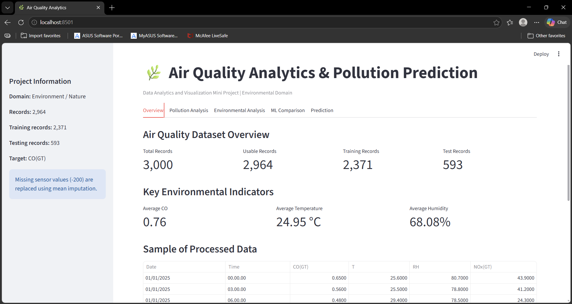
Figure 1. Air Quality Analytics dashboard — Overview tab showing dataset and environmental indicators.
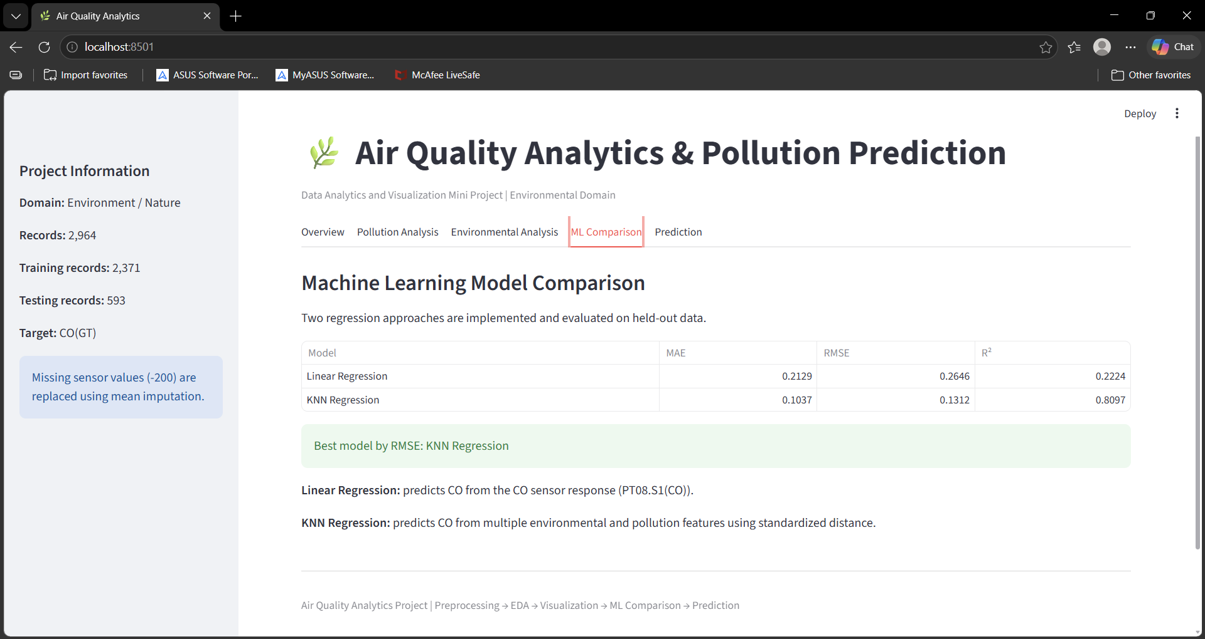
Figure 2. Machine Learning Model Comparison tab showing Linear Regression and KNN Regression metrics.
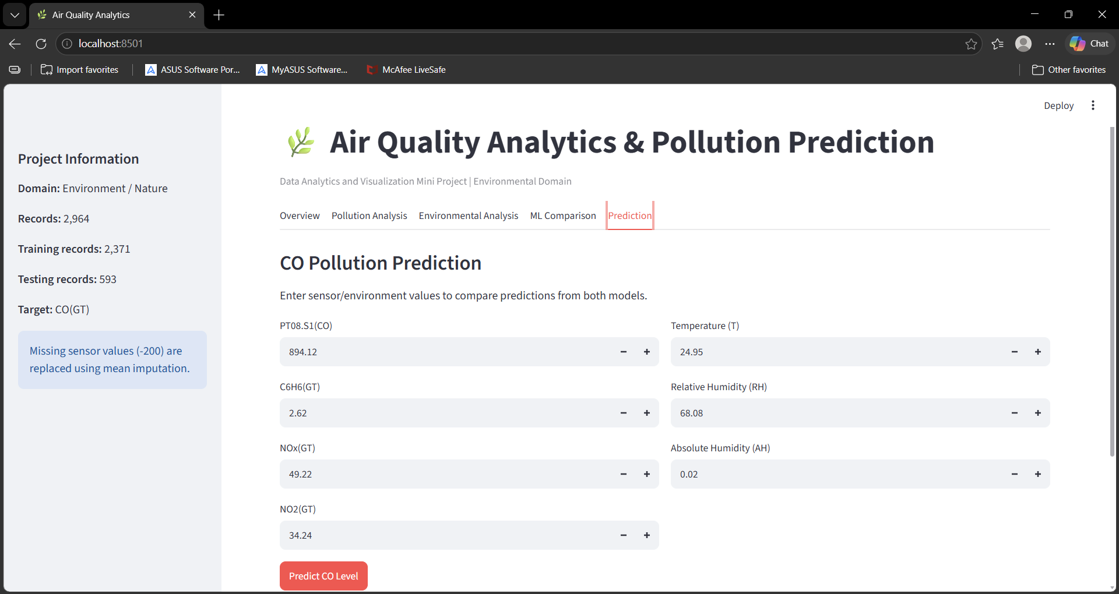
Figure 3. CO Pollution Prediction tab showing the interactive sensor/environment input interface.
The prediction interface provides input controls for PT08.S1(CO), C6H6(GT), NOx(GT), NO2(GT), temperature, relative humidity and absolute humidity. When the user selects Predict CO Level, the application calculates and displays a prediction from both models.

16. Testing
Test ID | Test Case | Expected Result | Observed Result | Status
TC01 | Load application | Dashboard opens without runtime error | Dashboard loaded at localhost:8501 | Pass
TC02 | Read 3,000-record CSV | All records are loaded | 3,000 records displayed | Pass
TC03 | Handle -200 values | Missing values are replaced | Usable records and imputation message displayed | Pass
TC04 | Training/testing split | 80/20 split is created | 2,371 train and 593 test records displayed | Pass
TC05 | Model comparison | Two models and metrics displayed | Linear Regression and KNN metrics displayed | Pass
TC06 | Best model identification | Model with lower RMSE is identified | KNN Regression identified | Pass
TC07 | Prediction input | User can enter sensor/environment values | Input controls displayed | Pass
TC08 | CO prediction | Both models return predictions | Prediction interface implemented | Pass

17. Results and Discussion
- The dashboard successfully processes 3,000 records and identifies 2,964 usable records after target validation.
- The application demonstrates missing-value handling through mean imputation.
- The analytics interface presents pollution and environmental summaries without requiring external plotting libraries.
- Both Linear Regression and KNN Regression are implemented and evaluated.
- KNN Regression produced substantially better displayed metrics for the supplied synthetic dataset.
- The interactive prediction interface demonstrates how the selected sensor and environmental values can be used to estimate CO.
- The strong KNN result should be interpreted only in the context of this synthetic academic dataset and its generated relationships. It should not be interpreted as evidence that KNN is universally superior for real-world air-quality prediction.

18. Limitations
- The supplied dataset is synthetic rather than measured real-world data.
- The application predicts CO concentration for academic demonstration and is not a certified environmental monitoring tool.
- Only two regression approaches are compared.
- The KNN metric calculation uses a 300-record evaluation subset for responsiveness.
- The current dashboard emphasizes compact tables and bar-style indicators rather than a full scientific visualization library.
- Model performance may change significantly when a real public dataset is substituted.

19. Future Enhancements
- Replace the synthetic dataset with a verified public or institutional air-quality dataset.
- Add Random Forest, Gradient Boosting, Decision Tree and other regression models.
- Evaluate all models on the same complete held-out test set.
- Add interactive time-series, scatter, heatmap and correlation visualizations.
- Add AQI category prediction in addition to continuous CO prediction.
- Add model persistence and automated retraining when new observations are uploaded.
- Deploy the application to a cloud platform for remote access.
- Add downloadable analytical reports and prediction summaries.

20. Conclusion
The Air Quality Analytics & Pollution Prediction project demonstrates an end-to-end data analytics and machine learning workflow in an interactive web application. The system loads and preprocesses a 3,000-record dataset, performs exploratory analysis, presents environmental and pollution indicators, implements two regression models and compares their performance using standard regression metrics. It also provides an interactive interface for CO prediction.
The implemented prototype satisfies the major functional requirements of a Data Analytics and Visualization mini project: preprocessing, EDA, meaningful analytical presentation, two ML models, model comparison and a user-friendly prediction interface. For formal real-world claims, the synthetic dataset should be replaced with an approved measured dataset.

21. References
- Python Documentation — Python 3.12 documentation.
- Streamlit Documentation — Streamlit application development and deployment concepts.
- Project source files: app.py, generate_data.py, air_quality_data.csv and README.md.
- Official UCI Air Quality dataset description (recommended source if the project is later migrated to real measured data).

Appendix A — Project Folder Structure
Air_Quality_Analytics/
├── data/
│ └── air_quality_data.csv
├── images/
├── models/
├── app.py
├── generate_data.py
├── requirements.txt
├── PROJECT_INFO.txt
├── README.md
└── run_project.bat

Appendix B — How to Run the Application
- Open the Air_Quality_Analytics folder in Visual Studio Code.
- Open a VS Code terminal.
- Create/activate the Python virtual environment if required.
- Run: python -m streamlit run app.py
- Open http://localhost:8501 in a browser if the browser does not open automatically.

