For your Software Engineering Architecture assignment, the most appropriate architecture is a Layered Architecture represented using the Component-and-Connector (C&C) View. This is a standard software architecture (IEEE 42010) and directly maps to your finalized module hierarchy and Level-2 DFD.

Software Architecture Design
Project: RescueLink – Real-Time Disaster Response & Rescue Coordination System
Architectural Style
Standard Layered Architecture (Component-and-Connector View)

Step 1: Major Software Components
The finalized modules are grouped into higher-level architectural components.
Component ID | Architectural Component | Modules Included | Responsibility
C1 | Presentation Component | Mobile App, Web Portal, Admin Dashboard, Control Room Dashboard | User interaction and visualization
C2 | Identity & Access Component | User Management, Security Management | Authentication, authorization, user profile management
C3 | Incident Management Component | Capture Incident, Validate Incident, Verify Incident, Classify & Prioritize Incident, Update Repository | Complete incident lifecycle
C4 | Rescue Coordination Component | Rescue Coordination | Team assignment, dispatch, tracking
C5 | Emergency Resource Component | Resource Management, Hospital Management, Shelter Management, Volunteer Management | Resource allocation and availability
C6 | Communication Component | Notification Management | SMS, Email, Push Notifications
C7 | Monitoring & Analytics Component | Monitoring & Analytics | Dashboard, reporting, analytics
C8 | Data Management Component | All Repository Modules | Data persistence and retrieval
C9 | System Management Component | Configuration Management, Audit Management | Configuration, logging, auditing
C10 | External Services Component | Google Maps, GPS, Weather API, SMS Gateway, Email Service | Third-party integrations

Step 2: Group Related Modules
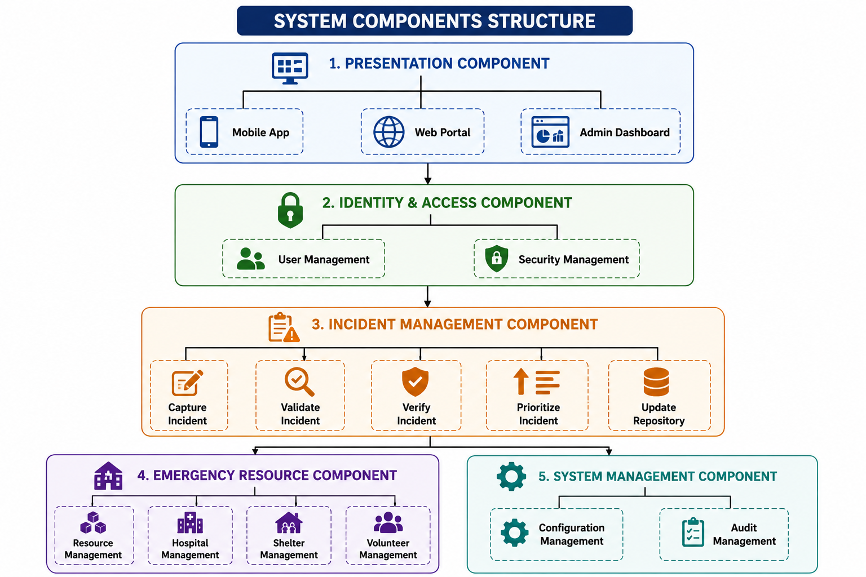

Step 3: Component Relationships and Communication
Source Component | Connector | Destination Component | Purpose
Presentation | REST API | Identity & Access | Login and authentication
Identity & Access | Service Interface | Incident Management | Secure user requests
Incident Management | Service Interface | Rescue Coordination | Verified incident information
Rescue Coordination | Service Interface | Emergency Resource | Request rescue resources
Rescue Coordination | Messaging Interface | Communication | Emergency notifications
Rescue Coordination | Data Interface | Monitoring & Analytics | Live operational updates
Business Components | Repository Interface | Data Management | Store and retrieve system data
Business Components | Configuration Interface | System Management | Configuration and audit logging
Business Components | External API Connector | External Services | GPS, maps, weather, messaging

Step 4: Components and Connectors View
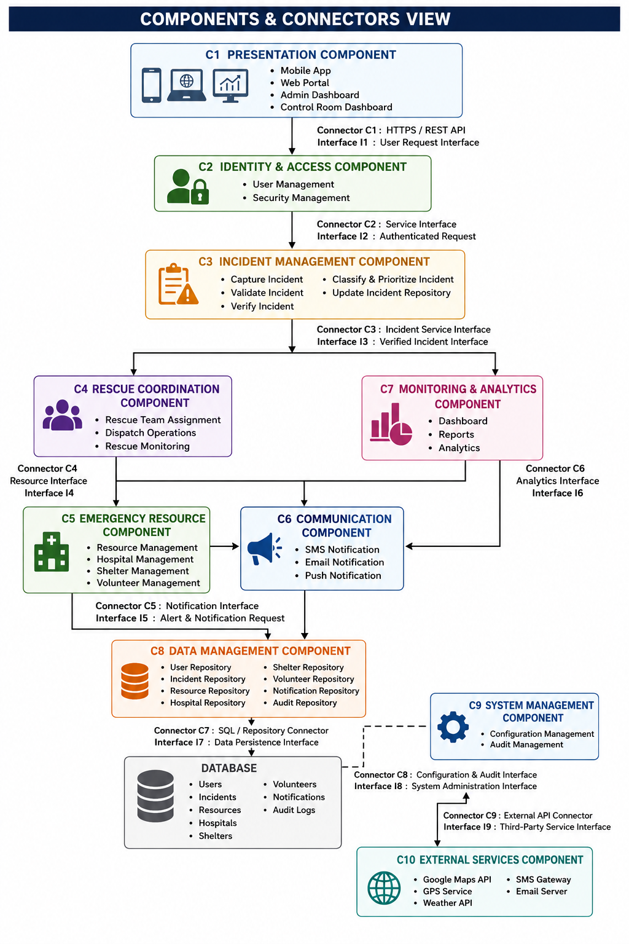

Step 5: Components, Connectors, and Interfaces
Component | Interface | Connector | Connected Component
Presentation | I1 User Request Interface | C1 HTTPS/REST API | Identity & Access
Identity & Access | I2 Authenticated Request | C2 Service Interface | Incident Management
Incident Management | I3 Verified Incident Interface | C3 Incident Service | Rescue Coordination
Rescue Coordination | I4 Resource Interface | C4 Service Interface | Emergency Resource
Rescue Coordination | I5 Notification Interface | C5 Messaging Connector | Communication
Rescue Coordination | I6 Analytics Interface | C6 Data Connector | Monitoring & Analytics
Business Components | I7 Data Persistence Interface | C7 Repository/SQL Connector | Data Management
Business Components | I8 System Administration Interface | C8 Configuration Connector | System Management
Business Components | I9 Third-Party Service Interface | C9 External API Connector | External Services

Step 6: Direction of Data Flow
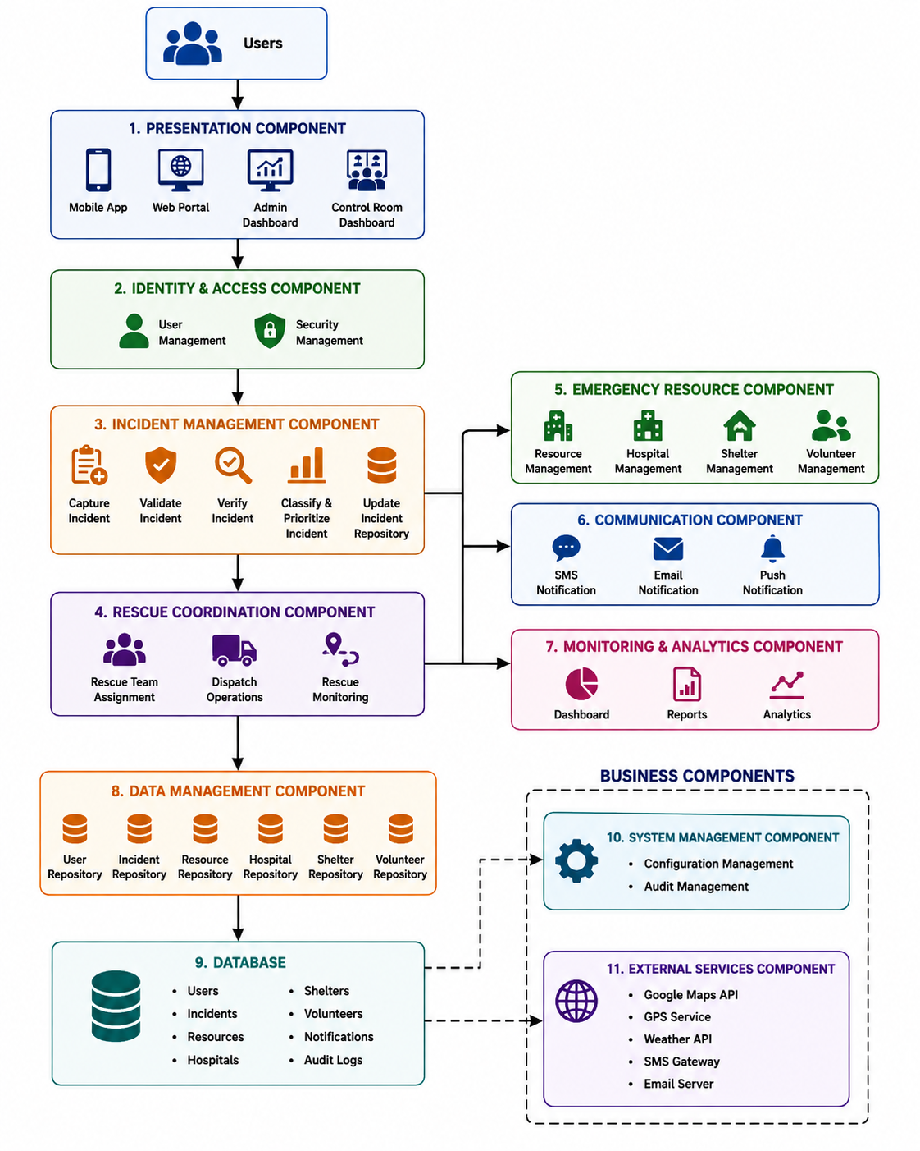
Step 7: Validation Against Requirements
Requirement | Status
1. Major software components identified | ✅
2. Related modules grouped into architectural components | ✅
3. Relationships and communication shown | ✅
4. Represented using Components & Connectors View | ✅
5. Components, connectors, and interfaces clearly labeled | ✅
6. Direction of data flow shown | ✅
7. Uses a standard Layered Software Architecture (IEEE/ISO standard) | ✅
Architectural Rationale
This design adopts a standard Layered Architecture expressed through a Components-and-Connectors view, which is widely accepted in software engineering. Each architectural component groups closely related modules from the validated module hierarchy, preserving high cohesion and low coupling. Communication occurs through explicit connectors and named interfaces (REST APIs, service interfaces, repository interfaces, and external API connectors), while the layered organization separates presentation, business logic, persistence, and external integrations. The architecture maps directly to the Level-2 DFD processes and the finalized module hierarchy, making it suitable for both academic documentation and practical implementation.

