Lab2 -sjf

#include <stdio.h>

#include <limits.h>

struct Process {

int pid;

int arrival_time;

int burst_time;

int remaining_time;

int waiting_time;

int turnaround_time;

int completed;

};

void sortByBurstTime(struct Process p[], int n) {

for (int i = 0; i < n - 1; i++) {

for (int j = 0; j < n - i - 1; j++) {

if (p[j].burst_time > p[j + 1].burst_time) {

struct Process temp = p[j];

p[j] = p[j + 1];

p[j + 1] = temp;

}

}

}

}

void sjf_non_preemptive(struct Process p[], int n) {

sortByBurstTime(p, n);

p[0].waiting_time = 0;

for (int i = 1; i < n; i++) {

p[i].waiting_time = p[i - 1].waiting_time + p[i - 1].burst_time;

}

for (int i = 0; i < n; i++) {

p[i].turnaround_time = p[i].waiting_time + p[i].burst_time;

}

}

void sjf_preemptive(struct Process p[], int n) {

int completed = 0, time = 0, min_index;

while (completed != n) {

min_index = -1;

int min_time = INT_MAX;

for (int i = 0; i < n; i++) {

if (p[i].arrival_time <= time && p[i].remaining_time > 0 && p[i].remaining_time < min_time) {

min_time = p[i].remaining_time;

min_index = i;

}

}

if (min_index == -1) {

time++;

continue;

}

p[min_index].remaining_time--;

time++;

if (p[min_index].remaining_time == 0) {

p[min_index].completed = 1;

completed++;

p[min_index].turnaround_time = time - p[min_index].arrival_time;

p[min_index].waiting_time = p[min_index].turnaround_time - p[min_index].burst_time;

}

}

}

void displayProcesses(struct Process p[], int n) {

float total_wt = 0, total_tat = 0;

printf("\nProcess\tArrival Time\tBurst Time\tWaiting Time\tTurnaround Time\n");

for (int i = 0; i < n; i++) {

printf("P%d\t%d\t\t%d\t\t%d\t\t%d\n", p[i].pid, p[i].arrival_time, p[i].burst_time, p[i].waiting_time, p[i].turnaround_time);

total_wt += p[i].waiting_time;

total_tat += p[i].turnaround_time;

}

printf("\nAverage Waiting Time: %.2f", total_wt / n);

printf("\nAverage Turnaround Time: %.2f\n", total_tat / n);

}

int main() {

int n, choice;

printf("Enter number of processes: ");

scanf("%d", &n);

struct Process p[n];

for (int i = 0; i < n; i++) {

p[i].pid = i + 1;

printf("Enter Arrival Time and Burst Time for Process %d: ", i + 1);

scanf("%d %d", &p[i].arrival_time, &p[i].burst_time);

p[i].remaining_time = p[i].burst_time;

p[i].completed = 0;

}

printf("Choose Scheduling Algorithm:\n1. Non-Preemptive SJF\n2. Preemptive SJF (SRTF)\nEnter choice: ");

scanf("%d", &choice);

if (choice == 1) {

sjf_non_preemptive(p, n);

} else if (choice == 2) {

sjf_preemptive(p, n);

} else {

printf("Invalid choice!\n");

return 1;

}

displayProcesses(p, n);

return 0;

}

Output:

Non preemtive:

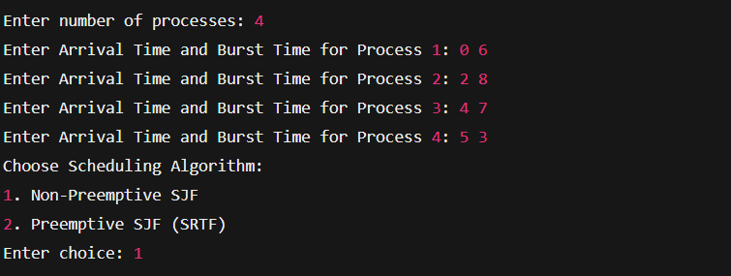

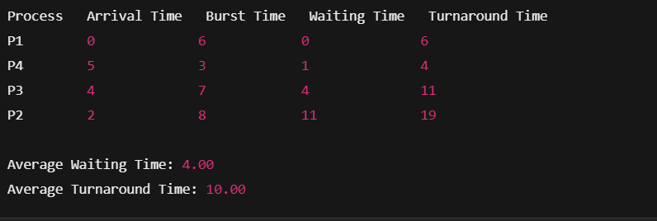

Preemptive:

