

DEPARTMENT OF COMPUTER SCIENCE AND ENGINEERING

MINI-PROJECT STUDENT HANDBOOK

Team Members:
- B. REVATHI
- C. SUJAL
- ABDUL REHAMAN
Guide: Ms. R ARUL SELVI


DEPARTMENT OF COMPUTER SCIENCE AND ENGINEERING

III B.TECH II SEMESTER

BATCH  2023-27 | MINI PROJECT  2025-26 | ACADEMIC YEAR  2025-26

TEAM ID: 23MPCS-H1
TEAM MEMBERS:

S.  No. | Roll Number | Student Name | Mail Id | Contact Number
1 | 24885A0548 | B. Revathi | revathibaraju56@gmail.com | 9182728488
2 | 24885A0551 | C. Sujal | chokkarapuwarsujal@gmail.com | 7815858730
3 | 23881A05EQ | Abdul Rehaman | abdulrehaman30023@gmail.com | 9676037287
GUIDE DETAILS:
Name of the Guide | : | Ms. R Arul Selvi
Designation | : | Assistant Professor
Department | : | COMPUTER SCIENCE AND ENGINEERING
Mail Id | : | arulselvi1985@gmail.com
Contact Number | : | 8973856211
Area of interest | : | Artificial Intelligence & Machine Learning

Signature of Guide Signature of Project Signature of HoD with Date Coordinator

PROJECT MILESTONE TRACKER

Phase | Task | Target Date | Status | Remarks
1 | Topic Selection | 20.11.2025
2 | Background Research | 27.11.2025
3 | Define Objectives | 30.11.2025
4 | Project Planning | 02.12.2025
5 | Literature Survey | 12.12.2025
6 | Review-I | 20.12.2025  To  24.12.2025
7 | Design Phase | 05.012026
8 | Implementation | 20.01.2026
9 | Review-II | 21.01.2026  To  24.01.2026
10 | Testing and Evaluation | 31.01.2026
11 | Documentation | 15.02.2026
12 | Final Presentation | 28.02.2026

Signature of Guide Signature of Project Signature of HoD with Date Coordinator
- Topic Selection

The project topic was selected based on personal interest and current relevance in the field of Artificial Intelligence and Machine Learning. Various emerging technologies related to Smart Cities, Urban Analytics, Digital Twin technology, and Predictive Modeling were studied to identify a topic that is practical, innovative, and feasible within the given time frame. Guidance was taken from faculty members and reference materials during the selection process. The topic was finalized by ensuring that it was neither too broad nor too narrow, allowing effective learning and implementation.
List of Project Titles

- AI-Based Smart City Traffic Simulation and Prediction System
- Intelligent Urban Infrastructure Monitoring Using Machine Learning
- Digital Twin Framework for Real-Time Urban Resource Management
- AI-Driven City Simulation Model for Sustainable Urban Planning
- Smart City Analytics Platform Using Artificial Intelligence
- Machine Learning-Based Urban Environment Monitoring System
- Predictive Urban Planning System Using Data-Driven Models
- AI-Powered Digital Twin for Integrated City Simulation
- AI-Driven Urban Digital Twin for Integrated City Simulation and Prediction Engine

Finalized Title: AI-Driven Urban Digital Twin for Integrated City Simulation and Prediction Engine

Date of Submission:

Internal Guide Project Coordinator
- Background Research.

List of Articles Referred

- A. Jayasinghe (2025)
  - Focuses on the transition from traditional urban planning to AI-driven Urban Informatics
  - Uses CNNs and Transformers to automate land-use detection and traffic analytics
  - Works well for analyzing static satellite imagery and planning data
  - Does not provide real-time, autonomous control mechanisms for city operations

- A. Patel and M. Musah (2025)
  - Focuses on the lifecycle performance of smart infrastructure using Digital Twins
  - Uses IoT sensors to monitor building structural integrity and energy consumption
  - Works well for predictive maintenance of individual buildings
  - Limited to specific infrastructure silos and lacks a holistic city-wide simulation
- M. Badouch et al. (2025)
  - Focuses on AI in the tourism sector
  - Uses predictive analytics to forecast demand and manage crowds
  - Works well for improving tourist experiences and reducing overcrowding
  - Treats tourism in isolation from waste and energy infrastructure
- C. Koo et al. (2025)
  - Focuses on a framework for Smart Tourism 2.0
  - Uses Metaverse concepts and Large Language Models (LLMs)
  - Works well as a theoretical model for data-centric tourism
  - Lacks a concrete, deployable prediction engine for real-world operations

- D. Kumar (2024)
  - Focuses on high-precision 3D urban mapping
  - Uses LiDAR technology to create geometrically accurate point clouds of cities
  - Works well for visualizing the static physical layout of urban areas
  - Does not capture the dynamic, temporal aspects (time-series data) of traffic or pollution

- Z. Xu et al. (2024)
  - Focuses on traffic flow prediction
  - Uses spatiotemporal convolutional networks to analyze flow sequences
  - Works well for forecasting congestion on road networks
  - Rely on traditional methods for management rather than AI-driven active control (Reinforcement Learning)

- F. A. S. Islam (2024)
  - Focuses on smart waste management systems
  - Uses IoT sensors in bins to detect fill levels and optimize collection routes
  - Works well for reducing fuel consumption and operational costs
  - Does not predict waste generation surges based on external events (e.g., festivals or weather)

- A. Shema and H. Abdulmalik (2024)
  - Focuses on the role of AI in architectural education and design studios
  - Uses generative design tools to aid students in visualizing concepts
  - Works well for conceptualization and the creative ideation phase
  - Does not result in deployable, operational systems for real-world city management

- J. Carpio-Pinedo (2024)
  - Focuses on analyzing urban land-use mix for sustainability
  - Uses AI classification to optimize the arrangement of residential and commercial zones
  - Works well for creating balanced long-term urban development plans
  - Does not capture the dynamic, temporal usage of space (e.g., how a street changes function from day to night)

- M. Badouch et al. (2025)
  - Focuses on AI applications in the tourism sector
  - Uses predictive analytics to forecast tourist demand and manage crowd flow
  - Works well for personalizing travel experiences and reducing overcrowding at specific sites
  - Does not account for the cascading impact of tourist crowds on city-wide utility services like waste and energy

- Y. Sanjalawe (2024)
  - Focuses on Smart Grids integrated with 6G networks
  - Uses secure, low-latency frameworks for energy management and anomaly detection
  - Works well for protecting grid infrastructure and ensuring rapid data transmission
  - Does not incorporate a multi-agent economic model for peer-to-peer energy trading between buildings

- A. Aabouelela (2024)
  - Focuses on sustainable, AI-powered street furniture (e.g., smart benches)
  - Uses embedded IoT sensors to manage local energy usage and provide user interactivity
  - Works well for improving energy efficiency at a micro-scale
  - Operates as isolated "smart objects" rather than part of a unified, communicating city network

- R. Sharma (2024)
  - Focuses on Digital Twins for Industry 5.0 and manufacturing
  - Uses human-centric and resilient modeling for industrial systems
  - Works well for controlled, structured environments like factories
  - Methods are not fully adapted to the unstructured, stochastic (random) nature of a living city

- C. Ezenwaka (2024)
  - Focuses on forecasting commercial real estate trends
  - Uses AI-powered Business Intelligence (BI) dashboards
  - Works well for financial planning and tenant retention analysis for property owners
  - Ignores the broader public impact of these trends on social welfare and urban equity

- A. E. Abdelsalam (2024)
  - Focuses on AI-integrated Virtual Reality (VR) systems
  - Uses immersive tech for participatory urban design
  - Works well for stakeholder engagement and visualization
  - Acts as a viewing tool rather than a predictive operational engine

- Y. Abdeahad (2024)
  - Focuses on predictive modeling for informal settlements
  - Uses ML to map and forecast slum expansion patterns
  - Works well for long-term policy and development planning
  - Lacks immediate response capabilities for emergencies like fires
- L. Lopez (2024)
  - Focuses on privacy-preserving data analytics
  - Uses Edge AI to process sensor data locally instead of in the cloud
  - Works well for protecting citizen privacy and reducing bandwidth
  - Lacks the central "big picture" view needed for city-wide optimization

Internal Guide Project Coordinator
- Define Objectives

Objectives

The objective of this project is to design a unified Urban Digital Reality platform that simulates, predicts, and optimizes all major city processes in real time by integrating multi-domain data, modeling human and system behavior, and enabling proactive decision-making.
Unlike existing urban management tools, the proposed system focuses on representing the city as a multidimensional dynamic system, rather than isolated problems, by combining multi-agent simulations, spatiotemporal deep learning, reinforcement learning, and “what-if” scenario analysis.

Detailed Objectives of the Project
- To develop a unified city digital twin
  - Integrate multi-domain data including traffic, energy, water, waste, pollution, climate, and infrastructure.
  - Maintain a dynamic representation of the city that reflects real-time and historical conditions.
- To model urban behavior using multi-agent simulations
  - Simulate realistic population mobility, interactions, and responses to city services.
  - Represent vehicles, people, buildings, and service infrastructures as agents to study emergent patterns.
- To predict learner mastery levels using machine learning
  - Apply ST-GNN, LSTM, and Transformer models to capture complex interdependencies across city systems.
  - Forecast traffic, energy demand, water usage, crowd density, and other key urban metrics.
- To optimize urban operations using reinforcement learning
  - Control traffic signals, energy distribution, and resource allocation for efficiency.
  - Learn adaptive policies that respond to changing conditions and unexpected events.
- To implement a “what-if” scenario engine
  - Simulate events such as heavy rainfall, road closures, public festivals, or infrastructure failures.
  - Evaluate policy interventions, disaster mitigation strategies, and emergency response plans.
- To enable predictive cascading risk analysis
  - Anticipate cross-domain failures (e.g., flood → traffic congestion → power outage).
  - Support proactive planning and decision-making to minimize disruptions.
- To provide actionable insights through an Urban AI assistant (Urban LLM)
  - Generate explainable predictions, recommendations, and policy insights.
  - Communicate results in an intuitive format for city planners, authorities, and stakeholders.

Internal Guide Project Coordinator
- Project Planning

Gantt Chart

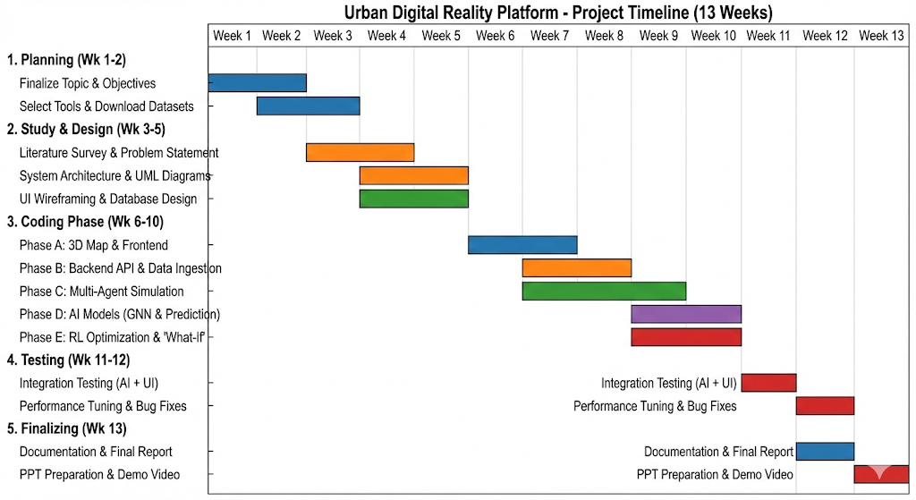

Internal Guide Project Coordinator
- Literature Survey

Title (with Author & Year) | What the Paper Did | Methodology Used | Gaps Identified
Smart Cities, Smarter Planning: The AI Revolution Urban Planners Can’t Afford to Miss – Jayasinghe (2025) | Explored shift from traditional planning to AI-driven urban informatics for livability improvement | CNNs, Transformers, urban data analytics, case studies | No real-time autonomous control for dynamic city operations
Performance Oriented Design of Smart Infrastructure Using Digital Platforms and AI Algorithms – Patel & Musah (2025) | Applied AI across infrastructure lifecycle to improve energy efficiency | Digital twins, IoT sensors, predictive AI models | Limited to single buildings, not city-wide simulations
Artificial Intelligence (AI) in Architecture and Design – Shema & Abdulmalik (2024) | Studied generative AI for architectural ideation and spatial optimization | Generative AI tools, design algorithms | No simulation of human behavior or operational use
`Virtual Cities: From Digital Twins to Autonomous AI Societies – IEEE Xplore (2024) | Proposed autonomous AI agents simulating social and economic interactions | Agent-based modeling, virtual city frameworks | Lacks real-world IoT data integration
Exploring AI-Integrated VR Systems – Abdelsalam (2024) | Evaluated VR for participatory urban design and visualization | AI-enhanced VR platforms, user testing | No predictive or cascading effect analysis
Digital Twins Powered by LiDAR for Metaverse-Based Sustainable Urban Planning – Kumar (2024) | Created accurate 3D urban models using LiDAR | LiDAR scanning, 3D point cloud modeling | Static models, no real-time temporal data
AI-Driven Predictive Modeling for Urban Slum Regeneration – Abdeahad (2024) | Predicted slum growth patterns for sustainable planning | Satellite imagery, ML prediction models | No short-term operational response capability
Digital Twins and AI: Real-Time Simulation of Complex Systems – ResearchGate (2024) | Discussed AI-driven self-updating digital twins | AI-integrated digital twin architectures | No unified city-scale cross-domain pipeline
Artificial Intelligence in Architecture and Design (Educational Perspective) – Shema (2024) | Analyzed AI use in design education | AI tools in architectural studios | Pedagogical focus, no real-world deployment
Edge AI for Privacy-Preserving Data Analytics in Smart Cities – Lopez (2024) | Proposed edge AI for privacy-safe smart city analytics | Edge computing, local AI inference | Lacks city-wide global optimization
AI-Powered Smart Tourism: Reimagining Travel – Badouch et al. (2024) | Used AI to improve tourist experience and crowd management | Predictive analytics, tourism datasets | Ignores interaction with other city systems
Title (with Author & Year) | What the Paper Did | Methodology Used | Gaps Identified
Machine Learning-Based Traffic Flow Prediction – Xu et al. (2024) | Predicted traffic congestion patterns | Spatiotemporal CNNs | No reinforcement learning-based control
Smart Waste Management Systems – Islam (2024) | Optimized waste collection using IoT and AI | Sensor networks, route optimization algorithms | No waste generation prediction from events/weather
Urban Land Use Mix and AI: A Systematic Review – Carpio-Pinedo (2024) | Reviewed AI-based land-use classification methods | Systematic literature review | Static analysis, no temporal usage modeling
AI-Powered Smart Grids in the 6G Era – Sanjalawe (2024) | Surveyed AI-enabled smart grids with 6G | AI forecasting, secure communication frameworks | No economic or multi-agent energy trading
AI-Powered Sustainable and Energy-Smart Urban Furniture – Aabouelela (2024) | Designed intelligent, energy-efficient urban furniture | Embedded AI, IoT-enabled objects | Isolated systems, no city-network integration
AI-powered Smart Tourism 2.0: A 10-year Retrospective – Koo et al. (2024) | Reviewed evolution of AI in smart tourism | Theoretical framework, literature synthesis | No practical prediction engine implementation
Digital Twins as Enablers of Industry 5.0 Infrastructure – Sharma (2024) | Examined digital twins in human-centric industrial systems | Review of Industry 5.0 frameworks | Not adapted to complex urban environments
Integrating AI-Powered BI Dashboards to Forecast Commercial Property Trends – Ezenwaka (2024) | Forecasted commercial property trends using AI dashboards | BI analytics, ML forecasting models | Ignores social and public urban impacts

Internal Guide Project Coordinator
- Design Phase Project Architecture
The project architecture describes the overall structure of the AI-driven city digital twin and explains how different subsystems interact to simulate, predict, and optimize city-wide operations. Unlike traditional urban systems that work in silos, this architecture integrates multiple city domains into a unified intelligent framework.

The system consists of the following modules:
- User Interface and Visualization Module
This module acts as the interaction layer between the system and stakeholders such as city planners, administrators, and researchers. It provides dashboards, maps, charts, and scenario controls for monitoring real-time city conditions and simulation outputs.
- Displays traffic, pollution, energy usage, crowd density, and alerts
- Allows users to define “what-if” scenarios (road closure, rainfall, events)
- Visualizes predictions and optimization results
- Data Ingestion and Integration Module
This module is responsible for collecting and integrating heterogeneous urban data from multiple sources.
- Real-time IoT sensor data (traffic sensors, weather stations, pollution monitors)
- Historical GIS and infrastructure data
- Public datasets and simulated inputs
The data is cleaned, synchronized, and transformed into a unified spatiotemporal format.
- City Digital Twin Module
This module maintains a virtual, continuously updated representation of the city.
- Represents roads, buildings, utilities, and zones spatially
- Maintains temporal states for each city component
- Serves as the environment for simulations and learning models
- Multi-Agent Simulation Module
This module models the dynamic behavior of city entities as autonomous agents.
- People agents simulate movement, commuting, and crowd behavior
- Vehicle agents simulate traffic flow and congestion
- Infrastructure agents represent services such as power, water, and transport
The interaction of agents produces emergent city-wide patterns.
- Spatiotemporal Prediction Module
This module applies deep learning techniques to predict future city conditions.
- Uses Spatiotemporal Graph Neural Networks (ST-GNNs) to model spatial dependencies
- Uses LSTMs and Transformers for temporal forecasting
- Predicts traffic congestion, energy demand, pollution spread, and crowd density
- Reinforcement Learning Optimization Module
This module focuses on decision-making and control.
- Learns optimal traffic signal timings
- Optimizes energy distribution and resource allocation
- Adapts policies based on changing city conditions
The module continuously improves through interaction with the city digital twin.

- What-If Scenario Simulation Module
This module enables scenario-based analysis and experimentation.
- Simulates events such as rainfall, festivals, accidents, or infrastructure failures
- Evaluates the impact of policy decisions before real-world deployment
- Supports risk analysis and emergency planning

- Database and Storage Module
This module provides persistent and efficient data storage.
- Stores sensor data, simulation states, predictions, and policies
- Maintains historical logs for training and evaluation
- Supports structured and time-series data storage

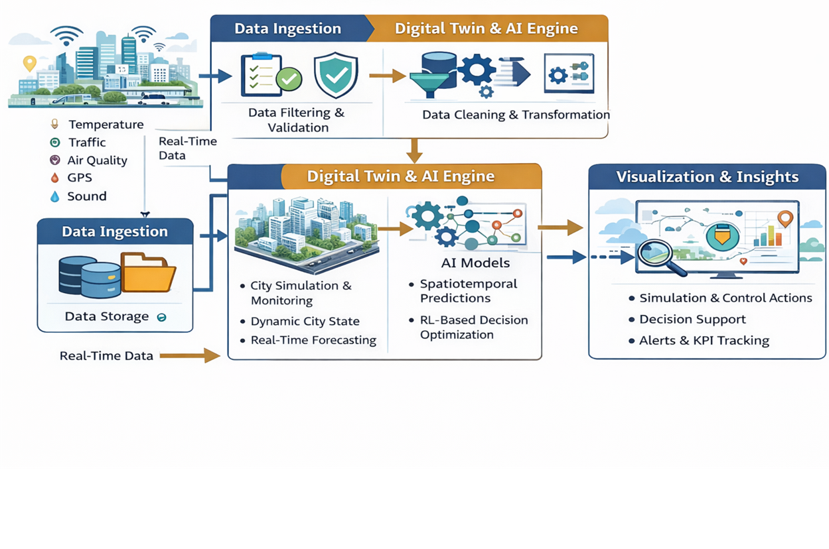
Use Case Diagram

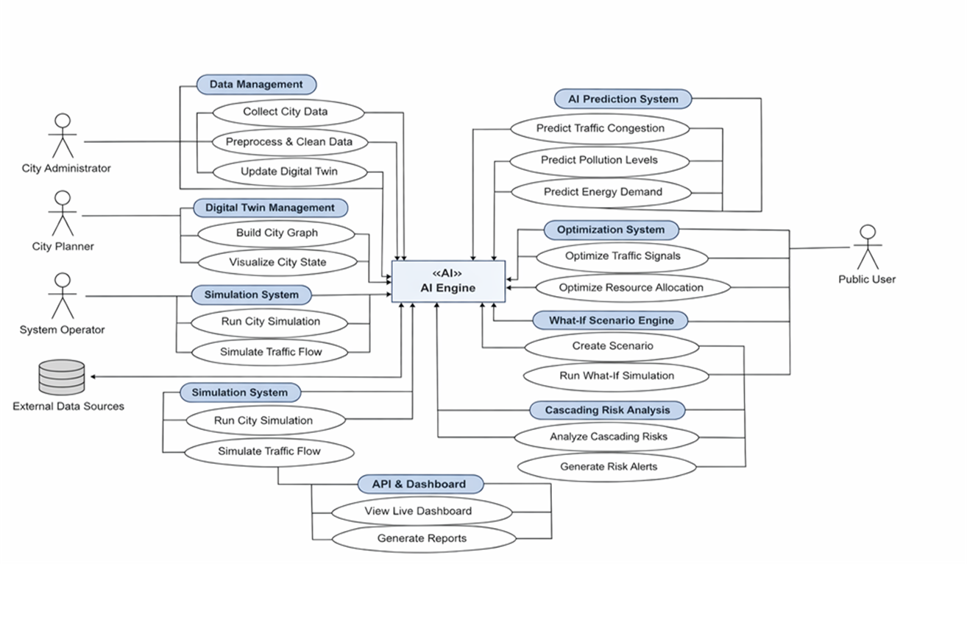

Class Diagram

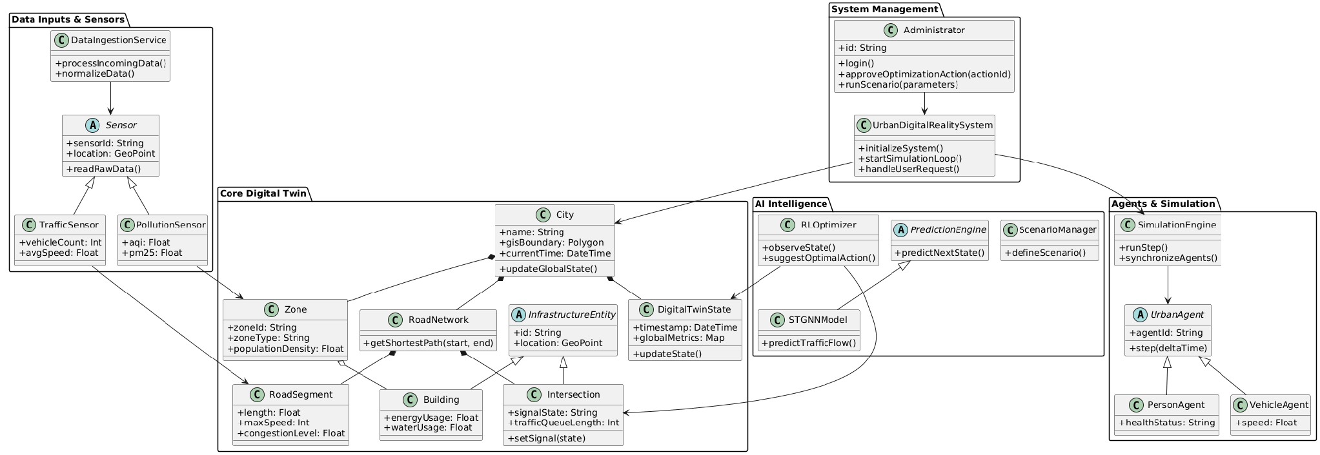
Sequence Diagram

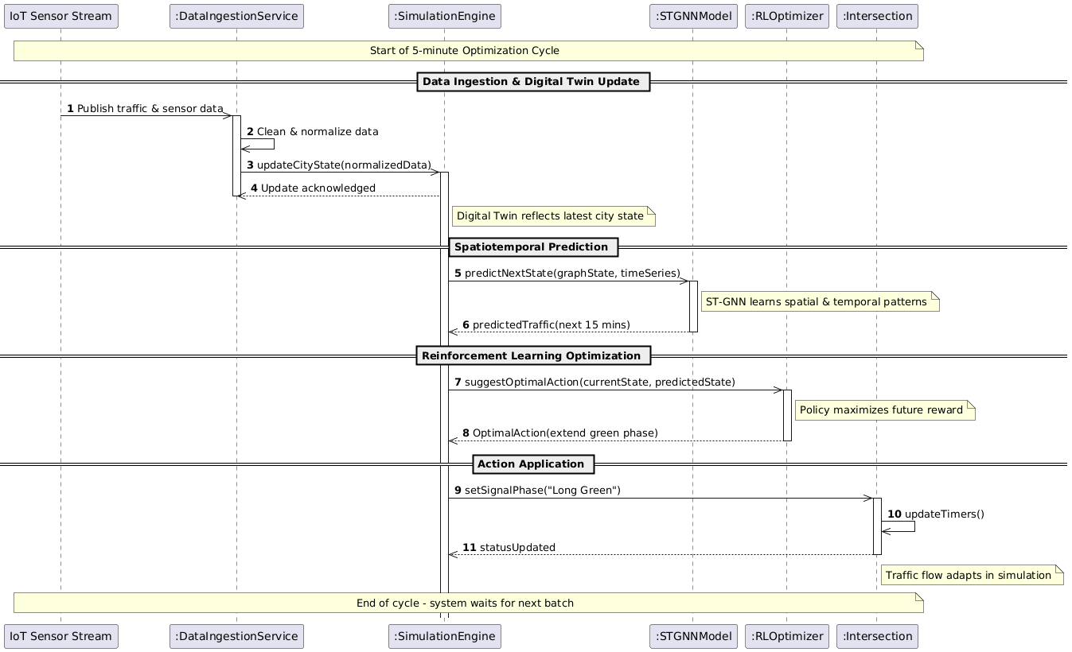

Activity Diagram

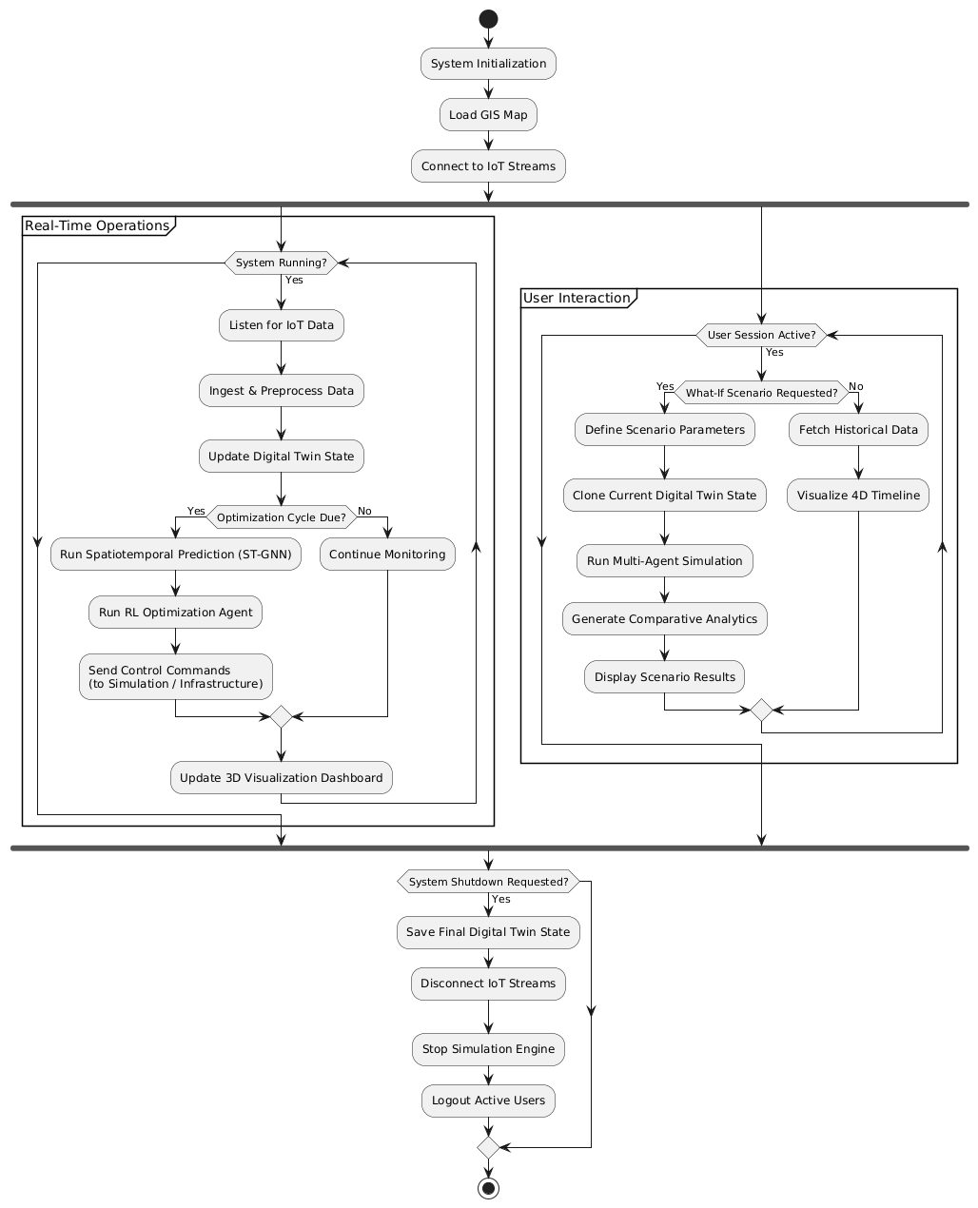

List of Tools to be used for implementation

- Python 3.x – Core Development and System Integration
- PyTorch / TensorFlow – Deep Learning Model Implementation
- PyTorch Geometric / DGL – Spatiotemporal Graph Neural Networks (ST-GNN)
- Mesa – Multi-agent City and Traffic Simulation
- Stable-Baselines3 – Reinforcement Learning for Traffic Optimization
- FastAPI – Backend API and Real-Time Services
- PostgreSQL / SQLite – Structured Data Storage and Management
- GitHub – Version Control and Code Management

Internal Guide Project Coordinator
- Implementation

The system is implemented using Python as the primary programming language due to its extensive support for data processing, machine learning, and simulation libraries. Development and experimentation are carried out using Google Colab and Visual Studio Code to enable both cloud-based and local execution.

Key tools and technologies used include:
- Python 3.x for core development
- PyTorch / TensorFlow for deep learning models
- PyTorch Geometric / DGL for Spatiotemporal Graph Neural Networks
- Mesa for multi-agent city simulation
- Stable-Baselines3 for reinforcement learning
- FastAPI for backend API services
- PostgreSQL / SQLite for structured data storage
- GitHub for version control and code management

  - Data Preprocessing (preprocessing/preprocess.py)
import pandas as pd

def load_and_clean(path):
df = pd.read_csv(path)
df = df.dropna()
df["timestamp"] = pd.to_datetime(df["timestamp"])
return df

traffic = load_and_clean("../data/traffic.csv")
weather = load_and_clean("../data/weather.csv")

merged = pd.merge_asof(
traffic.sort_values("timestamp"),
weather.sort_values("timestamp"),
on="timestamp"
)

merged.to_csv("../data/processed.csv", index=False)
print("Preprocessing completed.")

  - City Graph Construction (graph/city_graph.py)
import networkx as nx

def build_city_graph():
G = nx.Graph()

# Nodes = intersections
for i in range(10):
G.add_node(i, traffic=0.0)

# Edges = roads
edges = [(i, i+1) for i in range(9)]
G.add_edges_from(edges)

return G

if __name__ == "__main__":
graph = build_city_graph()
print("City Graph Nodes:", graph.nodes())

  - Spatio-Temporal GNN (models/stgnn.py)
import torch
import torch.nn as nn
from torch_geometric.nn import GCNConv

class STGNN(nn.Module):
def __init__(self, in_channels, hidden):
super().__init__()
self.gcn1 = GCNConv(in_channels, hidden)
self.lstm = nn.LSTM(hidden, hidden, batch_first=True)
self.fc = nn.Linear(hidden, 1)

def forward(self, x, edge_index):
x = self.gcn1(x, edge_index)
x = torch.relu(x)
x, _ = self.lstm(x.unsqueeze(0))
return self.fc(x.squeeze(0))

  - Transformer for Long-Term Prediction (models/transformer.py)
import torch.nn as nn

class CityTransformer(nn.Module):
def __init__(self, features):
super().__init__()
self.encoder = nn.TransformerEncoder(
nn.TransformerEncoderLayer(d_model=features, nhead=2),
num_layers=2
)
self.fc = nn.Linear(features, 1)

def forward(self, x):
x = self.encoder(x)
return self.fc(x)

  - Multi-Agent Simulation (simulation/agents.py)
from mesa import Agent, Model
from mesa.time import RandomActivation

class VehicleAgent(Agent):
def __init__(self, unique_id, model):
super().__init__(unique_id, model)
self.speed = 1

def step(self):
self.speed += self.random.choice([-1, 0, 1])

class CityModel(Model):
def __init__(self, n):
self.schedule = RandomActivation(self)
for i in range(n):
self.schedule.add(VehicleAgent(i, self))

def step(self):
self.schedule.step()

if __name__ == "__main__":
model = CityModel(5)
for _ in range(3):
model.step()

  - Reinforcement Learning (rl/traffic_rl.py)
import gymnasium as gym
from stable_baselines3 import PPO

class TrafficEnv(gym.Env):
def __init__(self):
self.observation_space = gym.spaces.Box(0, 1, (1,))
self.action_space = gym.spaces.Discrete(2)

def reset(self, seed=None):
return [0.5], {}

def step(self, action):
reward = 1 if action == 1 else -1
return [0.5], reward, False, False, {}

env = TrafficEnv()
model = PPO("MlpPolicy", env, verbose=0)
model.learn(total_timesteps=1000)

  - What-If Scenario Engine (scenario/what_if.py)
def simulate_event(event):
if event == "rain":
return "Traffic speed reduced by 30%"
if event == "road_closure":
return "Congestion increased in adjacent roads"
if event == "festival":
return "Pedestrian density increased"

print(simulate_event("rain"))

  - FastAPI Backend (api/main.py)
from fastapi import FastAPI
from scenario.what_if import simulate_event

app = FastAPI()

@app.get("/whatif/{event}")
def run_scenario(event: str):
return {"result": simulate_event(event)}

Internal Guide Project Coordinator

