ASSIGNMENT-I

Name:P.Revathi

ID:S170286

Section:C

1.Write a C program to convert Original number into Roman number?

#include<stdio.h>

int main()

{

printf("\t\tStudent Name:P.Revathi");

printf("\n\t\tID Number :S170286\n");

int n;

printf("enter the ordinary number:");

scanf("%d",&n);

while(n>=1000)

{

printf("M");

n-=1000;

}

if(n>=500)

{

printf("D");

n-=500;

}

while(n>=100)

{

printf("C");

n-=100;

}

if(n>=50)

{

printf("L");

n-=50;

}

while(n>=10)

{

printf("X");

n-=10;

}

if(n>=9)

{

printf("IX");

n-=9;

}

if(n>=5)

{

printf("V");

n-=5;

}

if(n>=4)

{

printf("IV");

n-=4;

}

while(n>=1)

{

printf("I");

n-=1;

}

}

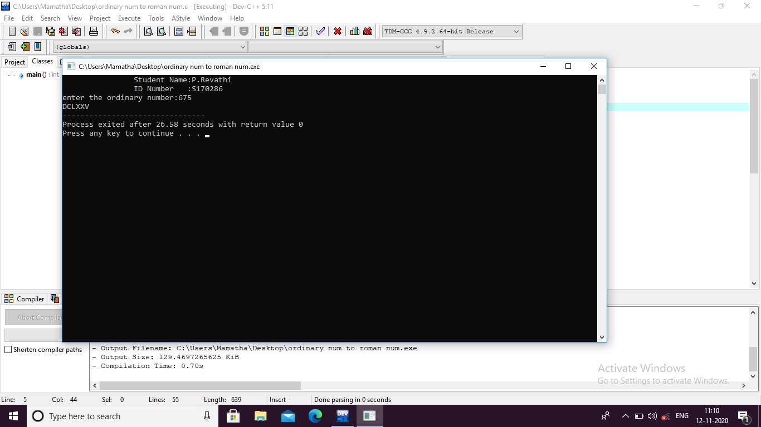

2.Write a C program to convert Roman number into Original number?

#include<stdio.h>

int main()

{

printf("\t\tStudent Name:P.Revathi");

printf("\n\t\tID Number :S170286\n");

char a[10];

int i,num=0;

printf("please enter the roman numeral in CAPITAL letters :");

gets(a);

while(a[i]!='\0')

{

switch(a[i])

{

case 'M': /\*i may give condition to convert "IM" roman numeral into decimal but it is not a valid numeral

because of we don't put high value previous low value roman numeral but for rectify the3 logical error i gave that condition also\*/

{

if(a[i-1]=='C')

{

num+=800;

}

else if(a[i-1]=='X')

{

num+=980;

}

else if(a[i-1]=='I')

{

num+=998;

}

else

{

num+=1000;

}

break;

}

case 'D':

{

if(a[i-1]=='C')

{

num+=300;

}

else if(a[i-1]=='X')

{

num+=980;

}

else if(a[i-1]=='I')

{

num+=498;

}

else

{

num+=500;

}

break;

}

case 'C':

{

if(a[i-1]=='X')

{

num+=80;

}

if(a[i-1]=='I')

{

num+=98;

}

else

{

num+=100;

}

break;

}

case 'L':

{

if(a[i-1]=='X')

{

num+=30;

}

if(a[i-1]=='I')

{

num+=48;

}

else

{

num+=50;

}

break;

}

case 'X':

{

if(a[i-1]=='I')

{

num+=8;

}

else

{

num+=10;

}

break;

}

case 'V':

{

if(a[i-1]=='I')

{

num+=3;

}

else

{

num+=5;

}

break;

}

case 'I':

{

num+=1;

break;

}

default:

{

printf("you entered INVALID roman number...");

break;

}

}

i++;

}

printf("corresponded decimal number is %d",num);

}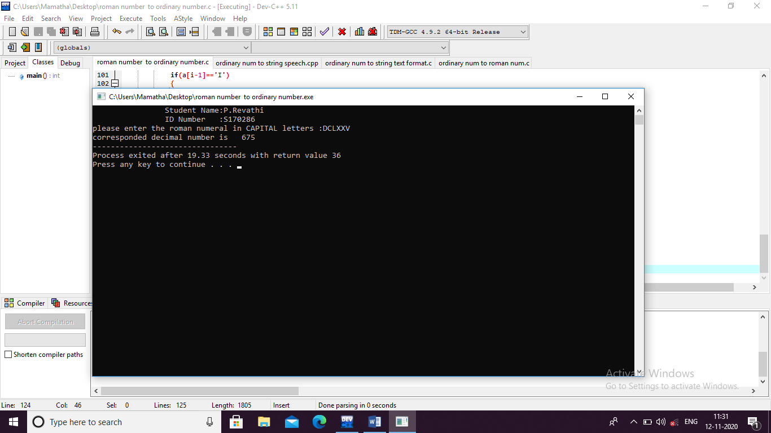

3.Write a C program to convert Original number into String format (in words)?

#include<stdio.h>

int main()

{

printf("\t\tStudent Name:P.Revathi");

printf("\n\t\tID Number :S170286\n");

int n,rev,t,c=0;

printf("enter the ordinary number:");

scanf("%d",&n);

rev=0;

t=n;

while(n!=0)

{

if(n%10==0)

{

c++;

}

rev=rev\*10+n%10;

n=n/10;

}

n=rev;

printf("the given ordinary number in string format \n");

while(n!=0)

{

switch(n%10)

{

case 1:

printf(" one ");

break;

case 2:

printf(" two ");

break;

case 3:

printf(" three ");

break;

case 4:

printf(" four ");

break;

case 5:

printf(" five ");

break;

case 6:

printf(" six ");

break;

case 7:

printf(" seven ");

break;

case 8:

printf(" eight ");

break;

case 9:

printf(" nine ");

break;

case 0:

printf(" zero ");

break;

}

n=n/10;

}

while(c)

{

printf(" zero ");

c--;

}

}

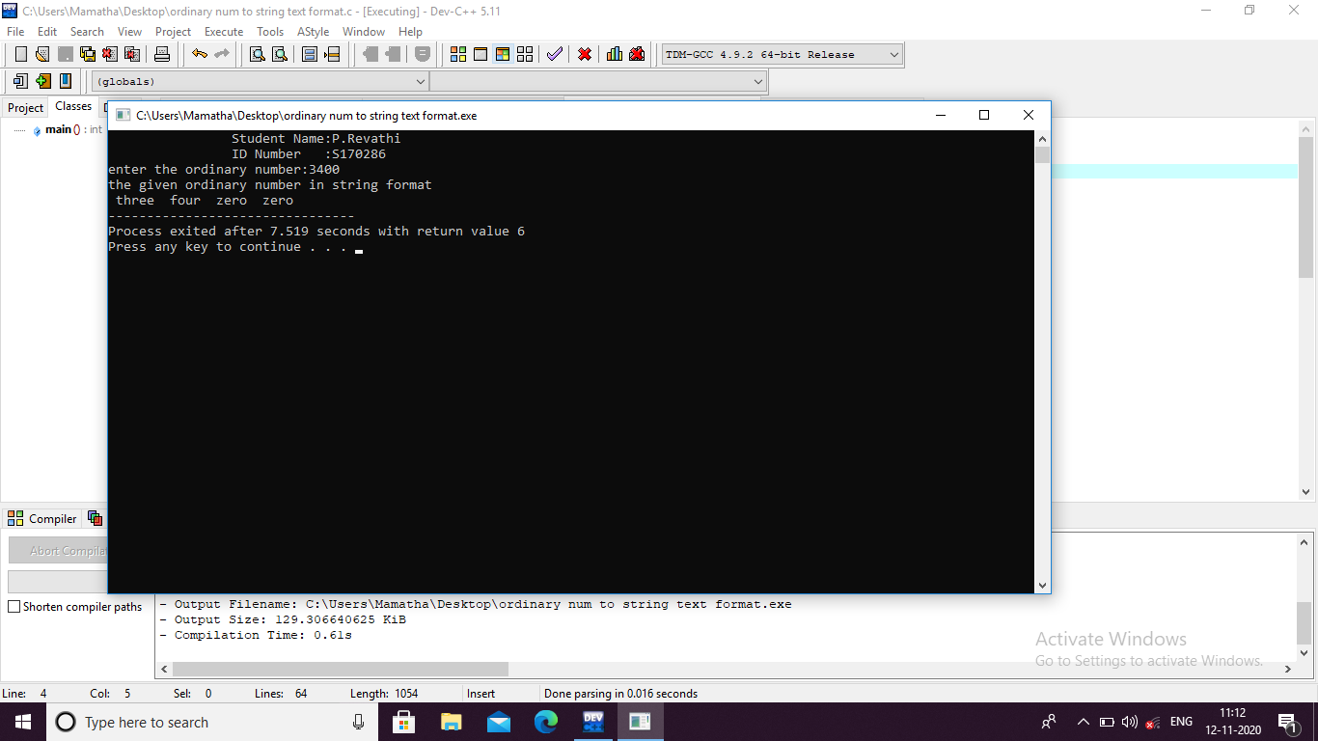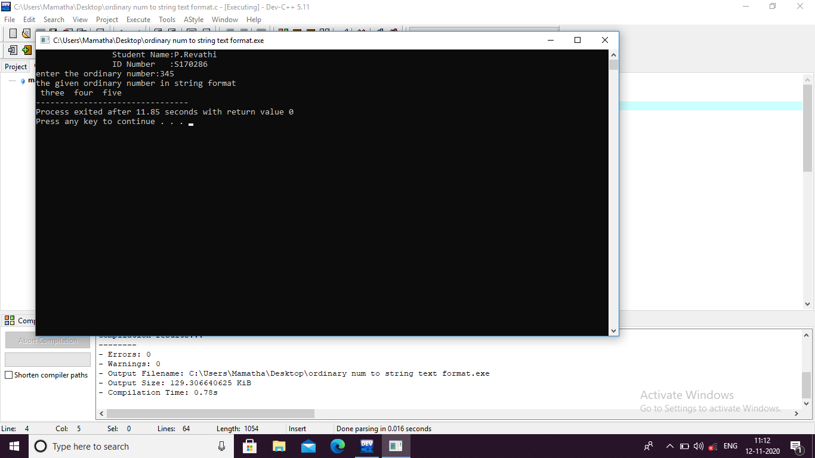

4.Write a C program to convert Original number into String format (in speech)?

#include<stdio.h>

int main()

{

printf("\t\tStudent Name:P.Revathi");

printf("\n\t\tID Number :S170286\n");

char a[10][10]={"zero","one","two","three","four","five","six","seven","eight","nine"};

char b[10][10]={"ten","eleven","twelve","thirteen","fourteen","fifteen","sixteen","seventeen","eighteen","nineteen"};

char c[10][10]={"ten","twenty","thirty","fourty","fifty","sixty","seventy","eighty","ninety","hundred"};

int n,i;

printf("enter the ordinary number:");

scanf("%d",&n);

if(n>10000)

{

printf("please enter the number less than ten thousand");

}

else

{

if(n>=1000)

{

i=n/1000;

printf("%s thousand ",a[i]);

n=n%1000;

}

if(n>100)

{

i=n/100;

printf("%s hundred and ",a[i]);

n=n%100;

}

if(n>=10&&n<20)

{

i=n%10;

printf("%s",b[i]);

}

if(n>19&&n<=100)

{

i=n/10;

printf("%s",c[i-1]);

n=n%10;

}

if(n>=1&&n<10)

{

printf(" %s",a[n]);

}

}

}

