**Cycle-1-Shell Scripting**

0:UNIX commands Date : 27/01/2020

**Problem 0: UNIX COMMANDS**

## AIM:

## Try out the following unix commands(use manual and help features for support).

1. echo, read

2. more, less

3. man

4. chmod, chown

5. cd, mkdir, pwd, ls, find

6. cat, mv, cp, rm

7. wc, cut, paste

8. head, tail, grep, expr

9. Redirections & Piping

10. useradd, usermod, userdel, passwd

11. tar

## PROGRAM CODE:

## 

|  |  |
| --- | --- |
| echoread | Echo displays line of text or strings that are passes as arguments.  Syntax : Echo [string] Read is used to get input from keyboard.Syntax : Read text |
| moreless | More is used to view the text file in command prompt displaying one screen at a time in case file is large.  Syntax : more -d sample.txt Less is used to read contents of text file in page per time. Syntax : sudo | less |
| man | man displays man pages for commands manmeors manual for command.  Syntax : man chown |
| Chmodchown | Chmod set the permission flag .  Syntax : chmod 766 ex.txt  Chown allow change owner and group owner of file.  Syntax : sudo chown clave : mary example.txt |
| cdmkdirpwdlsfind | Cd changes current directory.  Syntax : cd directory_name  Mkdir creates new directory .  Syntax : mkdir invoice  Pwd prints workind directory from root directory.  Syntax : pwd  Ls lists file and folder in directory .  Syntax : ls –l  Find tracks down file.  Syntax : find . name * ones |
| catmvcprm | Cat concatenates file and print to stdout.  Syntax : cat [OPTION]..[FILE]  Mv moves file or rename files.  Syntax : mv[OPTION]source    Cp copy files.  Syntax : cp [OPTION] source  Rm removes files and directories.  Syntax:rm [OPTION]…[FILE] |
| wccutpaste | Wc is used for printing newline , word and byte counts for files.  Cut is used for cutting out sections for each line of files and writes result to standard output.  Paste is used to join files horizontally by outputting lines. |
| head andtailgrepexpr | Head command prints lines from beginning of a file and tail prints lines from end of file.  Grep searches through a set of files for arbitrary text pattern through regular expression.  Expr evaluates a given expression and displays corresponding output. |
| Redirectionpiping | Redirection is a feature when executes a command, we can change input or output devices.  Piping is a form of redirection ie used in linux to send output of one command for further processing. |
| UseraddUsermoduserdelPasswd | Useradd is used to create new accounts in linux.  Usermod used to modify existing accounts in linux.  Userdel is used to delete account in linux.  Passwd is used to assign password to local accounts of users. |
| tar | Tar stands for tap to achieve which is used to tape drive back up command used by linux.  Syntax : tar [OPTIONS] [ARCHIEVE-FILE] [FILE OD DIRECTORY TO BE  ACHIEVED] |

## 1:welcome message Date : 02/02/2020

**Problem 1 : WELCOME MESSAGE**

## AIM:

## Print a customized welcome message. Get the name of the user as input and attach the name to the welcome message. Eg. “Welcome Rahul”.

## 

## PROGRAM CODE:

## 

|  |  |
| --- | --- |
| welcome | read -p “Enter your name “ nameecho Welcome $name |

## RESULT:

## Enter your name Revathy

## Welcome Revathy

## 2: Greatest of 2 numbers Date : 06/02/2020

**Problem 2 : GREATEST OF 2 NUMBERS**

## AIM:

## Take 2 numbers as input and print the greater of the two.

## 

## PROGRAM CODE:

## 

|  |  |
| --- | --- |
| greater | read -p “Enter first number “ num1read –p “Enter second number “ num2if [ $num1 –gt $num2 ]thenecho “ Largest number is :” $num1elseecho “Largest number is :” $num2fi |

## RESULT:

## Enter first number 45

## Enter second number 67

## Largest number is : 67

3: Odd numbers Date : 09/01/2020

**Problem 3: ODD NUMBERS**

## AIM:

## Print the first 20 odd numbers.

## PROGRAM CODE:

## 

|  |  |
| --- | --- |
| odd | i=1count=0echo “Odd numbers are :”while [ $i –lt 100 ]doecho $icount=` expr $count + 1 `if [ $count –eq 20 ]thenbreakfii=` expr $i + 2 ’done |

## RESULT:

## Odd numbers are :

## 1

## 3

## ….

## 39

## 4: Sum of 20 numbers Date : 16/02/2020

**Problem 4 : SUM OF 20 NUMBERS**

## AIM:

## Store 20 numbers in an array and print their sum.

## PROGRAM CODE:

## 

|  |  |
| --- | --- |
| arraysum | read –p “Enter 20 numbers” inputsum=0for i in ${input[@]}dosum=` expr $sum + $i `doneecho “The sum is :” $sum |

## RESULT:

## Enter 20 numbers 1 2 3 4 5 6 1 2 3 4 1 2 3 4 5 6 7 8 9 1

## The sum is : 77

## 5: Creating a text file Date : 16/02/2020

**Problem 5 : CREATING A TEXT FILE**

## AIM:

Create a text file with 20 lines of text.

## PROGRAM CODE:

## 

|  |  |
| --- | --- |
| text | cat > que5.txt  Welcome to Linux. Linux is the best-known and most-used [open source](https://opensource.com/resources/what-open-source) operating system. As an operating system, Linux is software that sits underneath all of the other software on a computer, receiving requests from those programs and relaying these requests to the computer’s hardware. Cntrl + D |

## RESULT:

File created que5.txt.

6: Replacing strings Date : 20/02/2020

**Problem 6: REPLACING STRING**

## AIM:

Open the file created in question 5 and replace any string with another without using stream editor.

## PROGRAM CODE:

## 

|  |  |
| --- | --- |
| replace | While read a; doecho ${a//linux/shell scripting}done<que5.txt>que5.txt.tmv que5.txt{.t,} |

## RESULT:

Welcome to shell scripting. Linux is the best-known and most-used [open source](https://opensource.com/resources/what-open-source) operating system. As an operating system, Linux is software that sits underneath all of the other software on a computer, receiving requests from those programs and relaying these requests to the computer’s hardware.

7:Protocols and description Date : 23/02/2020

**PROGRAM 7 : PROTOCOLS AND DESCRIPTION**

## AIM:

Open the /etc/protocols file and copy the protocol number of the following protocols into another file named "favorite protocols" and format it in the same way as the original /etc/protocol file.

1. udp

2. idrp

3. skip

4. ipip

**PROGRAM CODE:**

## 

|  |  |
| --- | --- |
| protocol | grep “udp\|idrp\|skip\|ipip” /etc/protocols> favoriteprotocols.txtcat favoriteprotocols.txt |

## RESULT:

## idrp 17 UDP #User Datagram Protocol

## idrp 45 IDRP #Inter- Domain Routing Protocol

## skip 57 SKIP #SKIP

## ipip 94 IPIP #IP- within- IP Encapsulation Protocol

8: Using AT and BATCH Date : 27/02/2020

**Problem 8: USING AT AND BATCH**

## AIM:

Use "at" and "batch" to schedule tasks.

**PROGRAM CODE:**

## 

|  |  |
| --- | --- |
| at | echo “sh execute.sh” |at now+1 minute |
| execute.sh | echo “ Hello world” >create.txt |
| Batch (In Terminal) | >batchWarning: commands will be executed using /bin/shat> echo “ welcome…. >out.txtat>cntrl + D |

## RESULT:

## job 1 at Mon Feb 27 21:55:00 2020

## The file named execute.sh will be executed and create.txt will be created after one minute.dd

## job 2 at Mon Feb 27 22:05:00 2020

## The file named out.txt will be created .

9:CRON command Date : 02/03/2020

**Problem 9: CRON COMMAND**

## AIM:

Use cron to schedule tasks.

**PROGRAM CODE:**

## 

|  |  |
| --- | --- |
| In terminal | Crontab –e |
| In nano editor | 49 * * * * cd/home/mca50/Downloads/sd && sh execute.sh |
| execute.sh | echo “Hello world “>create.txt |

## 

## RESULT:

## When time (minutes) becomes 49 execute.sh will be execute. In execute.sh , we wants to create a file named as create.txt with text “ Hello world “.

11: UNIX Mail Date : 05/03/2020

**Problem 10: UNIX MAIL**

## AIM:

Set up unix mail and use mail to send and receive mails to and from users using shell scripting.

**PROGRAM CODE:**

## 

|  |  |
| --- | --- |
| ques10.sh | echo “hi revathy, welcome “|mail –s “This is the subject” revathychandran47@gmail.com |

## 

## RESULT:

## In gmail

## 19mca50

## This is the subject

## Hi revathy, welcome

**Cycle 2- Version Control using git**

1:Git repository Date : 09/03/2020

**AIM:**

**PROGRAM 1 : GIT REPOSITORY**

1. Install and initialize git and perform the following operations
   1. Create a text file in your git directory.
   2. Configure your git with your credentials.
   3. Configure the default editor to your favorite editor
   4. Stage your files
   5. Create your first commit
   6. Push to remote repository

The following exercises must be done by a team of four students.

* + 1. Create team account.
    2. Create empty repository in any git remote repository service and add collaborators.
    3. Leader must create the first commit.
    4. All members must clone the remote repository.
    5. Each member must create a feature branch each and add features to them(any mod)
    6. Commit changes to branches.
    7. Push the branches.
    8. View Graph.
    9. Leader must make changes to the master.
    10. All member must rebase their branches to the position of latest commit in master.

11.Merge all branches to master.

12.Cherry pick commits from each branch created earlier.

13.View Status.

14.View History.

15.Delete all branches.

**PROGRAM CODE :**

Setting the git configurations in terminal.

* git config --global user.name Revathychandran47
* git config --global user.email [revathychandran47@gmail.com](mailto:revathychandran47@gmail.com)
* git config --global core.edit nano

Adding a file in your git initialized folder to staging area ,Use the command :

* git add filename.txt

We can use following command to see both tracked and untracked files.

* git status

To commit the added file to local repository, Use the command :

* git commit -m "a meaninful comment".

To clone the entire github repository , use command :

* git clone https://github.com/Anjali-941/first-repo.git.

To push the committed file to our git repository , use the below command:

* git pull <https://github.com/Anjali-941/first-repo.git>
* git push https://github.com/Anjali-941/first-repo.git master

To create a new branch and branch operations. Use the following commands

* git checkout -b revu /*to create a branch named revs*/
* git branch /*to show all branches*/
* git pull <https://github.com/Anjali-941/first-repo.git>
* git push https://github.com/Anjali-941/first-repo.git revs

To merge the branch to our master branch ,use following commands.

* git checkout master /*switching to master branch*/
* git merge revu /*merging the branch repos*/

To cherry pick a commit done in revs branch to master branch, use the command :

* git cherry-pick commitid

To view the operations in a graph format , use the command:

* git log –-graph

To rebase the branch to master branch , use the command :

* git checkout revu
* git rebase master / * rebasing branch to master branch*/

To view the history of git commits, use the command :

* git log --oneline

To delete a feature branch , use the command :

* git branch -d revu /*deletes repos branch*/

**RESULT :**

Output of git log --graph command

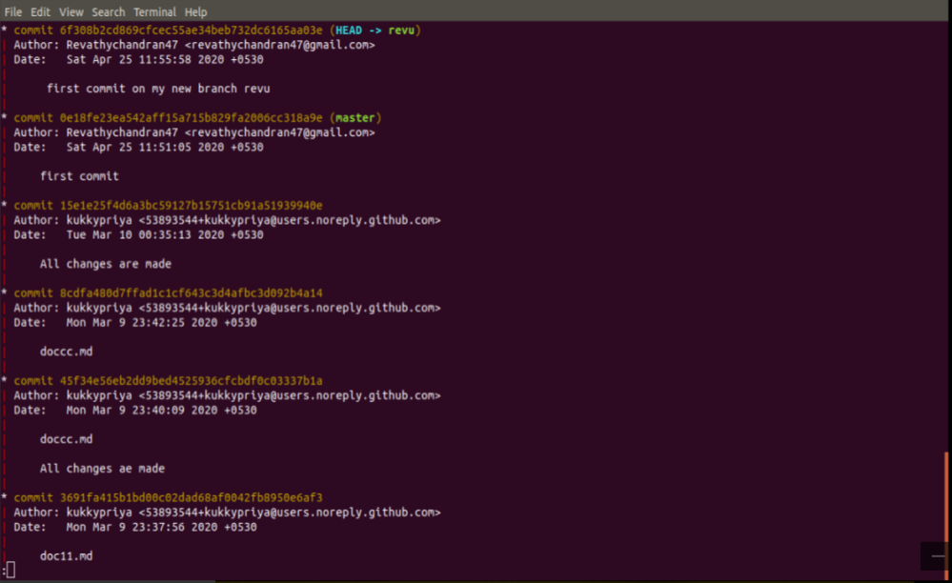

Figure 1 :Git graph

Output of git status command

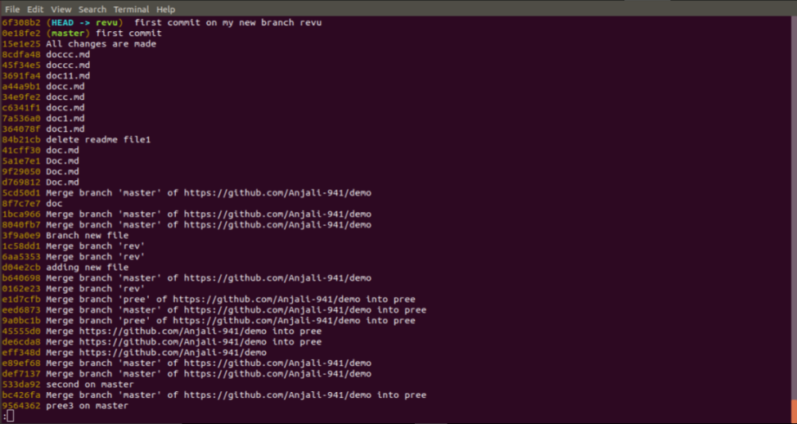

Figure 2 :Git status

**Cycle-3-Network Programming In Java**

1:TCP client-server Date : 12/3/2020

**Problem 1:TCP CLIENT - SERVER**

## AIM:

## Implement Bidirectional Client-Server communication using TCP.

## PROGRAM CODE:

## 

|  |  |
| --- | --- |
| Server2.java | import java.io.*;import java.net.*;class Server2 {public static void main(String args[])throws Exception{ServerSocket ss = new ServerSocket(888);Socket s = ss.accept();System.out.println("Connectionestablished");PrintStream ps = newPrintStream(s.getOutputStream());BufferedReader br = newBufferedReader(new InputStreamReader(s.getInputStream()));BufferedReader kb = newBufferedReader(new InputStreamReader(System.in));while (true) {String str, str1;while ((str = br.readLine()) != null){System.out.println(str);str1 = kb.readLine();ps.println(str1);}ps.close();br.close();kb.close();ss.close();s.close();System.exit(0);}}} |
| Client2.java | import java.io.*;  import java.net.*;  class Client2 {  public static void main(String args[])  throws Exception  {  Socket s = new Socket("localhost", 888);  DataOutputStream dos = new  DataOutputStream(s.getOutputStream());    BufferedReader br = new  BufferedReader(new InputStreamReader(  s.getInputStream()));    BufferedReader kb = new  BufferedReader(new InputStreamReader  (System.in));    String str, str1;  while (!(str = kb.readLine()).  equals("exit")) {    dos.writeBytes(str + "\n");  str1 = br.readLine();  System.out.println(str1);  }    dos.close();  br.close();  kb.close();  s.close();  }  } |

## RESULT:

## We are creating a local client and server communication. First running server program , if it is free of bugs it will wait for a client to connect. Then we run client program , if it is correct then a connection between client and server will be established.

## SCREENSHOTS:

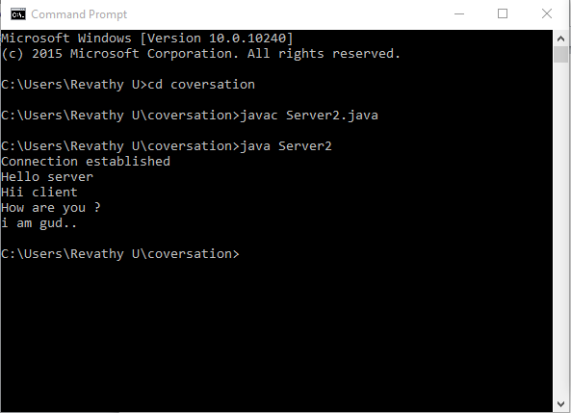Image Dimension: 5”x2.5”

Black border – 1pt solid

## 

## 

## 

## 

## Figure 1: This is the local server which communicates with

## client machine after the establishment of connection between client and server.

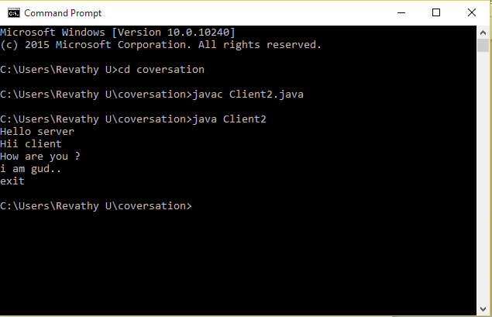

## Figure 2: This is the local client which communicates with server

## machine after the establishment of connection between client and server.

2:TCP echo server Date : 16/3/2020

**Problem 2:TCP ECHO SERVER**

## AIM:

Implement Echo Server using TCP.

## PROGRAM CODE:

## 

|  |  |
| --- | --- |
| EchoServer.java | import java.io.*;import java.net.*;public class EchoServer{public static void main(String args[]) throwsException{try{int Port;BufferedReader Buf =new BufferedReader(new InputStreamReader(System.in));System.out.print(" Enter the PortAddress : " );Port=Integer.parseInt(Buf.readLine());ServerSocket sok =new ServerSocket(Port);System.out.println(" Server is Ready ToReceive a Message. ");System.out.println(" Waiting ..... ");Socket so=sok.accept();if(so.isConnected()==true)System.out.println(" Client Socket isConnected Succecfully. ");InputStream in=so.getInputStream();OutputStream ou=so.getOutputStream();PrintWriter pr=new PrintWriter(ou);BufferedReader buf=new BufferedReader(new InputStreamReader(in));String str=buf.readLine();System.out.println(" Message ReceivedFrom Client : " + str);System.out.println(" This Message isForwarded To Client. ");pr.println(str);pr.flush();}catch(Exception e){System.out.println(" Error : " +e.getMessage());}}} |
| EchoClient.java | import java.io.*;  import java.net.*;  public class EchoClient  {  public static void main(String args[]) throws  Exception  {  try  {    int Port;  BufferedReader Buf =new BufferedReader  (new InputStreamReader(System.in));  System.out.print(" Enter the Port  Address : " );  Port=Integer.parseInt(Buf.readLine());  Socket sok=new Socket("localhost",  Port);      if(sok.isConnected()==true)  System.out.println(" Server Socket is  Connected Succecfully. ");  InputStream in=sok.getInputStream();  OutputStream ou=sok.getOutputStream();  PrintWriter pr=new PrintWriter(ou);  BufferedReader buf1=new BufferedReader  (new InputStreamReader (System.in));  BufferedReader buf2= new  BufferedReader(new InputStreamReader  (in));    String str1,str2;  System.out.println(" Enter the Message :  ");    str1=buf1.readLine();  pr.println(str1);  pr.flush();  System.out.println(" Message Send  Successfully. ");  str2=buf2.readLine();  System.out.println(" Message From  Server : " + str2);  }  catch(Exception e)  {  System.out.println(" Error : " +  e.getMessage());  }  } |

## RESULT:

## We are creating a local client and echo server communication. First running echo server program , if it is free of bugs it will wait for a client to connect. Then we run client program , if it is correct then a connection between client and echo server will be established. In our program , the message received from client is forwarded to client itself by the echo server.

## SCREENSHOTS:

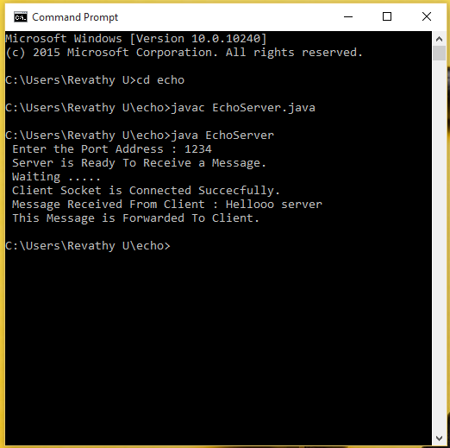

## 

## Figure 1:The first shows the starting page .If you are

## 

## Figure 1: This is the echo server which communicates with

## Client machine after the establishment of connection between client and server.

## The message received is forwarded to client.

## 

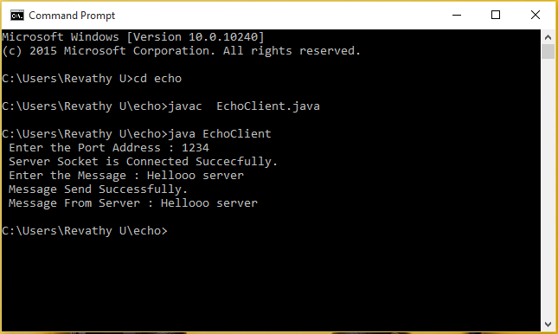

## 

## Figure 2: This is the client which communicates with

## echo server after the establishment of connection between client and server.

## 

## 3:UDP Chat server Date : 19/03/2020

**Problem 3:** **CHAT SERVER USING UDP**

## AIM:

Implement Chat Server using UDP.

## PROGRAM CODE:

## 

|  |  |
| --- | --- |
| UDPServer.java | import java.io.*;import java.net.*;class UDPServer{public static DatagramSocket serversocket;public static DatagramPacket dp;public static BufferedReader dis;public static InetAddress ia;public static byte buf[] = new byte[1024];public static int cport = 789,sport=790;public static void main(String[] a) throwsIOException{serversocket = new DatagramSocket(sport);dp = new DatagramPacket(buf,buf.length);dis = new BufferedReader(new InputStreamReader(System.in));ia = InetAddress.getLocalHost();System.out.println("Server is Running...");while(true){serversocket.receive(dp);String str = new String(dp.getData(), 0,dp.getLength());if(str.equals("STOP")){System.out.println("Terminated...");break;}System.out.println("Client: " + str);String str1 = new String(dis.readLine());buf = str1.getBytes();serversocket.send(newDatagramPacket(buf,str1.length(), ia,cport));}}} |
| UDPClient.java | import java.io.*;  import java.net.*;  class UDPClient  {  public static DatagramSocket clientsocket;  public static DatagramPacket dp;  public static BufferedReader dis;  public static InetAddress ia;  public static byte buf[] = new byte[1024];  public static int cport = 789, sport = 790;  public static void main(String[] a) throws  IOException  {  clientsocket = new DatagramSocket(cport);  dp = new DatagramPacket(buf, buf.length);  dis = new BufferedReader(new  InputStreamReader(System.in));  ia = InetAddress.getLocalHost();  System.out.println("Client is Running... Type  'STOP'to Quit");  while(true)    {  String str = new String(dis.readLine());  buf = str.getBytes();  if(str.equals("STOP"))  {  System.out.println("Terminated...");  clientsocket.send(new  DatagramPacket(buf,str.length(), ia,  sport));  break;  }  clientsocket.send(new DatagramPacket(buf,  str.length(), ia, sport));  clientsocket.receive(dp);  String str2 = new String(dp.getData(), 0,  dp.getLength());  System.out.println("Server: " + str2);  }  }  } |

## RESULT:

## We are creating a local client and echo server communication using UDP. First running server program , if it is free of bugs it will wait for a client to connect. Then we run client program , if it is correct then a connection between client and server will be established. Thus after the successful establishment of connection between them , they can send and receive messages as in a chat.

## SCREENSHOTS:

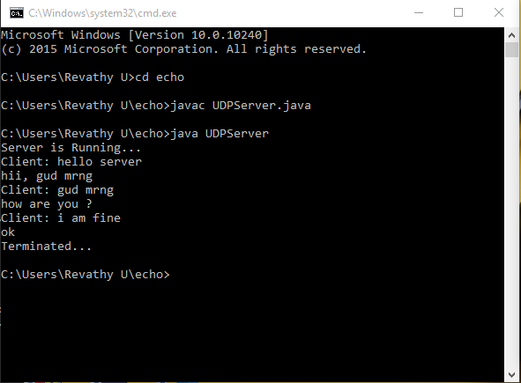

## 

## 

## Figure 1:The figure shows the local server. Server will wait for

## the client to connect. After the client has connected , client can send a message

## to server. It will be shown as a chat .

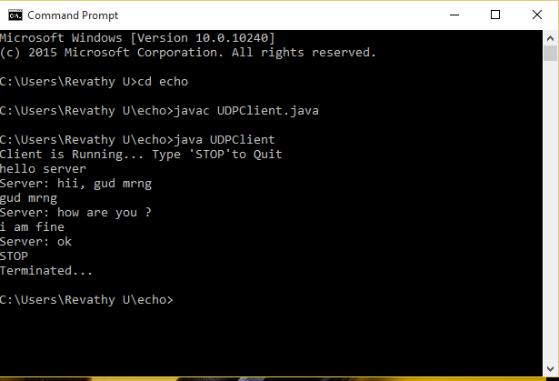

## Figure 2: The figure shows the local client. After the client has

## connected to the server , client can send a message to server. It will be shown

## as a chat . The chat can be stopped if client can send a message to server as STOP.