**BA EXPERIMENT 3**

**DESCRIBE MISSING DATA:**

**CODE:**

ods noproctitle;

proc format;

value _nmissprint low-high="Non-missing";

value $_cmissprint " "=" " other="Non-missing";

run;

proc freq data=WORK.IMPORT;

title3 "Missing Data Frequencies";

title4 h=2 "Legend: ., A, B, etc = Missing";

format 'RAM (GB)'n 'Screen Size (inch)'n 'Battery Life (hours)'n

'Weight (kg)'n 'Price ($)'n _nmissprint.;

format Brand Processor Storage GPU Resolution

'Operating System'n $_cmissprint.;

tables Brand 'RAM (GB)'n Processor Storage GPU 'Screen Size (inch)'n

Resolution 'Battery Life (hours)'n 'Operating System'n 'Weight (kg)'n

'Price ($)'n / missing nocum;

run;

proc freq data=WORK.IMPORT noprint;

table Brand * 'RAM (GB)'n * Processor * Storage * GPU * 'Screen Size (inch)'n

* Resolution * 'Battery Life (hours)'n * 'Operating System'n * 'Weight (kg)'n

* 'Price ($)'n / missing out=Work._MissingData_;

format 'RAM (GB)'n 'Screen Size (inch)'n 'Battery Life (hours)'n

'Weight (kg)'n 'Price ($)'n _nmissprint.;

format Brand Processor Storage GPU Resolution

'Operating System'n $_cmissprint.;

run;

proc print data=Work._MissingData_ noobs label;

title3 "Missing Data Patterns across Variables";

title4 h=2 "Legend: ., A, B, etc = Missing";

format 'RAM (GB)'n 'Screen Size (inch)'n 'Battery Life (hours)'n

'Weight (kg)'n 'Price ($)'n _nmissprint.;

format Brand Processor Storage GPU Resolution

'Operating System'n $_cmissprint.;

label count="Frequency" percent="Percent";

run;

title3;

proc delete data=Work._MissingData_;

run;

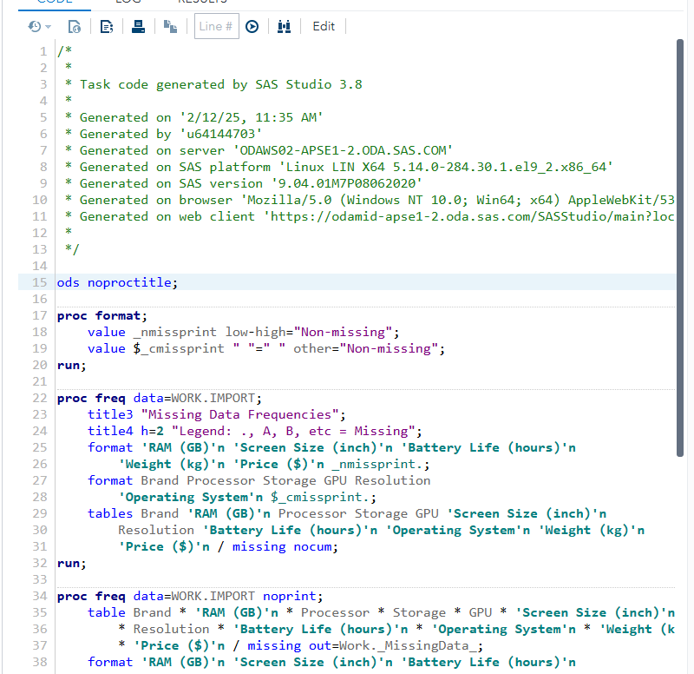

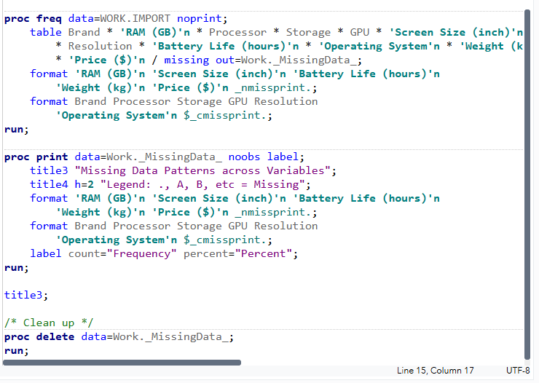

**RESULTS:**

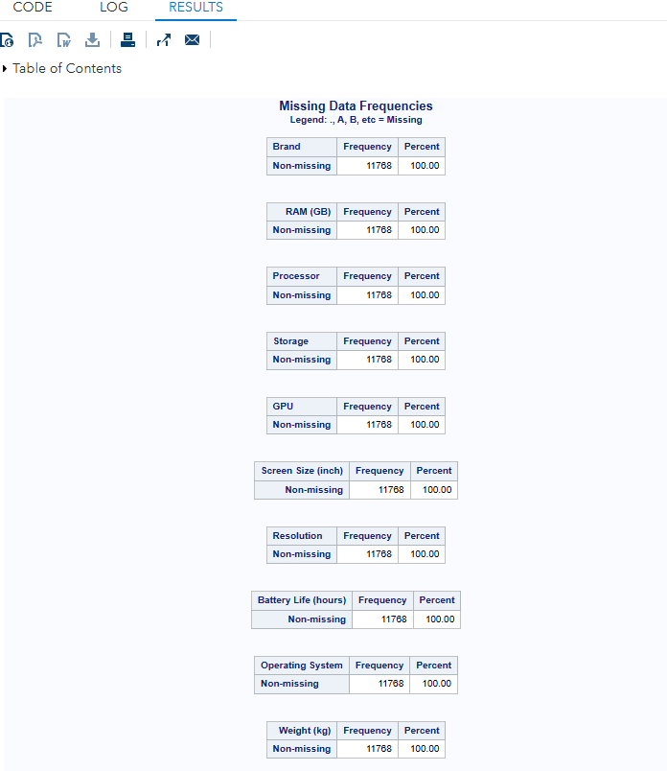

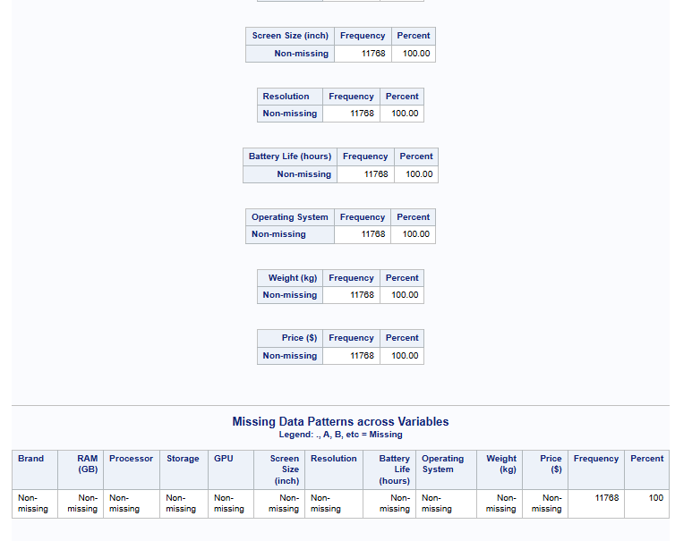

**STANDARIZE DATA:**

**CODE:**

ods noproctitle;

proc stdize data=WORK.IMPORT method=std nomiss out=work.Stdize oprefix

sprefix=Standardized_;

var 'RAM (GB)'n 'Screen Size (inch)'n 'Battery Life (hours)'n 'Weight (kg)'n

'Price ($)'n;

run;

**OUTPUT DATA:**

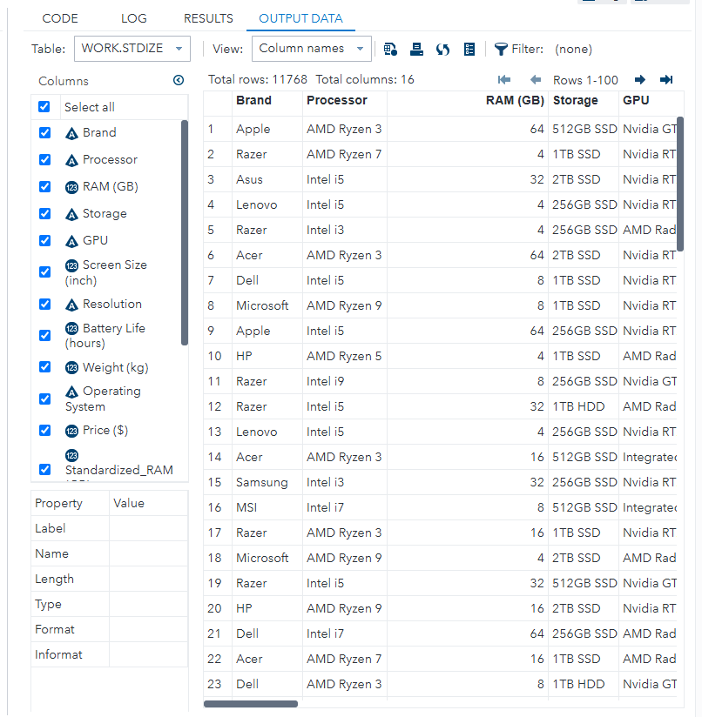

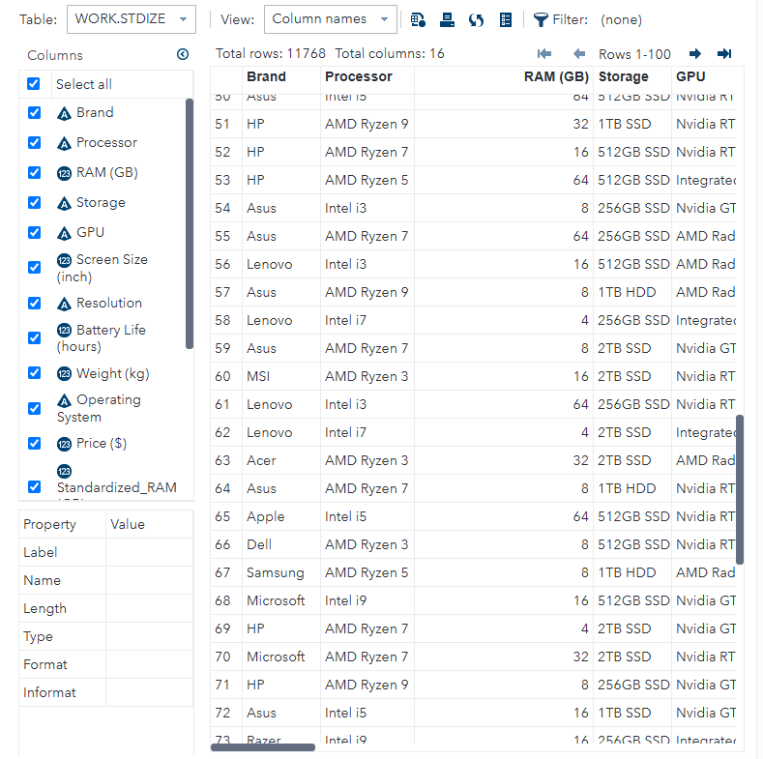

**FILTER DATA:**

**INPUT:**

proc sql noprint;

create table work.filter as select * from WORK.IMPORT where('RAM (GB)'n LT

input('16', BEST12.) );

quit;

**OUTPUT DATA:**

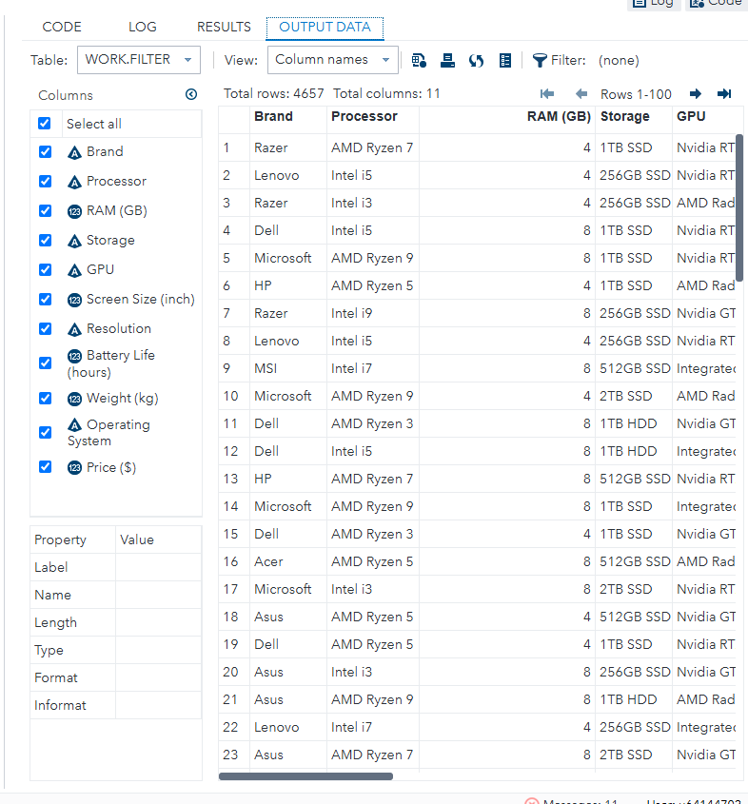

**GRAPH:**

**BAR CHART:**

INPUT:

ods graphics / reset width=6.4in height=4.8in imagemap;

proc sgplot data=WORK.IMPORT;

vbar 'RAM (GB)'n /;

yaxis grid;

run;

ods graphics / reset;

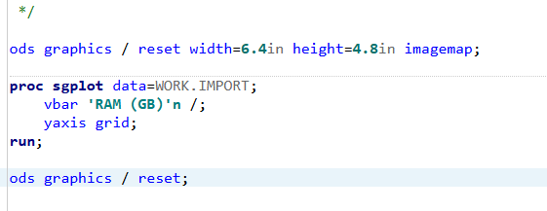

RESULTS:

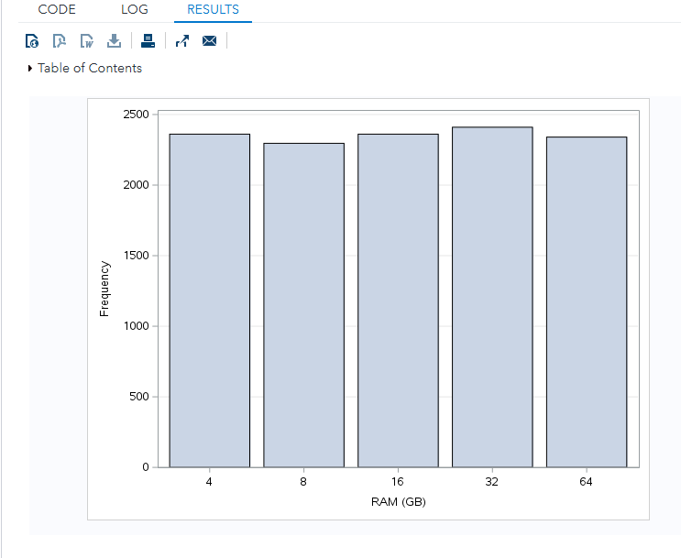

**BUBBLE PLOTS:**

**CODE:**

ods graphics / reset width=6.4in height=4.8in imagemap;

proc sgplot data=WORK.IMPORT;

bubble x='RAM (GB)'n y='Screen Size (inch)'n size='Weight (kg)'n/

group=Storage bradiusmin=7 bradiusmax=14;

xaxis grid;

yaxis grid;

run;

ods graphics / reset;

**LOG:**

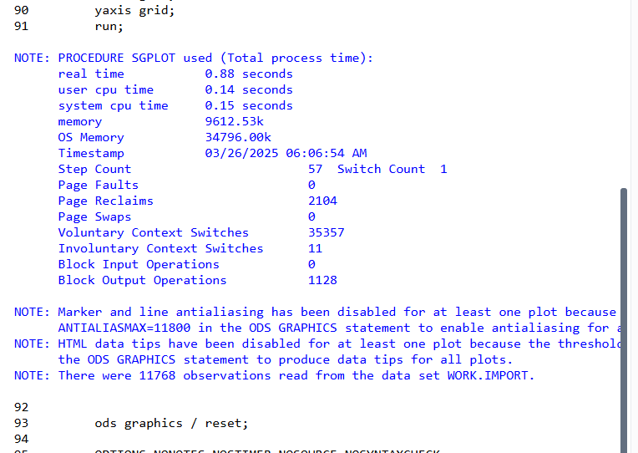

**OUTPUT:**

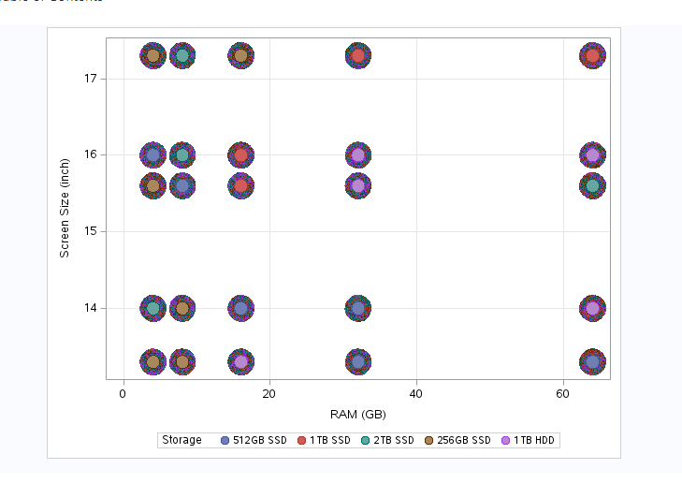

**HISTOGRAM:**

**CODE:**

ods graphics / reset width=6.4in height=4.8in imagemap;

proc sgplot data=WORK.IMPORT;

histogram 'Screen Size (inch)'n /;

yaxis grid;

run;

ods graphics / reset;

**LOG:**

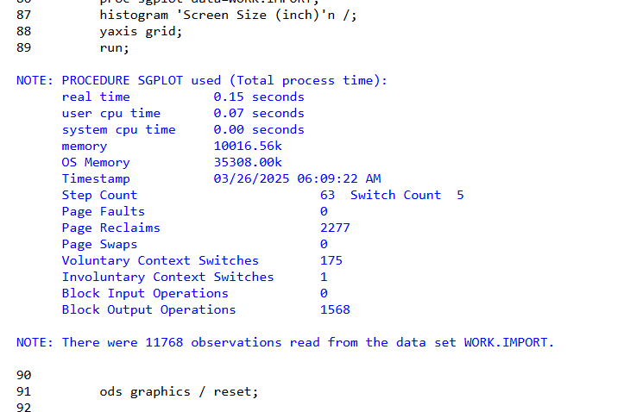

**OUTPUT:**

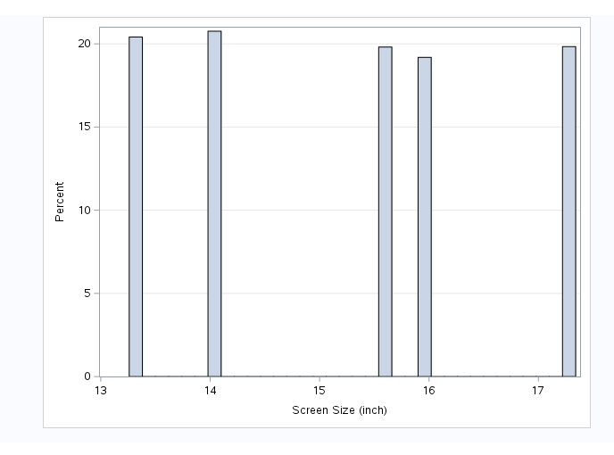

**SUMMARY OF STATISTICAL DATA:**

**ONE WAY FREQUENCY:**

**CODE:**

proc freq data=WORK.IMPORT;

tables GPU 'RAM (GB)'n / plots=(freqplot cumfreqplot);

run;

**LOG:**

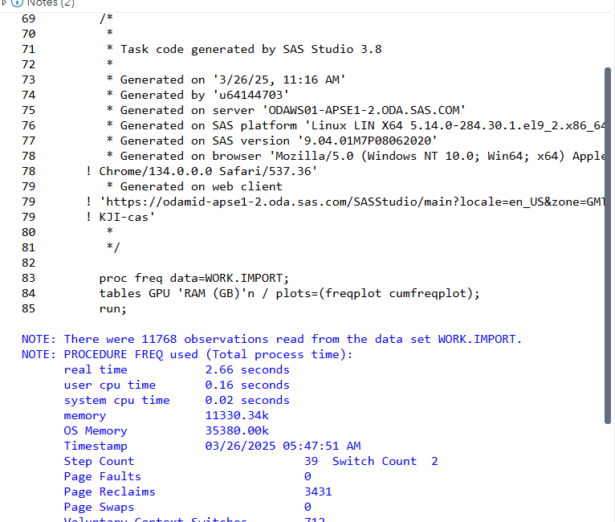

**OUTPUT:**

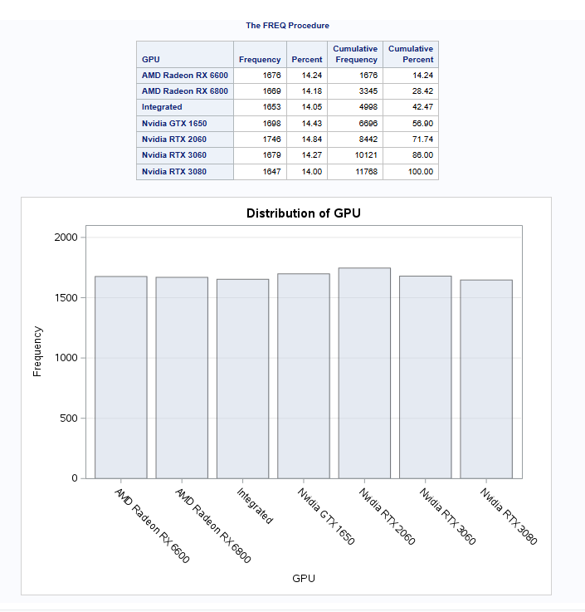

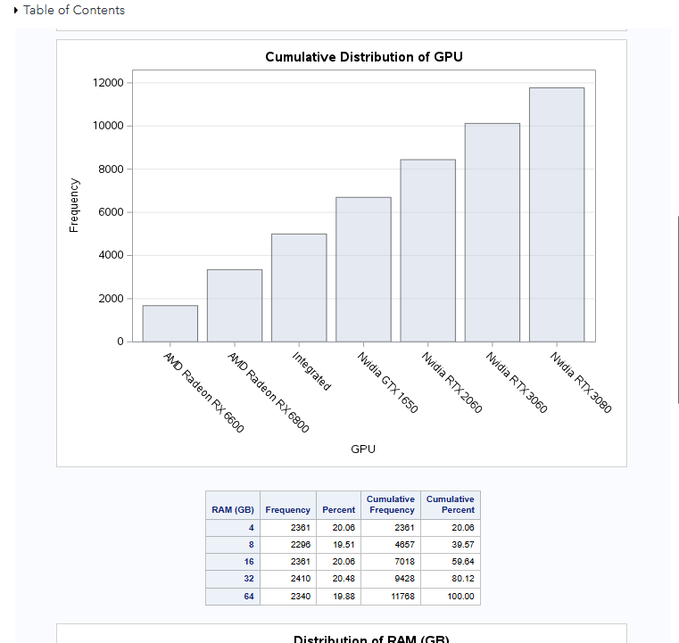

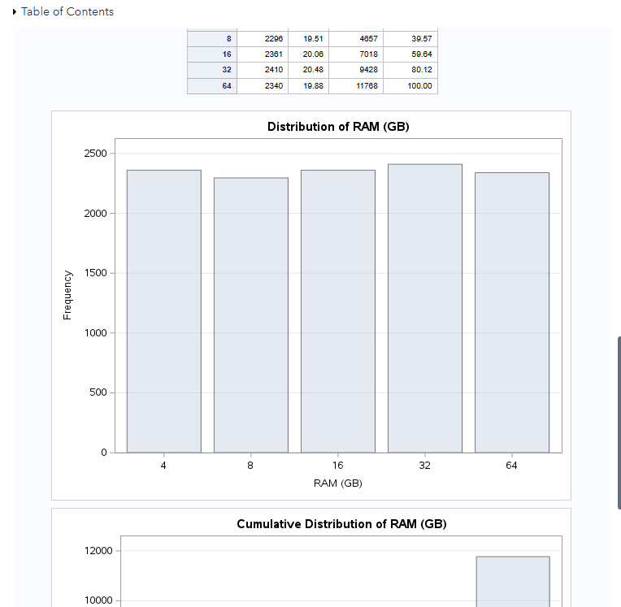

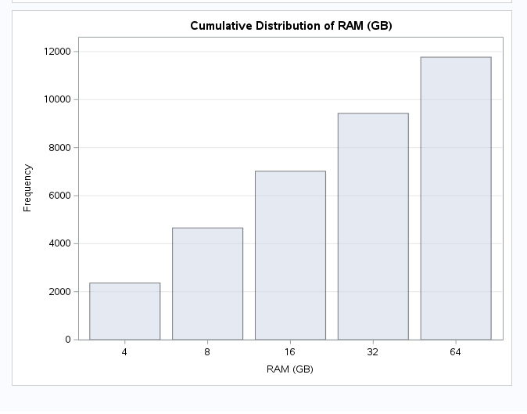

**PROC MEANS:**

**CODE:**

ods noproctitle;

ods graphics / imagemap=on;

proc means data=WORK.IMPORT chartype mean std min max n vardef=df;

var 'Battery Life (hours)'n;

run;

**LOG:**

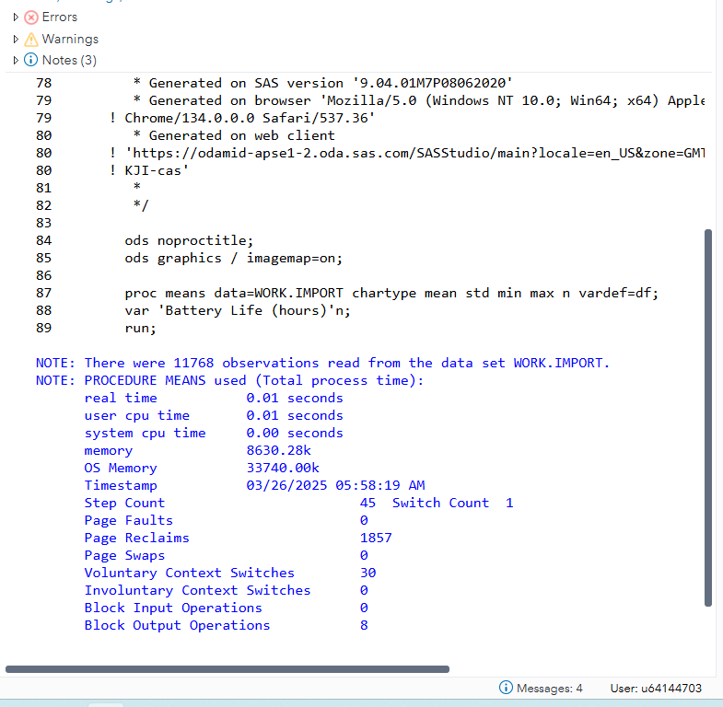

**OUTPUT:**

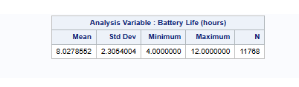

**PROC UNIVARIATE:**

**CODE:**

ods noproctitle;

ods graphics / imagemap=on;

/* Exploring Data */

proc univariate data=WORK.IMPORT;

ods select Histogram;

var 'Weight (kg)'n 'Battery Life (hours)'n;

histogram 'Weight (kg)'n 'Battery Life (hours)'n;

run;

**LOG:**

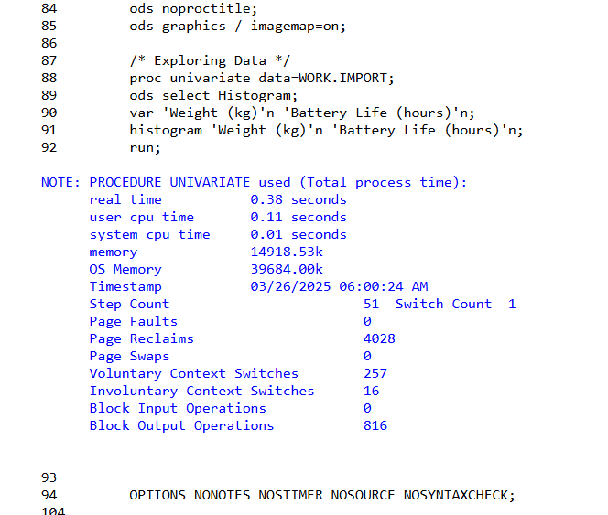

**OUTPUT:**

