**EXPERIMENT 2**

**Framing techniques:**

**Character count:**

**Code:**

print("Revati Singh 60004220031")

n=int(input("Enter number of frames:"))

str=""

for i in range(0,n):

text=input(f"Enter frame {i+1}:")

str+=f"{len(text)+1}"+text

print(str)

**Output:**

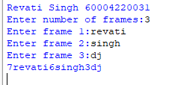

**Byte Stuffing:**

**Code:**

print("Revati Singh 60004220031")

str=input("Enter string:")

sf=input("Enter start flag:")

ef=input("Enter end flag:")

esc=input("Enter escape flag:")

text=""

text+=sf

for i in str:

if i==sf:

text+=(esc+i)

elif i==ef:

text+=(esc+i)

elif i==esc:

text+=(esc+i)

else:

text+=i

text+=ef

print(text)

**Output:**

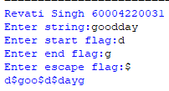

**BIT STUFFING:**

**Code:**

print("Revati Singh 60004220031")

str=input("Enter string:")

text=""

count=-1

for i in range(0,len(str)):

ch=str[i]

if ch=='1':

if i!=0:

if str[i-1]==0:

count=0

else:

count+=1

else:

count=-1

if count==5:

text+='0'

count=0

text+=ch

print(text)

**Output:**

