**Logo**

Clean and modern, our logo features lines above the Revature name that alludes to the markings on a tachometer, suggesting speed, velocity and forward momentum. The tagline — Advancing talent and technologies. — is optional.





**Using the Revature Logo: Clear Space Requirements**

Our logo needs breathing room and space to stand out. For our primary logo, the margin of clear space is measured by the size of the first letter “R.”

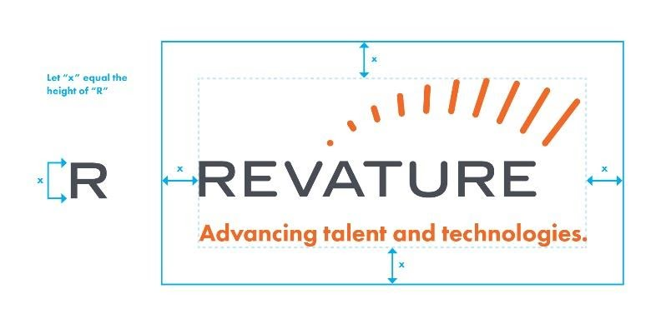

**Restrictions**

To make certain our logo appears as consistent with our brand throughout our communications, below are samples that highlight ways it should not be altered or appear:

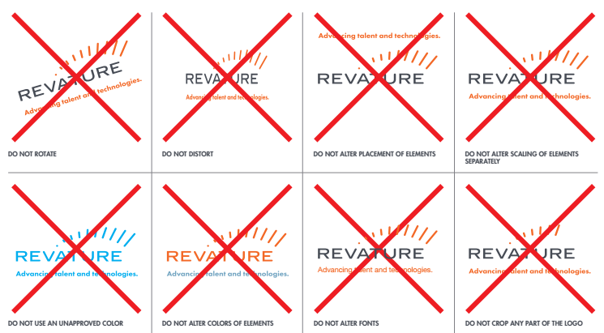

**Colors**

The Revature Color Palate consists of three primary colors and three secondary colors. The most commonly used reference for Microsoft Office will be RGB.

Primary

|  |  |  |
| --- | --- | --- |
| **Orange**  **PMS 021 C**  **PMS 021 U**  **CMYK: 0, 73, 97, 0**  **RGB: 242, 105, 38**  **Hex: #F26925** | **White**  **CMYK: 0, 0, 0, 0**  **RGB: 0, 0, 0**  **Hex: #FFFFF** | **Dark Gray**  **PMS Cool Gray 10 C**  **PMS Cool Gray 10 U**  **CMYK: 71, 62, 50, 33**  **RGB: 72, 76, 86**  **Hex: #474C55** |

Secondary

|  |  |  |
| --- | --- | --- |
| **Blue**  **PMS 542 C**  **PMS 543 U**  **CMYK: 56, 24, 14, 0**  **RGB: 115, 165, 194**  **Hex: #72A4C2** | **Yellow**  **PMS 130 C**  **PMS 7549 U**  **CMYK: 0, 32, 100, 0**  **RGB: 253, 181, 21**  **Hex: #FCB414** | **Light Gray**  **PMS Cool Gray 4 C**  **PMS Cool Gray 4 U**  **CMYK: 28, 22, 22, 0**  **RGB: 185, 185, 186**  **Hex: #B9B9BA** |