Project Plan

Professional Experience - 300579

Group 2: WSUSCC1 2020

19356440 Christian Politis

19352262 Kyle Diamond-Squires

19354718 Sampadanna Heng

19256883 Ismail Hossain

# Executive Summary

The following document provides a structured understanding of the approach and management of the project which we can utilise time and resources. It will outline details of the team’s strengths, weaknesses and skills, issues and risks that will be faced regarding project management as well as scheduling, Gantt chart with implemented milestones and required tasks that are expected to be completed from each member of the group for the Jukebox application. The resulting output of this document will provide a structured outline of how this project will be completed, time-managed and coordination of resources.

**Table of Contents**

[Executive Summary 1](#_Toc36238475)

[Introduction 4](#_Toc36238476)

[Group Details 5](#_Toc36238477)

[Figure 1.1 – Ismail Hossain Group Details Table 5](#_Toc36238478)

[Figure 1.2 – Christian Politis Group Details Table 6](#_Toc36238479)

[Figure 1.3 – Kyle Diamond-Squires Group Details Table 7](#_Toc36238480)

[Figure 1.4 – Sam Heng Group Details Table 8](#_Toc36238481)

[Work Breakdown Structure 9](#_Toc36238482)

[Figure 2 – Work Breakdown Structure 9](#_Toc36238483)

[Issues and Risks of Project Management 10](#_Toc36238484)

[Figure 3 – Issues and Risks of Project Management 10](#_Toc36238485)

[Milestone Plan - Based on Gantt Chart 11](#_Toc36238486)

[Figure 4 – Milestone Table 11](#_Toc36238487)

[Individual Task List 12](#_Toc36238488)

[Figure 5.1 – Kyle Diamond-Squires Individual Task List Table 12](#_Toc36238489)

[Figure 5.2 – Ismail Hossain Individual Task List Table 13](#_Toc36238490)

[Figure 5.3 – Christian Politis Individual Task List Table 14](#_Toc36238491)

[Figure 5.4 – Sam Heng Individual Task List Table 16](#_Toc36238492)

[Planned Meetings 17](#_Toc36238493)

[Client Meetings *(includes scheduled Group Meetings)* 17](#_Toc36238494)

[Figure 6 – Meeting Plan Table 17](#_Toc36238495)

[Figure 7.1.1 – Agenda of Team Meeting 1 18](#_Toc36238496)

[Figure 7.1.2 – Minutes of Team Meeting 1 19](#_Toc36238497)

[Figure 7.1.3 – Minutes Continued of Team Meeting 1 20](#_Toc36238498)

[Figure 7.2.1 – Agenda of Team Meeting 2 22](#_Toc36238499)

[Figure 7.2.2 – Minutes of Team Meeting 2 22](#_Toc36238500)

[Figure 8.1 – Gantt Chart (Screenshot 1) 25](#_Toc36238501)

[Figure 8.2 – Gantt Chart (Screenshot 2) 26](#_Toc36238502)

[Figure 8.3 – Gantt Chart (Screenshot 3) 27](#_Toc36238503)

[Figure 8.4 – Gantt Chart (Screenshot 4) 28](#_Toc36238504)

[Conclusion 29](#_Toc36238505)

[References 30](#_Toc36238506)

[Appendices 31](#_Toc36238507)

[Figure 1.1 – Ismail Hossain Group Details Table 31](#_Toc36238508)

[Figure 1.2 – Christian Politis Group Details Table 32](#_Toc36238509)

[Figure 1.3 – Kyle Diamond-Squires Group Details Table 33](#_Toc36238510)

[Figure 1.4 – Sam Heng Group Details Table 34](#_Toc36238511)

[Figure 2 – Work Breakdown Structure 35](#_Toc36238512)

[Figure 3 – Issues and Risks of Project Management 36](#_Toc36238513)

[Figure 4 – Milestone Table 37](#_Toc36238514)

[Figure 5.1 – Kyle Diamond-Squires Individual Task List Table 38](#_Toc36238515)

[Figure 5.2 – Ismail Hossain Individual Task List Table 39](#_Toc36238516)

[Figure 5.3 – Christian Politis Individual Task List Table 40](#_Toc36238517)

[Figure 5.4 – Sam Heng Individual Task List Table 41](#_Toc36238518)

[Figure 6 - Meeting Plan Table 43](#_Toc36238519)

[Figure 7.1.1 – Agenda of Team Meeting 1 44](#_Toc36238520)

[Figure 7.1.2 – Minutes of Team Meeting 1 45](#_Toc36238521)

[Figure 7.1.3 – Minutes Continued of Team Meeting 1 46](#_Toc36238522)

[Figure 7.2.1 – Agenda of Team Meeting 2 47](#_Toc36238523)

[Figure 7.2.2 – Minutes of Team Meeting 2 48](#_Toc36238524)

[Figure 7.3 – Team Availabilities documented for authenticity 49](#_Toc36238525)

[Figure 7.4 – Agenda of Team Meeting 3 50](#_Toc36238526)

[Figure 8.1 – Gantt Chart (Screenshot 1) 51](#_Toc36238527)

[Figure 8.2 – Gantt Chart (Screenshot 2) 52](#_Toc36238528)

[Figure 8.3 – Gantt Chart (Screenshot 3) 53](#_Toc36238529)

[Figure 8.4 – Gantt Chart (Screenshot 4) 54](#_Toc36238530)

# Introduction

Currently every fitness centre and gym requires a desirable music system to allow gym members to focus and be excited when working out at the gym. It is apparent that gym members would like to choose their own music that they may find more appropriate when exercising. Squashlands Gym Squashlands Gym & Fitness currently faces this situation daily. Currently gym owners are being pressed every day for music that meets the gym member’s desires.

A Jukebox application is the best solution for this problem. Users are able to access a tablet system provided by the gym which will allow users to access a large range of songs and playlists where they are able to choose from and listen to. It will eliminate the middleman which would be the staff member and cause less friction over what is being played as a result. This application aims to meet the needs of both the client and members of the gym.

# Group Details

|  |  |
| --- | --- |
| Strengths, Skills and Weaknesses | |
| Ismail Hossain | **Skills**  Ismail has an ability to create a user interface because he has done some work on it in other units in the previous semester.  He has a primary knowledge on Programming languages (HTML, Java, SQL). He has the ability to organise the work with different types of people as he has an experience from the previous semesters.  **Strengths**  He has the Flexibility skills which makes others group members to work comfortably and have the ability to adopt in different circumstances.  Ismail always believes in work not believing in words so he is very realistic when it comes to work.  He has the ability to cooperate in team settings at the same time he is able to take over a role if someone does not like the particular role themselves.  He is able to make good documentation which is very important for the project.  **Weaknesses**  Ismail does not like to talk too much.  He is the person who doesn't like to express himself in a group or in a crowded area because he struggles to think on the spot and communicate his thoughts simultaneously.  He does not have in- depth knowledge of programming languages. |

### Figure 1.1 – Ismail Hossain Group Details Table

|  |  |
| --- | --- |
| Strengths, Skills and Weaknesses | |
| Christian Politis | **Skills**  Christian provides an analytical approach and is a proficient problem solver.    He has a background foundation with programming primarily with data science languages however has exposure and experience with front end and object oriented languages.  **Strengths**  Has experience with Java, Python, and other UI based languages.  Completed Extension 1 mathematics in high school and a good understanding of statistical mathematics.  At the time when the project manager is not able to lead the group, they are able to take charge when necessary.  Christian also has experience in a professional environment that can be beneficial for improving the quality and management of the team.  **Weaknesses**  Not as confident in their soft skills and can become abreast with their opinions as a result tend to be strong-willed at times. |

### Figure 1.2 – Christian Politis Group Details Table

|  |  |
| --- | --- |
| Strengths, Skills and Weaknesses | |
| Kyle Diamond-Squires | **Skills**  A broad basic understanding of programming languages such as Java, PHP, JavaScript, Python, Html, as well as understanding the concept and logic involved.  Able to work well with others cooperatively, thriving off of one another to produce the best product the team is able too.  Soft skills come easily due to being raised in a rural environment, I am able to communicate with others effectively by adjusting my own wavelength to understand others to appeal to both parties.  With the ability to control a crowd, I am able to manage a variety of scenarios that may be presented to me.  As a creative individual, I like problem solving in relation to creation and destruction, fixing issues and improving already existing solutions.  **Strengths**  Soft skills are one of the greatest strengths, this is because they influence every other aspect of dealing with teams, mentors, and clients.  Creativity enables alternative solutions to find their way into issues, providing a healthy solution for both parties.  Being able to work as a team, the work produced is of aa higher quality due to combined effort and input from those around.  By setting realistic goals and standards to keep in mind for myself and those around me, ensures a stress free working environment for the entire team, while realistic goals, I strive to do the most possible for the situation.  **Weaknesses**  Time management sometimes comes as an issue, as I over or underestimate the amount of time I have or need. To combat this, I will be closely following our teams Gantt chart.  Technical knowledge limitations can sometimes arise. These limitations are simply due to a lack of experience and can be combatted by investing time and effort into learning new skills and capabilities |

### Figure 1.3 – Kyle Diamond-Squires Group Details Table

|  |  |
| --- | --- |
| Strengths, Skills and Weaknesses | |
| Sam Heng | **Skills**  Sam is proficient in Programming using Java and Python. With previous junior experience as a software developer in High School and competitions hosted by USYD.  He has great time management and organisational skills.  Adequate soft skills with the ability to lead, present and portray an idea amongst a group of people, whether it is in writing or through verbal communication.  **Strengths**  Sam has excellent organisational skills that allows him to be able to balance workload and distribute equally amongst teams as a Project Manager.  He is highly co-operative being able to contribute ideas and advise others on information.  Being proactive and able to change a situation for the better.  **Weaknesses**  Minimal experience as a Team Lead or Project Manager within a team, this leads to the weakness of being unable to motivate team members to get on board with contribution and work at times.  At times, technical knowledge. This is due to the lack of experience in certain situations. |

### Figure 1.4 – Sam Heng Group Details Table

# Work Breakdown Structure

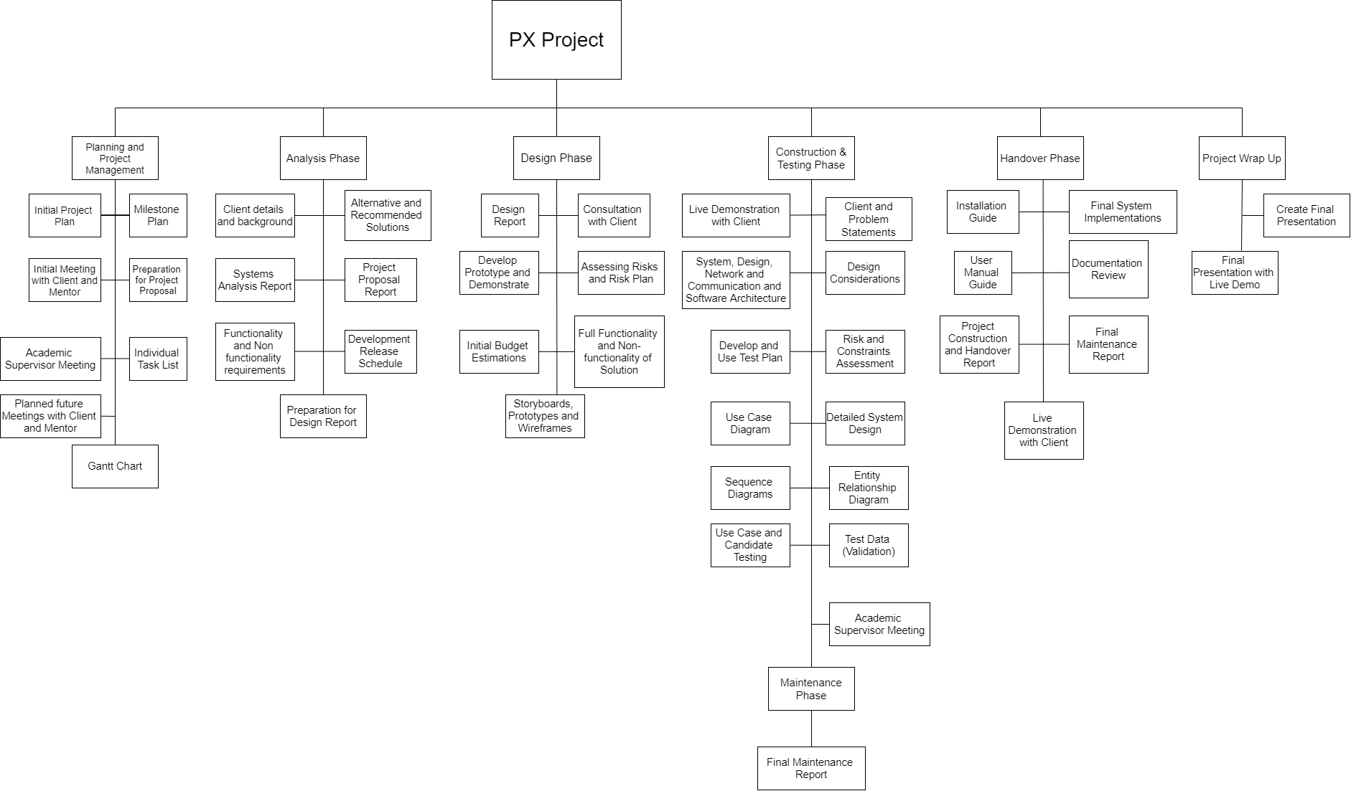

### Figure 2 – Work Breakdown Structure

# Issues and Risks of Project Management

|  |  |  |  |
| --- | --- | --- | --- |
| Project Management | | | |
|  | **Risk/Issue** | **Type** | **Resolution Expected to be Actioned** |
| 1. | New, unproven technologies | Risk | Appropriate training and knowledge is key to understanding the proper and appropriate use of technology as a result not leading to failure of the project. |
| 2. | User and functional requirements | Issues | Project requirements should be concise and consistent with the project brief. Understanding the specific requirements that will meet the user’s needs is key to establishing a successful and quality solution. |
| 3. | Application and system architecture | Risk | Using the appropriate platform and language as well as architecture for the project |
| 4. | Performance | Issue | Benchmarking and threshold testing should occur often as a result consistent performance and no depletion of the system quality. |
| 5. | Organizational | Risk | Management of the needs of the development team and the expectations of the client must find a balance. As a result this will allow perfect execution of the project and will deliver a good outcome. |

### Figure 3 – Issues and Risks of Project Management

# Milestone Plan - Based on Gantt Chart

|  |  |  |  |
| --- | --- | --- | --- |
| Milestone | Main Responsibility | Planned Date | Actual Date |
| Initial Project Plan Report | Sam | Friday  27/03/2020 | Friday  27/03/2020 |
| Project Proposal | Kyle | Wednesday  1/04/2020 |  |
| Analysis Report | Ismail | Tuesday  7/04/20 |  |
| Design Report | Sam | Friday  17/04/20 |  |
| Test Plan Document and Testing | Ismail | Friday  8/05/20 |  |
| Maintenance Test Phase and Report | Christian | Friday  22/05/20 |  |
| Project Construction and Handover Report | Kyle | Wednesday  27/05/20 |  |
| Project Completion Report | Christian | Friday  5/06/20 |  |

### Figure 4 – Milestone Table

# Individual Task List

|  |  |  |  |  |
| --- | --- | --- | --- | --- |
| Team Member: Kyle Diamond-Squires | | | | |
| Detailed Task / Activity | **Phase / Deliverable** | **Start Date** | **End Date** | **% Complete (as of the reporting date)** |
| Group Details | Project Plan | 19/03/20 | 26/03/20 | 100 |
| Individual Task List | Project Plan | 24/03/20 | 27/03/20 | 0 |
| Conclusion | Project Plan | 26/03/20 | 27/03/20 | 100 |
| An Alternative Solution | Project Proposal | 28/03/20 | 30/03/20 | 0 |
| Recommend Solution | Project Proposal | 31/03/20 | 31/03/20 | 0 |
| Non-Functionality Requirements | Project Proposal | 1/04/20 | 1/04/20 | 0 |
| Development Release Schedule | Project Proposal | 1/04/20 | 1/04/20 | 0 |
| Business Case (Risk and Risk Plan) | Systems Analysis and Design Report | 1/04/20 | 2/04/20 | 0 |
| Solution to resolve Issues | Systems Analysis and Design Report | 2/04/20 | 3/04/20 | 0 |
| Create Test Plan | Project Construction and Testing | 17/04/10 | 18/04/20 | 0 |
| Risk and Constraints | Analysis Report | 17/04/20 | 20/04/20 | 0 |
| Design Considerations | Analysis Report | 21/04/20 | 22/04/20 | 0 |
| Coding | Project Construction | 4/05/20 | 8/05/20 | 0 |
| Sequence Diagrams | Design Report | 30/04/20 | 1/05/20 | 0 |
| Features and Use Case Test | Design Report | 4/05/20 | 7/05/20 | 0 |
| Maintenance Test and Troubleshooting | Maintenance Phase | 20/05/20 | 22/05/20 | 0 |
| Installation Guide | Handover and Handover Report | 18/05/20 | 25/05/20 | 0 |
| Live Demo and Handover | Handover and Handover Report | 26/05/20 | 27/05/20 | 0 |
| Final Presentation | Project Wrap Up | 29/05/20 | 5/06/20 | 0 |

### Figure 5.1 – Kyle Diamond-Squires Individual Task List Table

|  |  |  |  |  |
| --- | --- | --- | --- | --- |
| Team Member: Ismail Hossain | | | | |
| Detailed Task / Activity | **Phase / Deliverable** | **Start Date** | **End Date** | **% Complete (as of the reporting date)** |
| Introduction | Project Plan | 19/03/20 | 19/03/20 | 100 |
| Group Details | Project Plan | 19/03/20 | 26/03/20 | 100 |
| Work Breakdown Structure | Project Plan | 24/03/20 | 27/03/20 | 100 |
| Problem Statement | Project Proposal | 28/03/20 | 28/03/20 | 0 |
| Solution Description for Each | Project Proposal | 31/03/20 | 31/03/20 | 0 |
| Non-Functionality Requirements | Project Proposal | 1/04/20 | 1/04/20 | 0 |
| Development Release Schedule | Project Proposal | 1/04/20 | 1/04/20 | 0 |
| Business Advantages | Design Phase | 1/04/20 | 2/04/20 | 0 |
| Wireframes and Storyboard | Design Phase | 4/04/20 | 6/04/20 | 0 |
| Client Statement | Project Construction and Testing | 17/04/20 | 19/04/20 | 0 |
| Problem Statement | Project Construction and Testing | 17/04/20 | 19/04/20 | 0 |
| Coding | Project Construction and Testing | 27/04/20 | 1/05/20 | 0 |
| Entity Relationship Diagram | Project Construction and Testing | 4/05/20 | 6/05/20 | 0 |
| Candidate Test Cases and Test Data | Project Construction and Testing | 4/05/20 | 7/05/20 | 0 |
| Revision of Systems Analysis Design Document | Analysis and Design Phase | 7/05/20 | 11/05/20 | 0 |
| Documentation Review of Handover Document | Handover Phase | 25/05/20 | 27/05/20 | 0 |
| Live Demo and Handover | Handover Phase | 26/05/20 | 27/05/20 | 0 |
| Final Maintenance Report | Handover Phase | 22/05/20 | 27/05/20 | 0 |
| Final Presentation | Project Wrap Up | 29/05/20 | 5/06/20 | 0 |

### Figure 5.2 – Ismail Hossain Individual Task List Table

|  |  |  |  |  |
| --- | --- | --- | --- | --- |
| Team Member: Christian Politis | | | | |
| Detailed Task / Activity | **Phase / Deliverable** | **Start Date** | **End Date** | **% Complete (as of the reporting date)** |
| Executive Summary | Project Plan | 19/03/20 | 19/03/20 | 100 |
| Group Details | Project Plan | 19/03/20 | 26/03/20 | 100 |
| Project Management Related Issues | Project Plan | 24/03/20 | 27/03/20 | 0 |
| Planned Meetings | Project Plan | 23/03/20 | 27/03/20 | 0 |
| Client Details and Project Background | Project Proposal | 27/03/20 | 27/03/20 | 0 |
| Problem Statement | Project Proposal | 28/03/20 | 28/03/20 | 0 |
| An Alternative Solution | Project Proposal | 28/03/20 | 30/03/20 | 0 |
| Solution Description | Project Proposal | 31/03/20 | 31/03/20 | 0 |
| Functionality Requirements and Use Cases | Project Proposal | 1/04/20 | 1/04/20 | 0 |
| Interpretation Potential Issues and Communicate with Client | Analysis Phase | 27/03/20 | 1/04/20 | 0 |
| Establishment of Software Development Team with Client | Analysis Phase | 1/04/20 | 1/04/20 | 0 |
| Full-Functionality and Non-Functionality | Analysis Phase | 2/04/20 | 7/04/20 | 0 |
| Develop Working Prototype | Analysis Phase | 7/04/20 | 17/04/20 | 0 |
| Coding | Project Construction and Testing | 20/04/20 | 24/04/20 | 0 |
| Develop Test Plan | Testing Phase | 17/04/20 | 18/04/20 | 0 |
| System Architecture | Design Phase | 18/04/20 | 20/04/20 | 0 |
| Software Architecture | Design Phase | 21/04/20 | 22/04/20 | 0 |
| Use Case Diagram | Design Phase | 23/04/20 | 24/04/20 | 0 |
| Expanded Use Cases | Design Phase | 27/04/20 | 30/04/20 | 0 |
| Code Review | Project Construction and Testing | 11/05/20 | 14/05/20 | 0 |
| Test Plan | Testing Phase | 6/05/20 | 8/05/20 | 0 |
| Code Review | Project Construction and Testing | 15/05/20 | 27/05/20 | 0 |
| Maintenance Test | Testing Phase | 20/05/20 | 22/05/20 | 0 |
| Export Project and Test Finalisation | Handover Phase | 26/05/20 | 27/05/20 | 0 |
| MIT Licensing | Handover Phase | 26/05/20 | 26/05/20 | 0 |
| Live Demo and Handover | Handover Phase | 26/05/20 | 27/05/20 | 0 |
| Final Presentation | Project Wrap Up | 29/05/20 | 5/06/20 |  |

### Figure 5.3 – Christian Politis Individual Task List Table

|  |  |  |  |  |
| --- | --- | --- | --- | --- |
| Team Member: Sam Heng | | | | |
| Detailed Task / Activity | **Phase / Deliverable** | **Start Date** | **End Date** | **% Complete (as of the reporting date)** |
| Individual Task List | Project Plan | 26/03/20 | 27/03/20 | 100 |
| Group Details | Project Plan | 19/03/20 | 26/03/20 | 100 |
| Work Breakdown Structure | Project Plan | 24/03/20 | 27/03/20 | 100 |
| Milestone Plan | Project Plan | 24/03/20 | 27/03/20 | 100 |
| Individual Task List | Project Plan | 24/03/20 | 27/03/20 | 100 |
| Gantt Chart | Project Plan | 23/03/20 | 23/03/20 | 100 |
| Client Details and Project Background | Project Proposal | 27/03/20 | 27/03/20 | 0 |
| An Alternative Solution | Project Proposal | 28/03/20 | 28/03/20 | 0 |
| Recommended Solution | Project Proposal | 31/03/20 | 31/03/20 | 0 |
| Functionality Requirements and Use Case | Project Proposal | 1/04/20 | 1/04/20 | 0 |
| Prepare Initial Budget Estimates | Analysis Phase | 1/04/20 | 1/04/20 | 0 |
| Full Functionality and Non-Functionality Solution | Analysis Phase | 2/04/20 | 7/04/20 | 0 |
| Communicate Design Details to Team | Design Phase | 27/03/20 | 28/03/20 | 0 |
| Wireframes and Storyboards | Design Phase | 4/04/20 | 6/04/20 | 0 |
| Develop Working Prototype | Design Phase | 7/04/20 | 17/04/20 | 0 |
| System Requirements | Analysis Phase | 17/04/20 | 20/04/20 | 0 |
| Network and Communication Architecture | Design Phase | 21/04/20 | 22/04/20 | 0 |
| Detailed System Design | Design Phase | 23/04/20 | 24/04/20 | 0 |
| Expanded Use Cases | Design Phase | 27/04/20 | 30/04/20 | 0 |
| Code Review | Project Construction and Testing | 11/05/20 | 14/05/20 | 0 |
| Entity Relationship Diagram | Design Phase | 4/05/20 | 6/05/20 | 0 |
| Test Plan | Testing Phase | 6/05/20 | 8/05/20 | 0 |
| Review of Systems Analysis Document | Analysis and Design Phase | 7/05/20 | 11/05/20 | 0 |
| Code Review – Check for Functionality Fulfilment | Testing Phase | 15/05/20 | 27/05/20 | 0 |
| User Manual Guide | Handover Phase | 11/05/20 | 15/05/20 | 0 |
| Live Demo and Handover | Handover Phase | 26/05/20 | 27/05/20 | 0 |
| Final Presentation with Live Demo | Project Wrap Up | 29/05/20 | 5/06/20 | 0 |

### Figure 5.4 – Sam Heng Individual Task List Table

# Planned Meetings

## Client Meetings *(includes scheduled Group Meetings)*

|  |  |  |  |  |  |
| --- | --- | --- | --- | --- | --- |
| Meeting Type | Length | First Meeting | How Often? | Number of Meetings Planned | Location or Mode |
| Academic Supervisor  Meetings | 2 hours | 13/03/2020 | Once Every 10 weeks on Friday | 2 | Face to Face or Zoom Online Meeting (depends on situation) |
| Mentor Meetings | 1 hour | 19/03/2020 | Once a week  Thursday 5:30 PM | 12 | Zoom Online Meeting |
| Client Meetings | 1 hour | 25/03/2020 | When necessary | 5-8 | Zoom Online Meeting |
| Group Meetings | 2 hours | 19/03/2020 | 2-3 times a week | 25 - 30 | Discord Comms  Server |

### Figure 6 – Meeting Plan Table

**Team Meetings**

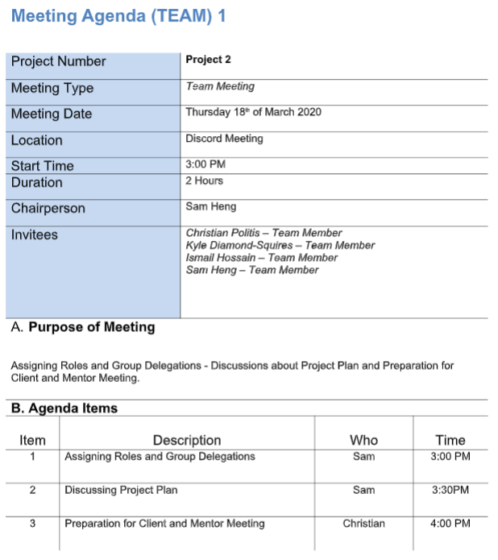Below is a screenshot of each of the team’s agendas, minutes of meetings we had that formal amongst the group. When we needed to work on Project Plan and other assessments or discuss questions for upcoming meetings, we hosted the meeting informally on our Discord Communications Server, which is easily accessible only for team members and allows us to work together efficiently with the flexibility to allow the *host* (no hosts on the server) leave without interrupting work production.

### Figure 7.1.1 – Agenda of Team Meeting 1

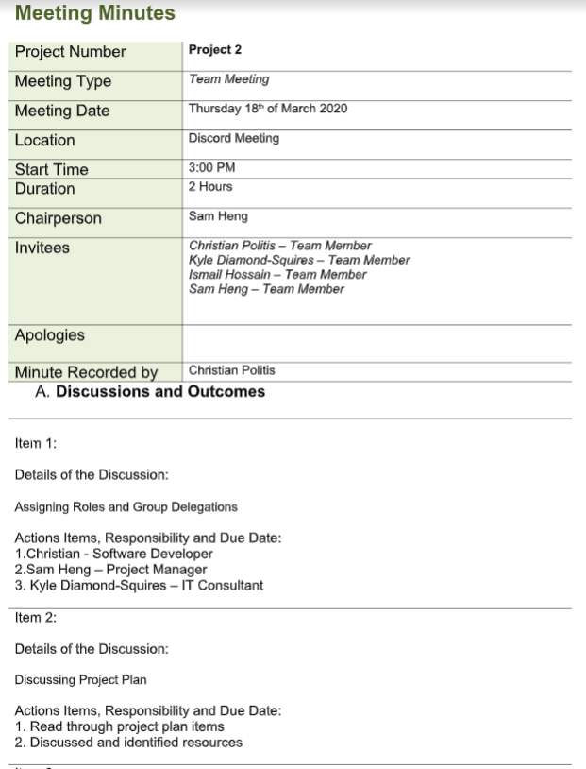

### Figure 7.1.2 – Minutes of Team Meeting 1

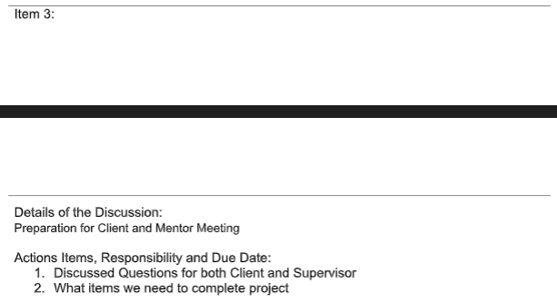

### Figure 7.1.3 – Minutes Continued of Team Meeting 1

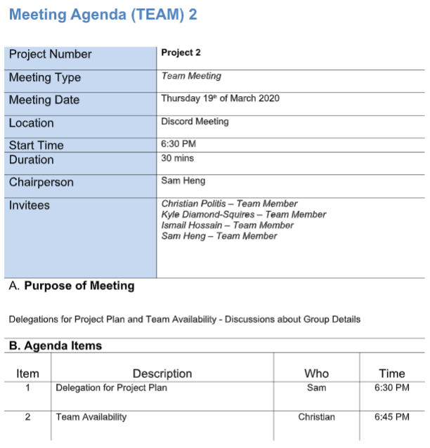

### Figure 7.2.1 – Agenda of Team Meeting 2

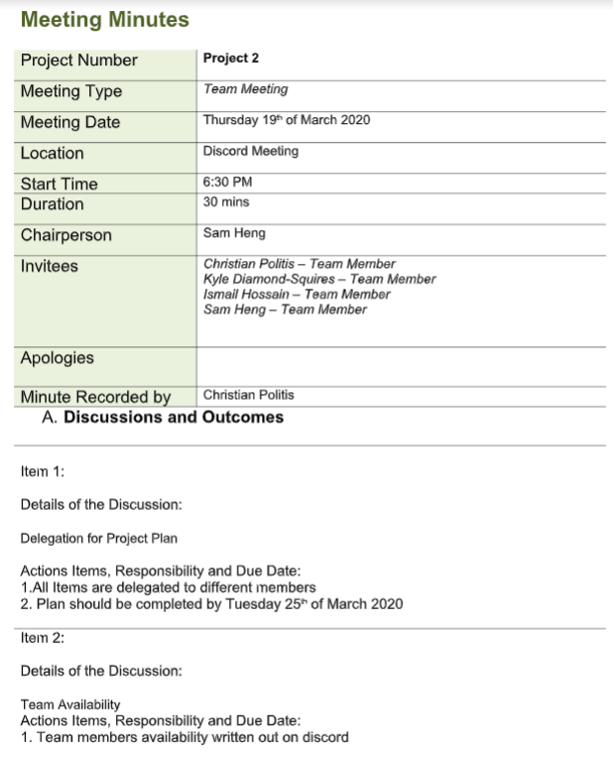

### Figure 7.2.2 – Minutes of Team Meeting 2

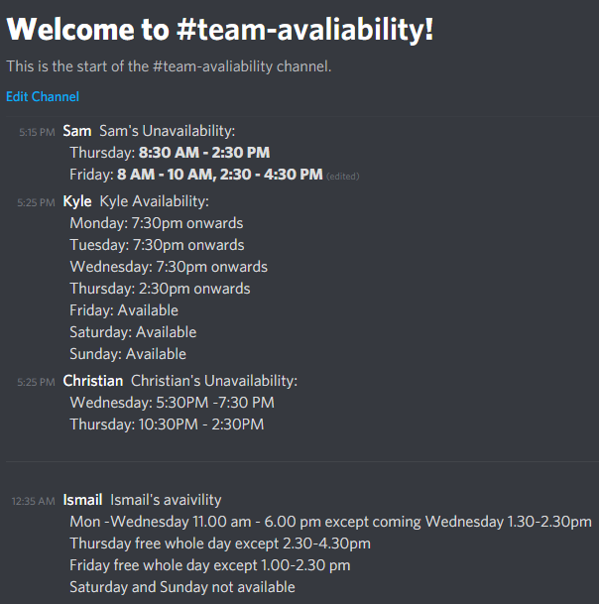 Figure 7.3 – Team Availabilities documented for authenticity

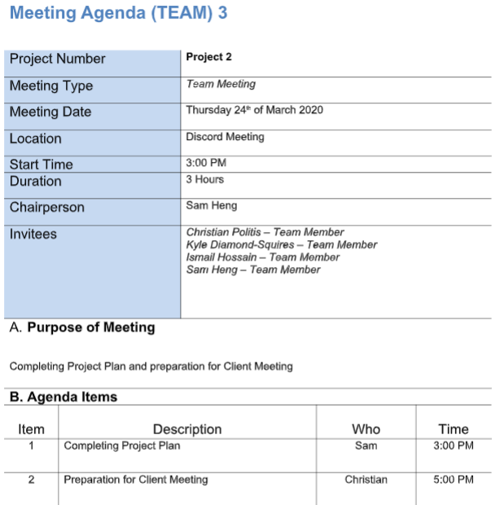 Figure 7.4 – Agenda of Team Meeting 3

# Figure 8.1 – Gantt Chart (Screenshot 1)

# Figure 8.2 – Gantt Chart (Screenshot 2)

# Figure 8.3 – Gantt Chart (Screenshot 3)

# Figure 8.4 – Gantt Chart (Screenshot 4)

# Conclusion

It is apparent to our team, that the jukebox application will need a variety of GUI enhancements implemented as well as some back end features we believe need to be added for the app to function desirably. Our team thinks we are able to provide this desired application within the allocated time slot as listed within the following document as a project plan.

This document details our team's project plan as we understand the concept, requirements, and process that will be undertaken as essential tasks in order to acquire a high quality result. The result of the team's work should result in a high quality application that eliminates the need for a middleman and allows gym-goers to easily play music on a dedicated device.

Moving forward, the client and mentor of this group shall expect a Project Proposal that will distinguish and indicates the groups understanding in the project requirements and further details on the functionality and non-functionality of the application.

# References

Cast Software. (2019 , September 2). *Risk Management in Software Development and Software Engineering Projects*. Retrieved from Cast Software: https://www.castsoftware.com/research-labs/risk-management-in-software-development-and-software-engineering-projects

# Appendices

## Figure 1.1 – Ismail Hossain Group Details Table

|  |  |
| --- | --- |
| Strengths, Skills and Weaknesses | |
| Ismail Hossain | **Skills**  Ismail has an ability to create a user interface because he has done some work on it in other units in the previous semester.  He has a primary knowledge on Programming languages (HTML, Java, SQL). He has the ability to organise the work with different types of people as he has an experience from the previous semesters.  **Strengths**  He has the Flexibility skills which makes others group members to work comfortably and have the ability to adopt in different circumstances.  Ismail always believes in work not believing in words so he is very realistic when it comes to work.  He has the ability to cooperate in team settings at the same time he is able to take over a role if someone does not like the particular role themselves.  He is able to make good documentation which is very important for the project.  **Weaknesses**  Ismail does not like to talk too much.  He is the person who doesn't like to express himself in a group or in a crowded area because he struggles to think on the spot and communicate his thoughts simultaneously.  He does not have in- depth knowledge of programming languages. |

## Figure 1.2 – Christian Politis Group Details Table

|  |  |
| --- | --- |
| Strengths, Skills and Weaknesses | |
| Christian Politis | **Skills**  Christian provides an analytical approach and is a proficient problem solver.    He has a background foundation with programming primarily with data science languages however has exposure and experience with front end and object oriented languages.  **Strengths**  Has experience with Java, Python, and other UI based languages.  Completed Extension 1 mathematics in high school and a good understanding of statistical mathematics.  At the time when the project manager is not able to lead the group, they are able to take charge when necessary.  Christian also has experience in a professional environment that can be beneficial for improving the quality and management of the team.  **Weaknesses**  Not as confident in their soft skills and can become abreast with their opinions as a result tend to be strong-willed at times. |

|  |  |
| --- | --- |
| Strengths, Skills and Weaknesses | |
| Kyle Diamond-Squires | **Skills**  A broad basic understanding of programming languages such as Java, PHP, JavaScript, Python, Html, as well as understanding the concept and logic involved.  Able to work well with others cooperatively, thriving off of one another to produce the best product the team is able too.  Soft skills come easily due to being raised in a rural environment, I am able to communicate with others effectively by adjusting my own wavelength to understand others to appeal to both parties.  With the ability to control a crowd, I am able to manage a variety of scenarios that may be presented to me.  As a creative individual, I like problem solving in relation to creation and destruction, fixing issues and improving already existing solutions.  **Strengths**  Soft skills are one of the greatest strengths, this is because they influence every other aspect of dealing with teams, mentors, and clients.  Creativity enables alternative solutions to find their way into issues, providing a healthy solution for both parties.  Being able to work as a team, the work produced is of aa higher quality due to combined effort and input from those around.  By setting realistic goals and standards to keep in mind for myself and those around me, ensures a stress free working environment for the entire team, while realistic goals, I strive to do the most possible for the situation.  **Weaknesses**  Time management sometimes comes as an issue, as I over or underestimate the amount of time I have or need. To combat this, I will be closely following our teams Gantt chart.  Technical knowledge limitations can sometimes arise. These limitations are simply due to a lack of experience and can be combatted by investing time and effort into learning new skills and capabilities |

## Figure 1.3 – Kyle Diamond-Squires Group Details Table

|  |  |
| --- | --- |
| Strengths, Skills and Weaknesses | |
| Sam Heng | **Skills**  Sam is proficient in Programming using Java and Python. With previous junior experience as a software developer in High School and competitions hosted by USYD.  He has great time management and organisational skills.  Adequate soft skills with the ability to lead, present and portray an idea amongst a group of people, whether it is in writing or through verbal communication.  **Strengths**  Sam has excellent organisational skills that allows him to be able to balance workload and distribute equally amongst teams as a Project Manager.  He is highly co-operative being able to contribute ideas and advise others on information.  Being proactive and able to change a situation for the better.  **Weaknesses**  Minimal experience as a Team Lead or Project Manager within a team, this leads to the weakness of being unable to motivate team members to get on board with contribution and work at times.  At times, technical knowledge. This is due to the lack of experience in certain situations. |

## Figure 1.4 – Sam Heng Group Details Table

## Work_Breakdown_Structure_Professional_Experience_Revised_2Figure 2 – Work Breakdown Structure

|  |  |  |  |
| --- | --- | --- | --- |
| Project Management | | | |
|  | **Risk/Issue** | **Type** | **Resolution Expected to be Actioned** |
| 1. | New, unproven technologies | Risk | Appropriate training and knowledge is key to understanding the proper and appropriate use of technology as a result not leading to failure of the project. |
| 2. | User and functional requirements | Issues | Project requirements should be concise and consistent with the project brief. Understanding the specific requirements that will meet the user’s needs is key to establishing a successful and quality solution. |
| 3. | Application and system architecture | Risk | Using the appropriate platform and language as well as architecture for the project |
| 4. | Performance | Issue | Benchmarking and threshold testing should occur often as a result consistent performance and no depletion of the system quality. |
| 5. | Organizational | Risk | Management of the needs of the development team and the expectations of the client must find a balance. As a result this will allow perfect execution of the project and will deliver a good outcome. |

## Figure 3 – Issues and Risks of Project Management

## Figure 4 – Milestone Table

|  |  |  |  |
| --- | --- | --- | --- |
| Milestone | Main Responsibility | Planned Date | Actual Date |
| Initial Project Plan Report | Sam | Friday  27/03/2020 | Friday  27/03/2020 |
| Project Proposal | Kyle | Wednesday  1/04/2020 |  |
| Analysis Report | Ismail | Tuesday  7/04/20 |  |
| Design Report | Sam | Friday  17/04/20 |  |
| Test Plan Document and Testing | Ismail | Friday  8/05/20 |  |
| Maintenance Test Phase and Report | Christian | Friday  22/05/20 |  |
| Project Construction and Handover Report | Kyle | Wednesday  27/05/20 |  |
| Project Completion Report | Christian | Friday  5/06/20 |  |

|  |  |  |  |  |
| --- | --- | --- | --- | --- |
| Team Member: Kyle Diamond-Squires | | | | |
| Detailed Task / Activity | **Phase / Deliverable** | **Start Date** | **End Date** | **% Complete (as of the reporting date)** |
| Group Details | Project Plan | 19/03/20 | 26/03/20 | 100 |
| Individual Task List | Project Plan | 24/03/20 | 27/03/20 | 0 |
| Conclusion | Project Plan | 26/03/20 | 27/03/20 | 100 |
| An Alternative Solution | Project Proposal | 28/03/20 | 30/03/20 | 0 |
| Recommend Solution | Project Proposal | 31/03/20 | 31/03/20 | 0 |
| Non-Functionality Requirements | Project Proposal | 1/04/20 | 1/04/20 | 0 |
| Development Release Schedule | Project Proposal | 1/04/20 | 1/04/20 | 0 |
| Business Case (Risk and Risk Plan) | Systems Analysis and Design Report | 1/04/20 | 2/04/20 | 0 |
| Solution to resolve Issues | Systems Analysis and Design Report | 2/04/20 | 3/04/20 | 0 |
| Create Test Plan | Project Construction and Testing | 17/04/10 | 18/04/20 | 0 |
| Risk and Constraints | Analysis Report | 17/04/20 | 20/04/20 | 0 |
| Design Considerations | Analysis Report | 21/04/20 | 22/04/20 | 0 |
| Coding | Project Construction | 4/05/20 | 8/05/20 | 0 |
| Sequence Diagrams | Design Report | 30/04/20 | 1/05/20 | 0 |
| Features and Use Case Test | Design Report | 4/05/20 | 7/05/20 | 0 |
| Maintenance Test and Troubleshooting | Maintenance Phase | 20/05/20 | 22/05/20 | 0 |
| Installation Guide | Handover and Handover Report | 18/05/20 | 25/05/20 | 0 |
| Live Demo and Handover | Handover and Handover Report | 26/05/20 | 27/05/20 | 0 |
| Final Presentation | Project Wrap Up | 29/05/20 | 5/06/20 | 0 |

## Figure 5.1 – Kyle Diamond-Squires Individual Task List Table

|  |  |  |  |  |
| --- | --- | --- | --- | --- |
| Team Member: Ismail Hossain | | | | |
| Detailed Task / Activity | **Phase / Deliverable** | **Start Date** | **End Date** | **% Complete (as of the reporting date)** |
| Introduction | Project Plan | 19/03/20 | 19/03/20 | 100 |
| Group Details | Project Plan | 19/03/20 | 26/03/20 | 100 |
| Work Breakdown Structure | Project Plan | 24/03/20 | 27/03/20 | 100 |
| Problem Statement | Project Proposal | 28/03/20 | 28/03/20 | 0 |
| Solution Description for Each | Project Proposal | 31/03/20 | 31/03/20 | 0 |
| Non-Functionality Requirements | Project Proposal | 1/04/20 | 1/04/20 | 0 |
| Development Release Schedule | Project Proposal | 1/04/20 | 1/04/20 | 0 |
| Business Advantages | Design Phase | 1/04/20 | 2/04/20 | 0 |
| Wireframes and Storyboard | Design Phase | 4/04/20 | 6/04/20 | 0 |
| Client Statement | Project Construction and Testing | 17/04/20 | 19/04/20 | 0 |
| Problem Statement | Project Construction and Testing | 17/04/20 | 19/04/20 | 0 |
| Coding | Project Construction and Testing | 27/04/20 | 1/05/20 | 0 |
| Entity Relationship Diagram | Project Construction and Testing | 4/05/20 | 6/05/20 | 0 |
| Candidate Test Cases and Test Data | Project Construction and Testing | 4/05/20 | 7/05/20 | 0 |
| Revision of Systems Analysis Design Document | Analysis and Design Phase | 7/05/20 | 11/05/20 | 0 |
| Documentation Review of Handover Document | Handover Phase | 25/05/20 | 27/05/20 | 0 |
| Live Demo and Handover | Handover Phase | 26/05/20 | 27/05/20 | 0 |
| Final Maintenance Report | Handover Phase | 22/05/20 | 27/05/20 | 0 |
| Final Presentation | Project Wrap Up | 29/05/20 | 5/06/20 | 0 |

## Figure 5.2 – Ismail Hossain Individual Task List Table

|  |  |  |  |  |
| --- | --- | --- | --- | --- |
| Team Member: Christian Politis | | | | |
| Detailed Task / Activity | **Phase / Deliverable** | **Start Date** | **End Date** | **% Complete (as of the reporting date)** |
| Executive Summary | Project Plan | 19/03/20 | 19/03/20 | 100 |
| Group Details | Project Plan | 19/03/20 | 26/03/20 | 100 |
| Project Management Related Issues | Project Plan | 24/03/20 | 27/03/20 | 0 |
| Planned Meetings | Project Plan | 23/03/20 | 27/03/20 | 0 |
| Client Details and Project Background | Project Proposal | 27/03/20 | 27/03/20 | 0 |
| Problem Statement | Project Proposal | 28/03/20 | 28/03/20 | 0 |
| An Alternative Solution | Project Proposal | 28/03/20 | 30/03/20 | 0 |
| Solution Description | Project Proposal | 31/03/20 | 31/03/20 | 0 |
| Functionality Requirements and Use Cases | Project Proposal | 1/04/20 | 1/04/20 | 0 |
| Interpretation Potential Issues and Communicate with Client | Analysis Phase | 27/03/20 | 1/04/20 | 0 |
| Establishment of Software Development Team with Client | Analysis Phase | 1/04/20 | 1/04/20 | 0 |
| Full-Functionality and Non-Functionality | Analysis Phase | 2/04/20 | 7/04/20 | 0 |
| Develop Working Prototype | Analysis Phase | 7/04/20 | 17/04/20 | 0 |
| Coding | Project Construction and Testing | 20/04/20 | 24/04/20 | 0 |
| Develop Test Plan | Testing Phase | 17/04/20 | 18/04/20 | 0 |
| System Architecture | Design Phase | 18/04/20 | 20/04/20 | 0 |
| Software Architecture | Design Phase | 21/04/20 | 22/04/20 | 0 |
| Use Case Diagram | Design Phase | 23/04/20 | 24/04/20 | 0 |
| Expanded Use Cases | Design Phase | 27/04/20 | 30/04/20 | 0 |
| Code Review | Project Construction and Testing | 11/05/20 | 14/05/20 | 0 |
| Test Plan | Testing Phase | 6/05/20 | 8/05/20 | 0 |
| Code Review | Project Construction and Testing | 15/05/20 | 27/05/20 | 0 |
| Maintenance Test | Testing Phase | 20/05/20 | 22/05/20 | 0 |
| Export Project and Test Finalisation | Handover Phase | 26/05/20 | 27/05/20 | 0 |
| MIT Licensing | Handover Phase | 26/05/20 | 26/05/20 | 0 |
| Live Demo and Handover | Handover Phase | 26/05/20 | 27/05/20 | 0 |
| Final Presentation | Project Wrap Up | 29/05/20 | 5/06/20 |  |

## Figure 5.3 – Christian Politis Individual Task List Table

## Figure 5.4 – Sam Heng Individual Task List Table

|  |  |  |  |  |
| --- | --- | --- | --- | --- |
| Team Member: Sam Heng | | | | |
| Detailed Task / Activity | **Phase / Deliverable** | **Start Date** | **End Date** | **% Complete (as of the reporting date)** |
| Individual Task List | Project Plan | 26/03/20 | 27/03/20 | 100 |
| Group Details | Project Plan | 19/03/20 | 26/03/20 | 100 |
| Work Breakdown Structure | Project Plan | 24/03/20 | 27/03/20 | 100 |
| Milestone Plan | Project Plan | 24/03/20 | 27/03/20 | 100 |
| Individual Task List | Project Plan | 24/03/20 | 27/03/20 | 100 |
| Gantt Chart | Project Plan | 23/03/20 | 23/03/20 | 100 |
| Client Details and Project Background | Project Proposal | 27/03/20 | 27/03/20 | 0 |
| An Alternative Solution | Project Proposal | 28/03/20 | 28/03/20 | 0 |
| Recommended Solution | Project Proposal | 31/03/20 | 31/03/20 | 0 |
| Functionality Requirements and Use Case | Project Proposal | 1/04/20 | 1/04/20 | 0 |
| Prepare Initial Budget Estimates | Analysis Phase | 1/04/20 | 1/04/20 | 0 |
| Full Functionality and Non-Functionality Solution | Analysis Phase | 2/04/20 | 7/04/20 | 0 |
| Communicate Design Details to Team | Design Phase | 27/03/20 | 28/03/20 | 0 |
| Wireframes and Storyboards | Design Phase | 4/04/20 | 6/04/20 | 0 |
| Develop Working Prototype | Design Phase | 7/04/20 | 17/04/20 | 0 |
| System Requirements | Analysis Phase | 17/04/20 | 20/04/20 | 0 |
| Network and Communication Architecture | Design Phase | 21/04/20 | 22/04/20 | 0 |
| Detailed System Design | Design Phase | 23/04/20 | 24/04/20 | 0 |
| Expanded Use Cases | Design Phase | 27/04/20 | 30/04/20 | 0 |
| Code Review | Project Construction and Testing | 11/05/20 | 14/05/20 | 0 |
| Entity Relationship Diagram | Design Phase | 4/05/20 | 6/05/20 | 0 |
| Test Plan | Testing Phase | 6/05/20 | 8/05/20 | 0 |
| Review of Systems Analysis Document | Analysis and Design Phase | 7/05/20 | 11/05/20 | 0 |
| Code Review – Check for Functionality Fulfilment | Testing Phase | 15/05/20 | 27/05/20 | 0 |
| User Manual Guide | Handover Phase | 11/05/20 | 15/05/20 | 0 |
| Live Demo and Handover | Handover Phase | 26/05/20 | 27/05/20 | 0 |
| Final Presentation with Live Demo | Project Wrap Up | 29/05/20 | 5/06/20 | 0 |

|  |  |  |  |  |  |
| --- | --- | --- | --- | --- | --- |
| Meeting Type | Length | First Meeting | How Often? | Number of Meetings Planned | Location or Mode |
| Academic Supervisor  Meetings | 2 hours | 13/03/2020 | Once Every 10 weeks on Friday | 2 | Face to Face or Zoom Online Meeting (depends on situation) |
| Mentor Meetings | 1 hour | 19/03/2020 | Once a week  Thursday 5:30 PM | 12 | Zoom Online Meeting |
| Client Meetings | 1 hour | 25/03/2020 | When necessary | 5-8 | Zoom Online Meeting |
| Group Meetings | 2 hours | 19/03/2020 | 2-3 times a week | 25 - 30 | Discord Comms  Server |

## Figure 6 - Meeting Plan Table

## Figure 7.1.1 – Agenda of Team Meeting 1

## Figure 7.1.2 – Minutes of Team Meeting 1

## Figure 7.1.3 – Minutes Continued of Team Meeting 1

## Figure 7.2.1 – Agenda of Team Meeting 2



## Figure 7.2.2 – Minutes of Team Meeting 2

## **Figure 7.3 – Team Availabilities documented for authenticity**

Figure 7.4 – Agenda of Team Meeting 3

## Figure 8.1 – Gantt Chart (Screenshot 1)

## Figure 8.2 – Gantt Chart (Screenshot 2)

## Figure 8.3 – Gantt Chart (Screenshot 3)

## Figure 8.4 – Gantt Chart (Screenshot 4)