Python Cheat Sheet: Classes

 | Description | Example
Classes | A class encapsulates data and functionality: data as attributes, and functionality as methods. It is a blueprint for creating concrete instances in memory.  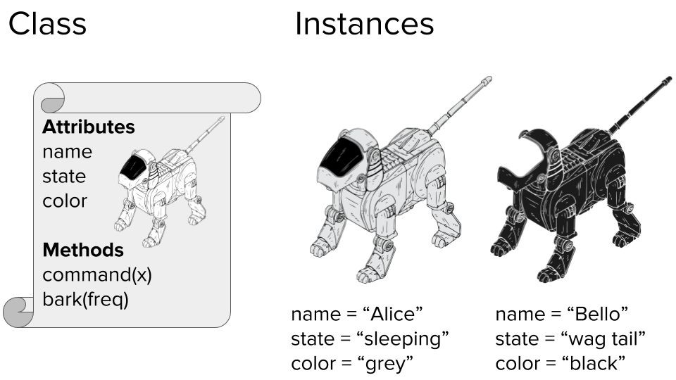 | class​ ​Dog​:  """ Blueprint of a dog """ # class variable shared by all instances species = [​"canis lupus"​]  def​ ​__init__​(self, name, color)​: self.name = name  self.state = ​"sleeping" self.color = color  def​ ​command​(self, x)​: if​ x == self.name:  self.bark(​2​) elif​ x == ​"sit"​:  self.state = ​"sit" else​:  self.state = ​"wag tail"  def​ ​bark​(self, freq)​: for​ i ​in​ range(freq):  print(​"["​ + self.name  + ​"]: Woof!"​)  bello = Dog(​"bello"​, ​"black"​) alice = Dog(​"alice"​, ​"white"​)  print(bello.color) ​# black print(alice.color) ​# white  bello.bark(​1​) ​# [bello]: Woof!  alice.command(​"sit"​) print(​"[alice]: "​ + alice.state)  # [alice]: sit  bello.command(​"no"​) print(​"[bello]: "​ + bello.state)  # [bello]: wag tail  alice.command(​"alice"​) # [alice]: Woof!  # [alice]: Woof! bello.species += [​"wulf"​] print(len(bello.species)  == len(alice.species)) ​# True (!)
Instance | You are an instance of the class human. An instance is a concrete implementation of a class: all attributes of an instance have a fixed value. Your hair is blond, brown, or black--but never unspecified.  Each instance has its own attributes independent of other instances. Yet, class variables are different. These are data values associated with the class, not the instances. Hence, all instance share the same class variable ​species ​in the example.
Self | The first argument when defining any method is always the ​self ​argument. This argument specifies the instance on which you call the method.  self ​gives the Python interpreter the information about the concrete instance. To ​define ​a method, you use self​ to modify the instance attributes. But to ​call ​an instance  method, you do not need to specify ​self​.
Creation | You can create classes “on the fly” and use them as logical units to store complex data types.  class​ ​Employee()​: pass employee = Employee() employee.salary = ​122000 employee.firstname = ​"alice" employee.lastname = ​"wonderland"  print(employee.firstname + ​" "  + employee.lastname + ​" "  + str(employee.salary) + ​"$")​ # alice wonderland 122000$

