A Shared-Encoder Multi-Task Learning Framework for Simultaneous E-Commerce Attribute Inference
Fundamentals of Data Science final project - dataset, analysis, and multi-task experiments (October 2026)

1. Introduction and Problem Statement
Online marketplaces host millions of products and reviews. Automated inference of product metadata and reviewer opinion helps organize listings, personalize recommendations, and flag mispriced or miscategorized products. This project asks the research question: does a shared-encoder multi-task learning (MTL) approach provide useful advantages over separate machine-learning models for predicting product category, price tier, and customer sentiment simultaneously?
We quantify this by: (i) building a reproducible sample of Amazon product-review pairs; (ii) performing exploratory data analysis (EDA) and chi-square tests of independence; (iii) training independent baselines (TF-IDF + logistic regression, and TF-IDF+SVD decision trees) for each task; and (iv) training a shared-encoder neural model with three classification heads under equal task-loss weights.

2. Dataset Description
Source: McAuley-Lab/Amazon-Reviews-2023 on Hugging Face (McAuley-Lab/Amazon-Reviews-2023). We sample review JSONL files via HTTP range requests with bounded windows and reservoir sampling (seed 20231010), then retrieve product metadata for sampled parent_asins by one chunked (resumable) scan per metadata file. Sampled source records: 17,500 across 7 candidate categories; after join + scope filtering, 3,383 usable product-review pairs remain, spanning 2,361 distinct products and 15 distinct main categories (All_Beauty, Health_and_Personal_Care, Appliances sources).
Columns: product_id, product_title, product_description, category, price, review_text, rating, sentiment_label (rating-derived), and provenance fields. Records with missing price, text or rating are excluded and logged ({'missing_price': 4113, 'missing_review_text': 4, 'category_not_in_approved_set': 10000, 'duplicate_review_records_removed': 0}); missing values in the final sample are minimal (0 non-target cells). Local dataset-related storage on disk is 149.9 MB, well below the 5 GB local-storage ceiling. However, cumulative lifetime network download volume is recorded as 5.12 GB, exceeding the 4.5 GB download budget. Therefore, the local storage footprint is below 5 GB, but the cumulative download budget was exceeded; these are distinct measures.

3. Data Preprocessing
Text fields are concatenated as 'title. description. review_text' into a single input string per pair. Price tiers are low/medium/high using 33rd/67th percentiles fit ONLY on the training split; the same thresholds are then applied unchanged to validation and test. Sentiment labels are derived from ratings (1-2 negative, 3 neutral, 4-5 positive) and are explicitly proxies, not human-annotated sentiment. Leakage prevention: ratings are excluded from sentiment inputs; raw prices and price-derived features are excluded from price-tier inputs; category labels are excluded from category inputs; TF-IDF vectorizers are fit on training data only. Splits are product-grouped (70/15/15) with fixed seed 20231010 so no product spans multiple splits (verified no_overlap=True).

4. Exploratory Data Analysis
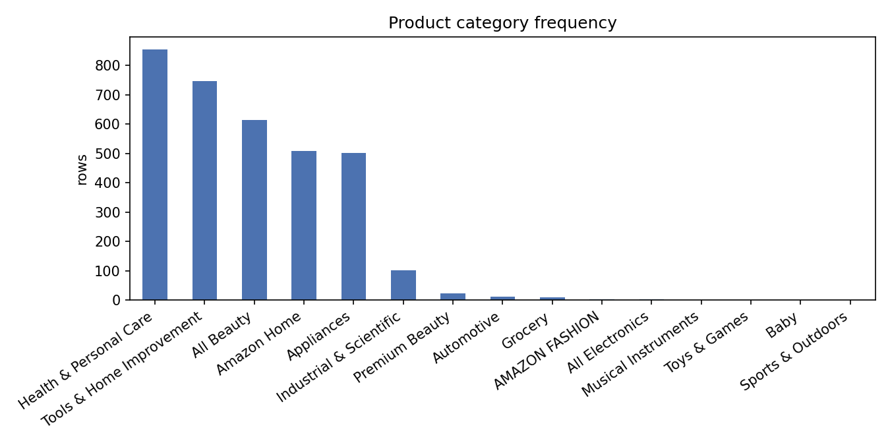
Figure 1. Product category frequency; three source categories dominate a long tail of rare meta labels.
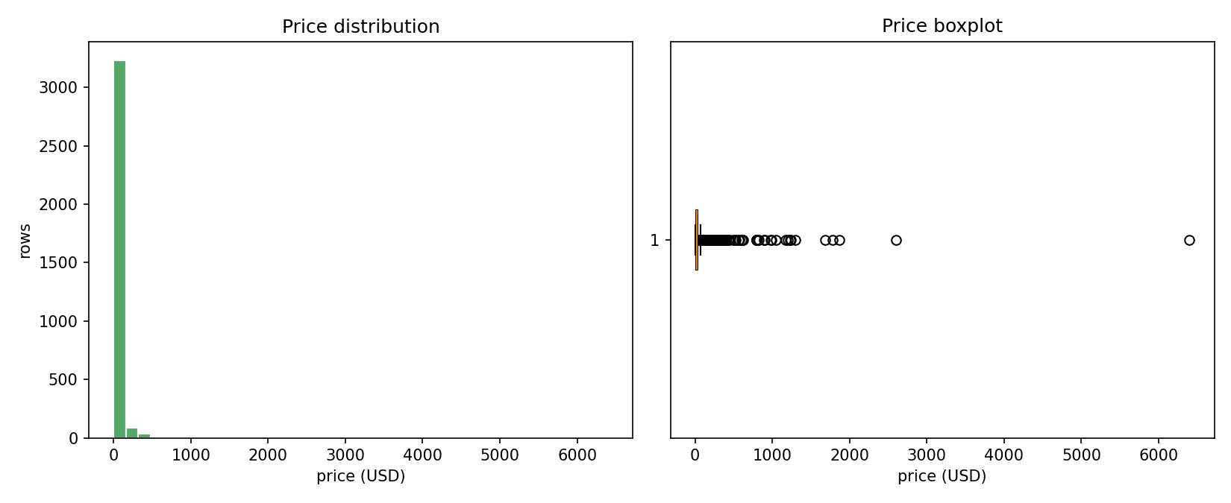
Figure 2. Prices are right-skewed; median ≈ 19.99 USD with a heavy tail beyond ~50 USD.
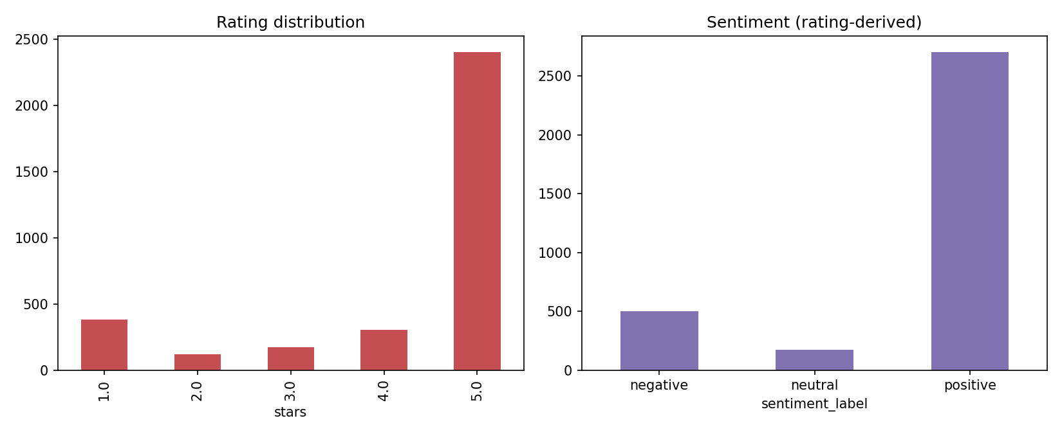
Figure 3. Ratings skew strongly to 5 stars; sentiment classes are imbalanced (80%/15%/5%).
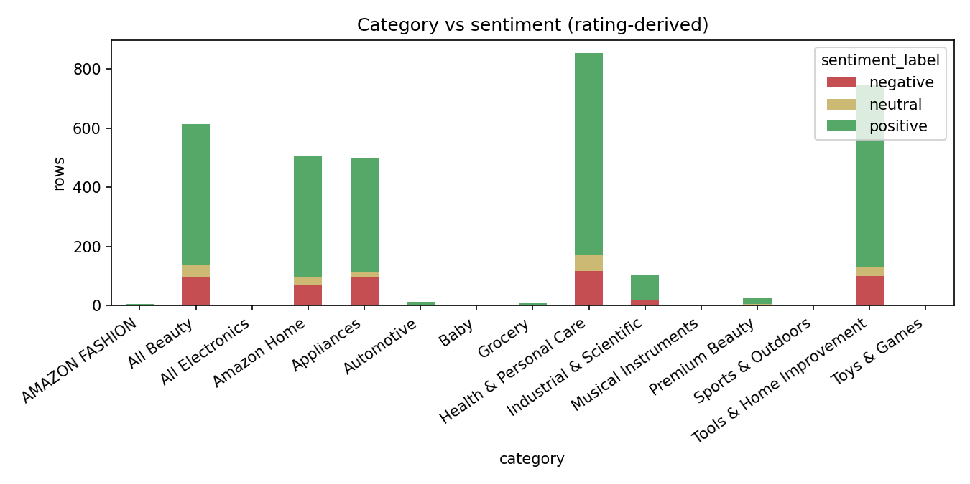
Figure 4. Positive reviews dominate all categories; negative share is highest in Health & Personal Care.
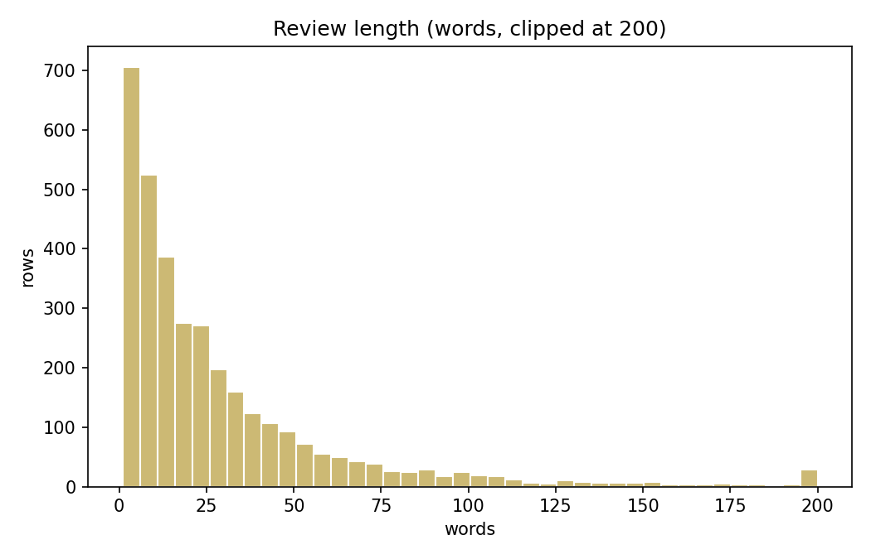
Figure 5. Review lengths are right-skewed; most reviews are under ~50 words.
Key descriptive statistics: median price 19.99 USD (IQR 12.00 - 35.99); mean review length 29.6 words; duplicate review texts: 116 (deduplicated by (product, user, timestamp)).

5. Methodology / Analysis

5.1 Statistical hypothesis testing
H1 (sentiment ⊥ product category): chi-square(12) = 22.01, p = 0.0374, Cramér's V = 0.057, n = 3383. At alpha = 0.05 we REJECT H0 - i.e. a statistically significant but weak association exists. Some expected cells remain sparse (min 2.8); interpretation is cautious.
H2 (sentiment ⊥ price tier): chi-square(4) = 8.58, p = 0.0724, Cramér's V = 0.036. At alpha = 0.05 we FAIL TO REJECT H0 - i.e. no statistically significant association between price tier and sentiment is established in this sample. Associations never imply causation.

5.2 Independent baselines
Per task: TF-IDF (5k features, 1-2 grams, train-fit) + Logistic Regression (C=1), and a Decision Tree (depth 8) on a 100-dim SVD of TF-IDF. A majority-class reference is also included (mode of the TRAIN target, applied unchanged to val/test). Validation set is used for model selection; the test set is scored once. Metrics: accuracy, macro precision / recall / F1 (macro chosen because of class imbalance), and confusion matrices.

5.3 Shared-encoder multi-task model
Architecture: TF-IDF (5000 features) -> dense shared encoder (256 -> 128 ReLU, dropout 0.2) -> three linear heads (category, price_tier, sentiment). Loss L_total = L_category + 1.0*L_price + 1.0*L_sentiment; Adam (lr 1e-3), batch 64, up to 30 epochs with best-epoch checkpointing on validation mean macro-F1. Trained 2.6s; ~5139 KB of parameters. Checkpoint saved to data/models/mtl_best.pt with config data/models/mtl_config.json.
Rare-category handling: categories with fewer than 30 TRAIN rows are relabeled 'Other' (rule decided from train data only; applied unchanged to val/test). All compared models are re-run consistently under this grouped label space.

6. Results and Discussion
Task | Model | Acc | P_macro | R_macro | F1_macro | Time_s
category | decision_tree_test | 0.410 | 0.136 | 0.137 | 0.133 | 0.16
category | logreg_test | 0.573 | 0.201 | 0.192 | 0.190 | 1.04
category | majority_class(Health & Personal Care) | 0.209 | 0.017 | 0.083 | 0.029 | 0.00
category | mtl_shared_encoder | 0.492 | 0.245 | 0.254 | 0.248 | 2.63
price_tier | decision_tree_test | 0.400 | 0.398 | 0.396 | 0.394 | 0.15
price_tier | logreg_test | 0.479 | 0.471 | 0.476 | 0.472 | 0.27
price_tier | majority_class(low) | 0.297 | 0.099 | 0.333 | 0.153 | 0.00
price_tier | mtl_shared_encoder | 0.452 | 0.453 | 0.453 | 0.452 | 2.63
sentiment | decision_tree_test | 0.745 | 0.392 | 0.406 | 0.399 | 0.14
sentiment | logreg_test | 0.849 | 0.571 | 0.446 | 0.469 | 0.18
sentiment | majority_class(positive) | 0.801 | 0.267 | 0.333 | 0.297 | 0.00
sentiment | mtl_shared_encoder | 0.841 | 0.595 | 0.541 | 0.560 | 2.63
Table 1. Test-set performance under the original category-label space; all models use the same product-grouped test split.
Task | Model (grouped cats) | Acc | P_macro | R_macro | F1_macro | Time_s
category | decision_tree_test | 0.410 | 0.292 | 0.294 | 0.286 | 0.15
category | logreg_test | 0.577 | 0.433 | 0.415 | 0.410 | 0.54
category | mtl_shared_encoder | 0.483 | 0.337 | 0.353 | 0.344 | 2.36
price_tier | decision_tree_test | 0.400 | 0.398 | 0.396 | 0.394 | 0.15
price_tier | logreg_test | 0.479 | 0.471 | 0.476 | 0.472 | 0.26
price_tier | mtl_shared_encoder | 0.446 | 0.443 | 0.443 | 0.443 | 2.36
sentiment | decision_tree_test | 0.745 | 0.392 | 0.406 | 0.399 | 0.14
sentiment | logreg_test | 0.849 | 0.571 | 0.446 | 0.469 | 0.18
sentiment | mtl_shared_encoder | 0.856 | 0.631 | 0.528 | 0.563 | 2.36
Table 2. Test-set performance after grouping categories with fewer than 30 training rows into 'Other'; results are a separate label-space experiment.
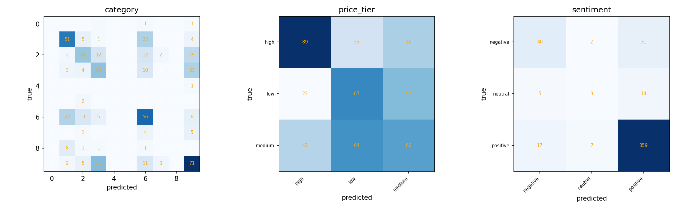
Figure 6. MTL confusion matrices on the test split (original label space).
Error analysis. Under the original category-label space, category macro-F1 is low for all models, although MTL (0.248) exceeds logistic regression (0.190). Under the grouped label space, logistic regression reaches 0.410 macro-F1 versus 0.344 for MTL, so the ranking reverses when rare categories are grouped. Price tier is the weakest task overall: review text carries limited reliable price signal. Sentiment is the strongest task for MTL, which exceeds the majority-class baseline in macro-F1; the small neutral class still affects macro-averaged metrics.
Task-level verdict from the actual test metrics: sentiment improves under joint learning (original-label MTL macro-F1 0.5605 vs logistic regression 0.4691; grouped-label MTL 0.563 vs logistic regression 0.469). Price-tier performance is lower for MTL in both experiments (original labels 0.4516 vs 0.4724; grouped labels 0.443 vs 0.472). Category performance depends on label space: MTL is higher under original labels (0.2482 vs 0.1895), while logistic regression is higher after grouping rare categories (0.410 vs 0.344). Overall, results do not support a claim that multi-task learning is uniformly superior; the observed benefit is task- and label-space-specific.

7. Conclusion
We built a product-grouped pipeline, performed EDA and chi-square tests, and benchmarked independent learners against a shared-encoder multi-task neural model. MTL improved sentiment macro-F1 but did not outperform logistic regression on price tier, and its category ranking depended on the label space. The local dataset footprint was within 5 GB; however, recorded cumulative network downloads exceeded the 4.5 GB download budget. Future work includes richer encoders, task-weight tuning, longer training, and evaluation on a larger sample.

8. References
Hou, Y., et al. (2024). Amazon Reviews 2023. arXiv:2403.03952. URL: https://huggingface.co/datasets/McAuley-Lab/Amazon-Reviews-2023
Pedregosa, F., et al. (2011). Scikit-learn: Machine Learning in Python. JMLR 12.
Paszke, A., et al. (2019). PyTorch: An Imperative Style, High-Performance Deep Learning Library. NeurIPS.
Vitter, J. S. (1985). Random sampling with a reservoir. ACM TOMS 11(1).

