A Shared-Encoder Multi-Task Learning Framework for Simultaneous E-Commerce Attribute Inference
Fundamentals of Data Science final project - dataset, analysis, and multi-task experiments (October 2026)

1. Introduction and Problem Statement
Online marketplaces host millions of products and reviews. Automated inference of product metadata and reviewer opinion helps organize listings, personalize recommendations, and flag mispriced or miscategorized products. This project asks the research question: does a shared-encoder multi-task learning (MTL) approach provide useful advantages over separate machine-learning models for predicting product category, price tier, and customer sentiment simultaneously?
We quantify this by: (i) building a reproducible sample of Amazon product-review pairs; (ii) performing exploratory data analysis (EDA) and chi-square tests of independence; (iii) training independent TF-IDF + Logistic Regression and TF-IDF/SVD Decision Tree baselines; (iv) evaluating a shared TF-IDF encoder with three classification heads; and (v) comparing three independently fine-tuned DistilBERT models with a shared DistilBERT multi-task model.

2. Dataset Description
Source: McAuley-Lab/Amazon-Reviews-2023 on Hugging Face (McAuley-Lab/Amazon-Reviews-2023). We sample review JSONL files via HTTP range requests with bounded windows and reservoir sampling (seed 20231010), then retrieve product metadata for sampled parent_asins by one chunked (resumable) scan per metadata file. Sampled source records: 17,500 across 7 candidate categories; after join + scope filtering, 3,383 usable product-review pairs remain, spanning 2,361 distinct products and 15 distinct main categories (All_Beauty, Health_and_Personal_Care, Appliances sources).
Columns: product_id, product_title, product_description, category, price, review_text, rating, sentiment_label (rating-derived), and provenance fields. Records with missing price, text or rating are excluded and logged ({'missing_price': 4113, 'missing_review_text': 4, 'category_not_in_approved_set': 10000, 'duplicate_review_records_removed': 0}); missing values in the final sample are minimal (0 non-target cells). Local dataset-related storage on disk is 149.9 MB, well below the 5 GB local-storage ceiling. However, cumulative lifetime network download volume is recorded as 5.12 GB, exceeding the 4.5 GB download budget. Therefore, the local storage footprint is below 5 GB, but the cumulative download budget was exceeded; these are distinct measures.

3. Data Preprocessing
Text fields are concatenated as 'title. description. review_text' into a single input string per pair. Price tiers are low/medium/high using 33rd/67th percentiles fit ONLY on the training split; the same thresholds are then applied unchanged to validation and test. Sentiment labels are derived from ratings (1-2 negative, 3 neutral, 4-5 positive) and are explicitly proxies, not human-annotated sentiment. Leakage prevention: ratings are excluded from sentiment inputs; raw prices and price-derived features are excluded from price-tier inputs; category labels are excluded from category inputs; TF-IDF vectorizers are fit on training data only. Splits are product-grouped (70/15/15) with fixed seed 20231010 so no product spans multiple splits (verified no_overlap=True).

4. Exploratory Data Analysis
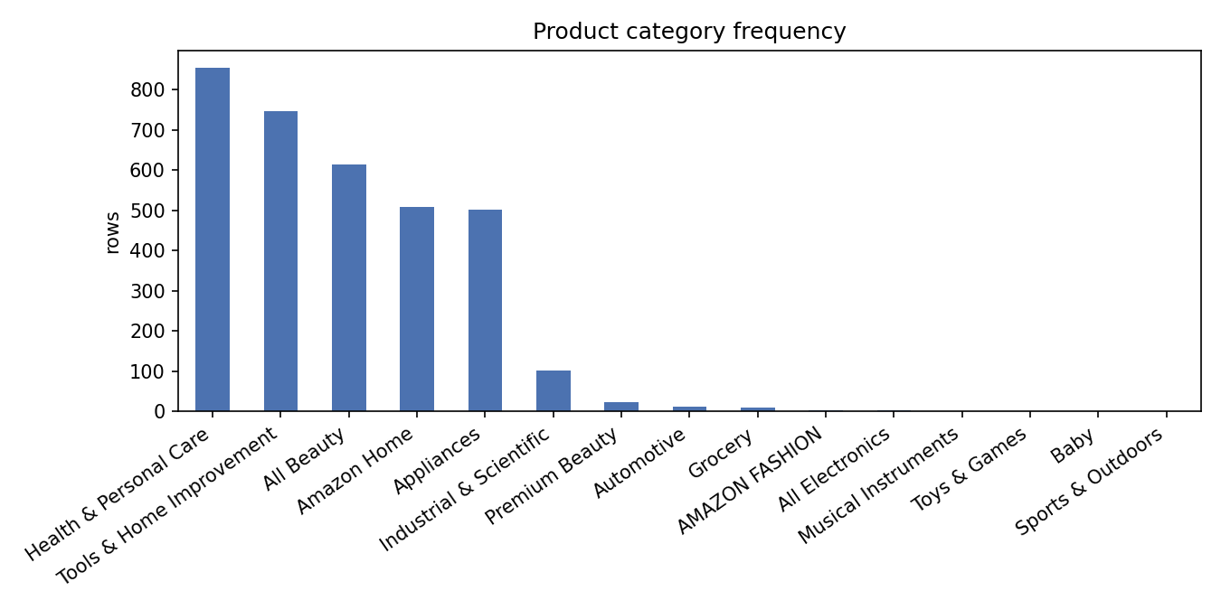
Figure 1. Product category frequency; three source categories dominate a long tail of rare meta labels.
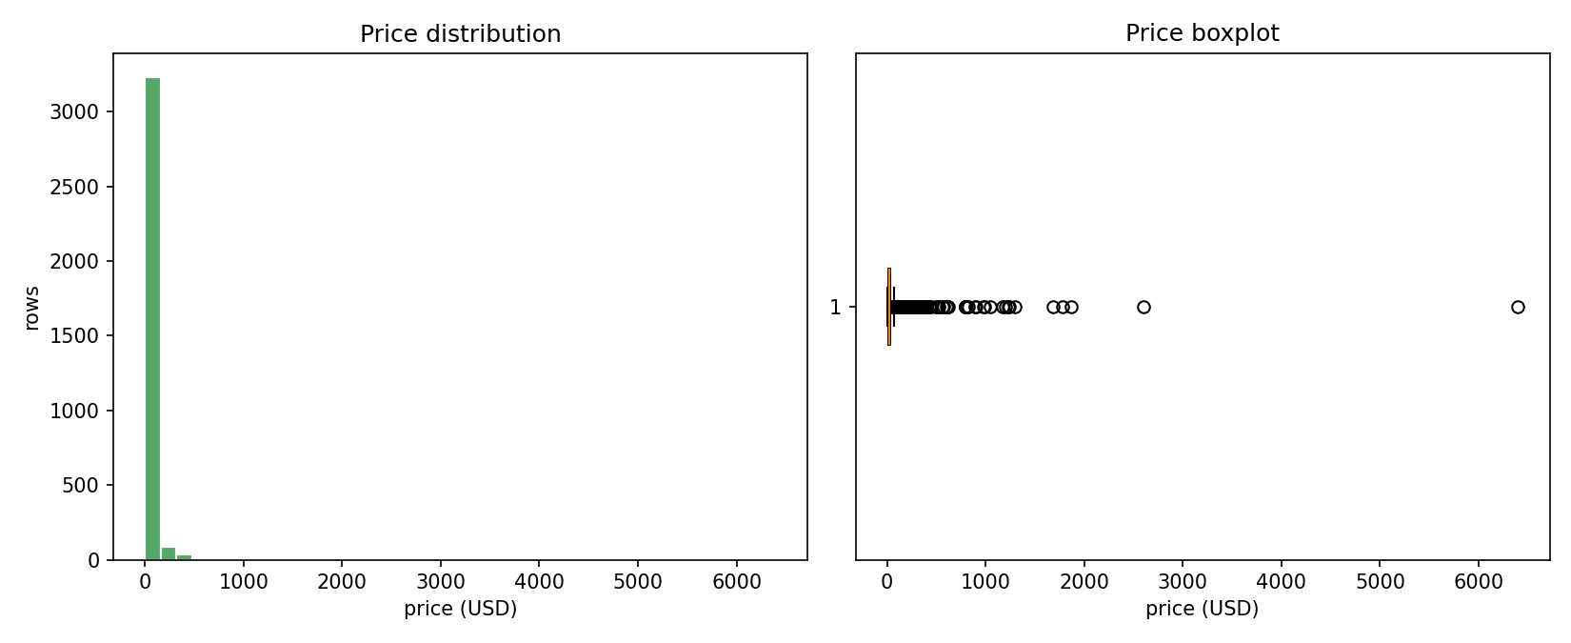
Figure 2. Prices are right-skewed; median ≈ 19.99 USD with a heavy tail beyond ~50 USD.
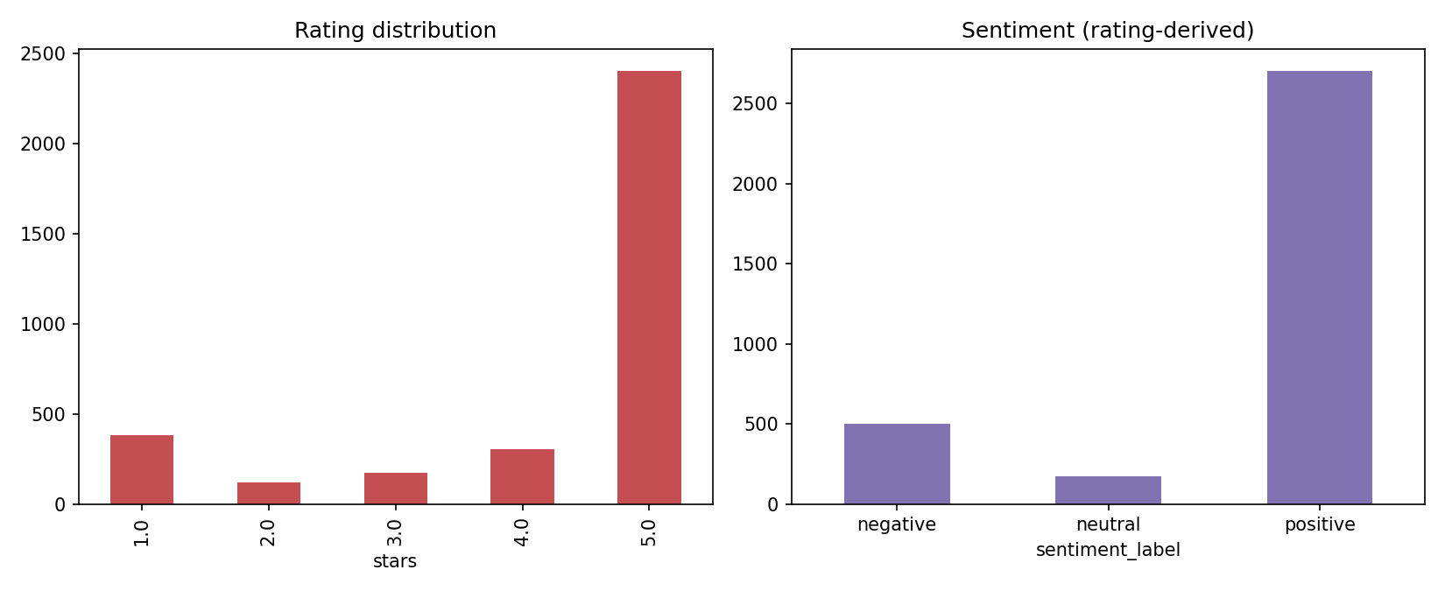
Figure 3. Ratings skew strongly to 5 stars; sentiment classes are imbalanced (80%/15%/5%).
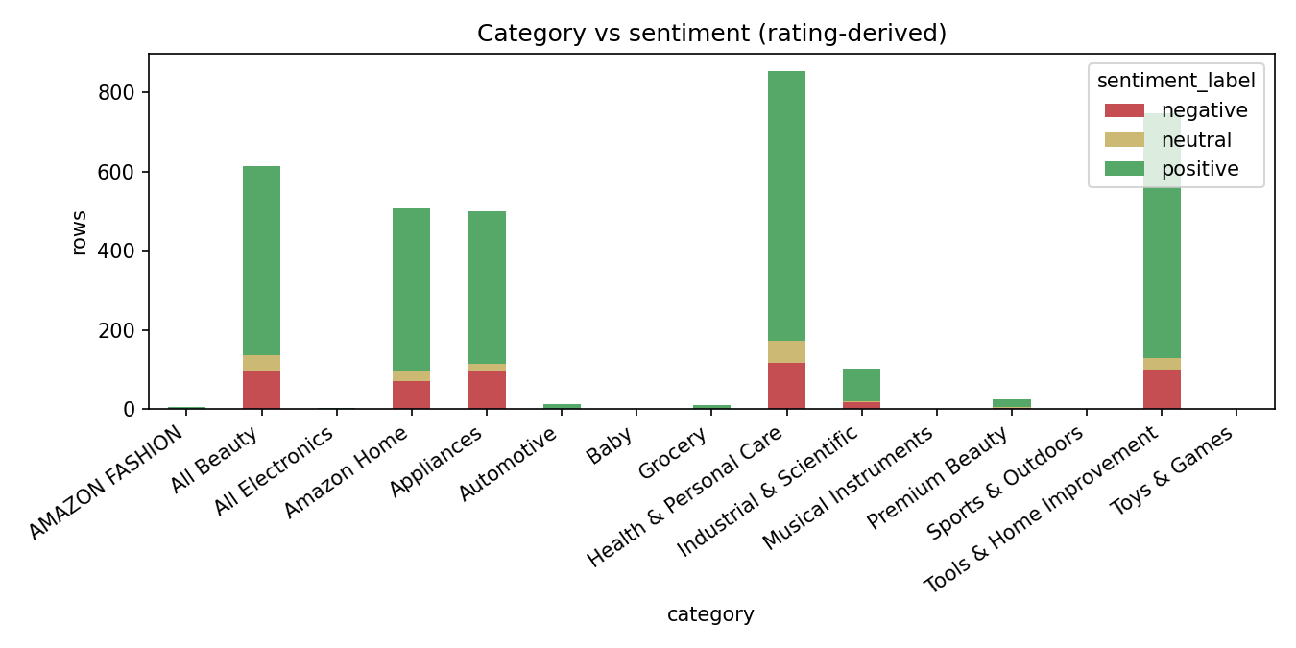
Figure 4. Positive reviews dominate all categories; negative share is highest in Health & Personal Care.
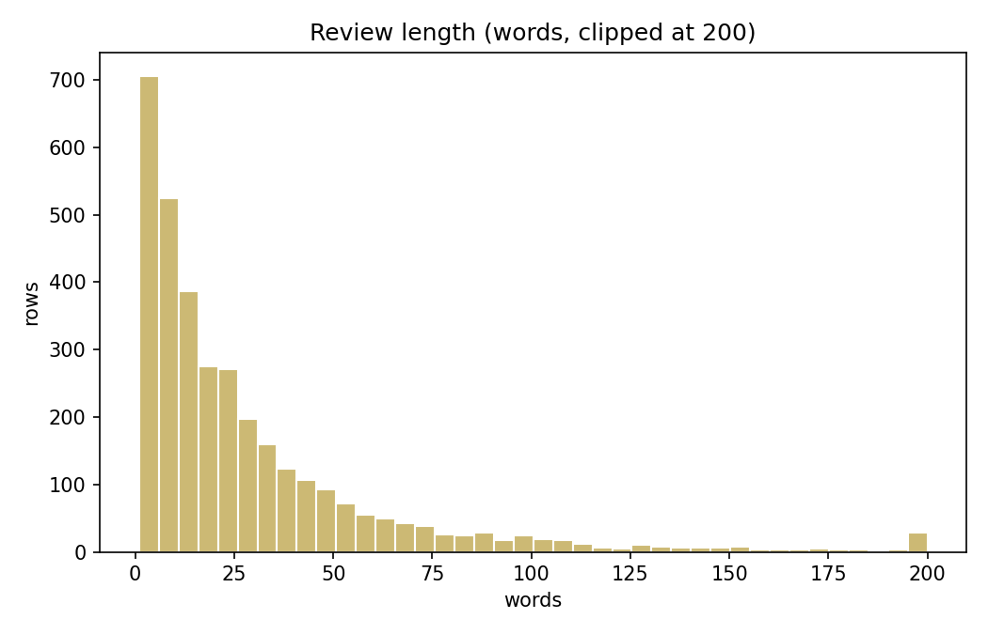
Figure 5. Review lengths are right-skewed; most reviews are under ~50 words.
Key descriptive statistics: median price 19.99 USD (IQR 12.00 - 35.99); mean review length 29.6 words; duplicate review texts: 116 (deduplicated by (product, user, timestamp)).

5. Methodology / Analysis

5.1 Statistical hypothesis testing
H1 (sentiment ⊥ product category): chi-square(12) = 22.01, p = 0.0374, Cramér's V = 0.057, n = 3383. At alpha = 0.05 we REJECT H0 - i.e. a statistically significant but weak association exists. Some expected cells remain sparse (min 2.8); interpretation is cautious.
H2 (sentiment ⊥ price tier): chi-square(4) = 8.58, p = 0.0724, Cramér's V = 0.036. At alpha = 0.05 we FAIL TO REJECT H0 - i.e. no statistically significant association between price tier and sentiment is established in this sample. Associations never imply causation.

5.2 Independent baselines
Per task: TF-IDF (5k features, 1-2 grams, train-fit) + Logistic Regression (C=1), and a Decision Tree (depth 8) on a 100-dim SVD of TF-IDF. A majority-class reference is also included (mode of the TRAIN target, applied unchanged to val/test). Validation set is used for model selection; the test set is scored once. Metrics: accuracy, macro precision / recall / F1 (macro chosen because of class imbalance), and confusion matrices.

5.3 Shared-encoder multi-task model
Architecture: TF-IDF (5000 features) -> dense shared encoder (256 -> 128 ReLU, dropout 0.2) -> three linear heads (category, price_tier, sentiment). Loss L_total = L_category + 1.0*L_price + 1.0*L_sentiment; Adam (lr 1e-3), batch 64, up to 30 epochs with best-epoch checkpointing on validation mean macro-F1. Trained 2.6s; ~5139 KB of parameters. Checkpoint saved to data/models/mtl_best.pt with config data/models/mtl_config.json.
Rare-category handling: categories with fewer than 30 TRAIN rows are relabeled 'Other' (rule decided from train data only; applied unchanged to val/test). All compared models are re-run consistently under this grouped label space.

6. Results and Discussion
Task | Model | Acc | P_macro | R_macro | F1_macro | Time_s
category | decision_tree_test | 0.410 | 0.136 | 0.137 | 0.133 | 0.16
category | logreg_test | 0.573 | 0.201 | 0.192 | 0.190 | 1.04
category | majority_class(Health & Personal Care) | 0.209 | 0.017 | 0.083 | 0.029 | 0.00
category | mtl_shared_encoder | 0.492 | 0.245 | 0.254 | 0.248 | 2.63
price_tier | decision_tree_test | 0.400 | 0.398 | 0.396 | 0.394 | 0.15
price_tier | logreg_test | 0.479 | 0.471 | 0.476 | 0.472 | 0.27
price_tier | majority_class(low) | 0.297 | 0.099 | 0.333 | 0.153 | 0.00
price_tier | mtl_shared_encoder | 0.452 | 0.453 | 0.453 | 0.452 | 2.63
sentiment | decision_tree_test | 0.745 | 0.392 | 0.406 | 0.399 | 0.14
sentiment | logreg_test | 0.849 | 0.571 | 0.446 | 0.469 | 0.18
sentiment | majority_class(positive) | 0.801 | 0.267 | 0.333 | 0.297 | 0.00
sentiment | mtl_shared_encoder | 0.841 | 0.595 | 0.541 | 0.560 | 2.63
Table 1. Test-set performance under the original category-label space; all models use the same product-grouped test split.
Task | Model (grouped cats) | Acc | P_macro | R_macro | F1_macro | Time_s
category | decision_tree_test | 0.410 | 0.292 | 0.294 | 0.286 | 0.15
category | logreg_test | 0.577 | 0.433 | 0.415 | 0.410 | 0.54
category | mtl_shared_encoder | 0.483 | 0.337 | 0.353 | 0.344 | 2.36
price_tier | decision_tree_test | 0.400 | 0.398 | 0.396 | 0.394 | 0.15
price_tier | logreg_test | 0.479 | 0.471 | 0.476 | 0.472 | 0.26
price_tier | mtl_shared_encoder | 0.446 | 0.443 | 0.443 | 0.443 | 2.36
sentiment | decision_tree_test | 0.745 | 0.392 | 0.406 | 0.399 | 0.14
sentiment | logreg_test | 0.849 | 0.571 | 0.446 | 0.469 | 0.18
sentiment | mtl_shared_encoder | 0.856 | 0.631 | 0.528 | 0.563 | 2.36
Table 2. Test-set performance after grouping categories with fewer than 30 training rows into 'Other'; results are a separate label-space experiment.
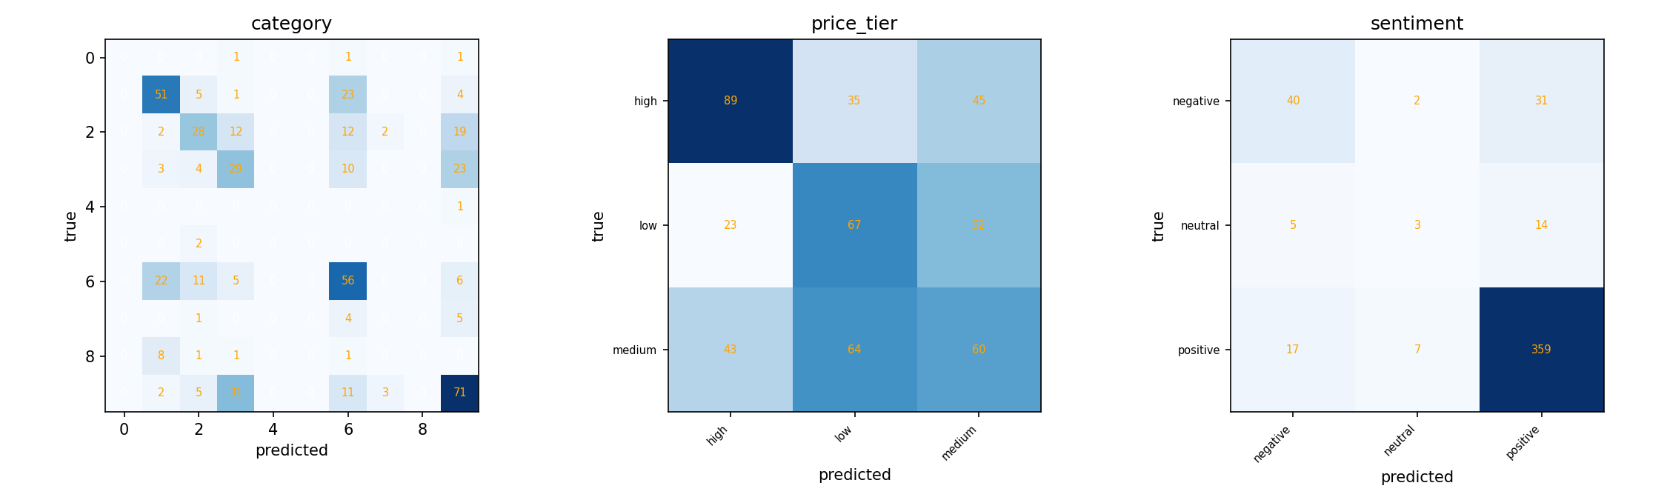
Figure 6. MTL confusion matrices on the test split (original label space).
Error analysis. Under the original category-label space, category macro-F1 is low for all models, although MTL (0.248) exceeds logistic regression (0.190). Under the grouped label space, logistic regression reaches 0.410 macro-F1 versus 0.344 for MTL, so the ranking reverses when rare categories are grouped. Price tier is the weakest task overall: review text carries limited reliable price signal. Sentiment is the strongest task for MTL, which exceeds the majority-class baseline in macro-F1; the small neutral class still affects macro-averaged metrics.
Task-level verdict from the actual test metrics: sentiment improves under joint learning (original-label MTL macro-F1 0.5605 vs logistic regression 0.4691; grouped-label MTL 0.563 vs logistic regression 0.469). Price-tier performance is lower for MTL in both experiments (original labels 0.4516 vs 0.4724; grouped labels 0.443 vs 0.472). Category performance depends on label space: MTL is higher under original labels (0.2482 vs 0.1895), while logistic regression is higher after grouping rare categories (0.410 vs 0.344). Overall, results do not support a claim that multi-task learning is uniformly superior; the observed benefit is task- and label-space-specific.

7. Stage 2: Independent and Shared Transformer Experiments
Stage 2 uses pretrained distilbert-base-uncased. Stage 2A fine-tunes three independent models, one each for category, price tier (low/medium/high), and rating-derived sentiment. Stage 2B fine-tunes one shared DistilBERT encoder with three task-specific classification heads and a combined loss. Training uses three epochs, sequence length 128, batch size 8, and learning rate 2e-5. The independent models select their checkpoints using validation macro-F1 for the corresponding task; the shared model uses validation mean macro-F1.
Both approaches reuse the processed sample and product-grouped train/validation/test split, apply the same leakage-safe grouped-category label space, and use the same text fields. The test set is evaluated after checkpoint selection. Reported metrics below are from the notebook outputs; all macro-F1 values are computed on the held-out test split.
Results: both Stage 2 training paths completed. Independent DistilBERT achieved test macro-F1 of 0.4232 for category, 0.5039 for price tier, and 0.7134 for sentiment. Shared DistilBERT achieved 0.4236, 0.4285, and 0.5634 respectively. The shared model is effectively tied with the independent model on category, while independent fine-tuning performs better on price tier and sentiment.
Task | Model | Accuracy | Macro precision | Macro recall | Macro-F1 | Train time (s)
Category | TF-IDF + Logistic Regression | 0.5774 | 0.4326 | 0.4151 | 0.4097 | 0.50
Category | Shared TF-IDF MTL | 0.4833 | 0.3374 | 0.3529 | 0.3440 | 2.57
Category | Independent DistilBERT | 0.5962 | 0.4242 | 0.4324 | 0.4232 | 53.65
Category | Shared DistilBERT MTL | 0.5879 | 0.4152 | 0.4347 | 0.4236 | 53.64
Price tier | TF-IDF + Logistic Regression | 0.4791 | 0.4707 | 0.4764 | 0.4724 | 0.25
Price tier | Shared TF-IDF MTL | 0.4456 | 0.4435 | 0.4434 | 0.4434 | 2.57
Price tier | Independent DistilBERT | 0.5146 | 0.5069 | 0.5157 | 0.5039 | 53.25
Price tier | Shared DistilBERT MTL | 0.4561 | 0.4450 | 0.4599 | 0.4285 | 53.64
Sentiment | TF-IDF + Logistic Regression | 0.8494 | 0.5708 | 0.4457 | 0.4691 | 0.17
Sentiment | Shared TF-IDF MTL | 0.8556 | 0.6314 | 0.5282 | 0.5629 | 2.57
Sentiment | Independent DistilBERT | 0.9121 | 0.7449 | 0.6896 | 0.7134 | 53.47
Sentiment | Shared DistilBERT MTL | 0.8870 | 0.5329 | 0.6056 | 0.5634 | 53.64
Table 3. Test-set comparison under the grouped category-label space.
Interpretation. Independent DistilBERT gives the highest macro-F1 for price tier (0.5039) and sentiment (0.7134). For category, independent and shared DistilBERT are nearly tied (0.4232 vs 0.4236); the shared model improves by only 0.0004 macro-F1, which should not be treated as a meaningful difference without repeated-seed evaluation. Sharing reduces duplicated encoders, but the observed task-level results do not establish uniform predictive superiority.
Table 3 compares the transformer models with the traditional and shared TF-IDF baselines under the grouped category-label experiment. The primary metric is macro-F1 because the labels are imbalanced; accuracy, macro precision, macro recall, and training time are also reported. The notebook records about 53.6 seconds for the shared model and about 53 seconds per independent model; three independent runs therefore require roughly three times the training time of the shared run, although timing is hardware- and run-dependent.
The comparison uses the same product-grouped split and permitted text fields. Sentiment remains a rating-derived proxy, and price-tier prediction remains a text-only inference task. The limited sample size, long-tailed category distribution, and single experimental run constrain generalization; future work should test multiple seeds, tune task-loss weights, and evaluate on a larger sample.

9. Conclusion
We built a product-grouped pipeline, performed EDA and chi-square tests, and compared traditional ML, shared TF-IDF multi-task learning, independent fine-tuned DistilBERT models, and a shared DistilBERT model. Transformer fine-tuning improved category macro-F1 modestly and improved price-tier and sentiment macro-F1 most clearly when trained independently. The shared transformer remained competitive on category but underperformed the independent model on price tier and sentiment. These results do not support the claim that shared multi-task learning is uniformly superior; instead, they show task-dependent trade-offs between sharing and task-specific fine-tuning. The sample is small and imbalanced, sentiment is rating-derived, and price tier is inferred from text alone, so findings should be interpreted as exploratory.
Sanh, V., Debut, L., Chaumond, J., & Wolf, T. (2019). DistilBERT, a distilled version of BERT: smaller, faster, cheaper and lighter. arXiv:1910.01108.

10. References
Hou, Y., et al. (2024). Amazon Reviews 2023. arXiv:2403.03952. URL: https://huggingface.co/datasets/McAuley-Lab/Amazon-Reviews-2023
Pedregosa, F., et al. (2011). Scikit-learn: Machine Learning in Python. JMLR 12.
Paszke, A., et al. (2019). PyTorch: An Imperative Style, High-Performance Deep Learning Library. NeurIPS.
Vitter, J. S. (1985). Random sampling with a reservoir. ACM TOMS 11(1).

