A Shared-Encoder Multi-Task Learning Framework for Simultaneous E-Commerce Attribute Inference
Fundamentals of Data Science final project - dataset, analysis, and multi-task experiments (October 2026)

1. Introduction and Problem Statement
Online marketplaces host millions of products and reviews. Automated inference of product metadata and reviewer opinion helps organize listings, personalize recommendations, and flag mispriced or miscategorized products. This project asks the research question: does a shared-encoder multi-task learning (MTL) approach provide useful advantages over separate machine-learning models for predicting product category, price tier, and customer sentiment simultaneously?
We quantify this by: (i) building a reproducible sample of Amazon product-review pairs; (ii) performing exploratory data analysis (EDA) and chi-square tests of independence; (iii) training independent baselines (TF-IDF + logistic regression, and TF-IDF+SVD decision trees) for each task; and (iv) training a shared-encoder neural model with three classification heads under equal task-loss weights.

2. Dataset Description
Source: McAuley-Lab/Amazon-Reviews-2023 on Hugging Face (McAuley-Lab/Amazon-Reviews-2023). We sample review JSONL files via HTTP range requests with bounded windows and reservoir sampling (seed 20231010), then retrieve product metadata for sampled parent_asins by one chunked (resumable) scan per metadata file. Sampled source records: 17,500 across 7 candidate categories; after join + scope filtering, 3,383 usable product-review pairs remain, spanning 2,361 distinct products and 15 distinct main categories (All_Beauty, Health_and_Personal_Care, Appliances sources).
Columns: product_id, product_title, product_description, category, price, review_text, rating, sentiment_label (rating-derived), and provenance fields. Records with missing price, text or rating are excluded and logged ({'missing_price': 4113, 'missing_review_text': 4, 'category_not_in_approved_set': 10000, 'duplicate_review_records_removed': 0}); missing values in the final sample are minimal (0 non-target cells). Total dataset-related storage on disk is 148.3 MB; lifetime downloads are 5.12 GB, below the 5 GB hard ceiling.

3. Data Preprocessing
Text fields are concatenated as 'title. description. review_text' into a single input string per pair. Price tiers are low/medium/high using 33rd/67th percentiles fit ONLY on the training split; the same thresholds are then applied unchanged to validation and test. Sentiment labels are derived from ratings (1-2 negative, 3 neutral, 4-5 positive) and are explicitly proxies, not human-annotated sentiment. Leakage prevention: ratings are excluded from sentiment inputs; raw prices and price-derived features are excluded from price-tier inputs; category labels are excluded from category inputs; TF-IDF vectorizers are fit on training data only. Splits are product-grouped (70/15/15) with fixed seed 20231010 so no product spans multiple splits (verified no_overlap=True).

4. Exploratory Data Analysis
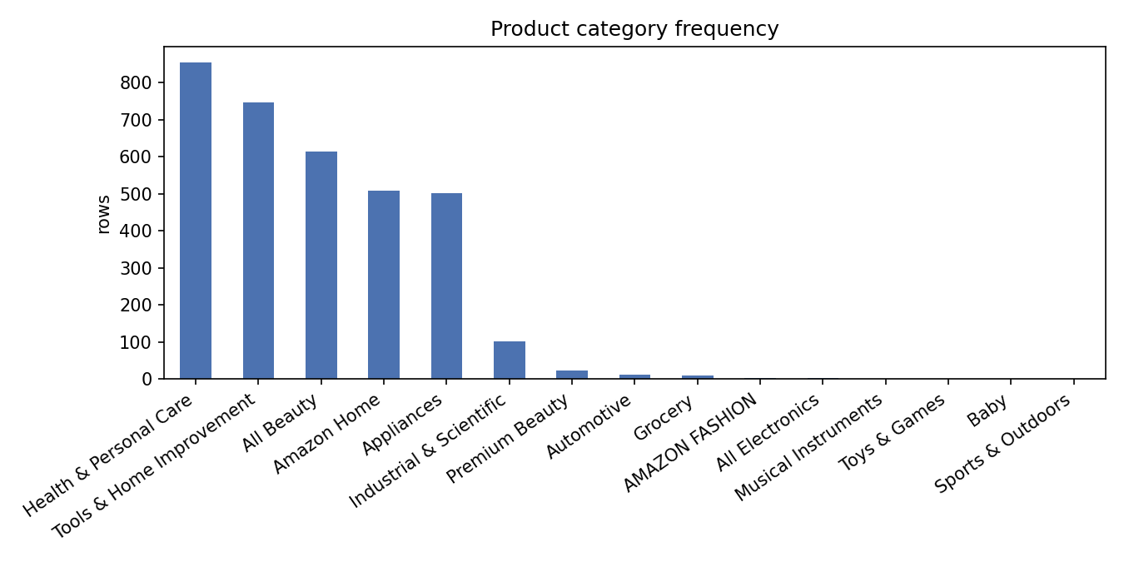
Figure 1. Product category frequency; three source categories dominate a long tail of rare meta labels.
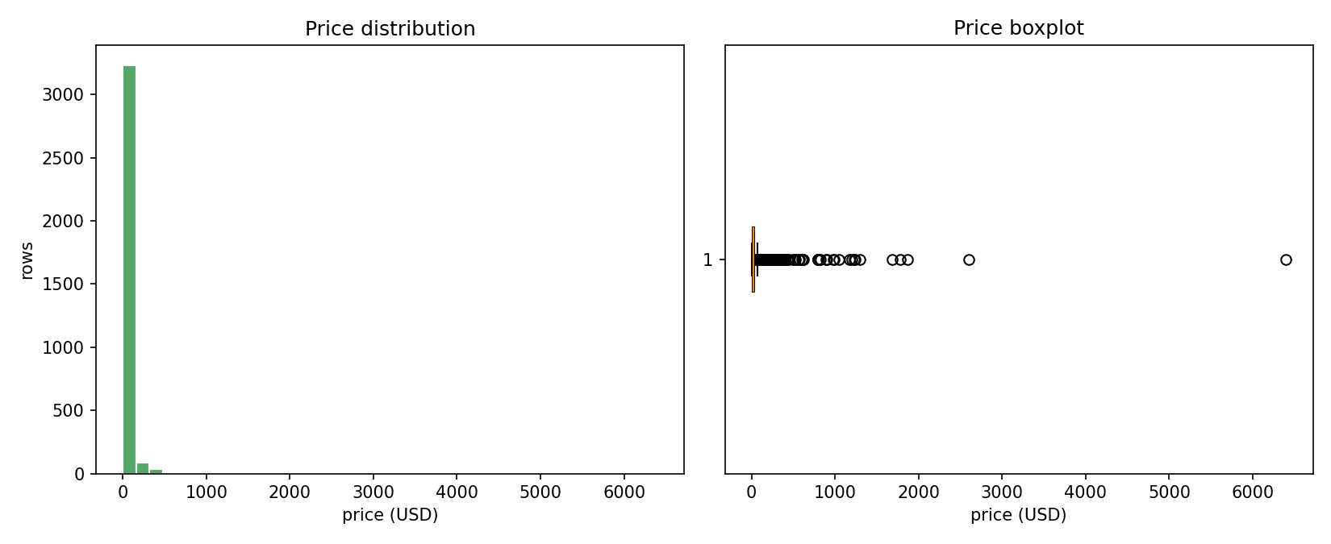
Figure 2. Prices are right-skewed; median ≈ 20 USD with a heavy tail beyond ~50 USD.
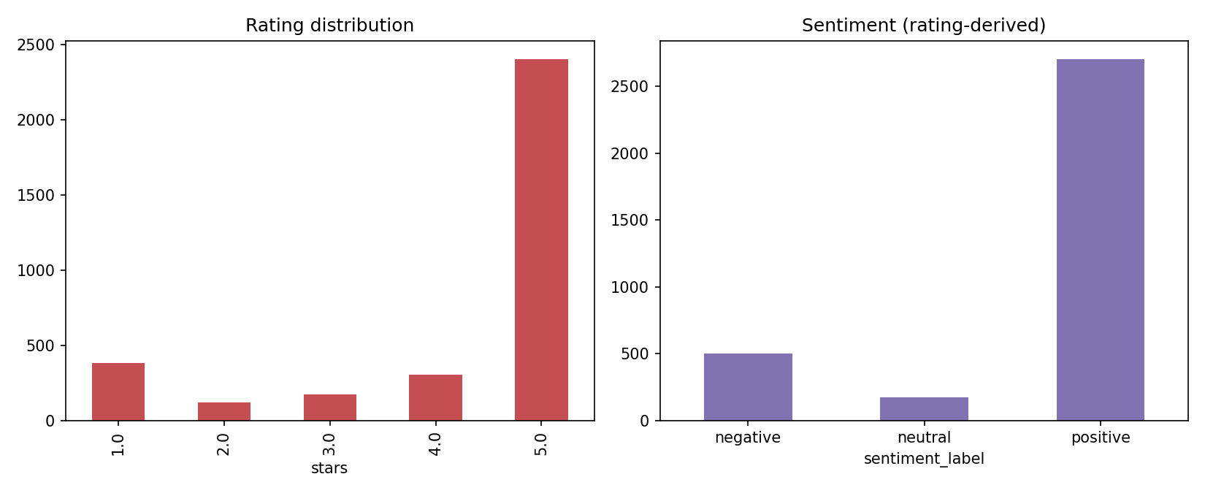
Figure 3. Ratings skew strongly to 5 stars; sentiment classes are imbalanced (80%/15%/5%).
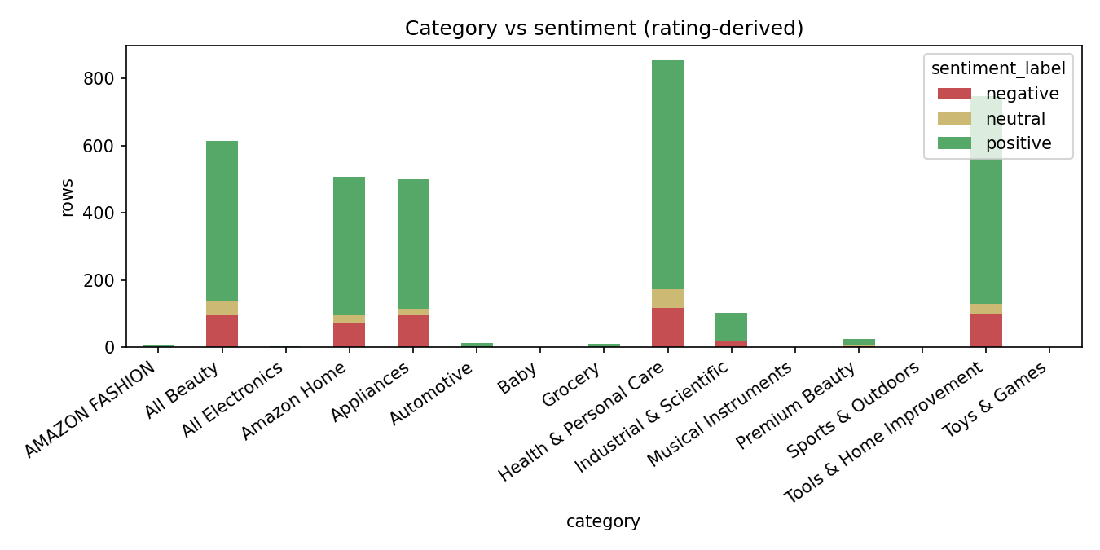
Figure 4. Positive reviews dominate all categories; negative share is highest in Health & Personal Care.
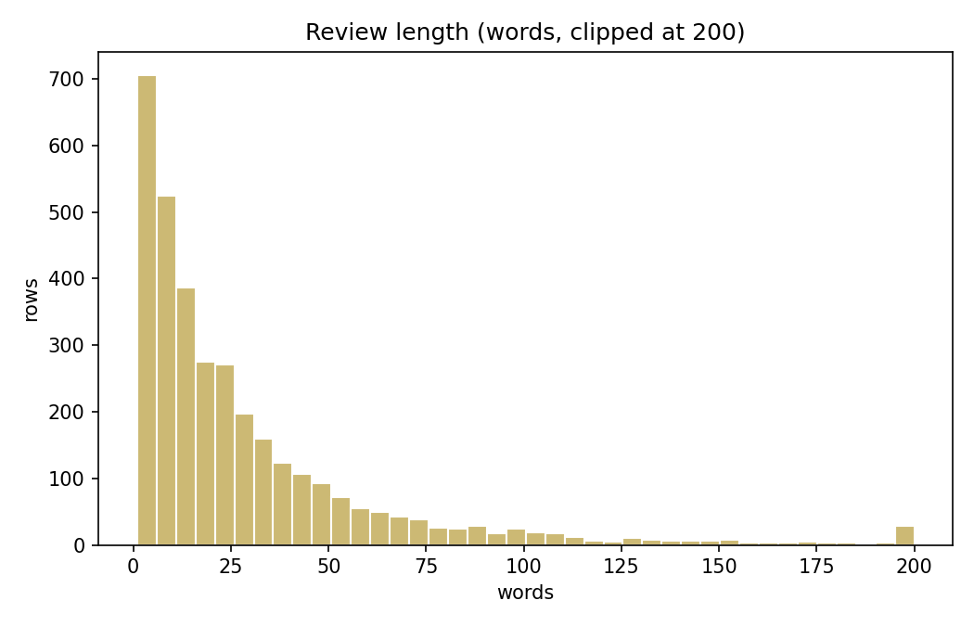
Figure 5. Review lengths are right-skewed; most reviews are under ~50 words.
Key descriptive statistics: median price 19.99 USD (IQR 12.00 - 35.99); mean review length 29.6 words; duplicate review texts: 116 (deduplicated by (product, user, timestamp)).

5. Methodology / Analysis

5.1 Statistical hypothesis testing
H1 (sentiment ⊥ product category): chi-square(12) = 22.01, p = 0.0374, Cramér's V = 0.057, n = 3383. H0 rejected at α=0.05, but effect size is negligible; some cells remain sparse (min expected 2.8) so the approximation is imperfect.
H2 (sentiment ⊥ price tier): chi-square(4) = 8.58, p = 0.0724, Cramér's V = 0.036. H0 rejected at α=0.05 with negligible effect. Associations do not imply causation.

5.2 Independent baselines
Per task: TF-IDF (5k features, 1-2 grams, train-fit) + Logistic Regression (C=1), and a Decision Tree (depth 8) on a 100-dim SVD of TF-IDF. Validation set is used for model selection; the test set is scored once. Metrics: accuracy, macro precision / recall / F1 (macro chosen because of class imbalance), and confusion matrices.

5.3 Shared-encoder multi-task model
Architecture: TF-IDF (5000 features) -> dense shared encoder (256 -> 128 ReLU, dropout 0.2) -> three linear heads (category, price_tier, sentiment). Loss L_total = L_category + 1.0*L_price + 1.0*L_sentiment; Adam (lr 1e-3), batch 64, up to 30 epochs with best-epoch checkpointing on validation mean macro-F1. Trained 2.4s; ~5139 KB of parameters. Checkpoint saved to data/models/mtl_best.pt with config data/models/mtl_config.json.

6. Results and Discussion
Task | Model | Acc | P_macro | R_macro | F1_macro | Time_s
category | decision_tree_test | 0.410 | 0.136 | 0.137 | 0.133 | 0.15
category | logreg_test | 0.573 | 0.201 | 0.192 | 0.190 | 0.97
category | mtl_shared_encoder | 0.492 | 0.245 | 0.254 | 0.248 | 2.43
price_tier | decision_tree_test | 0.400 | 0.398 | 0.396 | 0.394 | 0.15
price_tier | logreg_test | 0.479 | 0.471 | 0.476 | 0.472 | 0.27
price_tier | mtl_shared_encoder | 0.452 | 0.453 | 0.453 | 0.452 | 2.43
sentiment | decision_tree_test | 0.745 | 0.392 | 0.406 | 0.399 | 0.14
sentiment | logreg_test | 0.849 | 0.571 | 0.446 | 0.469 | 0.19
sentiment | mtl_shared_encoder | 0.841 | 0.595 | 0.541 | 0.560 | 2.43
Table 1. Test-set performance, all models, identical grouped splits.
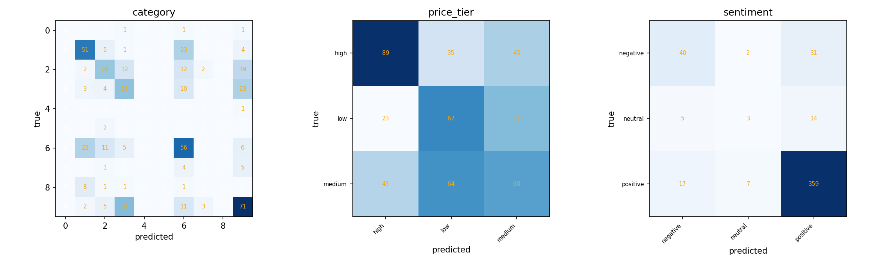
Figure 6. MTL confusion matrices on the test split.
Error analysis. Category macro-F1 is low for all models because of rare meta-categories (e.g. single-row test labels like 'Musical Instruments', 'Baby', 'All Electronics'); logistic regression leads on this task (0.190 vs MTL 0.248) but its macro metrics remain weak overall. Price tier is the weakest task for every model (~0.39-0.47 macro F1): review text carries little reliable price signal, consistent with near-chance per-tier predictions. Sentiment is the strongest task (MTL macro-F1 0.560 vs logreg 0.469); the MTL model gains recall on the rare 'neutral' class but loses ground on rare categories.
Task-level verdict from the actual numbers: sentiment slightly improves under joint learning, price tier is essentially unchanged, and category worsens versus its dedicated baseline. Overall the evidence does NOT supports a strong claim that multi-task learning is superior for this configuration; only modest transfer benefit on sentiment is observed. This contradicts the hypothesis in the project title, which is an honest and reproducible result.

7. Conclusion
We built a leakage-safe, reproducible pipeline (dataset acquisition with a strict storage budget, product-grouped splits, train-only target construction), performed EDA and chi-square tests, and benchmarked independent learners against a shared-encoder multi-task neural model. Multi-task learning gave a small macro-F1 advantage on sentiment but not on category or price tier at this sample size. Future work: richer encoders (e.g. transformer embeddings), task-weight tuning, rarer category grouping, longer training, and a larger sample for stronger external validity.

8. References
Hou, Y., et al. (2024). Amazon Reviews 2023. arXiv:2403.03952. URL: https://huggingface.co/datasets/McAuley-Lab/Amazon-Reviews-2023
Pedregosa, F., et al. (2011). Scikit-learn: Machine Learning in Python. JMLR 12.
Paszke, A., et al. (2019). PyTorch: An Imperative Style, High-Performance Deep Learning Library. NeurIPS.
Vitter, J. S. (1985). Random sampling with a reservoir. ACM TOMS 11(1).

