Data Mining

Group B

Karate data set (5 clusters)

For my implementation the density-connected tree is not equal every time I generate it.

Between 1 and 3 edges/links are different so the Theorem 1 does not apply her.

Football data set (12 clusters)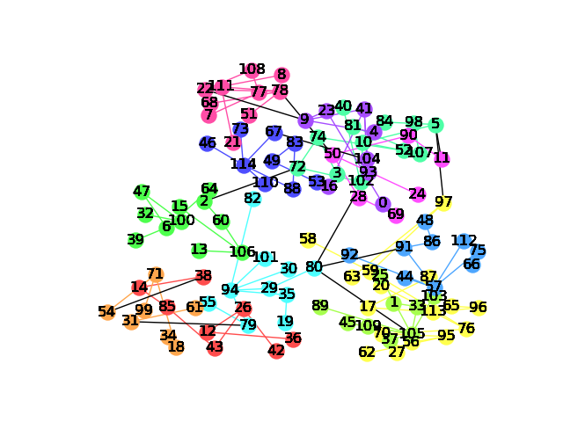

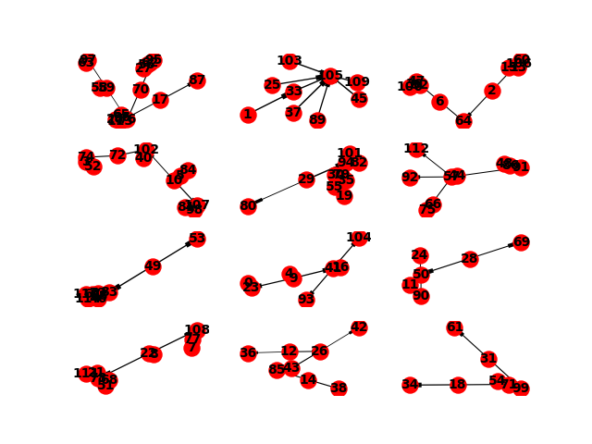

Yeast data set (12 clusters)

The calculated scores were:

* Purity: 0.27113309352517984
* Mutal info: 0.0418213312274
* Rand: 0.020142438188