Functional Specification

Year: 2021 Semester: Fall Team: #6 Project: RevEx

Creation Date: August 30, 2021 Last Modified: August 31, 2021

Team Members (#1 is Team Leader):

Member 1: Matthew Rumple Email: rumple0@purdue.edu

Member 2: Isaac Hagedorn Email: ihagedo@purdue.edu

Member 3: Zach Ghera Email: zghera@purdue.edu

Member 4: Swagat Bhattacharyya Email: bhatta21@purdue.edu

Assignment Evaluation:

|  |  |  |  |  |
| --- | --- | --- | --- | --- |
| **Item** | **Score (0-5)** | **Weight** | **Points** | **Notes** |
| **Assignment-Specific Items** | | | | |
| **Functional Description** |  | x3 |  |  |
| **Theory of Operation** |  | x3 |  |  |
| **Expected Usage Case** |  | x3 |  |  |
| **Design Constraints** |  | x3 |  |  |
| **Writing-Specific Items** | | | | |
| **Spelling and Grammar** |  | x2 |  |  |
| **Formatting and Citations** |  | x1 |  |  |
| **Figures and Graphs** |  | x2 |  |  |
| **Technical Writing Style** |  | x3 |  |  |
| **Total Score** |  | | |  |

5: Excellent 4: Good 3: Acceptable 2: Poor 1: Very Poor 0: Not attempted

General Comments:

1.0 Functional Description

Immersive virtual reality (VR) is the focus of a current engineering grand challenge: Enhance Virtual Reality. Beyond recreation, VR simulations are becoming increasingly important for occupational training, especially in remote or high-risk occupations. VR simulations usually allow the user to interact with virtual objects via camera-based appendage tracking, which is generally imprecise and has positional jitter. Hence, there is a need to more accurately track a user’s appendages for a more realistic simulation of the user’s motions in a virtual environment. Haptic feedback in virtual reality has countless applications in the future from training for many hands-on occupations to gaming with realistic environmental feedback; however, more current VR simulations do not provide enough haptic feedback and preexisting VR simulators with haptic feedback are overly expensive and too bulky to allow fluid movement.

RevEx is a non-optical virtual reality (VR) input device with haptic feedback that creates a more immersive VR experience. The system is composed of a low-power wearable device that collects and relays sensor data to a host computer. The host computer will run a simulation that allows the user to interact with objects in VR. Various actions the user performs in VR (e.g. lifting, pushing, etc. an object), will trigger haptic feedback (passive resistance) at the user’s joint(s).

2.0 Theory of Operation

RevEx is a wearable system mounted to user’s joints (with the main node attached to an elbow joint). RevEx uses an inertial measurement unit (IMU) attached to the upper arm, which contains an accelerometer and gyroscope, as well as a potentiometer attached to the rotating elbow joint to estimate arm orientation. The raw sensor data will be transmitted to a host computer via Bluetooth low energy (BLE). A complementary filter [3] algorithm on the host computer will use accelerometer and gyroscope data to accurately estimate the roll, pitch, and yaw of the IMU; the complementary filter uses gyroscope data for rapid orientation updates while correcting for integration drift using a gravity vector estimate from the accelerometer. The angle between the user’s upper arm and forearm can be inferred from the potentiometer on the rotating elbow joint.

On the host computer, information of the user’s appendage lengths collected during a calibration can be used to determine the position and orientation of the user’s upper arm and forearm relative to the shoulder joint in a VR simulation. Haptic feedback generated in the VR simulation (Eg. as a result of a collision in the simulation) is mapped to a “duty cycle” and transmitted to the wearable via BLE. This “duty cycle” is used to modulate solid-state relays that short the coils of a motor connected to the elbow joint via a gear reduction system. When the coils of a permanent magnet motor are shorted, the motor can act as an electronically-controlled rotary dashpot; this dampening effect is leveraged to deliver haptic feedback to the user. The braking torque generated by a bipolar stepper motor (the derivation is based off state equations given in [2]) when the coils are shorted with duty cycle $D$ is given in the Laplace Domain by: $τ_{m}(s)=β(sθ)$, where $β≈b+\frac{{k_{m}}^{2}}{{sL+((R}_{Phase}+R_{On})/D)}$, $θ$ denotes the rotation angle, *b* denotes the inherent (open-circuit) viscous damping, $k_{m}$ denotes the motor torque constant, *L* denotes the phase inductance of the motor (can usually be neglected for light-weight motors), and $R_{Phase}$ denotes the phase resistance of the motor, and $R_{On}$ denotes the on resistance of the solid-state relays. A preliminary test demonstrated that Team 6 could successfully modulate $β$ over an order of magnitude (Fig. 1).

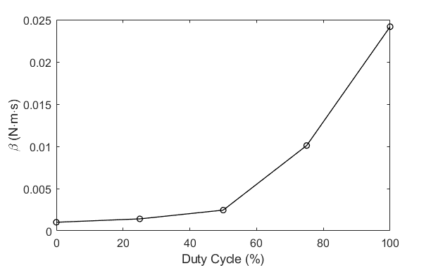

**Fig. 1:** Experimentally measured viscous damping coefficient $β$ vs. duty cycle *D* for a low-profile bipolar stepper motor (the plot is not as linear as is suggested by the derivation)

RevEx is a low-power system, with target maximum power draws of 10 mW during data transmission and 1 mW when the user is not moving. The residual back EMF of the motor (present when coils are not shorted) is harvested to recharge the battery using a commercial energy harvesting chip. An impedance is utilized before the energy harvesting chip to ensure that the torque induced by passive energy harvesting stays below the human perceptual threshold. If the user has not moved for some time, the microcontroller, IMU, and bluetooth module are put into low-power modes. These devices can be awoken via interrupts generated by (i) a significant motion detection by the IMU (ii) a signal on the I2C bus (iii) a transient signal detection by a low-power analog event detector. The low-power analog event detector is a sub-milliwatt mixed-signal circuit with two analog input channels that generates a digital pulse when any of the input channels has a significant transient. In this way, the analog event detector can be paired with a wide variety of sensors including potentiometers, flex sensors, and electromyograms. RevEx is inherently modular, so the user can attach additional sensing nodes if he or she wishes (Eg. a glove unit or another elbow joint); these additional nodes can communicate to the master node via the I2C protocol.

3.0 Expected Usage Case

RevEx will be used in occupational training as a non-optical virtual reality (VR) input device with haptic feedback. There are two components of the RevEx system: a wearable “exoskeleton” that will clamp to the user’s arms as well as a host computer that runs an executable containing the VR simulation. The wearable portion of the system should comfortably fit all users and should be able to function for all typical human body movements. This product is intended to be used by employees in roles that require occupational training. Thus, the user should not be expected to have any technical skills or literacy other than familiarity with virtual reality.

4.0 Design Constraints

4.1 Computational Constraints

The primary computational functions of RevEx include:

* Read in IMU and potentiometer sensor data
* Package sensor data and send packets to host (via Bluetooth)
* Sensor fusion to estimate arm position (orientation relative to VR headset)
* VR simulation to interact with virtual objects
* Calculating haptic feedback information based on VR interactions
* Packaging haptic feedback information and send controls to the MCU (via Bluetooth)
* Applying haptic feedback controls to motors

With regards to memory, the MCU simply needs to store the sensor packet information in RAM. Since most of the computation will be taken care of on a host computer, there should be little to no memory constraints for this Revex.

The primary timing constraint will be the frequency that the MCU and host send and receive packets over Bluetooth. Since the VR simulation can run at a maximum of 90 Hz, the plan is to tranceive packets at 100Hz.

4.2 Electronics Constraints

For this project Team 6 will be using low powered microcontrollers to drive an IMU, a potentiometer, a stepper motor, and bluetooth low energy. The microcontroller will likely communicate with the IMU via I2C and will receive inputs from a built-in accelerometer and gyroscope. The potentiometer will likely communicate over GPIO inputs and be converted through an ADC for transmission as a packet over the bluetooth communication. As a result, the potentiometer could use up several pins and cause a constraint on the pins available for other peripherals. The microcontroller will drive the passive breaking using PWM, and it will communicate with the bluetooth chip using UART.

One early constraint from the team’s design choice is the low powered constraint and the other constraints it carries with it. Most of the system will operate at 1.8 V and will require efficient or nonexistent computation on the microcontroller to maintain a low power usage. Another constraint is the sampling frequency for location and the storage of past data points. These will need to be appropriate to match the internal clock rate and the total RAM available. Additionally, since this data will be supporting a virtual reality environment, other constraints such as latency and location of computations will be important constraints to consider.

Both the IMU and microcontroller will need to be mounted on a brace that the user wears around their elbow. This will require secure, comfortable packaging to protect these devices and the user. Additionally, a battery pack and the bluetooth chip could be in multiple different locations and will require their own packaging. The constraints for the battery and Bluetooth include the usage of wires to communicate with brace and feasibility of communicating over those wires.

The final electronics constraint which the team has encountered multiple times to date is the silicon shortage and the backlog of parts available to the public. Availability of chips and devices will be a major constraint for this project.

4.3 Thermal/Power Constraints

The power and thermal constraints of the system are relatively easy to determine based on the nature of the system being a wearable and a controller for a simulation. Due to these two facts, the overall device temperature should strive to stay below 45 C, based on a study conducted in 2007 [1]. This study found that any plastic handheld device is no longer comfortable to hold once its exterior temperature exceeds 45 C. The plastic specification was used because a large majority of the system will be 3D printed PLA. The system will be extremely low power, the main source of heat will come from energy dissipation from the passive haptic feedback. Most of this energy will be dissipated as heat through the motor, which will act as a passive heat sink for the system.

A standard timeframe for usage of occupational training devices would be an average workday, so the device is expected to perform nominally for at least 8 hours of use. Additional methods of energy scavenging, and conservation may be used to increase the time in between charges even more. This will allow the device to be used for a whole day on a single charge.

4.4 Mechanical Constraints

Thesystem is a wearable controller that will be worn during a VR simulation. Therefore, it must be appropriately sized to be mounted to a user’s arm. It must also not pose a serious obstacle in terms of weight while being worn. Any overall weight over 5 pounds would not be acceptable. This will allow the system to be portable and low profile, complimenting the current style of Virtual Reality devices, such as controllers and headsets. Since this device will be worn on the elbow, it is prone to falling from that approximate height. Therefore, it will be important for the system to be able to survive a drop test of around 4 feet to include a safety factor. Most of the packaging will be fabricated from PLA and 3D printing. This will allow the packaging to be durable but flexible enough that it won’t be brittle. Any parts under mechanical load may be made from more exotic materials, such as Onyx filament or metal.

The packaging of the device will help seal it from any serious dust problems, while also providing a safe interface for the user, enclosing any sections that may be considered a pinch point. Overall, this system will also be subjected to a similar environment that normal Virtual Reality equipment is subjected to, which means that it will not need to be waterproof.

4.5 Economic Constraints

RevEx should be a low-cost alternative to optical tracking devices commonly found in Virtual Reality. The standard VR controllers that provide limited feedback and tracking that is prone to occlusion typically sell for $69 from Oculus directly. The system being created should strive to stay very close to that price point. Since the system is not mass produced and offers some additional benefits, keeping it under $100 should be an acceptable margin. A separate competing hardware called Anti-Latency uses IR LED’s and RF communication to transmit position and rotation of a sensor to a computer cost upwards of $600, which is not viable for any consumer buyers, let alone for large-scale purchasing for large companies to transition to Virtual occupational training.

5.0 Sources Cited:

[1] Berhe, Mulugeta. (2007). Ergonomic Temperature Limits for Handheld Electronic Devices.

10.1115/IPACK2007-33873. ([Ergonomic Temperature Limits for Handheld Electronic Devices (researchgate.net)](https://www.researchgate.net/publication/267597664_Ergonomic_Temperature_Limits_for_Handheld_Electronic_Devices))

[2] M. Bodson and J. Chiasson, "Application of nonlinear control methods to the positioning of a permanent magnet stepper motor," Proceedings of the 28th IEEE Conference on Decision and Control,, 1989, pp. 531-532 vol.1, doi: 10.1109/CDC.1989.70170. (<https://ieeexplore-ieee-org.ezproxy.lib.purdue.edu/stamp/stamp.jsp?tp=&arnumber=70170&tag=1>)

[3] S. Colton, “The balance filter,” *Presentation, Massachusetts Institute of Technology*, 2007. ([ourdev_665531S2JZG6.pdf (amobbs.com)](https://d1.amobbs.com/bbs_upload782111/files_44/ourdev_665531S2JZG6.pdf))

Appendix 1: Functional Block Diagram

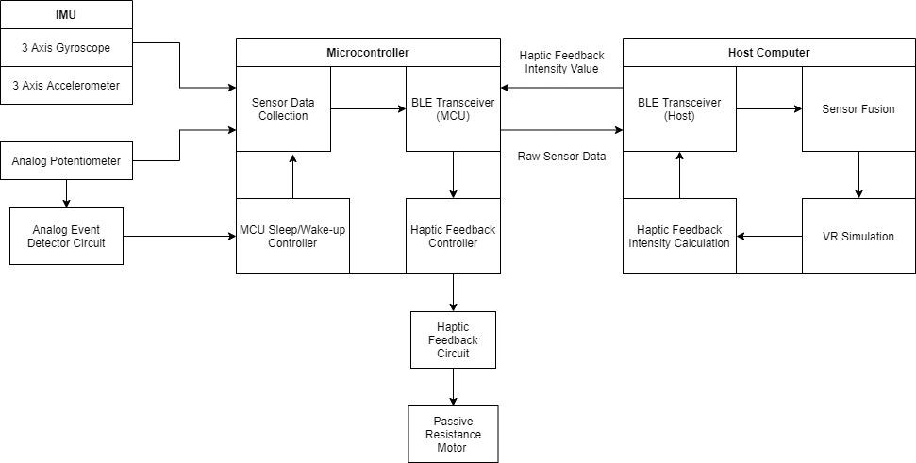

Appendix 2: Sketch of Project Prototype

