Electrical Overview

Year: 2021 Semester: Fall Team: 6 Project:RevEx

Creation Date: 09/11/2021 Last Modified: September 17, 2020

Author: Swagat Bhattacharyya Email: bhatta21@purdue.edu

Assignment Evaluation:

|  |  |  |  |  |
| --- | --- | --- | --- | --- |
| **Item** | **Score (0-5)** | **Weight** | **Points** | **Notes** |
| **Assignment-Specific Items** | | | | |
| **Electrical Overview** |  | x3 |  |  |
| **Electrical Considerations** |  | x3 |  |  |
| **Interface Considerations** |  | x3 |  |  |
| **System Block Diagram** |  | x3 |  |  |
| **Writing-Specific Items** | | | | |
| **Spelling and Grammar** |  | x2 |  |  |
| **Formatting and Citations** |  | x1 |  |  |
| **Figures and Graphs** |  | x2 |  |  |
| **Technical Writing Style** |  | x3 |  |  |
| **Total Score** |  | | |  |

5: Excellent 4: Good 3: Acceptable 2: Poor 1: Very Poor 0: Not attempted

General Comments:

*Relevant overall comments about the paper will be included here*

1.0 Electrical Overview

Our project, RevEx, consists of a bluetooth-compatible, wearable sensing device that can be mounted on a user’s arm and a host computer that processes the data from the wearable. The host computer accurately renders the user’s arm in a virtual scene and determines the amount of haptic feedback to be delivered. The proposed system is used in conjunction with a commercially-available VR headset for a more comprehensive user experience. The scope of this document is the electrical systems contained in our custom wearable sensing device.

The signal flow among the subsystems of RevEx is shown in Fig. 1. The wearable device is a multi-node system with nodes sharing an I2C bus and “raw” power lines[1]. Each node consists of at least one PCB, the Data Acquisition System (DAqS). Furthermore, the elbow joint consists of an additional PCB, the Haptics and Battery-management System (HBmS). The DAqS serves to acquire, preprocess, and transmit the data from the sensors on the wearable and to produce a control signal for the HBmS. The HBmS serves to administer haptic feedback to the user and to provide power to the wearable; hence, the HBmS contains circuits for battery charging, energy harvesting, power source switching, and coarse voltage regulation. There are three reasons for the separate PCBs:

1. **Modularization:** Two PCBs are preferred for space considerations since only one node in the wearable needs the components in the HBmS. Two PCBs may help with electronic isolation (there are a couple switching circuits in the HBmS).
2. **R&D Ease:** PCBs can be individually tested on the benchtop, and emergency revisions may be made on one PCB without affecting the other PCB[2].
3. **Patent Concept:** If not all of RevEx, we would like to separately pursue a patent for the technology in the HBmS[3]. A separate PCB for the HBmS would help gather the necessary characterization data for a patent.

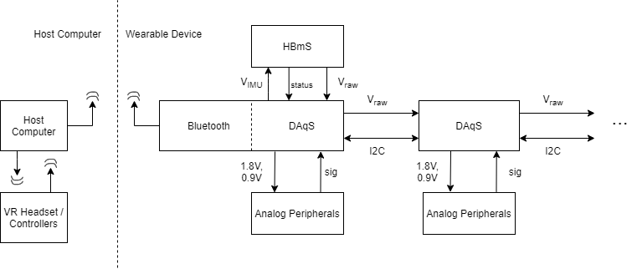

**Fig. 1:** RevEx multinodal signal/energy flow diagram

DAqS PCBs are composed of five major subblocks, as shown in Fig. 2. The objectives and functionalities of each major subblock are as follows:

1. **LDO(s):** Two LDOs are used to generate 1.8 V and 0.9 V for the DAqS subblocks. LDOs are preferred over other regulator topologies because the supply rails require exceptionally-low noise content; these supplies are used to produce voltage references for an ADC and analog circuits with large gain (eg. our event detector design amplifies any ripple in the 0.9 V line by a factor of 50). The 0.9 V line has <0.1 mA current draw; thus, the vast majority of power-conversion losses originate from the 1.8 V LDO, which operates at 70% efficiency (given a 2.5 V input voltage), lowering overall battery life. Nevertheless, the maximum thermal power dissipation (TDP) of the 1.8 V regulator is ~12 mW, which is miniscule.
2. **IMU:** A 9-DOF IMU is used to gather data from which the orientation of the DAqS can be inferred: magnetic field (via a magnetometer), angular acceleration (via a gyroscope), and linear acceleration (via an accelerometer). The IMU and the MCU communicate via a four-wire SPI interface. The IMU is queried for new data at a rate of 100 Hz. Every IMU query returns a tuple of nine 16-bit signed integers. The IMU is configured to output a “wake on motion interrupt” and is put into a low-power mode when the MCU is placed into “deep sleep.” This interrupt signal can be used to wake the MCU.
3. **Analog Filterbank & Event Detector:** The analog filterbank contains passive filters (driven by a voltage buffer) to mitigate ADC aliasing. Lowpass filters with cutoffs at the ADC Nyquist Frequency are expected to be the predominant filter type in the filterbank. Nevertheless, filters can be individually-configured for highpass, lowpass, or bandpass operation by choosing the appropriate passive values (including 0-Ohm shorts and no-connects). The event detector is a mixed-signal circuit that detects a transient on one analog input channel. Transient signals are indicative of an interesting sensor “event”; thus, the event detector is used to wake the MCU from deep sleep mode when an analog transient is detected. The working principle of the event detector is as follows:

* The analog input is passed into a robust highpass filter with a large gain. The highpass filter output rises above or falls below midrail if there is a positive or negative signal transient, respectively.
* The highpass filter output is passed to two comparators, one with a threshold above midrail and another with a threshold below midrail, to determine if there is a signal transient. Comparator thresholds are generated via the forward voltage drop of two matched Schottky diodes.
* The comparator outputs are passed to an OR gate to generate a single wakeup interrupt for the MCU.

The circuits described in this subsection utilize a quad operational amplifier, an instrumentation amplifier, an OR gate, and several passive components (i.e. resistors, capacitors, and diodes). The analog circuits are measured to have a power draw of 1.1 mW, and the event detector is found to have a typical latency of 3 ms between transient signal onset and interrupt generation. Analog inputs can be any voltage signal, given that the signal is confined to the operational amplifier input voltage range and the frequency contents of interest are below the ADC Nyquist rate. The elbow joint will only use a potentiometer as an analog input. Nevertheless, the adaptability of the analog filterbank and event detector opens the possibility for the DAqS PCB to be used for other sensing schemes (such as flex sensors on the user’s wrist).

1. **Bluetooth (Low Energy) Module:** A bluetooth low energy (BLE) module is used to transmit packaged sensor data from the wearable and receive haptic feedback information from the host computer. The BLE module and the MCU communicate via UART. Note that only the master node of the wearable needs a BLE module.
2. **MCU:** A low-power, 32-bit microcontroller unit (MCU) is the core of the DAqS and is used to acquire, package, and relay sensor information. A 12-bit ADC internal to the MCU will be used to acquire analog signals, and the MCU will also manage busses for the following digital interfaces: I2C, SPI, and UART. The MCU will not be performing computationally- intensive operations. Rather, it will perform inexpensive operations like bit masking and table lookup.

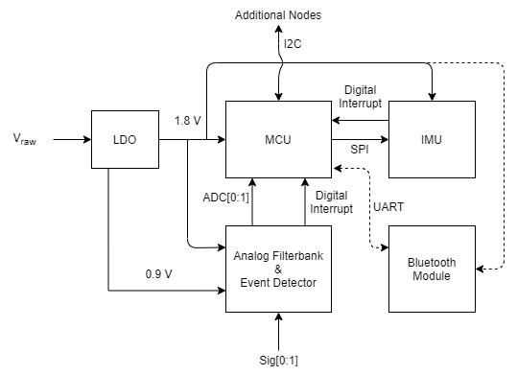

**Fig. 2:** Data Acquisition System (DAqS) signal/energy flow diagram

HBmS PCBs are composed of seven major subblocks, as shown in Fig. 3. The objectives and functionalities of each major subblock are as follows:

1. **Battery:** A 3.7 V lithium polymer (LiPo) battery is used as the primary power source for the wearable. We prefer the LiPo chemistry because it has a good compromise between weight, durability, and safety compared to other battery chemistries.
2. **Battery Charging Circuit:** A commercially-available LiPo charging IC is used to recharge the LiPo from a micro-USB power jack. Initially, we planned to recharge the LiPo via the energy harvesting circuit (there would continue to be an option to charge the device over micro-USB in this design). However, this design has a low efficiency (~60%)[4]. Hence, we do not use the energy harvesting circuit to recharge the LiPo.
3. **Energy Harvesting System:** The energy harvesting system features a commercially- available chip used for energy harvesting from piezoelectric transducers, which are “high voltage” AC sources (just like stepper motors). The energy harvesting system utilizes the residual back-emf of a stepper motor to produce usable DC power. Special care is taken to limit the input current into the chip (piezoelectric transducers are high-impedance sources). The voltage-regulated output of this chip is stored in a supercapacitor for immediate use.
4. **Smart Switch:** A smart switch is used to select the power supply for the system based on which supply has the higher voltage. This simple method facilitates power demand sharing between the LiPo battery and the energy harvesting system.
5. **Bipolar Stepper Motor:** A bipolar stepper motor is used for haptic feedback and energy harvesting. Bipolar stepper motors are inexpensive and produce significant passive haptic feedback even without gear reduction (as demonstrated in our progress reports).
6. **Relays & Driver System:** Two lowpower optoelectronic relays are used to variably-short the two pairs of motor coils, generating haptic feedback. These relays are driven with NPN BJTs; MOSFETs are not used because discrete nFET packages tend to have a high Vds voltage for Id=0.5 mA and Vgs=1.8 V (i.e. the channel resistance tends to be fairly high for the gate voltages we would be supplying). The BJT-based driver circuit is designed to current-starve the relays during operation, which lowers the maximum power draw of the haptic feedback generation system to 2.2 mW but increases the turn-on time of the relays to ~8 ms. The driver is controlled via a PWM signal generated by the MCU. The mean torque felt by the user increases approximately linearly with the PWM duty cycle, and the perceived vibration depends on the PWM signal frequency.
7. **Buck Converter:** A buck-converter is used to step-down the smart switch output from ~3.7 V to ~2.5 V (slightly above the minimum supply voltage of the LDOs). This improves the overall efficiency of the wearable by mitigating LDO losses. Note that the buck converter can be removed from the design without loss of functionality.

Note that special care was taken during parts selection so that no signal level translation would be necessary in the wearable.

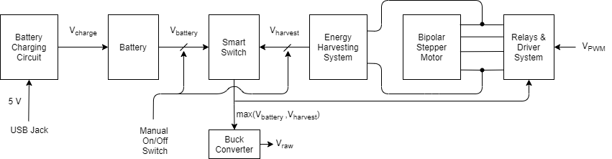

**Fig. 3:** Haptics and Battery-management System (HBmS) signal/energy flow diagram

2.0 Electrical Considerations

To conceptually-support the descriptions and claims in Section 1, we have provided schematics for circuits which have already been validated on a breadboard testbench (Fig. 4).

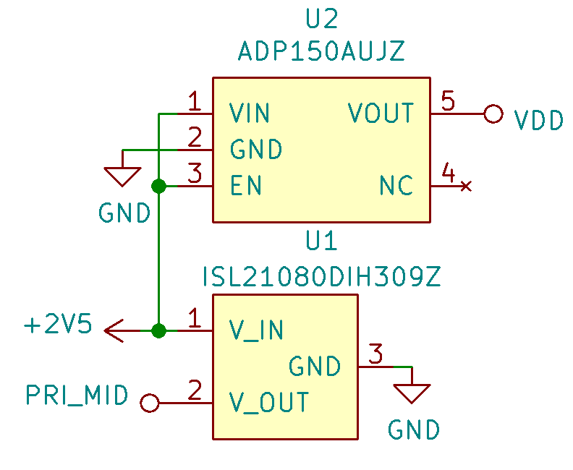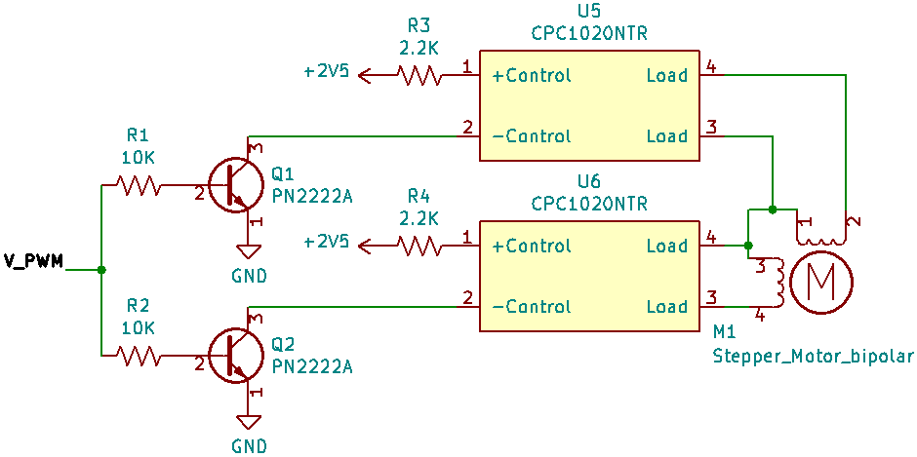

1. (b)

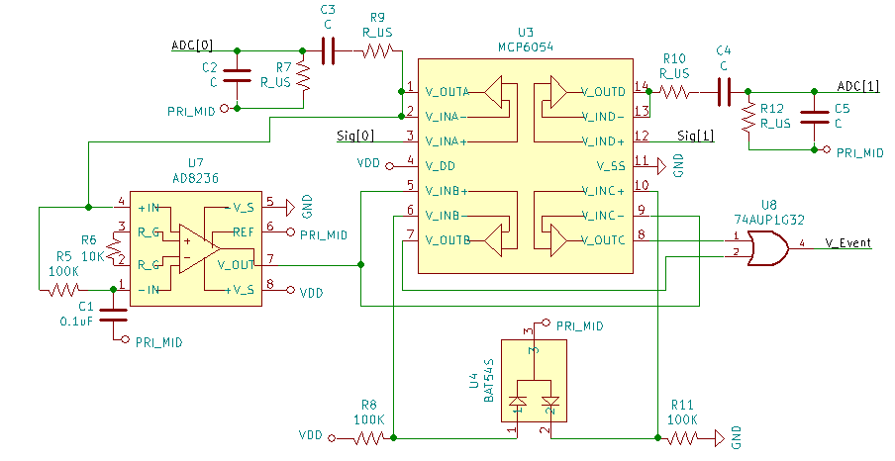

(c)

**Fig. 4:** Schematics of the (a) LDOs (b) relays and driver system (c) analog filterbank and event detector. Decoupling capacitors have been omitted for readability.

There are four main system voltages: 3.7 V, 2.5 V, and 1.8 V. Note that the 0.9 V supply is used as an analog voltage reference by several analog subcircuits but is not used for power; hence, the current draw at the 0.9 V rail is <100 uA. The power draw of the major components on each of the main system voltages are summarized in Table 1. The maximum instantaneous discharge current from the battery is expected to be ~15 mA. Due to power mode cycling, the mean discharge current will be much less than 15 mA (we are currently targeting 5 mA).

**Table 1:** Summary of power requirements at each system voltage level

|  |  |  |  |
| --- | --- | --- | --- |
| System Voltage (V) | Components | Max Current (mA) | Max Power Delivered to Component (mW) |
| 3.7 | LTC4412 [1] | 0.03 | 0.01 |
| Pololu Buck Converter (D24V5F2) [2] | 15.1 | 56.0 |
| 2.5 | ADP150AUJZ [3] | 17.0 | 42.5 |
| ISL21080DIH309Z [4] | 0.1 | 0.25 |
| Relays & Driver Circuits | 0.9 | 2.3 |
| 1.8 | ZB7412-00 [5] | 9.0 | 16.2 |
| STM32L081KZT6 [6] | 4.0 | 7.2 |
| ICM-20948 [7] | 3.1 | 5.6 |
| Analog Filterbank and Event Detector | 0.6 | 1.1 |
| 10 K Potentiometer (EWV-YG9U03B14) [8] | 0.2 | 0.4 |

The meticulous voltage regulation on our wearable makes it difficult for components to exceed their voltage limits, and current limits are usually not a major issue given our low current draw. Nevertheless, the two most sensitive components are contained in the HBmS since they directly interface with power sources:

* The LiPo charger (LTC4071 [9]): This chip uses an external resistor to maintain its input voltage within voltage limits (4.0 V - 4.2 V), but the input current must not exceed 50 mA. We have fixed the external charger voltage to ~5 V, so a sufficiently-large external resistor would ensure that these current limits are not exceeded.
* The energy harvesting chip (LTC3588EMSE [10]): This chip can function from 2.7 VAC to 20 VAC input. There are protective shunts on the inputs to prevent overvoltage; however, the input current and output current of this chip are limited to 25 mA and 100 mA, respectively. Sufficiently-large resistors on the inputs and output would ensure that these current limits are not exceeded.

Note that the LiPo battery (LP402535 [11]) operates from 4.28 V to 3.0 V and a protection circuit on the LP402535 protects against over charge, over discharge, and over current.

The clock frequency of our microcontroller (STM32L081KZT6 [6]) will be 16 MHz (provided via the internal HSI clock reference). Although a bit higher than necessary, a 16 MHz clock provides a balance between computational performance[5] and power draw (which scales linearly with clock speed). A packet (sampling) rate of 100 Hz is adopted for the IMU and ADC since this is the lowest configurable rate on our IMU (ICM-20948 [7]) that is faster than the 90 Hz refresh rate of most commercial VR displays. Although 12-bit precision is sufficient for our application, the ADC can be configured for hardware oversampling (for a higher effective number of bits) if the signal-noise ratios are found to be too low during testing.

Electrical loading issues have been implicitly addressed in the overall design. Microcontroller outputs usually lead to high-impedance CMOS inputs (eg. the IMU and BLE chip), and the GPIO pin supplying the PWM signal to the relay driver needs to supply only 180 uA (~1% of the maximum GPIO output current of the STM32L081KZT6). Similarly, analog sensor signals are first passed to high impedance inputs of the MCP6054 operational amplifiers. The wearable will also draw <10% of the standard discharge rate of the LP402535 battery.

3.0 Interface Considerations

* **MCU to Bluetooth Chip:**

This interface will be using UART to provide an asynchronous full-duplex communication channel. Each time step produces 12, 16-bit packets (9 packets from the IMU, 2 packets from analog sensors, and 1 packet for haptic feedback), leading to a minimum baud rate of 19200:

$$Baud_{min}=pkt*rate*12$$

$$pkt=16 bits, rate=100 Hz, ∴ Baud_{min}=19200 baud$$

Thus, the baud rate for this interface will most likely be a standard 115200 baud, which should easily meet the bluetooth communication constraints while being robust.

* **MCU to Inertial Measurement Unit (IMU):**

This interface will be using SPI as the main communication protocol. This protocol was chosen instead of I2C to establish an exclusive communication interface between the MCU and IMU, improving communication speed. The IMU supports SPI data rates of 7 Mbits/s, and the MCU supports up to 16 Mbits/s. In fact, the SPI rate will likely be slowed to 1 Mbits/s to improve robustness and maintain a lower power consumption.

* **Master Node to Additional Unit Nodes:**

This last interface is optional. In accordance with the team objective, the system is being built to possibly be modular. That means that multiple nodes could be “daisy-chained” to record data from multiple joints simultaneously. Only one bluetooth connection would need to be made to the host computer, meaning other nodes will need to transmit their data to a master node (which contains the bluetooth module). Therefore, there will be an off-board I2C interface to which nodes can connect, allowing for an extension of the scope of the wearable (time-permitting) to encompass additional joints. Due to the long physical length of this interface, the data rate would most likely be 100 kbits/s to help maintain off-board noise reduction.

4.0 Sources Cited:

[1] Linear Technology, “Low Loss PowerPath™ Controller in ThinSOT,” LTC4412 Datasheet, February 2015. [[Datasheet Link](https://www.analog.com/media/en/technical-documentation/data-sheets/4412fb.pdf)]

[2] Pololu, “Pololu 2.5V, 500mA Step-Down Voltage Regulator D24V5F2,” 2841. [[Pololu Link](https://www.pololu.com/product/2841)]

[3] Analog Devices, “Ultralow Noise, 150 mA CMOS Linear Regulator,” ADP150 Datasheet, August 2020. [[Datasheet Link](https://www.analog.com/media/en/technical-documentation/data-sheets/ADP150.pdf)]

[4] Renesas, “300nA NanoPower Voltage References,” ISL21080DIH309Z Datasheet, September 2018. [[Datasheet Link](https://www.renesas.com/us/en/document/dst/isl21080-datasheet)]

[5] ZB7412-00, “Simplelink Bluetooth Low Energy Wireless MCU Module,” ZB7412-00 Datasheet, January 2017. [[Datasheet Link](https://www.mouser.com/datasheet/2/1105/Jorjin_01292021_ZB7412_00-2090115.pdf)]

[6] STMicroelectronics, “STM32L081CB STM32L081CZ STM32L081KZ,” STM32L081KZT Datasheet, November 2019. [[Datasheet Link](https://www.mouser.com/datasheet/2/389/dm00162467-1798373.pdf)]

[7] InvenSense, “World’s Lowest Power 9-Axis MEMS MotionTracking Device,” ICM-20948 Datasheet, June 2017. [[Datasheet Link](https://datasheet.octopart.com/ICM-20948-InvenSense-datasheet-115290367.pdf)]

[8] Panasonic, “44/25 mm Center Space Rotary Potentiometers,” EWV-YG9U04B14 datasheet, Oct 2012. [[Datasheet Link](https://datasheet.octopart.com/EWV-YG9U04B14-Panasonic-datasheet-17726656.pdf)]

[9] Linear Technology, “Li-Ion/Polymer Shunt Battery Charger System with Low Battery Disconnect,” LTC4071 Datasheet, February 2020. [[Datasheet Link](https://www.analog.com/media/en/technical-documentation/data-sheets/LTC4071.pdf)]

[10] Linear Technology, “Nanopower Energy Harvesting Power Supply,” LTC3588EMSE Datasheet, September 2015. [[Datasheet Link](https://www.analog.com/media/en/technical-documentation/data-sheets/35881fc.pdf)]

[11] EEMB, “3.7V LiPo Battery 320mAh LiPo Battery,” LP402535. [[Amazon Link](https://www.amazon.com/dp/B08215N9R8/ref=emc_b_5_t)]

Appendix 1: System Block Diagram

N/A (in text). We opted for inbody figures to improve readability (the text cross-references the figures frequently).

1. To clarify, the shared power lines are down-regulated from ~3.7 V (battery voltage) to ~2.5 V with a buck converter, but each node also has its own pair of LDOs (for noise immunity) that generate 1.8 V and 0.9 V.
2. In the past, I had an experience where a seemingly innocuous PCB revision to one subsystem caused cross-coupling and negatively affected other subsystems (this was a mixed-signal system like RevEx).
3. Dr. Hong Tan believes the haptic interface is especially novel. We are still doing a comprehensive patent search.
4. Since the energy harvesting circuit output needs to be boosted for the charger (conversion efficiency of ~80%) and since LiPo chargers also have an efficiency of ~80%.
5. Although computational needs on the wearable are minimal, we do not want to become too constrained at the R&D stage.