ASSIGNMENT – 13

NAME : B. REVANTH

ENROLL NO. : 2403A52041

BATCH NO. : AIB03

Task-1:

Prompt: correct the code.

Code:
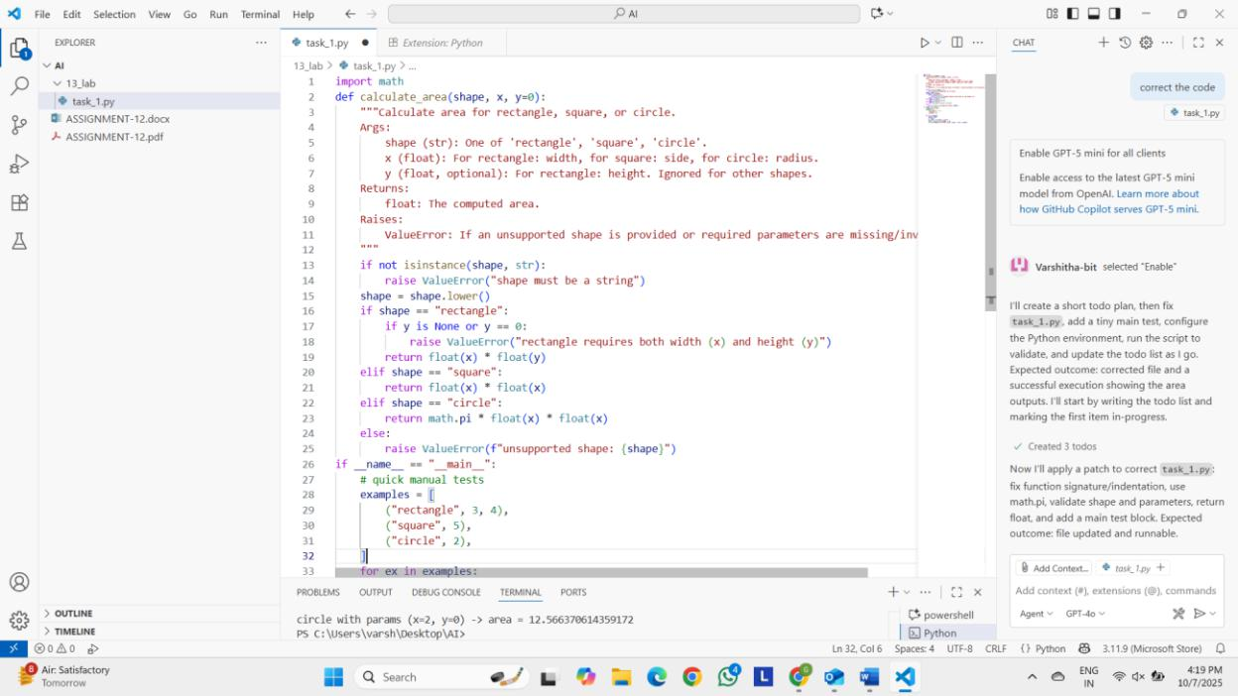

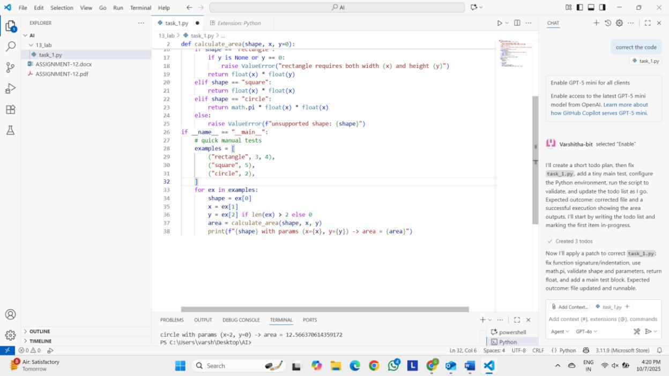

Output:
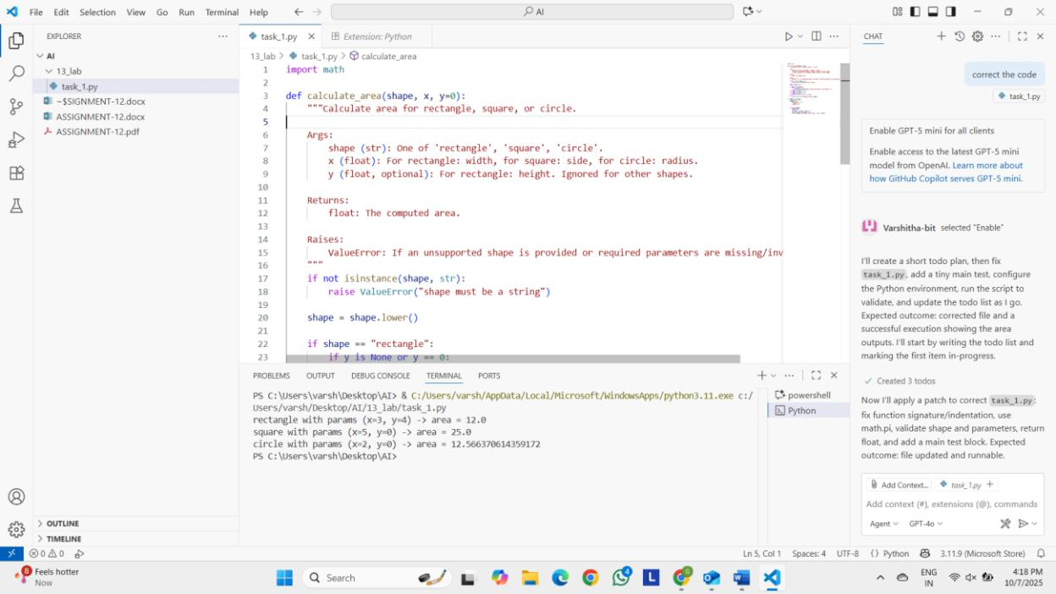

Observation:

First when we write the code in the work space, then when we give the prompt to correct the code it immediately changed the whole code. The original code was hardly 6 lines but the generated code is more lines. It even included comments so that we can understand the code easily. Now the code is in a correct structure.

Task-2:

Prompt: Correct my mistake

Code:
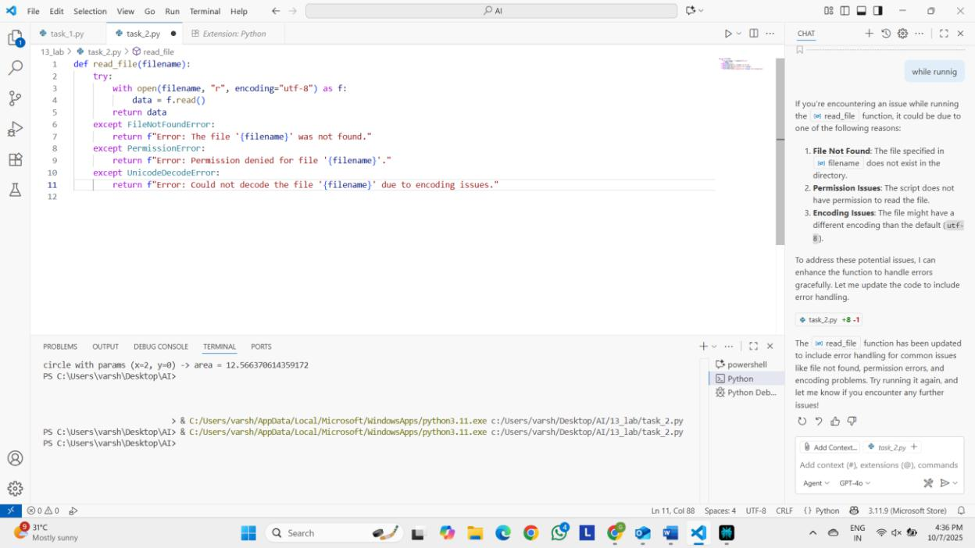

Output:

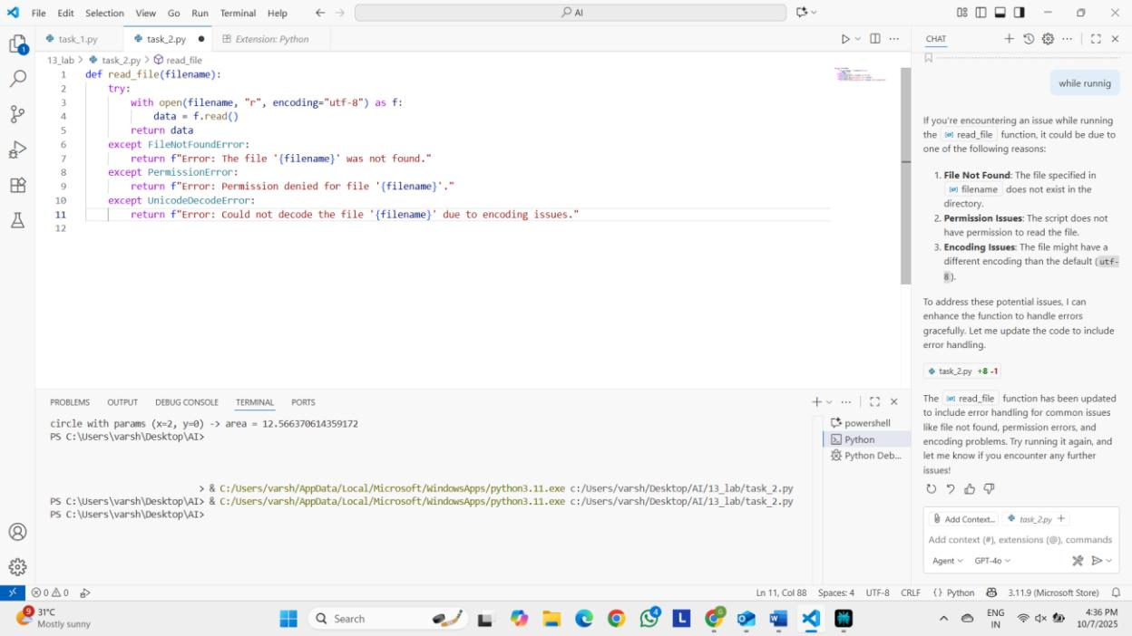

Observation:

In the give code we did not give a code with proper indentation. And file handling was also not perfect. But as we gave the prompt to correct it. It handled all that issues.

Task-3:

Prompt: correct my code. In this the attributes are name, age and marks.

Code:

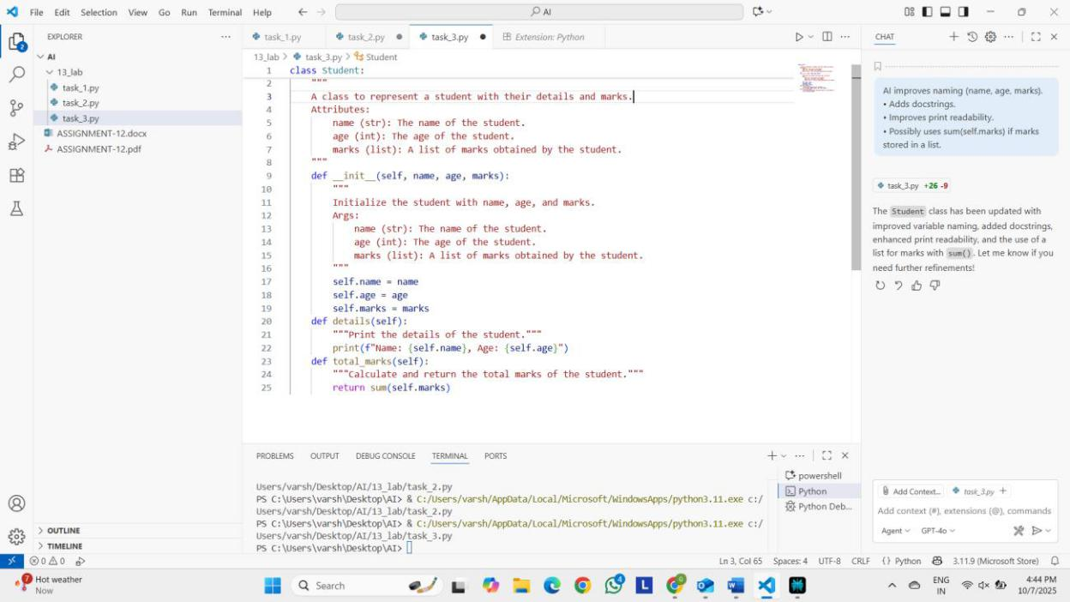

Output:

Observation:

First when we write the code in the work space, then when we give the prompt to correct the code it immediately changed the whole code. The original code was hardly 6 lines but the generated code is more lines. It even included comments so that we can understand the code easily. Now the code is in a correct structure

Task-4:

Prompt: Correct my mistake

Code:
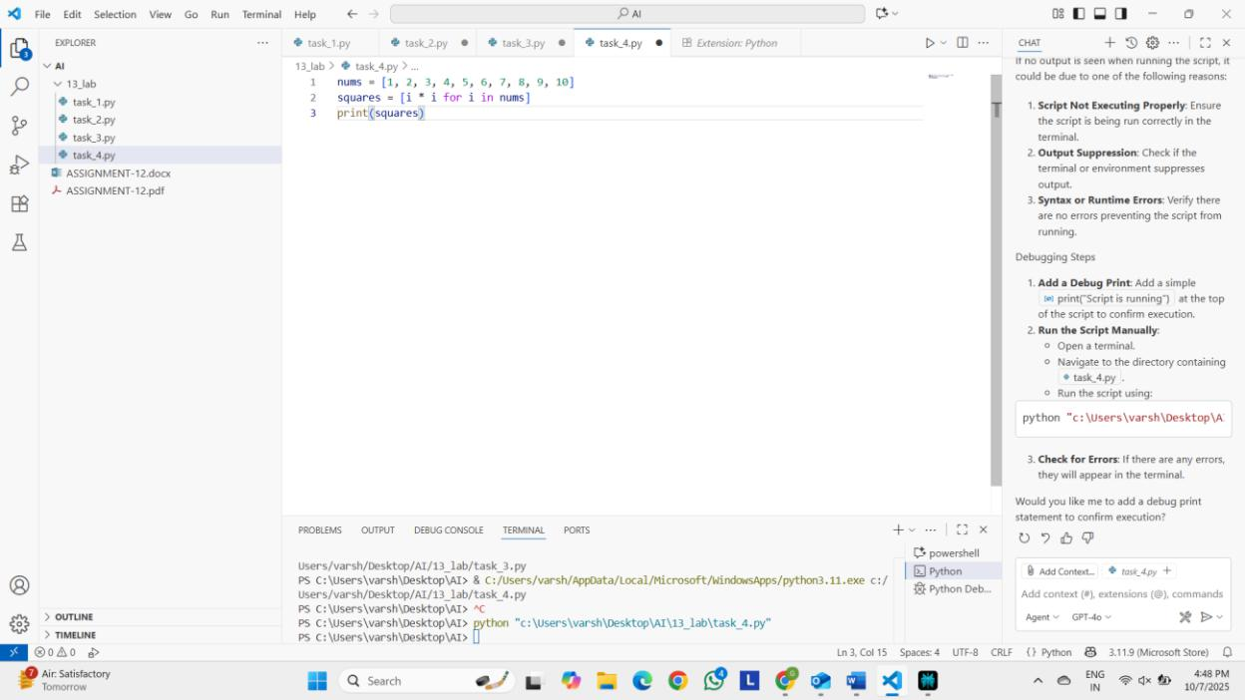

Output:

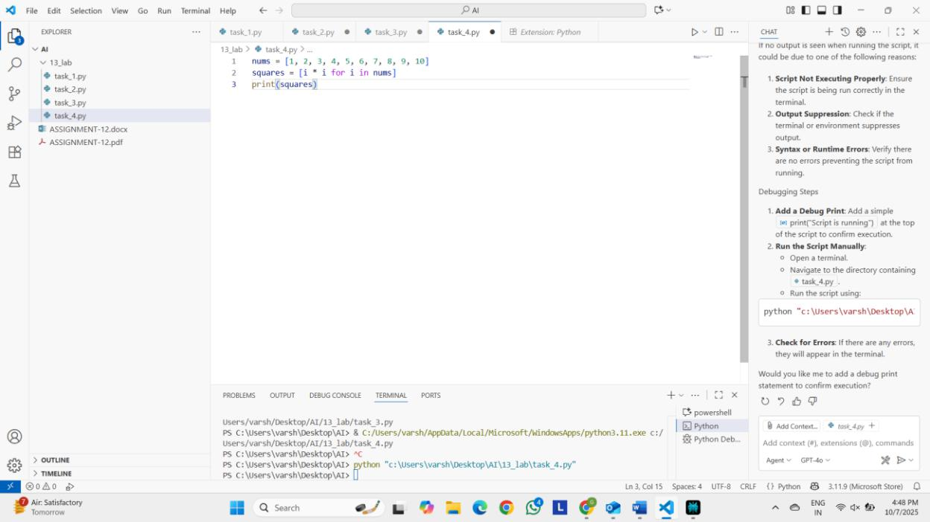

Observation:

First when we write the code in the work space, then when we give the prompt to correct the code it immediately changed the whole code. The original code was hardly 6 lines but the generated code is more lines. It even included comments so that we can understand the code easily. Now the code is in a correct structure

