ASSIGNMENT - 8
NAME: B. REVANTH
HT.NO: 2403A52041
BATCH: AIB03
Task-1
Write a test case to check if a function returns the square of a number.
Then write the function with help from GitHub Copilot or Cursor AI.
Prompt:1**2=1,2**2=4,3**2=9,4**2=16,5**2=25,6**2=36,7**2=49,8**2=64,9**2=81,10**2=100. according to the test case given to you, write a function to generate square of a given number. input is given dynamically
Code:
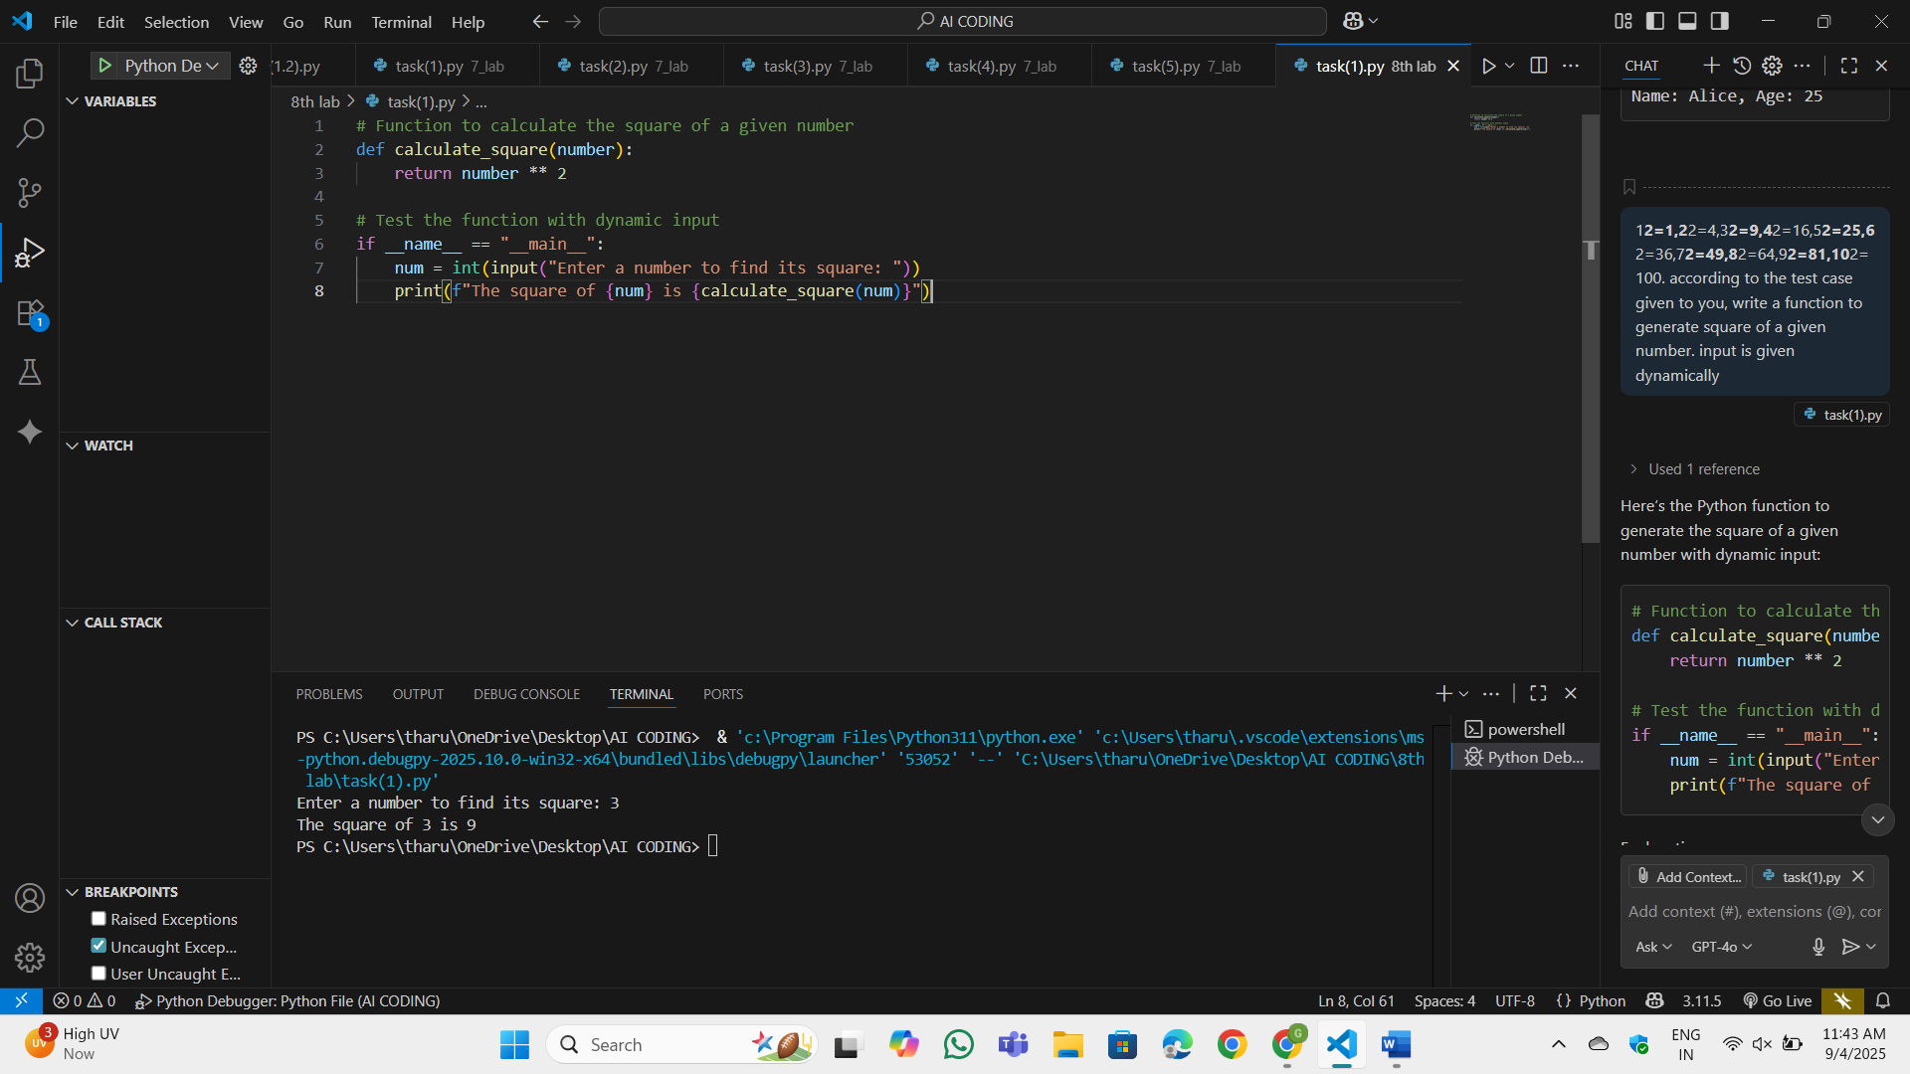
OP:
Observation:
The calculate_square function takes a number as input and returns its square using the ** operator. I have prompted to input a number dynamically.The program calculates the square of the input number and prints the result.
Task-2:
Create test cases to validate an email address (e.g., contains @ and .com).Use AI assistance to implement the validate_email() function
Prompt:
write a function which validates a email id. examples of a mail id is containt@gmail.com, madam@gmail.com, anyone@gmail.com. according to the test case/examples given generate code.
Code:
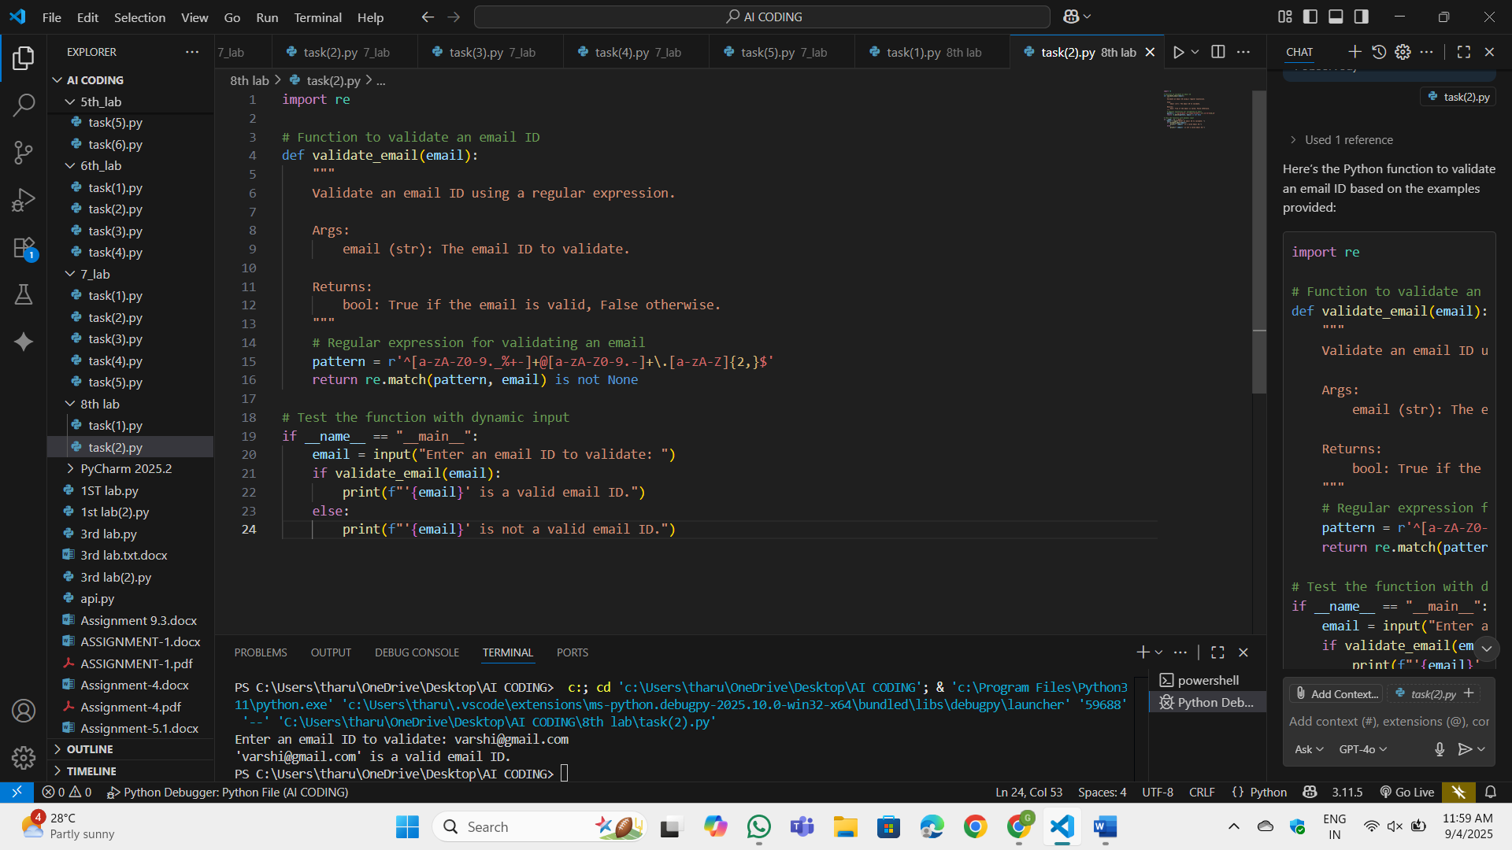
OP:
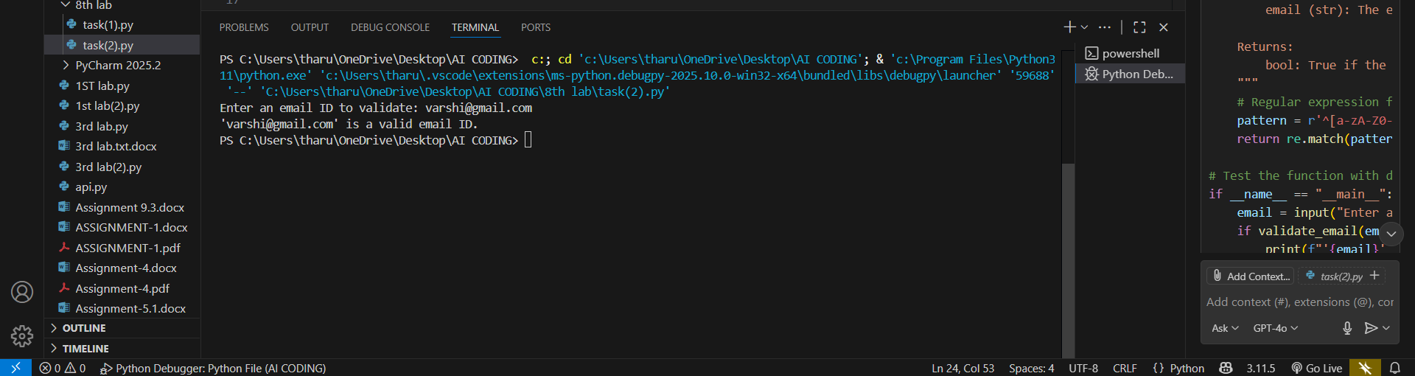
Observation:
Examples like containt@gmail.com, madam@gmail.com, and anyone@gmail.com are valid because, They contain alphanumeric characters before the @.They have a domain name after the @ (e.g., gmail.com). The domain name ends with a valid top-level domain (e.g., .com).Emails without an @ symbol or domain name are invalid.Emails with special characters in invalid positions (e.g., @example.com or name@.com) are invalid.
Task-3:
Write test cases for a function that returns the maximum of three numbers.Prompt Copilot/Cursor to write the logic based on tests
Prompt:
in 13,54,98 98 is the maximum of three numbers. 1,2,3 3 is the maximum of three numbers. now generate a function that returns the maximum of three numbers, according to the test case given. take input dynamically
Code:
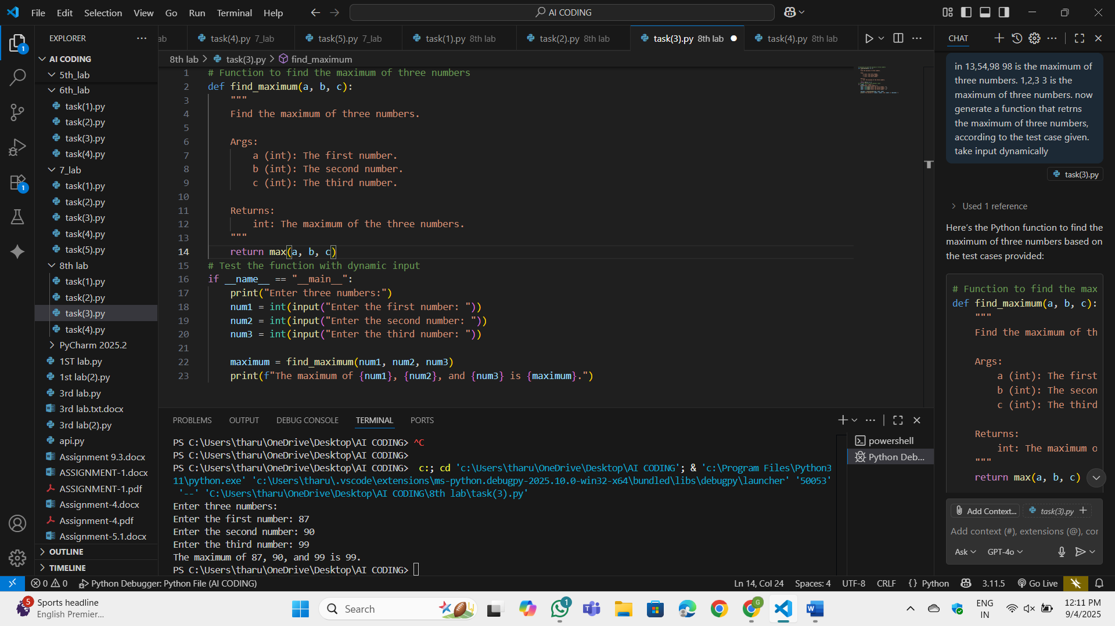
OP:
Observation:
The find_maximum function takes three numbers as arguments and returns the maximum using Python's built-in max() function. I have prompted to input three numbers dynamically.The program calculates the maximum of the three numbers and prints the result.
Task-4:
Use TDD to write a shopping cart class with methods to add, remove, and get total price.First write tests for each method, then generate code using AI.
Prompt:Now generate a Python class ShoppingCart that can add items, remove items, and calculate the total price according to the given test cases. Take input dynamically from the user.Input: Add Apple with quantity 2 and price 3.0 → Output: {"Apple": {"quantity": 2, "price": 3.0}}.Input: Remove Apple from the cart → Output: {}.Input: Add Apple (quantity 2, price 3.0) and Banana (quantity 1, price 1.5) → Output: Total price is 7.5.
Code:
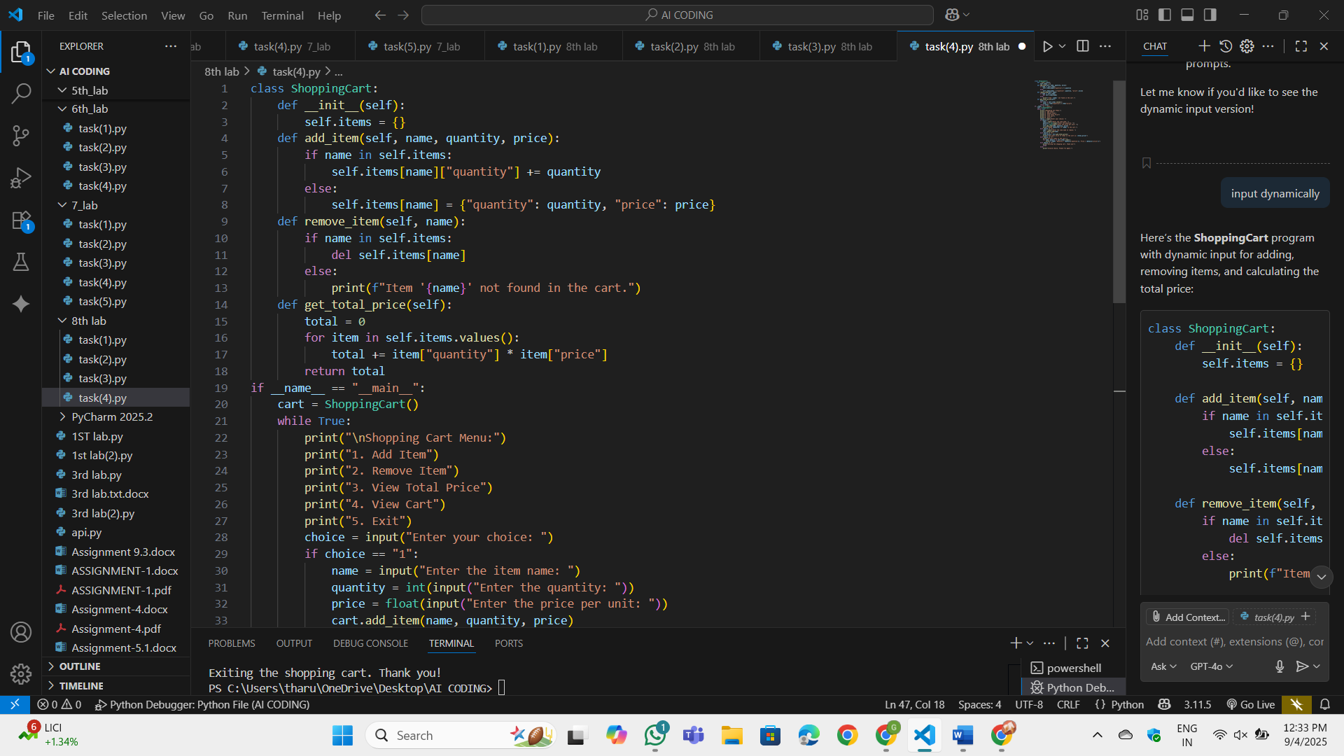
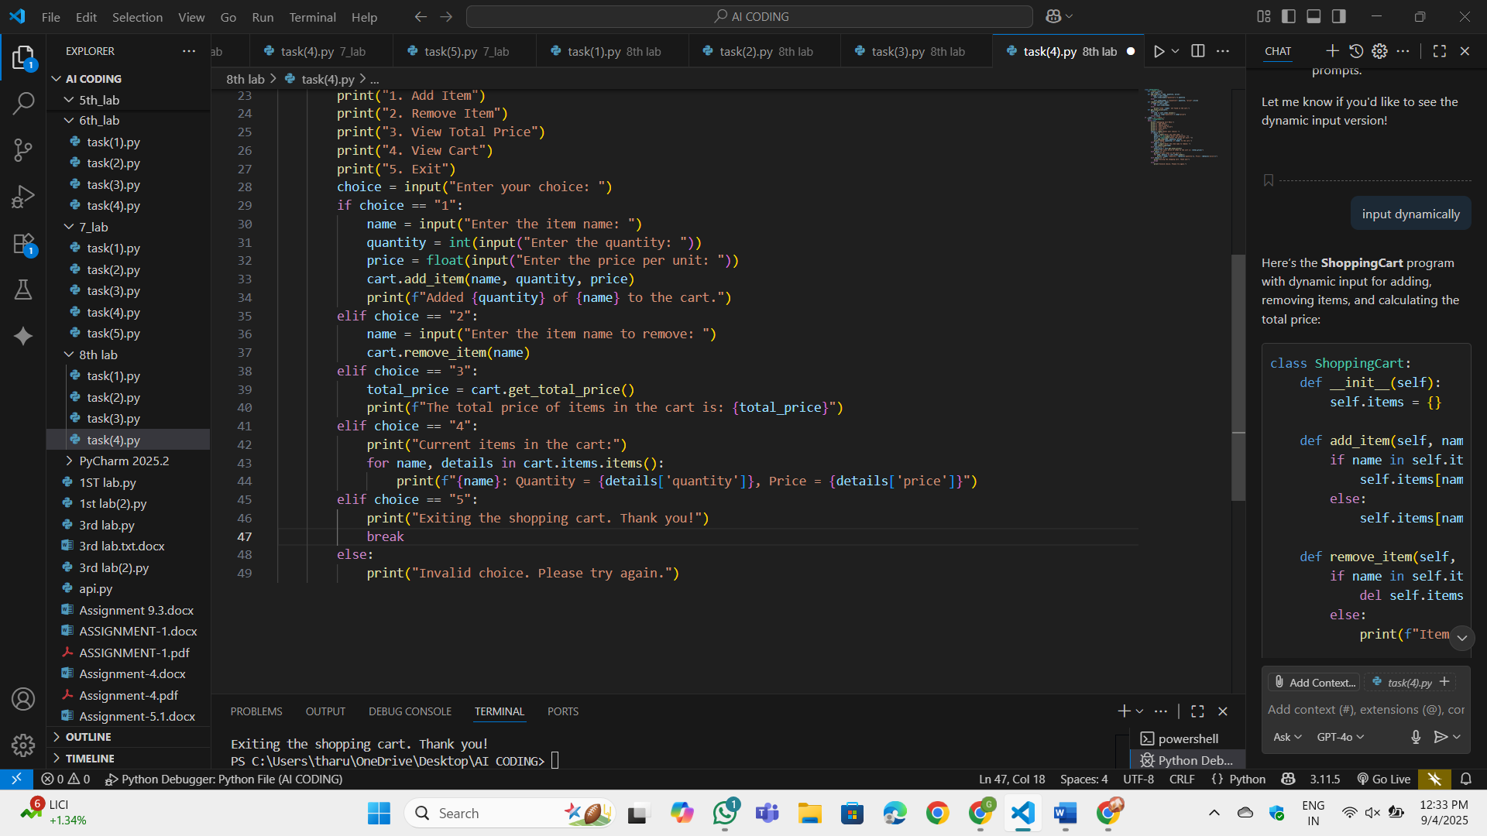
OP:
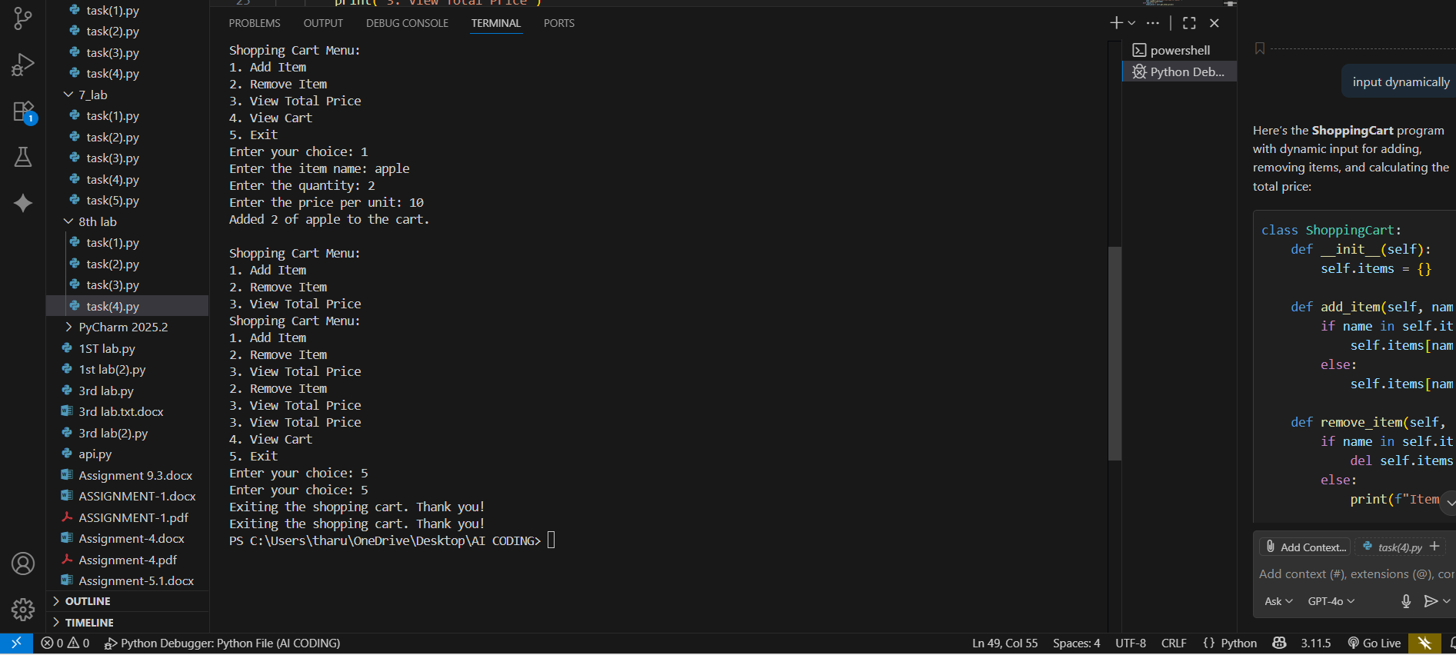
Observation:The program uses input() to allow the user to interact with the shopping cart dynamically.Users can add items, remove items, view the total price, and see the cart's contents.
  - Option 1: Add an item to the cart.
  - Option 2: Remove an item from the cart.
  - Option 3: Calculate and display the total price of items in the cart.
  - Option 4: Display all items in the cart.
  - Option 5: Exit the program.
If the user tries to remove an item that doesn’t exist, the program displays an appropriate message

Task-5:
Write tests for a palindrome checker (e.g., is_palindrome("level") → True).Let Copilot suggest the function based on test case expectations.
Prompt:
write a function to check whether a word or a number is palindrome or not. Example: level, 121
Code:
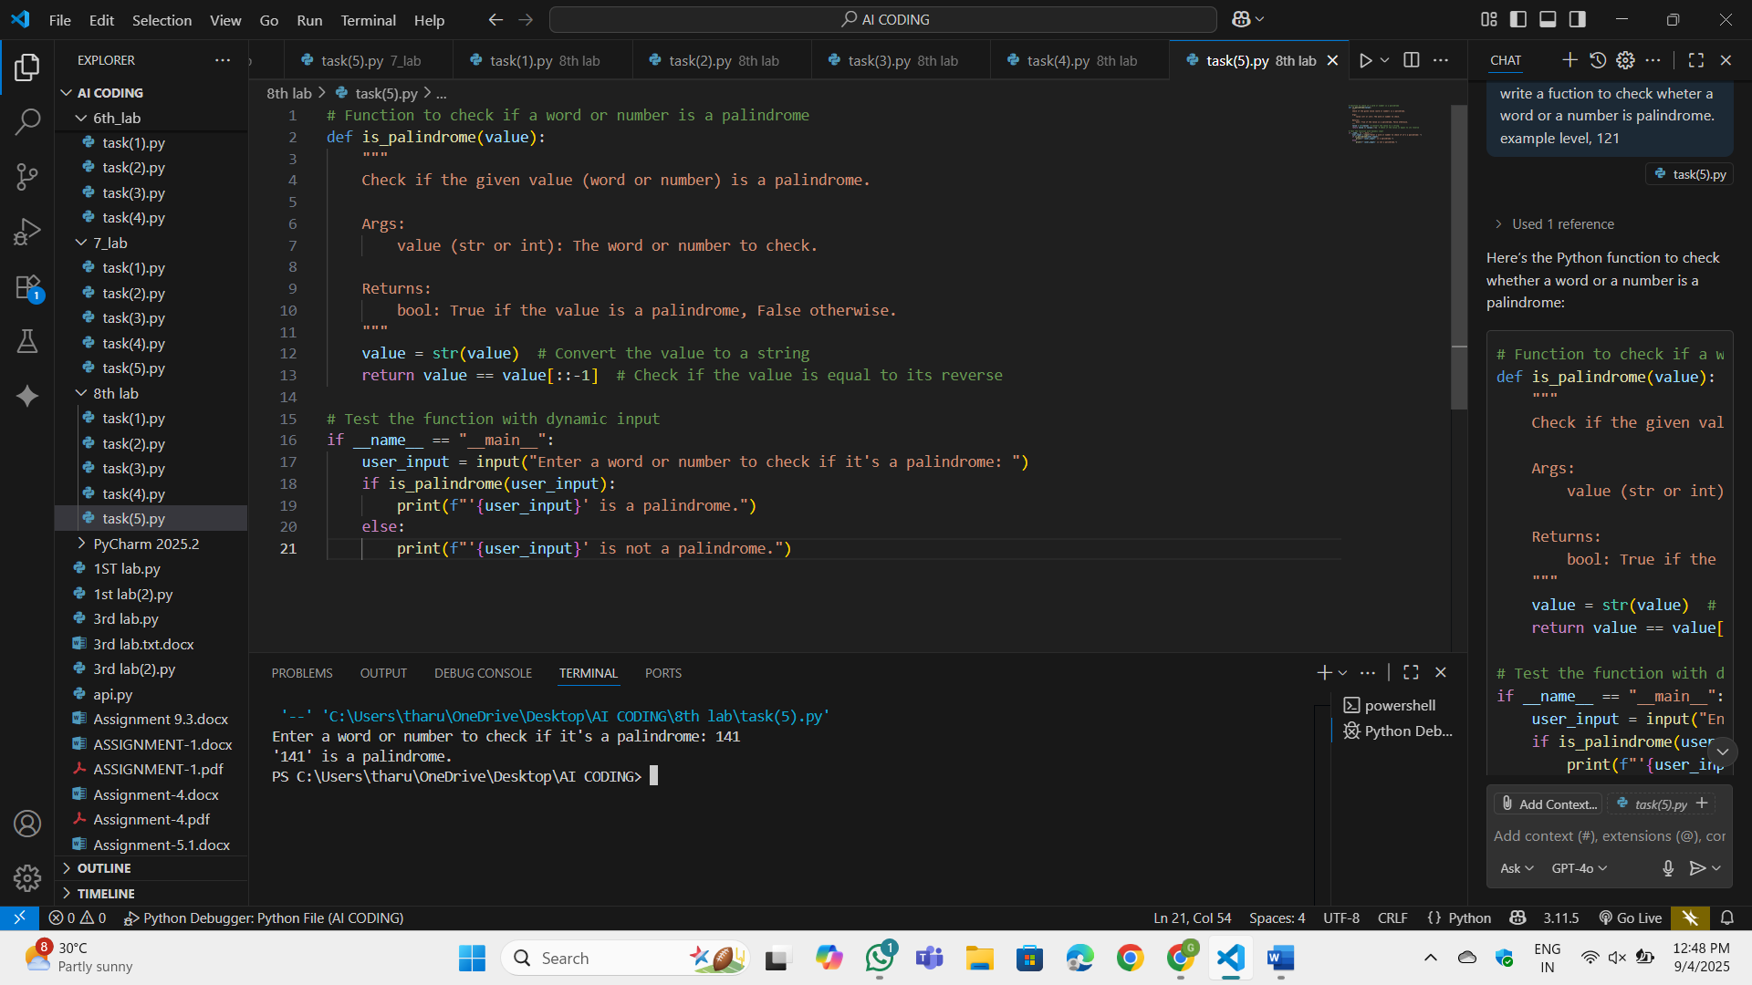
OP:
Observation:
The input value is converted to a string using str(value) to handle both words and numbers.The function checks if the string is equal to its reverse using slicing (value[::-1]).I have prompted to enter a word or number dynamically. The program prints whether the input is a palindrome

