1 Student Grade
Calculator

Accept marks of five subjects, calculate total,
average, and assign grades (A, B, C, etc.).
code:
# Student Grade Calculator

# Input marks for 5 subjects
sub1 = float(input("Enter marks for Subject 1: "))
sub2 = float(input("Enter marks for Subject 2: "))
sub3 = float(input("Enter marks for Subject 3: "))
sub4 = float(input("Enter marks for Subject 4: "))
sub5 = float(input("Enter marks for Subject 5: "))

# Calculate total and average
total = sub1 + sub2 + sub3 + sub4 + sub5
average = total / 5

# Assign grade
if average >= 90:
grade = "A+"
elif average >= 80:
grade = "A"
elif average >= 70:
grade = "B"
elif average >= 60:
grade = "C"
elif average >= 50:
grade = "D"
else:
grade = "F"

# Display results
print("\n----- Student Result -----")
print("Total Marks :", total)
print("Average Marks :", average)
print("Grade :", grade)
output:
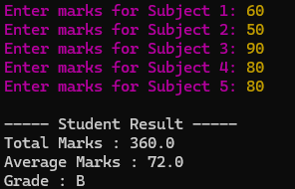
2 Employee Salary
Calculator

Calculate gross salary, deductions (PF, tax), and net
salary of an employee.
Code:
# Employee Salary Calculator

# Input employee details
name = input("Enter Employee Name: ")
basic_salary = float(input("Enter Basic Salary: "))

# Calculate allowances
hra = basic_salary * 0.20 # 20% HRA
da = basic_salary * 0.10 # 10% DA

# Gross Salary
gross_salary = basic_salary + hra + da

# Deductions
pf = basic_salary * 0.12 # 12% PF
tax = gross_salary * 0.10 # 10% Tax

# Net Salary
net_salary = gross_salary - (pf + tax)

# Display Salary Details
print("\n------ Employee Salary Slip ------")
print("Employee Name :", name)
print("Basic Salary :", basic_salary)
print("HRA :", hra)
print("DA :", da)
print("Gross Salary :", gross_salary)
print("PF Deduction :", pf)
print("Tax Deduction :", tax)
print("Net Salary :", net_salary)
output:
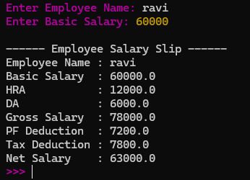
3 Electricity Bill
Generator

Calculate electricity bill based on slab-wise tariff
rates.
Code:
# Electricity Bill Generator

# Input
consumer_name = input("Enter Consumer Name: ")
units = int(input("Enter Units Consumed: "))

# Calculate bill
if units <= 100:
bill = units * 1.50
elif units <= 200:
bill = (100 * 1.50) + ((units - 100) * 2.50)
else:
bill = (100 * 1.50) + (100 * 2.50) + ((units - 200) * 4.00)

# Display bill
print("\n------ Electricity Bill ------")
print("Consumer Name :", consumer_name)
print("Units Consumed:", units)
print("Total Bill : $", bill)
output:
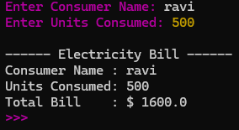
4 ATM Cash
Withdrawal System

Check account balance, verify PIN, and perform
withdrawal if sufficient balance exists.
Code:
# ATM Cash Withdrawal System

# Initial account details
balance = 10000
correct_pin = 1234

# User input
pin = int(input("Enter ATM PIN: "))

# Verify PIN
if pin == correct_pin:
print("PIN Verified Successfully")
print("Available Balance:", balance)

amount = float(input("Enter Withdrawal Amount: "))

if amount <= balance:
balance = balance - amount
print("\nWithdrawal Successful!")
print("Amount Withdrawn:", amount)
print("Remaining Balance:", balance)
else:
print("\nInsufficient Balance!")
else:
print("\nInvalid PIN!")
output:1
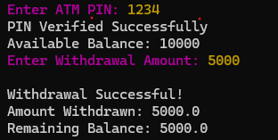
Output:2
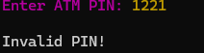
Output:3
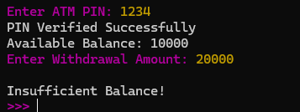
5 Online Shopping Bill Calculate total bill after applying discounts and GST

based on purchase amount.
Code:
# Online Shopping Bill Calculator

# Input
customer_name = input("Enter Customer Name: ")
purchase_amount = float(input("Enter Purchase Amount: "))

# Calculate discount
if purchase_amount >= 5000:
discount = purchase_amount * 0.20
elif purchase_amount >= 2000:
discount = purchase_amount * 0.10
else:
discount = 0

# Amount after discount
amount_after_discount = purchase_amount - discount

# Calculate GST (18%)
gst = amount_after_discount * 0.18

# Final Bill
total_bill = amount_after_discount + gst

# Display Bill
print("\n------ Online Shopping Bill ------")
print("Customer Name :", customer_name)
print("Purchase Amount : $", purchase_amount)
print("Discount : $", discount)
print("Amount After Discount: $", amount_after_discount)
print("GST (18%) : $", gst)
print("Total Bill : $", total_bill)
output:
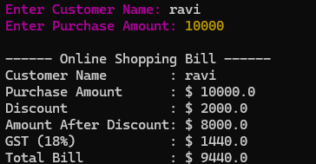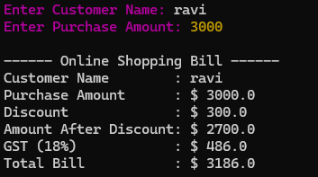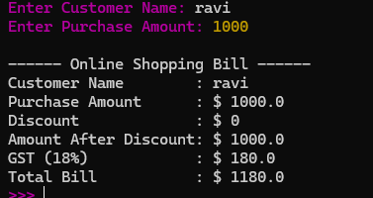
6 Restaurant Billing

System

Generate customer bill including GST and service
charges for ordered food items.
Code:
# Restaurant Billing System

# Input customer details
customer_name = input("Enter Customer Name: ")

# Input food item prices
item1 = float(input("Enter Price of Item 1: "))
item2 = float(input("Enter Price of Item 2: "))
item3 = float(input("Enter Price of Item 3: "))

# Calculate total food bill
total = item1 + item2 + item3

# Calculate service charge (5%)
service_charge = total * 0.05

# Calculate GST (18%)
gst = total * 0.18

# Calculate final bill
final_bill = total + service_charge + gst

# Display bill
print("\n------- Restaurant Bill -------")
print("Customer Name :", customer_name)
print("Food Total : $", total)
print("Service Charge : $", service_charge)
print("GST (18%) : $", gst)
print("Final Bill : $", final_bill)
print("-------------------------------")
print("Thank You! Visit Again.")
output:
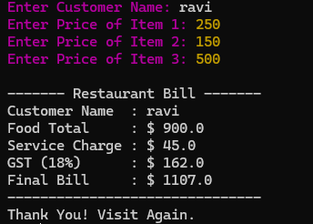
7 Bank Interest
Calculator

Calculate simple interest and compound interest for
a given principal, rate, and time.
Code:
# Bank Interest Calculator

# Input
principal = float(input("Enter Principal Amount: "))
rate = float(input("Enter Annual Interest Rate (%): "))
time = float(input("Enter Time (in years): "))

# Simple Interest
simple_interest = (principal * rate * time) / 100

# Compound Interest
amount = principal * (1 + rate / 100) ** time
compound_interest = amount - principal

# Display Results
print("\n------ Bank Interest Calculator ------")
print("Principal Amount : $", principal)
print("Rate of Interest :", rate, "%")
print("Time :", time, "years")
print("Simple Interest : $", simple_interest)
print("Compound Interest: $", compound_interest)
print("Total Amount (CI): $", amount)
output:
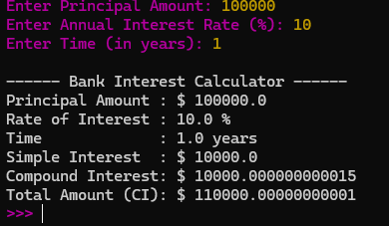
8 Hospital BMI
Calculator

Calculate Body Mass Index (BMI) and classify the
patient's health status.
Code:
# Hospital BMI Calculator

# Input patient details
name = input("Enter Patient Name: ")
weight = float(input("Enter Weight (kg): "))
height = float(input("Enter Height (meters): "))

# Calculate BMI
bmi = weight / (height ** 2)

# Classify BMI
if bmi < 18.5:
status = "Underweight"
elif bmi < 25:
status = "Normal Weight"
elif bmi < 30:
status = "Overweight"
else:
status = "Obese"

# Display results
print("\n------ Hospital BMI Report ------")
print("Patient Name :", name)
print("Weight :", weight, "kg")
print("Height :", height, "m")
print("BMI :", round(bmi, 2))
print("Health Status:", status)
output:
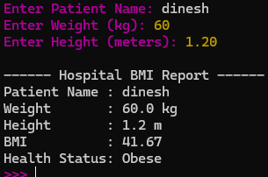

9 Library Fine
Calculator

Calculate library fine based on the number of
overdue days.
Code:
# Library Fine Calculator

# Input
student_name = input("Enter Student Name: ")
overdue_days = int(input("Enter Number of Overdue Days: "))

# Calculate Fine
if overdue_days == 0:
fine = 0
elif overdue_days <= 5:
fine = overdue_days * 2
elif overdue_days <= 10:
fine = overdue_days * 5
else:
fine = overdue_days * 10

# Display Result
print("\n------ Library Fine Details ------")
print("Student Name :", student_name)
print("Overdue Days :", overdue_days)
print("Fine Amount : $", fine)
output:
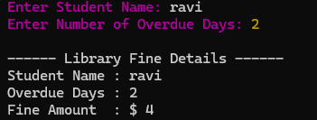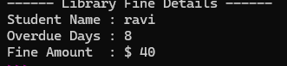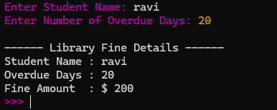
10 Railway Ticket Fare
Calculator

Calculate ticket fare based on age, class, and
available concessions.
Code:
# Railway Ticket Fare Calculator

# Input passenger details
name = input("Enter Passenger Name: ")
age = int(input("Enter Age: "))
travel_class = input("Enter Class (First/Second/Sleeper): ")

# Set base fare
if travel_class.lower() == "first":
fare = 500
elif travel_class.lower() == "second":
fare = 300
elif travel_class.lower() == "sleeper":
fare = 200
else:
print("Invalid Class!")
exit()

# Calculate discount
if age < 12:
discount = fare * 0.50
elif age >= 60:
discount = fare * 0.30
else:
discount = 0

# Final Fare
final_fare = fare - discount

# Display Ticket Details
print("\n------ Railway Ticket ------")
print("Passenger Name :", name)
print("Age :", age)
print("Class :", travel_class)
print("Base Fare : ₹", fare)
print("Discount : ₹", discount)
print("Final Fare : ₹", final_fare)
output:
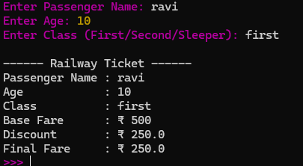
11 Vehicle Fuel Cost
Estimator

Calculate fuel expense for a trip based on distance,
mileage, and fuel price.
Code:
# Vehicle Fuel Cost Estimator

# Input
vehicle_name = input("Enter Vehicle Name: ")
distance = float(input("Enter Distance to Travel (km): "))
mileage = float(input("Enter Vehicle Mileage (km/litre): "))
fuel_price = float(input("Enter Fuel Price per Litre (₹): "))

# Calculate fuel required
fuel_required = distance / mileage

# Calculate total fuel cost
total_cost = fuel_required * fuel_price

# Display result
print("\n------ Fuel Cost Estimation ------")
print("Vehicle Name :", vehicle_name)
print("Distance :", distance, "km")
print("Mileage :", mileage, "km/litre")
print("Fuel Required :", round(fuel_required, 2), "litres")
print("Fuel Price : ₹", fuel_price)
print("Total Fuel Cost: ₹", round(total_cost, 2))
output:
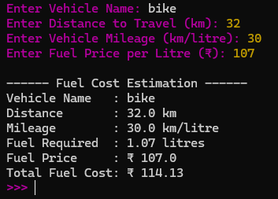
12 Mobile Recharge

Billing

Calculate final recharge amount after cashback or
promotional discounts.
Code:
# Mobile Recharge Billing

# Input
customer_name = input("Enter Customer Name: ")
mobile_number = input("Enter Mobile Number: ")
recharge_amount = float(input("Enter Recharge Amount (₹): "))

# Calculate Cashback
if recharge_amount >= 500:
cashback = recharge_amount * 0.20
elif recharge_amount >= 300:
cashback = recharge_amount * 0.10
else:
cashback = 0

# Final Amount
final_amount = recharge_amount - cashback

# Display Bill
print("\n------ Mobile Recharge Bill ------")
print("Customer Name :", customer_name)
print("Mobile Number :", mobile_number)
print("Recharge Amount : ₹", recharge_amount)
print("Cashback : ₹", cashback)
print("Final Amount : ₹", final_amount)
print("----------------------------------")
print("Recharge Successful!")
output:
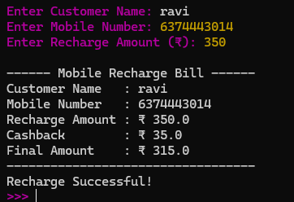
13 Parking Fee
Calculator

Compute parking charges based on vehicle type and
parking duration.
Code:
# Parking Fee Calculator

# Input
vehicle_number = input("Enter Vehicle Number: ")
vehicle_type = input("Enter Vehicle Type (Bike/Car/Bus): ")
hours = int(input("Enter Parking Duration (Hours): "))

# Calculate parking fee
if vehicle_type.lower() == "bike":
rate = 20
elif vehicle_type.lower() == "car":
rate = 50
elif vehicle_type.lower() == "bus":
rate = 100
else:
print("Invalid Vehicle Type!")
exit()

# Total Fee
total_fee = rate * hours

# Display Bill
print("\n------ Parking Fee Receipt ------")
print("Vehicle Number :", vehicle_number)
print("Vehicle Type :", vehicle_type)
print("Parking Hours :", hours)
print("Rate Per Hour : ₹", rate)
print("Total Parking Fee: ₹", total_fee)
print("---------------------------------")
print("Thank You! Visit Again.")
output:
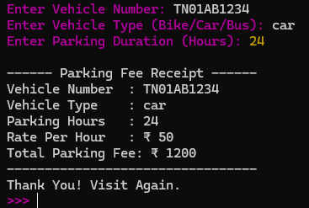
14 Attendance
Percentage
Calculator

Calculate attendance percentage and determine
examination eligibility (minimum 75%).
Code:
# Attendance Percentage Calculator

# Input
student_name = input("Enter Student Name: ")
total_classes = int(input("Enter Total Classes Held: "))
attended_classes = int(input("Enter Classes Attended: "))

# Calculate Attendance Percentage
attendance_percentage = (attended_classes / total_classes) * 100

# Check Eligibility
if attendance_percentage >= 75:
status = "Eligible for Examination"
else:
status = "Not Eligible for Examination"

# Display Result
print("\n------ Attendance Report ------")
print("Student Name :", student_name)
print("Total Classes :", total_classes)
print("Classes Attended :", attended_classes)
print("Attendance Percentage:", round(attendance_percentage, 2), "%")
print("Status :", status)
output:
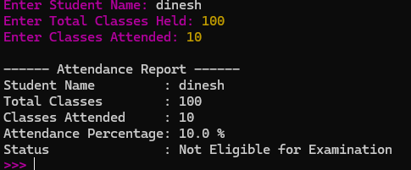
15 Weather Data
Analyzer

Store daily temperatures for a week and find
maximum, minimum, and average temperature.
Code:
# Weather Data Analyzer

# Store temperatures for 7 days
temperatures = []

print("Enter temperatures for 7 days:")

for i in range(7):
temp = float(input("Day " + str(i + 1) + ": "))
temperatures.append(temp)

# Calculate maximum, minimum, and average
maximum = max(temperatures)
minimum = min(temperatures)
average = sum(temperatures) / len(temperatures)

# Display results
print("\n------ Weather Report ------")
print("Temperatures:", temperatures)
print("Maximum Temperature:", maximum, "°C")
print("Minimum Temperature:", minimum, "°C")
print("Average Temperature:", round(average, 2), "°C")
output:
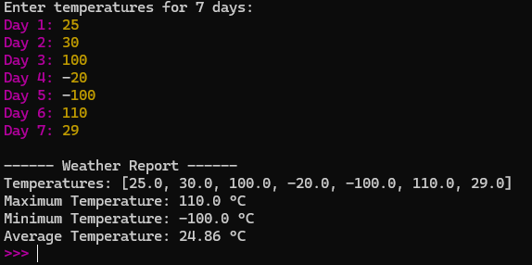
16 Online Voting
Eligibility Checker

Determine whether a citizen is eligible to vote based
on age and nationality.
Code:
# Online Voting Eligibility Checker

# Input
name = input("Enter Your Name: ")
age = int(input("Enter Your Age: "))
nationality = input("Enter Your Nationality: ")

# Check Eligibility
if age >= 18 and nationality.lower() == "indian":
print("\n------ Voting Eligibility ------")
print("Name :", name)
print("Age :", age)
print("Nationality :", nationality)
print("Status : Eligible to Vote")
else:
print("\n------ Voting Eligibility ------")
print("Name :", name)
print("Age :", age)
print("Nationality :", nationality)
print("Status : Not Eligible to Vote")
output:
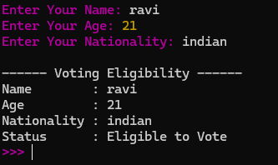
17 Password Strength

Checker

Check whether a password satisfies length,
uppercase, lowercase, digit, and special character
requirements.
Code:
# Password Strength Checker

# Input
password = input("Enter Password: ")

# Initialize conditions
has_upper = False
has_lower = False
has_digit = False
has_special = False

# Check each character
for ch in password:
if ch.isupper():
has_upper = True
elif ch.islower():
has_lower = True
elif ch.isdigit():
has_digit = True
elif ch in "@#$%^&*!":
has_special = True

# Check password strength
if len(password) >= 8 and has_upper and has_lower and has_digit and has_special:
print("\nPassword is Strong")
else:
print("\nPassword is Weak")
print("Password must contain:")
print("- At least 8 characters")
print("- One uppercase letter")
print("- One lowercase letter")
print("- One digit")
print("- One special character (@, #, $, %, ^, &, *, !)")
output:
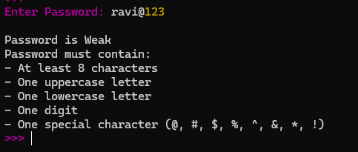
18 Blood Donation
Eligibility Checker

Determine donor eligibility based on age, weight, and
hemoglobin level.
Code:
# Blood Donation Eligibility Checker

# Input
name = input("Enter Donor Name: ")
age = int(input("Enter Age: "))
weight = float(input("Enter Weight (kg): "))
hemoglobin = float(input("Enter Hemoglobin Level (g/dL): "))

# Check eligibility
if age >= 18 and age <= 65 and weight >= 50 and hemoglobin >= 12.5:
status = "Eligible for Blood Donation"
else:
status = "Not Eligible for Blood Donation"

# Display Result
print("\n------ Blood Donation Report ------")
print("Donor Name :", name)
print("Age :", age)
print("Weight :", weight, "kg")
print("Hemoglobin Level :", hemoglobin, "g/dL")
print("Status :", status)
output:
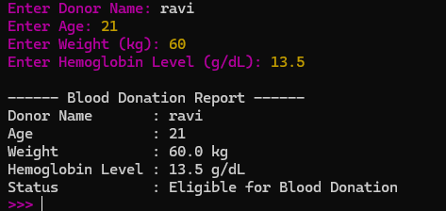
19 Inventory Stock
Management

Maintain product stock and notify when inventory
falls below a minimum threshold.
Code:
# Inventory Stock Management

# Input
product_name = input("Enter Product Name: ")
stock = int(input("Enter Available Stock: "))
minimum_stock = int(input("Enter Minimum Stock Level: "))

# Check stock level
if stock < minimum_stock:
print("\n------ Inventory Report ------")
print("Product Name :", product_name)
print("Available Stock :", stock)
print("Minimum Stock :", minimum_stock)
print("Status : Low Stock! Please Restock.")
else:
print("\n------ Inventory Report ------")
print("Product Name :", product_name)
print("Available Stock :", stock)
print("Minimum Stock :", minimum_stock)
print("Status : Stock Level is Sufficient.")
output:
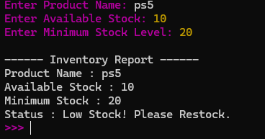
20 Movie Ticket Booking

System

Calculate ticket cost based on number of seats, seat
category, and applicable discounts.
Code:
# Movie Ticket Booking System

# Input
customer_name = input("Enter Customer Name: ")
seat_category = input("Enter Seat Category (Silver/Gold/Platinum): ")
number_of_seats = int(input("Enter Number of Seats: "))

# Ticket price
if seat_category.lower() == "silver":
price = 150
elif seat_category.lower() == "gold":
price = 250
elif seat_category.lower() == "platinum":
price = 400
else:
print("Invalid Seat Category!")
exit()

# Calculate total cost
total_cost = price * number_of_seats

# Apply discount
if number_of_seats >= 5:
discount = total_cost * 0.10
else:
discount = 0

# Final amount
final_amount = total_cost - discount

# Display ticket details
print("\n------ Movie Ticket Bill ------")
print("Customer Name :", customer_name)
print("Seat Category :", seat_category)
print("Number of Seats :", number_of_seats)
print("Price Per Seat : ₹", price)
print("Total Cost : ₹", total_cost)
print("Discount : ₹", discount)
print("Final Amount : ₹", final_amount)
print("-------------------------------")
print("Booking Confirmed!")
output:
