Using The App (Windows Only) (If you don’t have the app, [Click here](https://drive.google.com/open?id=0B1AT8doMER3vOWdlMXEyMExRWXc))

1. After Opening App, Click the “Select Spreadsheet” Button
   1. (Trying to read a Sheet without having selected a correct file will prompt the program to ask you for a valid sheet)

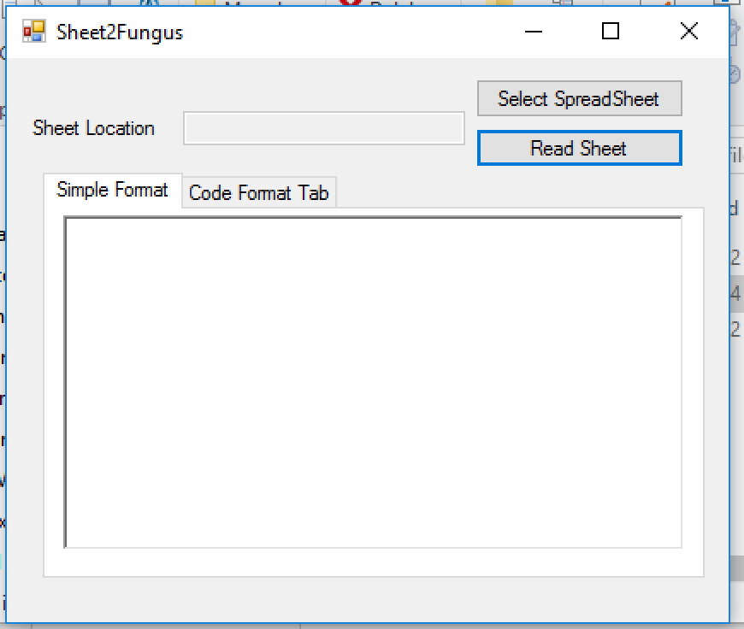

1. Find the Excel Sheet you wish to Read
   1. (if anyone uses some other program than Excel or Google Sheets, please inform me)

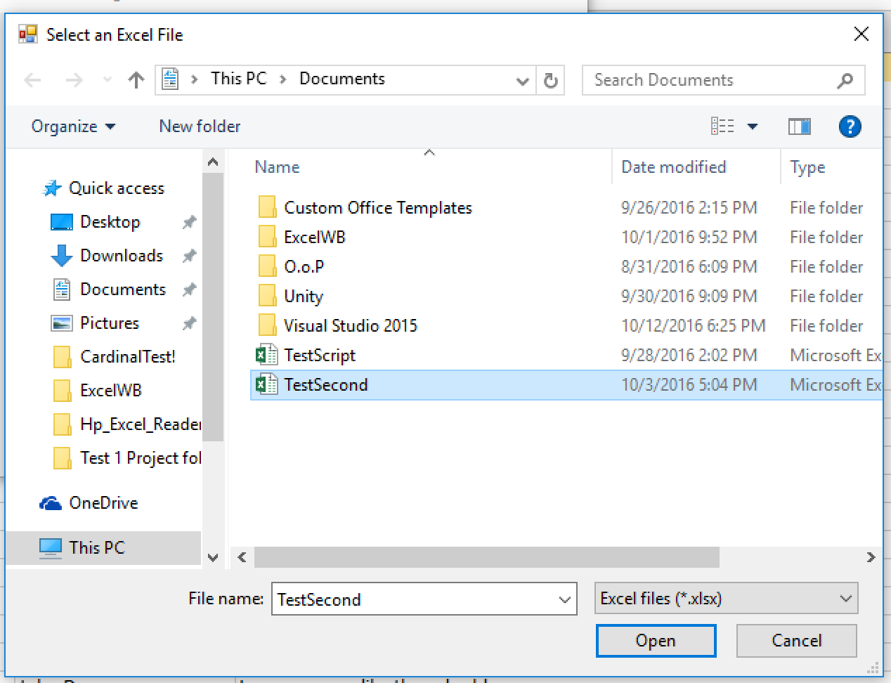

1. Once you have your file selected, Click “Read Sheet” The Program should start compiling the sheet into 2 formats
   1. Simple format; An easy to read format to help see how the script looks

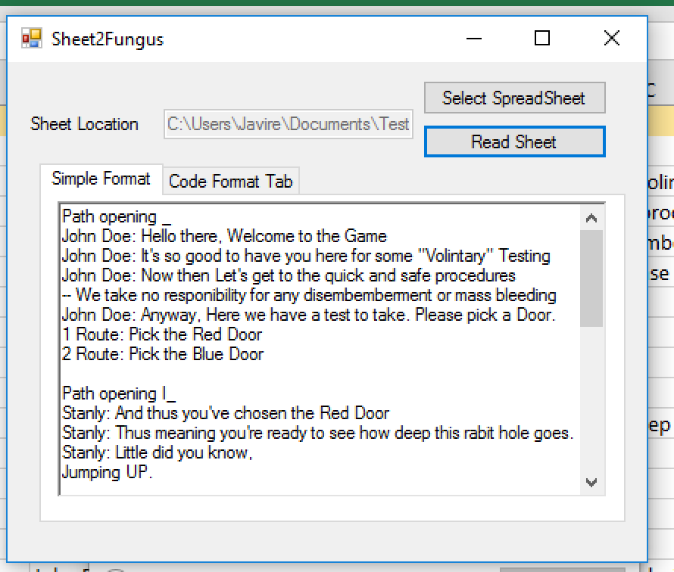

* 1. Code Format; The part that is meant to be read by the game engine(Unity) to be Displayed in game.

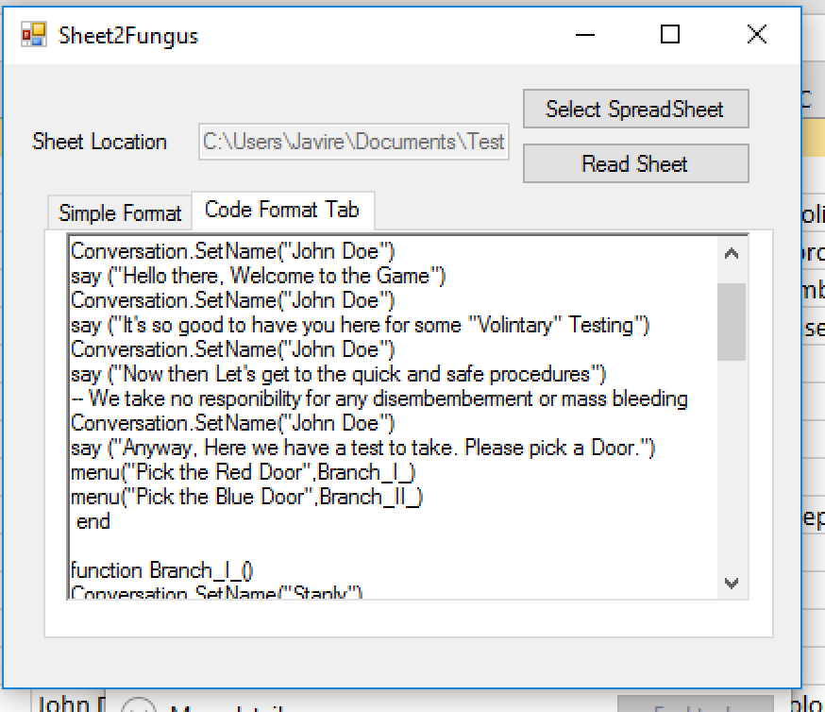

1. Now that you have the Code formatted script, open the Testing template (If you don’t have it, [Get it here](https://drive.google.com/open?id=0B1AT8doMER3vWEVJZXlCWDdKZVE).) Open the Test Scene folder, and then if you want to run your script, open the “Blank slate” scene.
   1. (Main test Contains a premade conversation made with the excel reader, the rest of the scenes don't matter)
2. Once there, find an object named “Lua.” It should have a component called “Lua Script” with a big text box in it. Paste the code format into the Text Box.

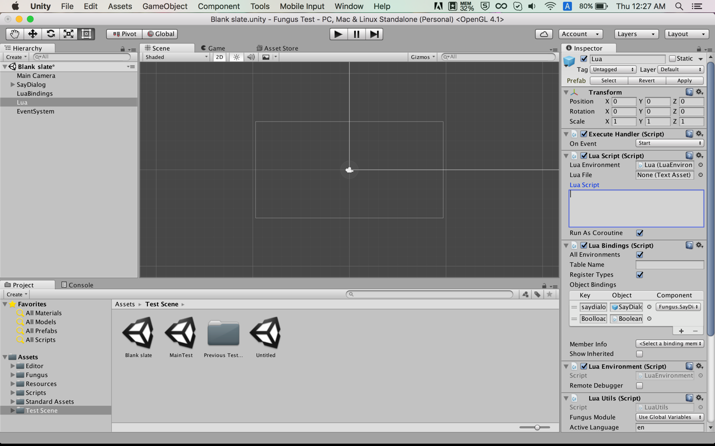

1. Congratulations! You’ve moved the script from a spreadsheet into the game! Now all you should have to is press play and watch the conversation unfold.

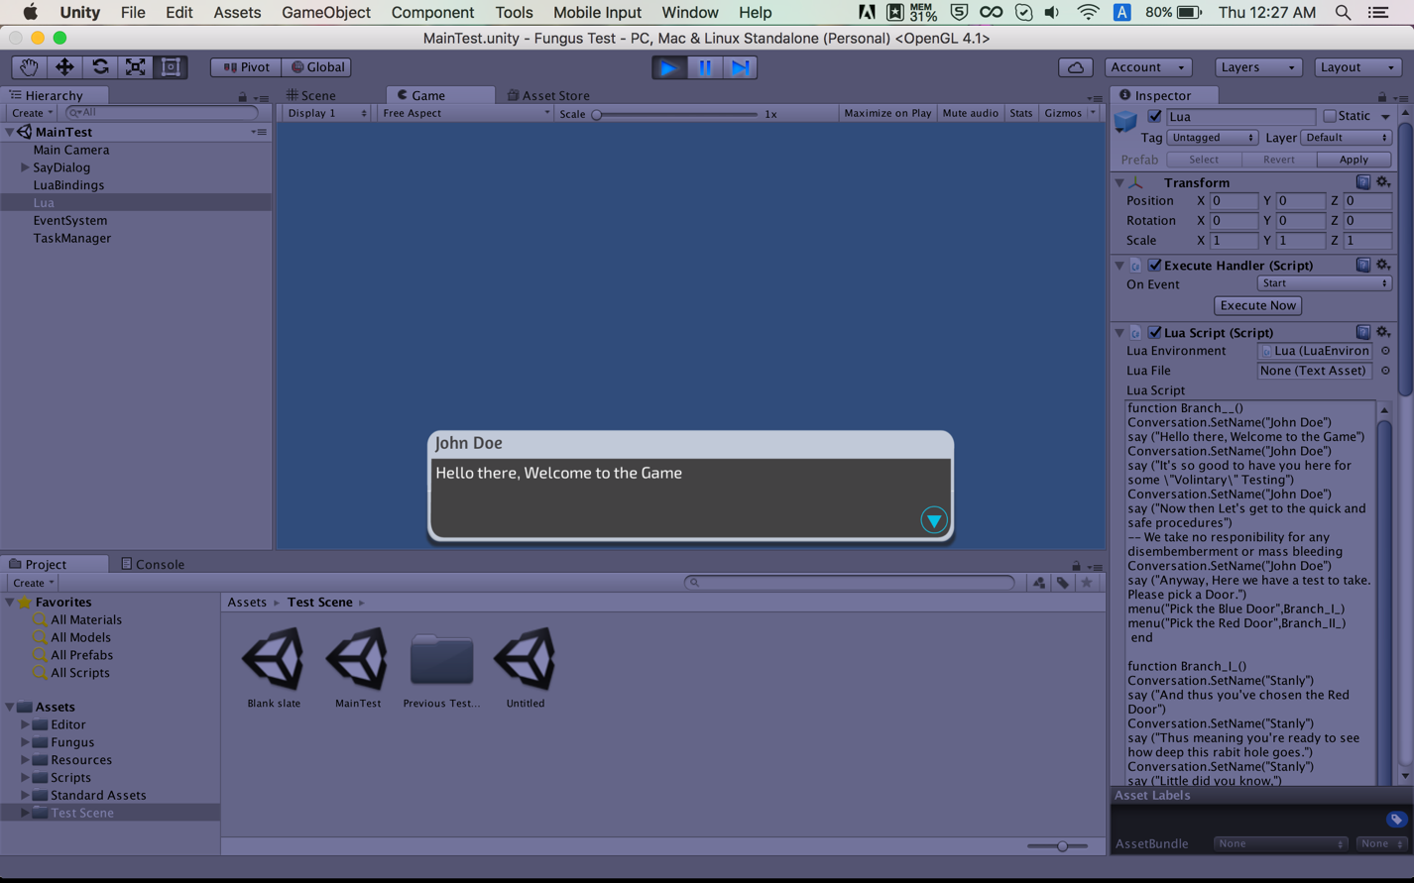

Note: Program is in its early stages so its prone to bugs. If something goes wrong, feel free to message me.

Also due to the fact that if statements require specific information from a specific scores that’s not made yet, they’ve been pseudo turned off by being turned into comments (which is a line with “--” in front)