Launching An Instance First:

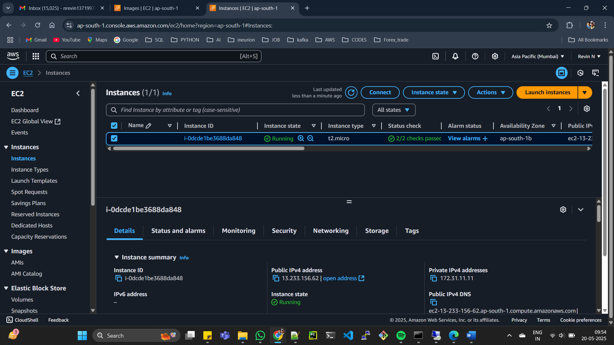

*2) Then click -> connect -> RDP Client-> get password -> upload pem file.*

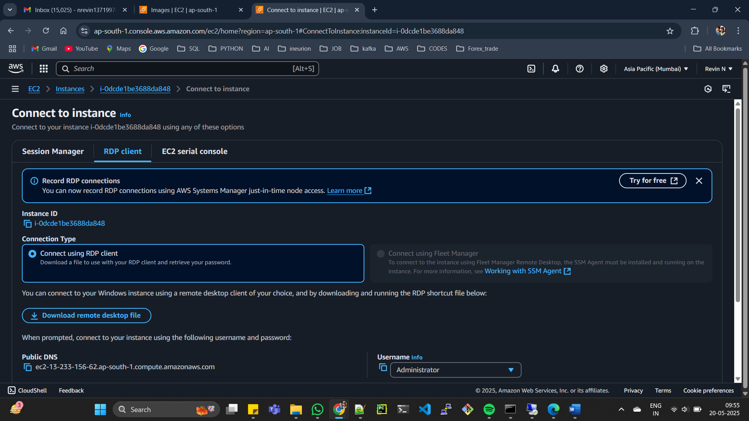

*3) goto search -> RDP -> connect with public IP -> USR NME : Adminstration -> pass : decripted pem file pass word and then u will get VM window .*

