For CI_CD Pipeline:

Source codes:

simple-web-app/

index.html

appspec.yml

buildspec.yml

└── scripts/

├── install_dependencies.sh

└── start_server.sh

**Launch an Ubuntu EC2 Instance:**

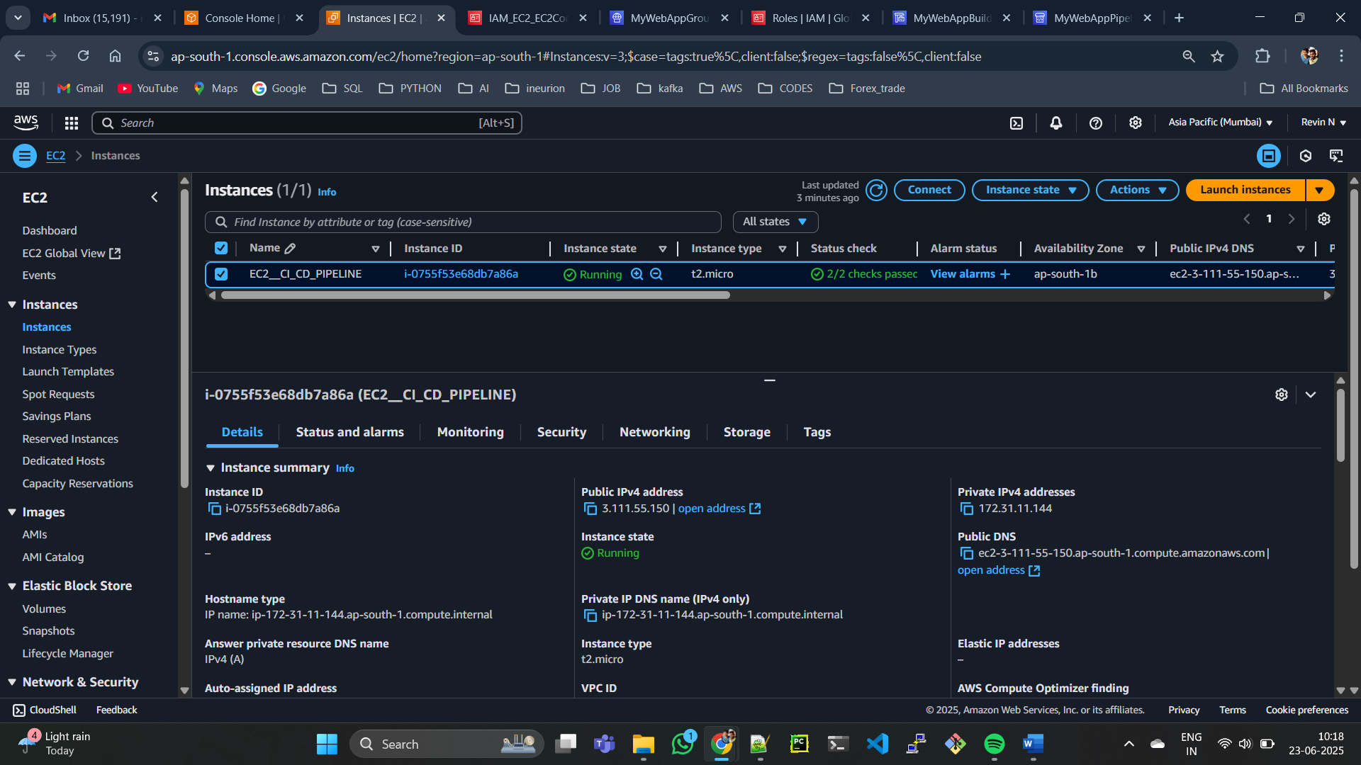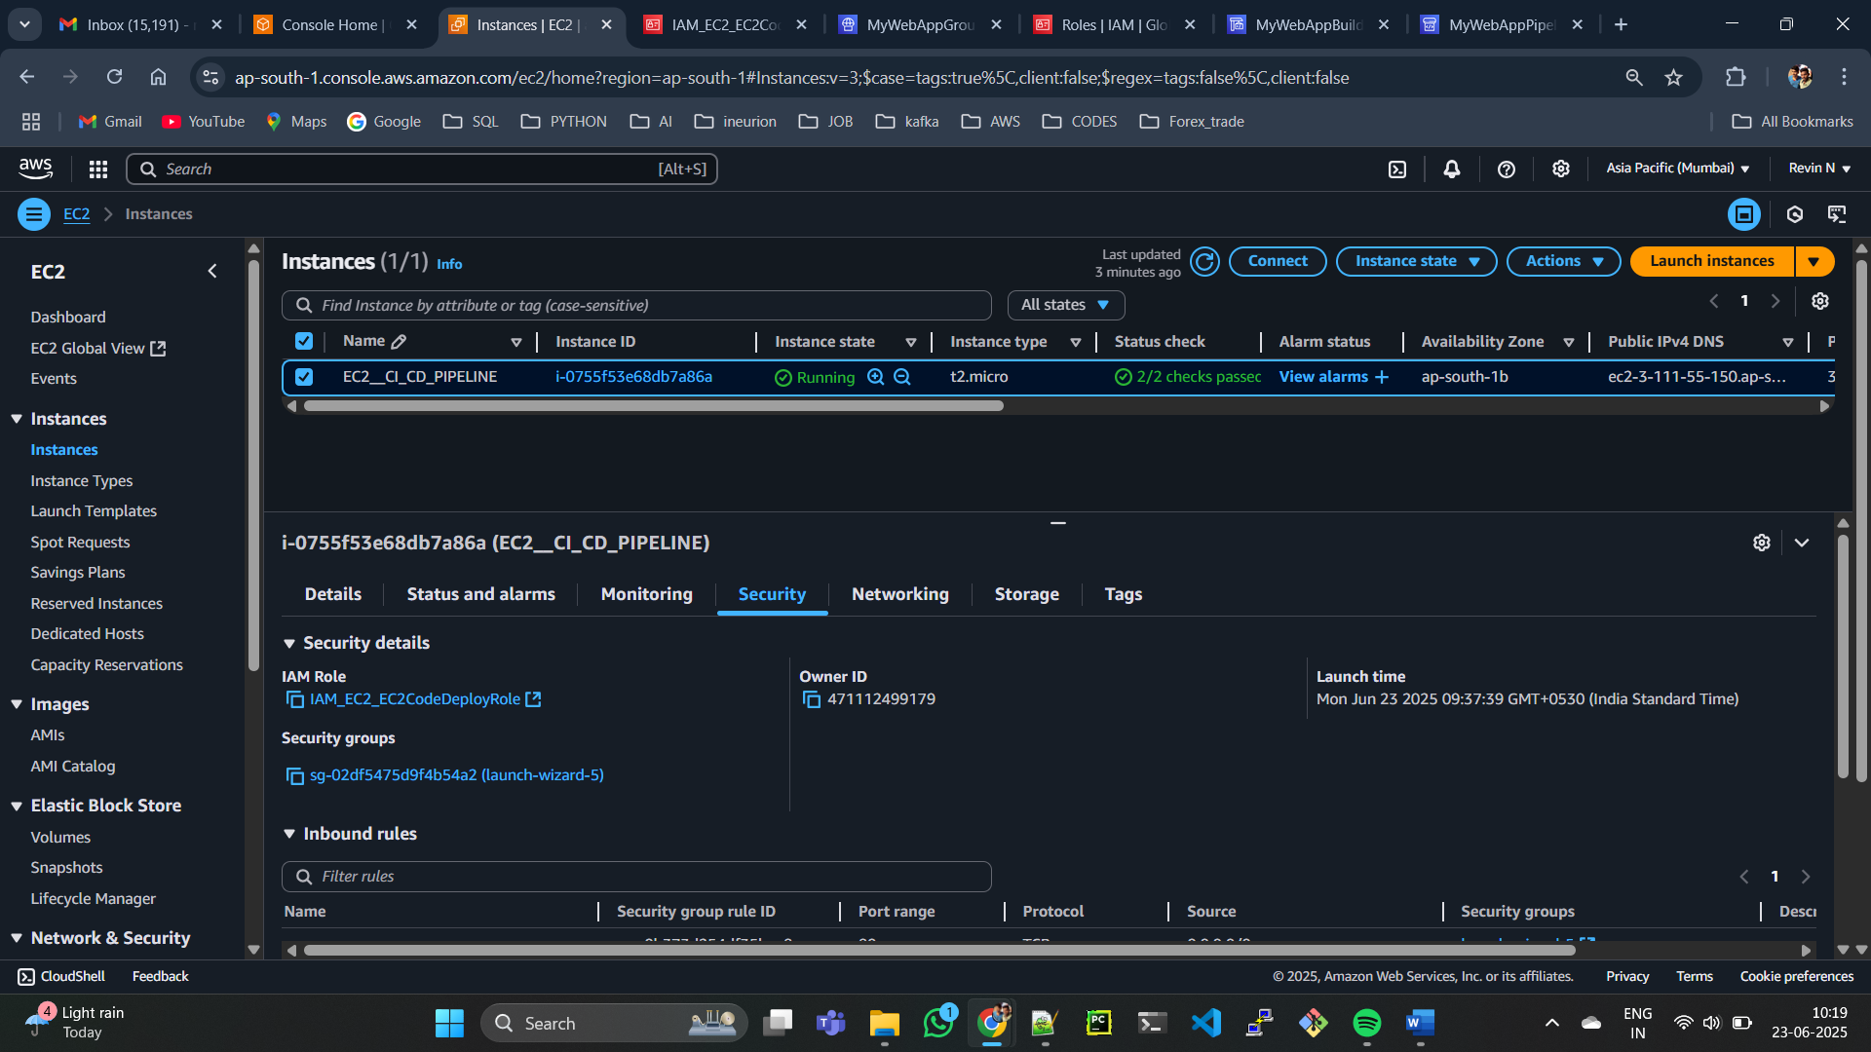

**Create IAM Roles:**

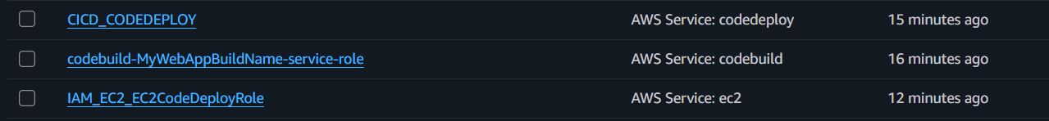

**CodeDeploy Setup:**

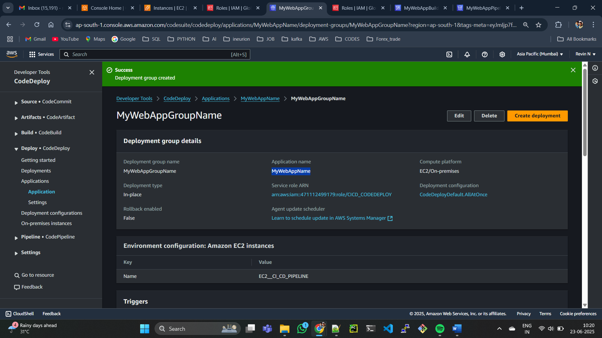

**Create CodeBuild Project:**

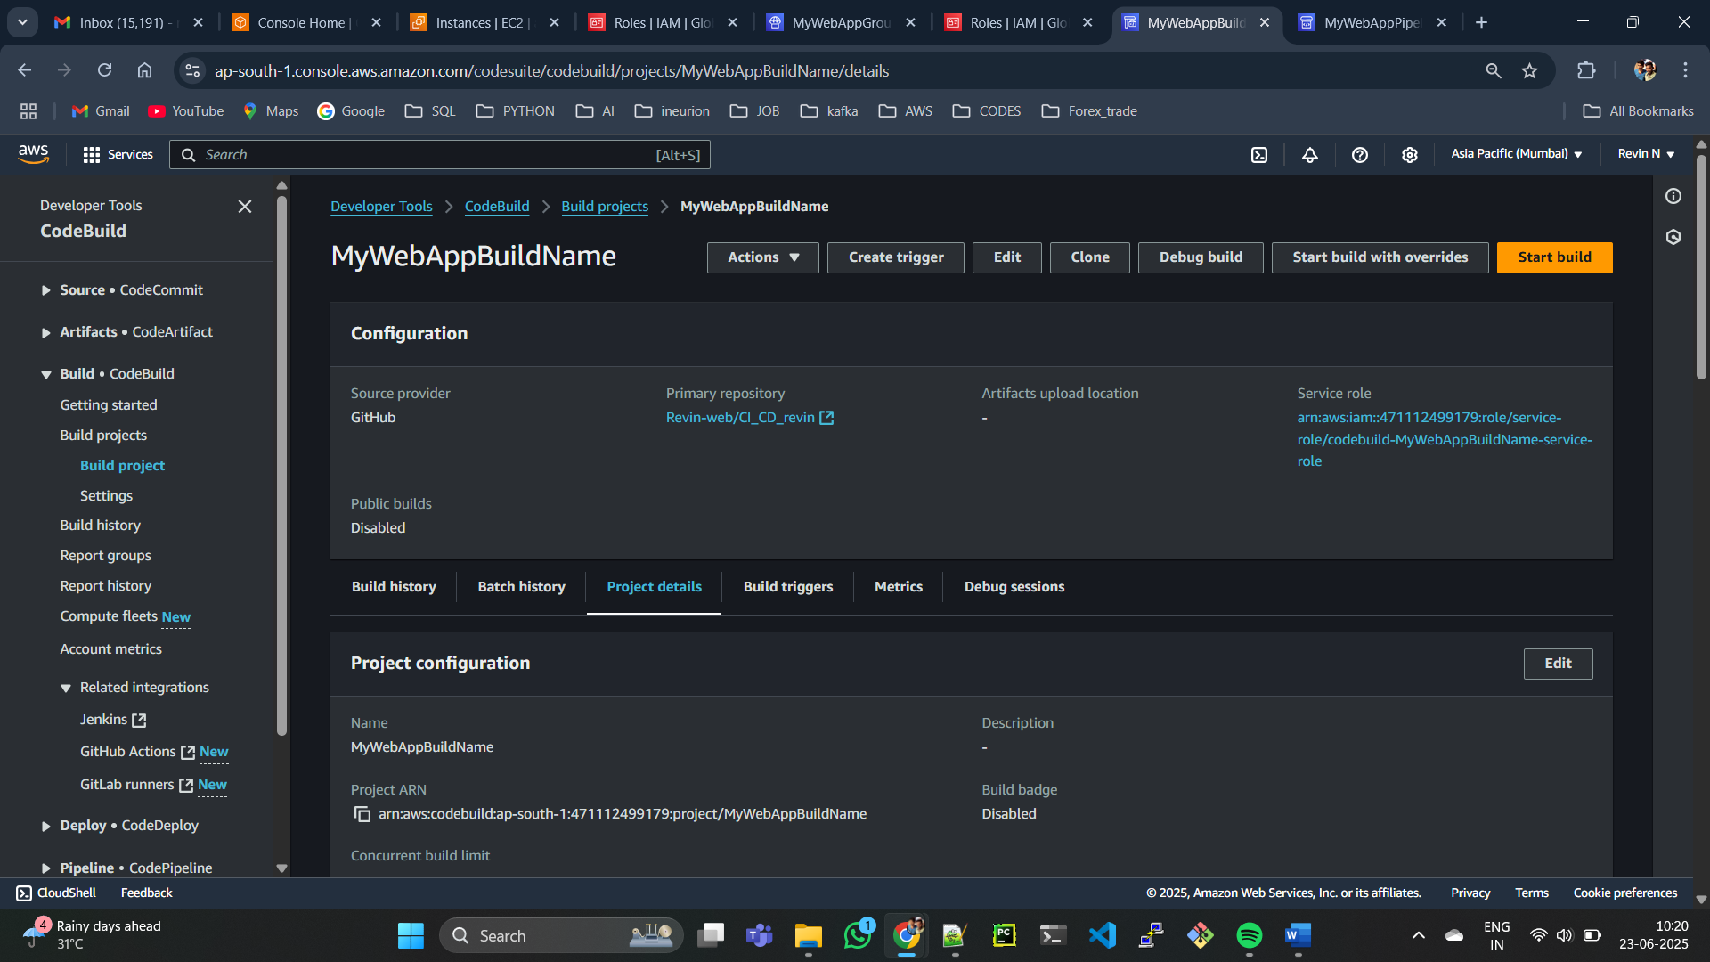

**Create CodePipeline:**

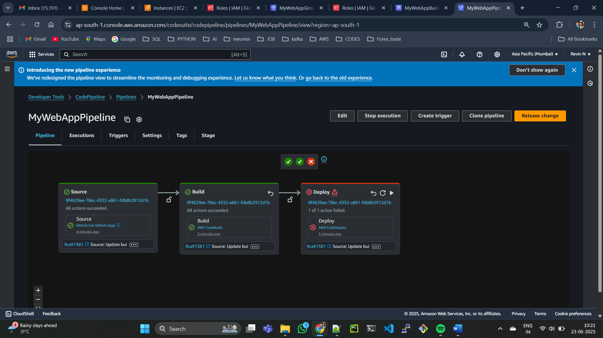

**Note:**

*) Last Step failing , I have tried more than 7 time ..

*) I followed all the steps which was thought in class but still fails.

*) Even in live class season this deploy got failed .

*) If you have solution for this guide us.