Create a custom docker image for nginx and deploy it using docker compose, where the volume bind mount should be at /var/opt/nginx location. Push the created custom docker image to your docker-hub.

Step1: launch EC2

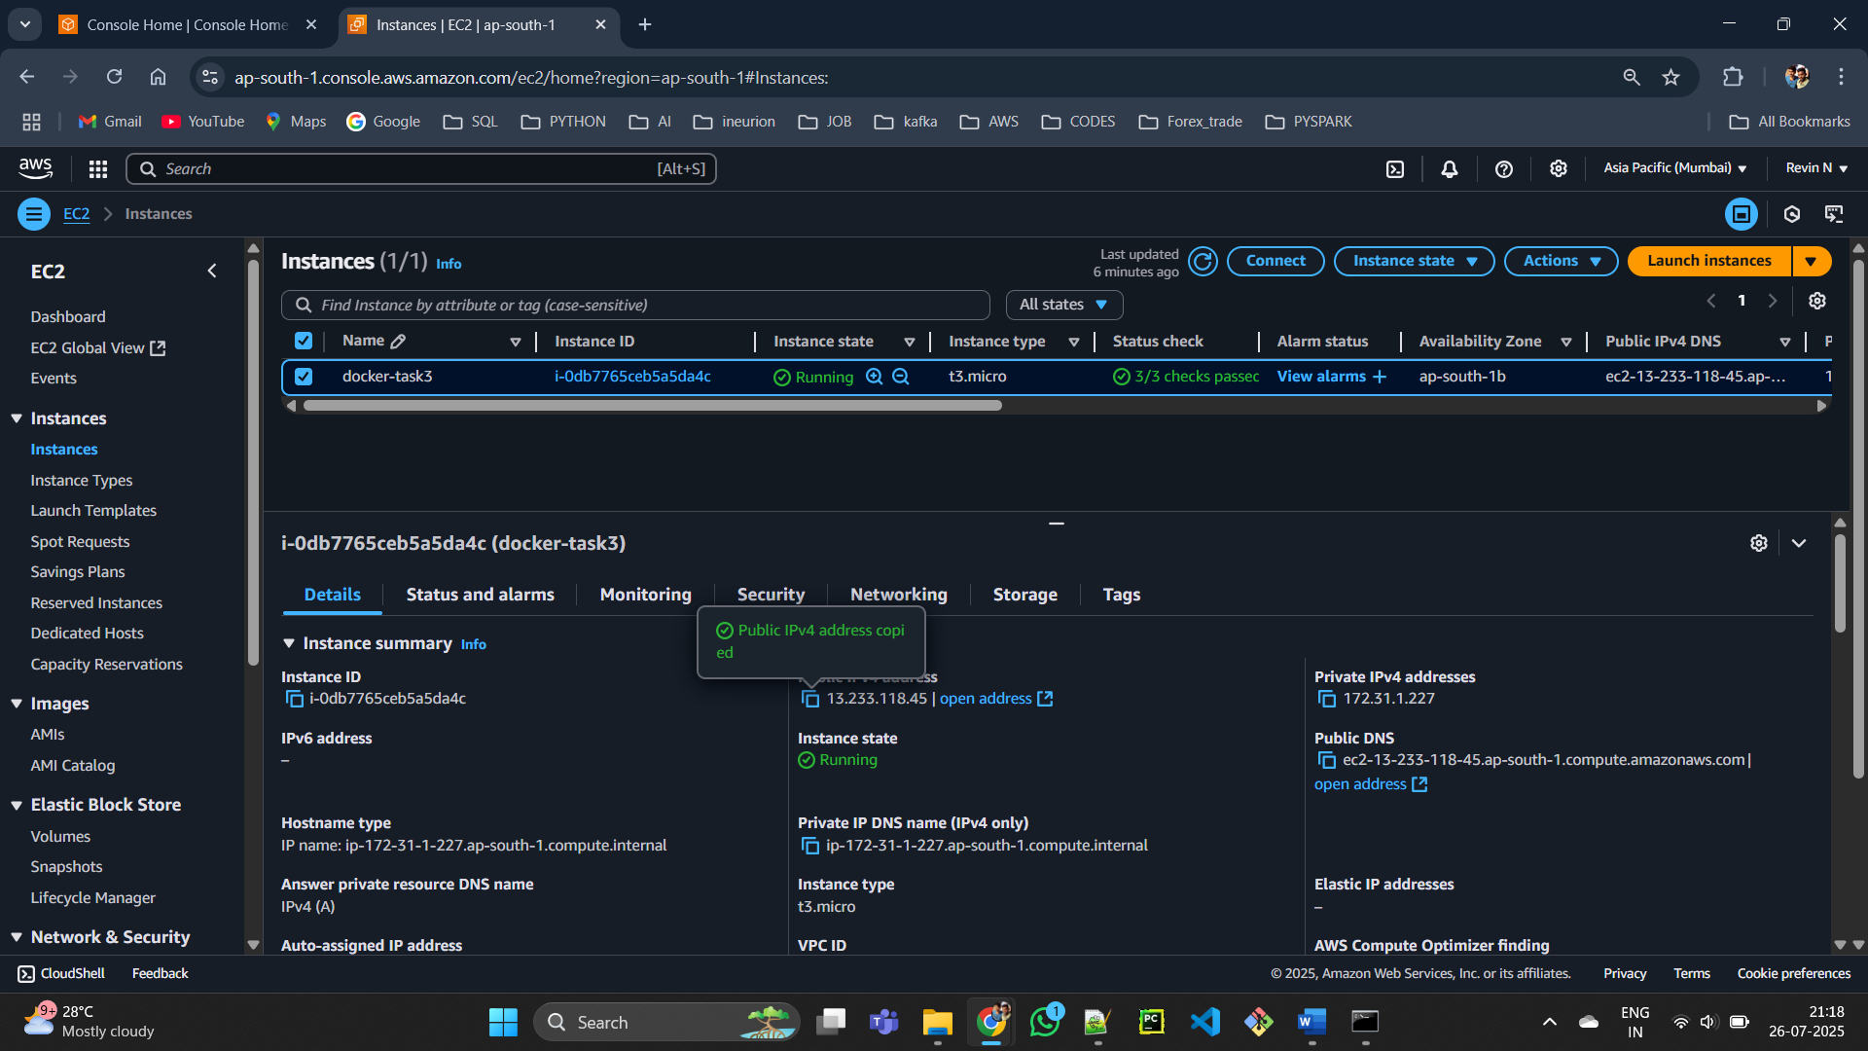

Step2: Install Docker and Docker Compose.

Step3: create docker , docker compose ,html file

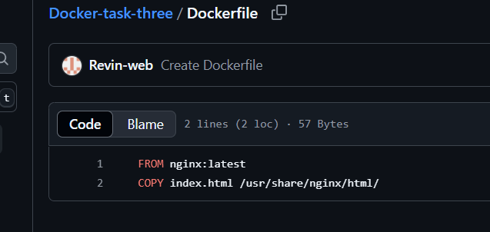

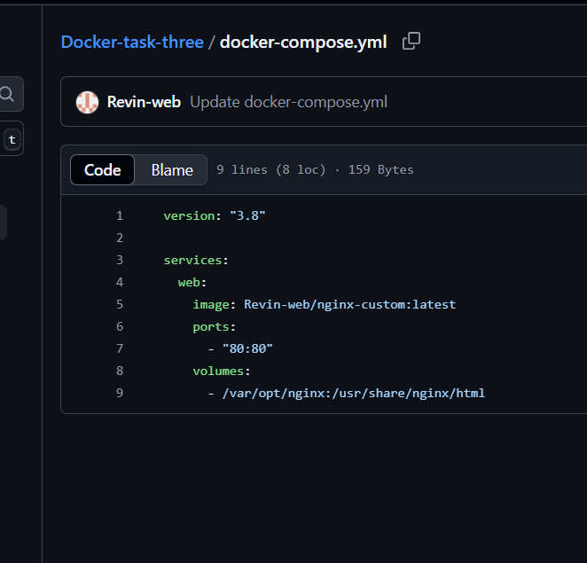

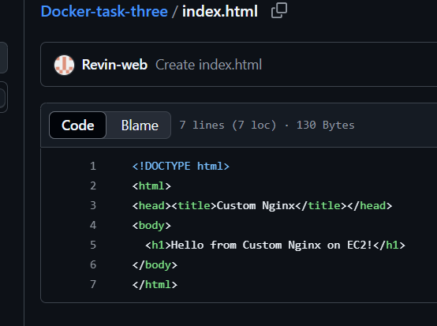

Step4:

