Create a directory called "my_folder" :

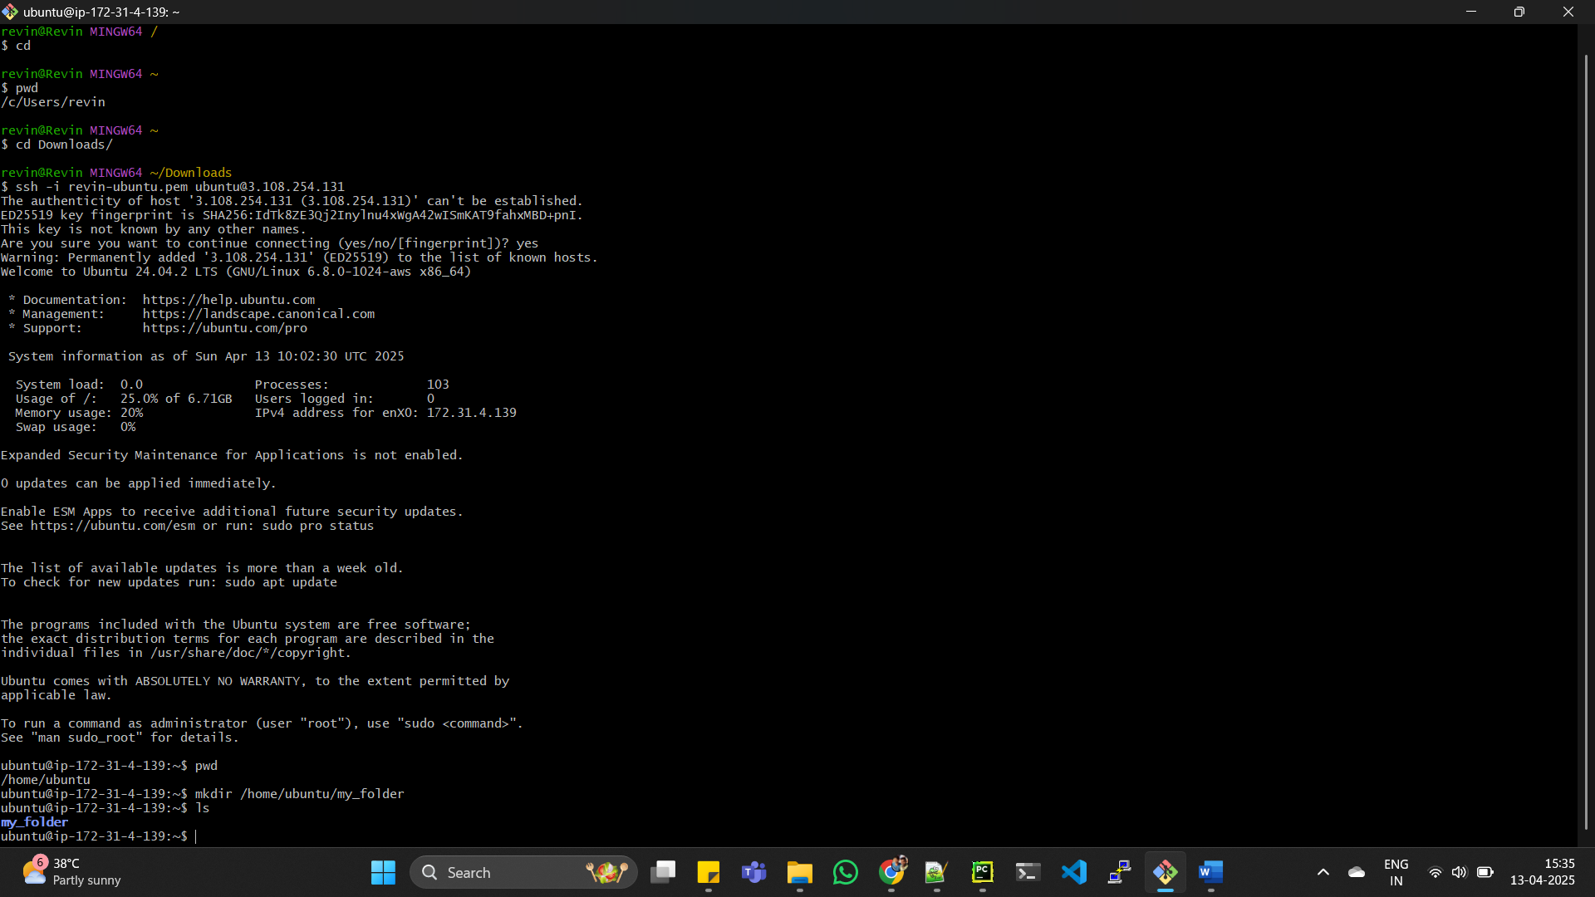

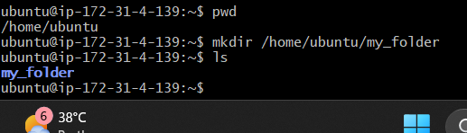

2) create a file named ""my_file.txt"" with some text :

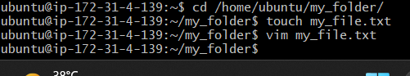

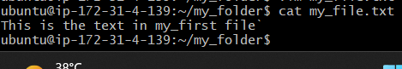

3) create another file named ""another_file.txt"" with some text:

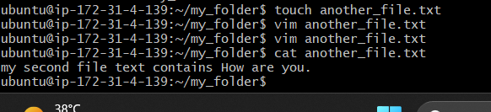

4) Moved my_file.txt content into another_file.txt:

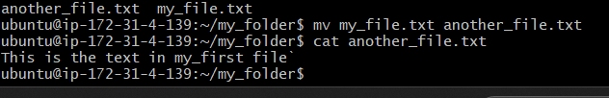

5) Finally, list all files and directories in the current directory:

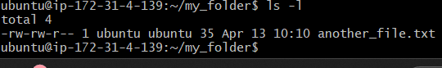

8) Print the latest created top 5 files among the total no of files:

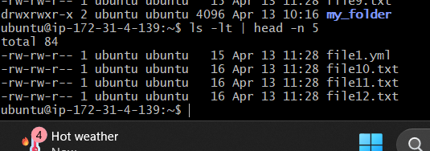

6)Create 20 files with .txt extensions:

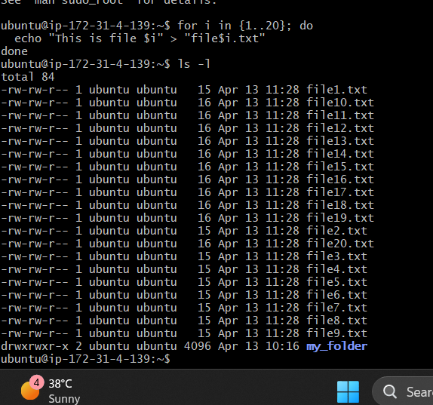

7)  rename the first 5 files to .yml :

