**Software Requirements Specification**

**SLYP Project**



**February 14, 2016**

**Team 1**

**Kieran Dunbar**

**Michael Carbone**

**Kevin Reynolds**

**Meagan Johnson**

**Kevin Caulfield**

**1. Introduction**

**1.1 Purpose of Document**

The purpose of this document is to provide a detailed description of the requirements for the Slyp product. It will illustrate the purpose and features of the product, the expected interfaces of the product, what the product will do, and the constraints under which it will operate. This document describes the product’s audience and is meant to be used as a reference by the team for development.

**1.2 Scope of the Development Project**

The product under development is called Slyp. Slyp is designed to enable the migration of virtual machines between three hypervisors: vSphere, Hyper-V and AWS-EC2. Slyp’s primary functions are: exporting virtual machines, converting virtual disks between .vmdk and .vhd formats, and deploying virtual machines. Slyp’s most distinct feature is the ability to execute these functions in sequence, migrating a virtual machine from one virtualization platform to another. This will allow the user to relocate virtual machines in the event of a hypervisor specific vulnerability or replicating a vm both on a public cloud and a private datacenter. Slyp is limited to working with vSphere, Hyper-V and AWS-EC2.

***1.3 Definitions, Acronyms, and Abbreviations***

***1.3.1 Definitions***

|  |  |
| --- | --- |
| **Term** | **Definitions** |
| Amazon Web Services | The cloud computing platform developed by Amazon |
| Bucket | An instance of the AWS storage service S3. |
| Microsoft Hyper-V | An instance of the type 1 hypervisor developed by Microsoft. When used in the document, Hyper-V refers to a deployment of one or more Hyper-V hosts. Slyp will interface directly with Hyper-V hosts. |
| Active Directory | A directory service developed by Microsoft for Windows domain networks. |
| Powershell | Shell scripting language developed by Microsoft for ease of local and remote management. |
| VMware vSphere | An instance of the virtualization software suite developed by VMware. In this document, vSphere refers to a deployment of VMware ESXi hosts being managed by a vCenter server. Slyp will interface directly with the vCenter server. |
| VMware ESXi | The type 1 hypervisor developed by VMware used to virtualize operating systems |
| VMware vCenter | A modified version of Suse Linux used to manage multiple ESXi hosts and enable advanced functionality of the vSphere suite. |
| Virtual Machine | Refers to a virtualized operating system. Includes the configuration files and virtual hard disks. |

**1.3.2 Acronyms and Abbreviations**

|  |  |
| --- | --- |
| **Acronym** | **Definition** |
| 2012 R2 | Windows Server 2012 R2 |
| AWS | Amazon Web Services |
| AD | Active Directory |
| CLI | Command-line interface |
| ESXi | Elastic Sky X |
| EC2 | Elastic Compute Cloud |
| IP | Internet Protocol |
| HV | Hyper-V |
| OVF | Open Virtualization Format |
| OVA | Open Virtualization Archive |
| PS | Powershell |
| S3 | [Amazon Simple Storage Service](https://aws.amazon.com/s3/) |
| SDK | Software Development Kit |
| VHD | Virtual Hard Disk. 2TB capacity |
| VHDX | Virtual Hard Disk. 64TB capacity + error correcting |
| VM | Virtual Machine |
| VMS | Virtual Machines |
| VMDK | Virtual Machine Disk |
| VS | vSphere |
| XML | Extensible Markup Language |

**1.4 References**

1. Amazon Web Services, Inc. "Amazon Web Services (AWS) - Cloud Computing Services." Amazon Web Services, Inc. Amazon Web Services, Inc., n.d. Web. 23 Mar. 2016.
2. AWS. (n.d.). Python. Retrieved March 24, 2016, from https://aws.amazon.com/developers/getting-started/python/
3. Boto. (n.d.). Boto/boto. Retrieved March 24, 2016, from https://github.com/boto/boto
4. Boto3 Reference. (n.d.). Retrieved February 12, 2016, from https://boto3.readthedocs.org/en/latest/reference/core/boto3.html
5. Daems, S. (2014, August 28). VMware: Nesting Hyper-V 2012 R2 on vSphere ESXi 5.5. Retrieved March 20, 2016, from http://blog.vmpros.nl/2014/08/28/vmware-nesting-hyper-v-2012-r2-on-vsphere-esxi-5-5/
6. Frommel, O. (n.d.). Controlling Amazon Cloud with Boto » ADMIN Magazine. Retrieved March 24, 2016, from http://www.admin-magazine.com/Articles/Integrating-AWS-Cloud-Services-with-Your-Custom-Apps
7. Garnaat, M. (n.d.). Boto: A Python interface to Amazon Web Services. Retrieved March 24, 2016, from http://boto.cloudhackers.com/en/latest/
8. Garnaat, M. (n.d.). Boto 2.39.0 : Python Package Index. Retrieved March 24, 2016, from https://pypi.python.org/pypi/boto
9. Hyper-V Cmdlets. (n.d.). Retrieved February 12, 2016, from https://technet.microsoft.com/en-us/library/hh848559.aspx
10. Jha, V. (n.d.). Getting Started with Boto (python Interface for AWS ) TO THE NEW Blog | TO THE NEW Blog. Retrieved March 24, 2016, from http://www.tothenew.com/blog/getting-started-with-boto-python-interface-for-aws/
11. Manage Hyper-V Server Remotely. (2012, September 4). Retrieved March 20, 2016, from https://technet.microsoft.com/en-us/library/jj647785.aspx
12. Omta, T. (2015, June 11). How to Convert a VMWare VMDK to Hyper-V VHD. Retrieved March 20, 2016, from https://blogs.msdn.microsoft.com/timomta/2015/06/11/how-to-convert-a-vmware-vmdk-to-hyper-v-vhd/
13. Osborne, R. (2013, March 10). Windows Server 2012 Hyper-V Best Practices (In Easy Checklist Form). Retrieved March 20, 2016, from <https://blogs.technet.microsoft.com/askpfeplat/2013/03/10/windows-server-2012-hyper-v-best-practices-in-easy-checklist-form/>
14. Poojary, N. (2015). Boto: Using Python to automate AWS services. Retrieved March 24, 2016, from http://cloudacademy.com/blog/boto-python-automate-aws-services/
15. Siron, E. (2013, October 16). Storage and Hyper-V Part 4: Formatting and File Systems. Retrieved March 20, 2016, from http://www.altaro.com/hyper-v/storage-and-hyper-v-part-4-file-systems/
16. System Requirements and Installation Information for Windows Server 2012 R2. (2015, October 20). Retrieved March 20, 2016, from <https://technet.microsoft.com/en-us/library/dn303418.aspx>
17. Vanover, R. (2011, September 14). Nesting Hyper-V with VMware Workstation 8 and ESXi 5. Retrieved March 20, 2016, from https://www.veeam.com/blog/nesting-hyper-v-with-vmware-workstation-8-and-esxi-5.html
18. VSphere 6.0 Documentation Center. (n.d.). Retrieved February 12, 2016, from http://pubs.vmware.com/vsphere-60/index.jsp?topic=/com.vmware.wssdk.apiref.doc/right-pane.html
19. VMware, Inc. "Cloud Computing." With VMware Cloud Technology. VMware, Inc., n.d. Web. 23 Mar. 2016.
20. Vmware/pyvmomi. (n.d.). Retrieved February 12, 2016, from https://github.com/vmware/pyvmomi
21. Dunbar, K., Johnson, M., Reynolds, K., Caulfield, K., & Carbone, M. (n.d.). Software Requirement Specification SLYP Project.

**1.5 Overview of Document**

The remaining sections of this document outline a general description of the product, specific product requirements, other requirements, and the use cases. The general description of the product is discussed in section 2, which is used to give an overview of the informal requirements and establish a context for the specific requirements. Section 3 discusses in technical terms the specific requirements of the product, which goes into detail explaining the external interface, functional, and performance requirements. Section 4 is dedicated to discussing other requirements, in this case, outlining the usability, performance, supportability, and reliability of the product. Section 5 contains the use cases.

**2. General Description**

**2.1 User Characteristics**

* Command line interface(CLI)
* CLI setup Wizard

**2.2 Product Perspective**

Stand alone, runs on windows server, runs against AWS, Microsoft Hyper V, VMware vSphere

External interfaces are powershell, Python, boto3, pyVmomi

**2.3 Overview of Functional Requirements**

1. The user will be able to store configuration data and credentials in Slyp for connecting to AWS
2. The user will be able to store configuration data and credentials in Slyp for connecting to Hyper V
3. The user will be able to store configuration data and credentials in Slyp for connecting to vSphere
4. The user will be able to list VMs running on AWS
5. The user will be able to list VMs running on Hyper-V
6. The user will be able to list VMs running on vSphere
7. The user will be able to retrieve the status of a given VM running in AWS
8. The user will be able to retrieve the status of a given VM running in Hyper-V
9. The user will be able to retrieve the status of a given VM running in vSphere
10. The user will be able to power on a given VM running in AWS
11. The user will be able to power on a given VM running in Hyper-V
12. The user will be able to power on a given VM running in vSphere
13. The user will be able to power off a given VM running in AWS
14. The user will be able to power off a given VM running in Hyper-V
15. The user will be able to power off a given VM running in vSphere
16. The user will be able to backup/export a given VM from AWS to shared storage
17. The user will be able to backup/export a given VM from Hyper-V to shared storage
18. The user will be able to backup/export a given VM from vSphere to shared storage
19. The user will be able to deploy/import a given VM into AWS from shared storage
20. The user will be able to deploy/import a given VM into Hyper-V from shared storage
21. The user will be able to deploy/import a given VM into vSphere from shared storage
22. The user will be able to convert an existing .VHD/.VHDX to a .vmdk
23. The user will be able to convert an existing .vmdk to a .VHD/.VHDX

*More information on each requirement can be found in section 3.2.x where x refers to the requirement number.

**2.4 Overview of Data Requirements**

The user will need to know the following information in order to operate Slyp correctly:

* Environment configuration for their Hypervisors
  + IP or Hostname
  + Port number(if applicable)
* User credentials for their Hypervisors
* EC2 access keys
* Active Directory Login
* Ingestion and Exporting Directories

**2.5 General Constraints, Assumptions, Dependencies, Guidelines**

Slyp requires a Windows Server 2012 R2 installation for its install base. This means that the 2012 R2 hardware minimum requirements apply and consist of the following:

1. 1.4GHz 64-bit processor
2. 512MB of RAM (For 2012 R2 to install in a vm, Allocate more than 800 MB RAM to the virtual machine you intend to install this release on, install, then reduce RAM)
3. 32GB of Disk space
4. Gigabit (10/100/1000baseT) Ethernet adapter
5. DVD drive (if you intend to install the operating system from DVD media)

General implementation will require Slyp to be connected via an IP network to at least one of the following: Hyper-V, vSphere, AWS.

To connect to Hyper-V, the 2012 R2 installation and the Hyper-V server must be joined to the same Active Directory forest and the 2012 R2 installation must have Powershell 4.0 installed (the latter comes installed by default on 2012 R2). Initial configuration is needed to set the IP/Hostname and the Credentials for Hyper-V access.

To connect to vSphere, the 2012 R2 installation requires IP connection to the vSphere machine. Initial Configuration is needed to set the IP/Hostname and the Credentials for vSphere access.

To connect to AWS, the 2012 R2 installation requires the python SDK for AWS EC2 called boto3. This module allows for instance control and import and export functionality to EC2 hosted by AWS. EC2 requires a private key in order to connect to the SDK.

Dependencies:

* Hyper-V
* Amazon Web Services
* PowerShell
* 2012R2 maybe same reqs
* Public Network connection
* vSphere
* Active Directory
* boto3
* python2.7
* pyVim
* pyVmomi

**2.6 User View of Product Use**

* The user will access Slyp through a CLI.
* The user will select an option based on the ones provided.

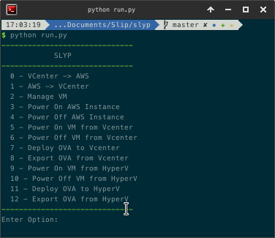

* The user will be able to edit the configuration and authentication for Slyp

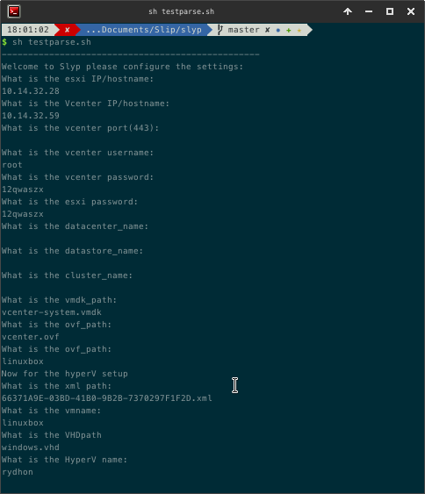

* The user will be able to power on or off the virtual machine after they edit the configuration.
* The user will be able to import and export the virtual machine from vSphere, Hyper-V, and AWS-EC2

**3. Specific Requirements**

**3.1 External Interface Requirements**

The necessary interfaces for interacting with Slyp consist of a qwerty keyboard and computer screen. The sole method of interaction with Slyp is a python command line interface. Powershell 4.0 is required for interaction with Hyper-V systems as it contains necessary commandlets for VM manipulation.

Python2.7 is required for Slyp to run. For full functionality the following python modules are needed:

* boto3: needed to connect to and control virtual instances on AWS EC2
* pyVmomi: Python implementation of the SDK for vSphere needed to connect and manage vSphere VMs
* subprocess: needed to launch powershell cmdlets from python
* sys: needed for common system functions
* os: needed for general Operating System related functions

Hypervisors:

vSphere: A virtual machine supplied by VMware that is used to manage several ESXi hosts in an environment.

Hyper-V: Microsoft’s Hypervisor

AWS-EC2: Amazon’s cloud based service for hosting virtual machines which include extensive SDKs

**3.2 Detailed Description of Functional Requirements**

1. Component Name: Configure AWS-EC2

•Purpose: The purpose of this requirement is to initially gather and later edit AWS-EC2 system information and access credentials. This will be done via the “Edit configuration” option from Slyp’s clui.

•Inputs to the Component: An interactive script will prompt the user to input AWS-EC2 system information and credentials as text.

•Processing: Parsing of interactive CLI script will determine the IP address or hostname of the target AWS-EC2 system as well as storing access credentials.

•Outputs: All information and credentials are stored an encrypted text file located on Slyp.

1. Component Name: Configure Hyper-V

•Purpose: The purpose of this requirement is to initially gather and later edit Hyper-V system information and access credentials.This will be done via the “Edit configuration” option from Slyp’s clui.

•Inputs to the Component: An interactive script will prompt the user to input Hyper-V system information and credentials as text.

•Processing: Parsing of interactive CLI script will determine the IP address or hostname of the target Hyper-V system as well as storing access credentials.

•Outputs: All information and credentials are stored an encrypted text file located on Slyp.

1. Component Name: Configure vSphere

•Purpose: The purpose of this requirement is to initially gather and later edit vSphere system information and access credentials. This will be done via the “Edit configuration” option from Slyp’s clui.

•Inputs to the Component: An interactive script will prompt the user to input vSphere system information and credentials as text.

•Processing: Parsing of interactive CLI script will determine the IP address or hostname of the target vSphere system as well as storing access credentials.

•Outputs: All information and credentials are stored an encrypted text file located on Slyp.

1. Component Name: List VMs on AWS-EC2

•Purpose: The purpose of this requirement is to return to the user a list of VMs running on the target AWS-EC2 system.

•Inputs to the Component: Text input via CLI by the user indicating which AWS-EC2 system they wish to list running VMs on.

•Processing: No processing is done, if the user input an invalid system name the user will get an error message informing them that the requested system was not found displayed on the CLI.

•Outputs: The output will be a list of VMs currently running on the target AWS-EC2 system.

1. Component Name: List VMs on Hyper-V

•Purpose: The purpose of this requirement is to return to the user a list of VMs running on the target Hyper-V system.

•Inputs to the Component: Text input via CLI by the user indicating which Hyper-V system they wish to list running VMs on.

•Processing: No processing is done, if the user input an invalid system name the user will get an error message informing them that the requested system was not found displayed on the CLI.

•Outputs: The output will be a list of VMs currently running on the target Hyper-V system.

1. Component Name: List VMs on vSphere

•Purpose: The purpose of this requirement is to return to the user a list of VMs running on the target vSphere system.

•Inputs to the Component: Text input via CLI by the user indicating which vSphere system they wish to list running VMs on.

•Processing: No processing is done, if the user input an invalid system name the user will get an error message informing them that the requested system was not found displayed on the CLI.

•Outputs: The output to the CLI will be a list of VMs currently running on the target vSphere system.

1. Component Name: Get status of VM on AWS-EC2

•Purpose: The purpose of this requirement is to return to the user the status of a specified VM running on the target AWS-EC2 system. This will be done via the “Get status” option from Slyp’s clui.

•Inputs to the Component: Text input via CLI by the user indicating the VM they need the status of and which AWS-EC2 system they wish to query for the status of the given VM

•Processing: No processing is done, if the user inputs an invalid system or VM name the user will get an error message informing them that the requested system or VM was not found displayed on the CLI.

•Outputs: The output will be the status of the given VM running on the target AWS-EC2 system shown on the CLI.

1. Component Name: Get status VM on Hyper-V

•Purpose: The purpose of this requirement is to return to the user the status of a specified VM running on the target Hyper-V system. This will be done via the “Get status” option from Slyp’s clui.

•Inputs to the Component: Text input via CLI by the user indicating the VM they need the status of and which Hyper-V system they wish to query for the status of the given VM

•Processing: No processing is done, if the user inputs an invalid system or VM name the user will get an error message informing them that the requested system or VM was not found displayed on the CLI.

•Outputs: The output will be the status of the given VM running on the target Hyper-V system shown on the CLI.

1. Component Name: Get status VM on vSphere

•Purpose: The purpose of this requirement is to return to the user the status of a specified VM running on the target vSphere system. This will be done via the “Get status” option from Slyp’s clui.

•Inputs to the Component: Text input via CLI by the user indicating the VM they need the status of and which vSphere system they wish to query for the status of the given VM

•Processing: No processing is done, if the user inputs an invalid system or VM name the user will get an error message informing them that the requested system or VM was not found displayed on the CLI.

•Outputs: The output will be the status of the given VM running on the target vSphere system shown on the CLI.

1. Component Name: Power on VM in AWS-EC2

•Purpose: The purpose of this requirement is to power on a specified VM running on the target AWS-EC2 system. This will be done via the “Power on” option from Slyp’s clui.

•Inputs to the Component: Text input via CLI by the user indicating the VM that is being powered on and which AWS-EC2 system the given VM is running on.

•Processing: No processing is done, if the user inputs an invalid system or VM name the user will get an error message informing them that the requested system or VM was not found displayed on the CLI.

•Outputs: The output will be whether or not the given VM is now running on the target AWS-EC2 system shown on the CLI.

1. Component Name: Power on VM in Hyper-V

•Purpose: The purpose of this requirement is to power on a specified VM running on the target Hyper-V system. This will be done via the “Power on” option from Slyp’s clui.

•Inputs to the Component: Text input via CLI by the user indicating the VM that is being powered on and which Hyper-V system the given VM is running on.

•Processing: No processing is done, if the user inputs an invalid system or VM name the user will get an error message informing them that the requested system or VM was not found displayed on the CLI.

•Outputs: The output will be whether or not the given VM is now running on the target Hyper-V system shown on the CLI.

1. Component Name: Power on VM in vSphere

•Purpose: The purpose of this requirement is to power on a specified VM running on the target vSphere system. This will be done via the “Power on” option from Slyp’s clui.

•Inputs to the Component: Text input via CLI by the user indicating the VM that is being powered on and which vSphere system the given VM is running on.

•Processing: No processing is done, if the user inputs an invalid system or VM name the user will get an error message informing them that the requested system or VM was not found displayed on the CLI.

•Outputs: The output will be whether or not the given VM is now running on the target vSphere system shown on the CLI.

1. Component Name: Power off VM in AWS-EC2

•Purpose: The purpose of this requirement is to power on a specified VM running on the target AWS-EC2 system. This will be done via the “Power off” option from Slyp’s clui.

•Inputs to the Component: Text input via CLI by the user indicating the VM that is being powered off and which AWS-EC2 system the given VM is running on.

•Processing: No processing is done, if the user inputs an invalid system or VM name the user will get an error message informing them that the requested system or VM was not found displayed on the CLI.

•Outputs: The output will be whether or not the given VM was powered off successfully on the target AWS-EC2 system shown on the CLI.

1. Component Name: Power off VM in Hyper-V

•Purpose: The purpose of this requirement is to power off a specified VM running on the target Hyper-V system. This will be done via the “Power off” option from Slyp’s clui.

•Inputs to the Component: Text input via CLI by the user indicating the VM that is being powered off and which Hyper-V system the given VM is running on.

•Processing: No processing is done, if the user inputs an invalid system or VM name the user will get an error message informing them that the requested system or VM was not found displayed on the CLI.

•Outputs: The output will be whether or not the given VM was powered off successfully on the target Hyper-V system shown on the CLI.

1. Component Name: Power off VM in vSphere

•Purpose: The purpose of this requirement is to power on a specified VM running on the target vSphere system. This will be done via the “Power off” option from Slyp’s clui.

•Inputs to the Component: Text input via CLI by the user indicating the VM that is being powered off and which vSphere system the given VM is running on.

•Processing: No processing is done, if the user inputs an invalid system or VM name the user will get an error message informing them that the requested system or VM was not found displayed on the CLI.

•Outputs: The output will be whether or not the given VM was powered off successfully on the target vSphere system shown on the CLI.

1. Component Name: Export VM to shared storage from AWS-EC2

•Purpose: The purpose of this requirement is to export a VM from AWS-EC2 to shared storage for the purposes of either backup or migration. This will be done via the “Export VM” option from Slyp’s clui.

•Inputs to the Component: Text input via CLI by the user indicating the AWS-EC2 system the VM is running on, the VM to be exported and the destination shared storage.

•Processing: No processing is done, if the user inputs an invalid system or VM name the user will get an error message informing them that the requested system, VM, or shared storage was not found displayed on the CLI.

•Outputs: The output will be whether or not the export of the given VM from AWS-EC2 to the given destination was successful shown on the CLI.

1. Component Name: Export VM to shared storage from Hyper-V

•Purpose: The purpose of this requirement is to export a VM from Hyper-V to shared storage for the purposes of either backup or migration. This will be done via the “Export VM” option from Slyp’s clui.

•Inputs to the Component: Text input via CLI by the user indicating the Hyper-V system the VM is running on, the VM to be exported and the destination shared storage.

•Processing: No processing is done, if the user inputs an invalid system or VM name the user will get an error message informing them that the requested system, VM, or shared storage was not found displayed on the CLI.

•Outputs: The output will be whether or not the export of the given VM from Hyper-V to the given destination was successful shown on the CLI.

1. Component Name: Export VM to shared storage from vSphere

•Purpose: The purpose of this requirement is to export a VM from vSphere to shared storage for the purposes of either backup or migration. This will be done via the “Export VM” option from Slyp’s clui.

•Inputs to the Component: Text input via CLI by the user indicating the vSphere system the VM is running on, the VM to be exported and the destination shared storage.

•Processing: No processing is done, if the user inputs an invalid system or VM name the user will get an error message informing them that the requested system, VM, or shared storage was not found displayed on the CLI.

•Outputs: The output will be whether or not the export of the given VM from vSphere to the given destination was successful shown on the CLI.

1. Component Name: Import VM from shared storage to AWS-EC2

•Purpose: The purpose of this requirement is to import a VM to AWS-EC2 from shared storage for the purposes of either deployment or migration. This will be done via the “Import VM” option from Slyp’s clui.

•Inputs to the Component: Text input via CLI by the user indicating the AWS-EC2 system the VM is running on, the VM to be imported and the origin shared storage.

•Processing: No processing is done, if the user inputs an invalid AWS-EC2 system, VM name or shared storage address the user will get an error message informing them that the requested system, VM, or shared storage was not found displayed on the CLI.

•Outputs: The output will be whether or not the import of the given VM to AWS-EC2 from the given origin shared storage was successful shown on the CLI.

1. Component Name: Import VM from shared storage to Hyper-V

•Purpose: The purpose of this requirement is to import a VM to Hyper-V from shared storage for the purposes of either deployment or migration. This will be done via the “Import VM” option from Slyp’s clui.

•Inputs to the Component: Text input via CLI by the user indicating the Hyper-V system the VM is running on, the VM to be imported and the origin shared storage.

•Processing: No processing is done, if the user inputs an invalid Hyper-V system, VM name or shared storage address the user will get an error message informing them that the requested system, VM, or shared storage was not found displayed on the CLI.

•Outputs: The output will be whether or not the import of the given VM to Hyper-V from the given origin shared storage was successful shown on the CLI.

1. Component Name: Import VM from shared storage to vSphere

•Purpose: The purpose of this requirement is to import a VM to vSphere from shared storage for the purposes of either deployment or migration. This will be done via the “Import VM” option from Slyp’s clui.

•Inputs to the Component: Text input via CLI by the user indicating the vSphere system the VM is running on, the VM to be imported and the origin shared storage.

•Processing: No processing is done, if the user inputs an invalid vSphere system, VM name or shared storage address the user will get an error message informing them that the requested system, VM, or shared storage was not found displayed on the CLI.

•Outputs: The output will be whether or not the import of the given VM to vSphere from the given origin shared storage was successful shown on the CLI.

1. Component Name: Convert .VHD/VHDX to .VMDK

•Purpose: The purpose of this requirement is to convert a .VHD/VHDX disk image into a .VMDK disk image.

•Inputs to the Component: Text input via CLI by the user indicating the path to the .VHD/VHDX disk image to be converted and the destination path.

•Processing: No processing is done, if the user inputs an invalid path for either argument the user will get an error message informing them that one of the paths was invalid displayed on the CLI.

•Outputs: The output will be whether or conversion was successful shown on the CLI.

1. Component Name: Convert .VMDK to .VHD/VHDX

•Purpose: The purpose of this requirement is to convert a .VMDK disk image into a .VHD/VHDX disk image.

•Inputs to the Component: Text input via CLI by the user indicating the path to the .VMDK disk image to be converted and the destination path.

•Processing: No processing is done, if the user inputs an invalid path for either argument the user will get an error message informing them that one of the paths was invalid displayed on the CLI.

•Outputs: The output will be whether or conversion was successful shown on the CLI.

**3.3 Performance Requirements**

Refer to section 4.

**3.4 Quality Attributes**

Refer to section 4.

**4. Other Requirements**

**4.1 Usability:**

Slyp is intended for use by Network Admins/technicians who are able to use CLI applications. Slyp is intended to be used in a daemonized mode or by one user at a specific time.

**4.2 Performance:**

**Response time** - Response time varies between 5ms to 500ms (trending closer to 5ms) depending on the proximity to the targets and the speed of the network connecting Slyp to the target.

**Throughput** - Throughput varies from system to system.

* Development tests indicate that a 34 GB Windows server 2012 R2 VM thin provisioned at 6.6GBs was exported in 1:42 on average.
* The same tests indicate that a 16 GB Ubuntu web server VM thin provisioned at 2.35 GB was exported in 48s on average.
* The two VMs were transferred from Hyper-V to a NAS across a gigabit network at an average speed of 112MB/s. 8.95 GB in 1:25
* The two VMs were transferred from from the NAS to Hyper-V across a gigabit network at an average speed of 111MB/s. 8.95 GB in 1:27
* Importing the VMs from a local drive into Hyper-V took 20s on average.
* Assuming a 1m conversion time, the estimated migration time for 2 VMs at 2.35 and 6.6GB is approximately 7.5 minutes.

**Scalability** - Slyp is considered highly scalable. Due to the external systems doing the majority of the disk and processor intensive work, the only work Slyp will have to do is converting disk images between VHD and vmdk. On a minimum requirement system, Slyp will be able to convert a single 6GB disk in 2 minutes. For larger migrations or simultaneous image conversion, a higher specced machine is recommended.

**Availability** - Due to the fact that Slyp is primarily a migration tool, availability is not directly applicable. Slyp is only as available as the system it is installed upon.

**4.3 Supportability:**

**Adaptability** - Slyp is supported only on Server 2012 R2.The supported version of external systems are 5.5 and up for vSphere and Hyper V Server 2012 R2 or Hyper V on Server 2012 R2.

**Maintainability** - Slyp is an open source project so the source code will be posted on GitHub where users will be able modify the source code to fix any errors unique to their deployment. These modifications can be pushed upstream and will eventually be integrated with the products source.

**4.4 Reliability:**

**Robustness** - When receiving input, Slyp checks the input to see if it is valid before executing commands. This means that improperly formed Slyp commands won’t run, ensuring a robust system.

**Safety** - Slyp is safe. Due to its primarily read oriented nature, it never deletes any files, only creates backups, new VMs, and converted disk images. Even the conversions are non-destructive, leaving the original image intact while creating a converted copy.

**5. Use Cases**

*Edit configuration Use Case*

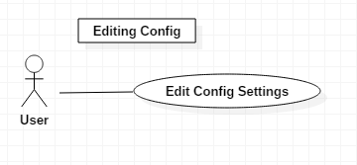

Description: The user will be able to edit their configuration settings for Hyper-V, ESXi, and AWS VM instances. This will allow for easy integration with Slyp. The user can select “Configuration” from the clui in order to edit the settings.

*Get Status of VM Use Case*

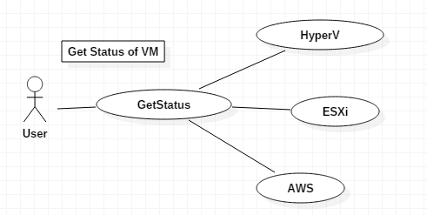

Description: The user will be able to get the status of their Hyper-V, ESXi, and AWS VM instances via Slyp’s CLI commands.The user can select the target hypervisor from the clui, then select “Get status” for that hypervisor.

*Power On VM Use Case*

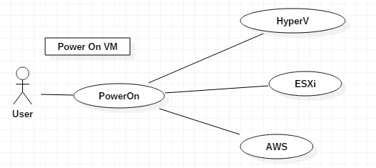

Description: The user will be able to power on their Hyper-V, ESXi, and AWS VM instances via Slyp’s CLI commands.The user can select the target hypervisor from the clui, then select “Power on” for that hypervisor.

*Power Off VM Use Case*

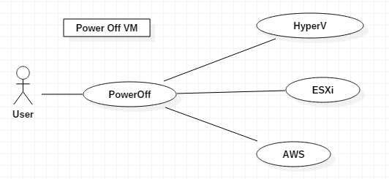

Description: The user will be able to power off their Hyper-V, ESXi, and AWS VMs via Slyp’s CLI commands.The user can select the target hypervisor from the clui, then select “Power off” for that hypervisor.

*Export VM Use Case*

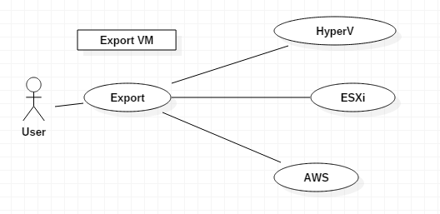

Description: The user will be able to export their HyperV, ESXi, and AWS VM instances via Slyp’s CLI commands.The user can select the target hypervisor from the clui, then select “Export” for that hypervisor.

*Convert .ova to .vhd Use Case*

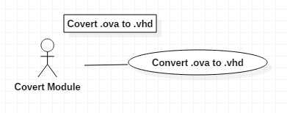

Description: The convert module will convert .ova files to .vhd files. This is necessary in order to move a VM image from one hypervisor to another.

*Convert .vhd to .ova Use Case*

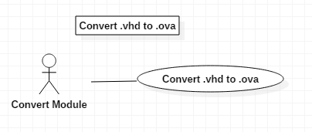

Description: The convert module will convert .vhd files to .ova files. This is necessary in order to move a VM image from one hypervisor to another.

*Import VM Use Case*

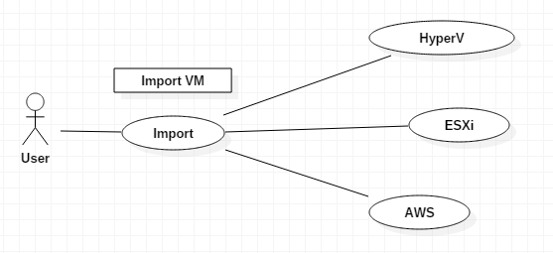

Description: The user will be able to import their HyperV, ESXi, and AWS VM instances via Slyp’s CLI commands.The user can select the target hypervisor from the clui, then select “Import” for that hypervisor.

*Migrate VM Use Case*

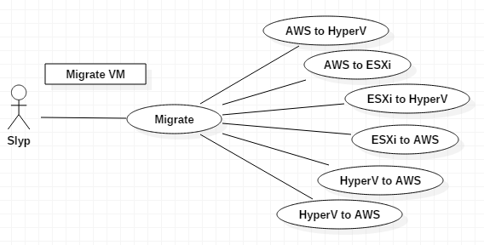

Description: Slyp will migrate any Hyper-V, ESXi, or AWS VM instance to any other AWS, ESXi, or AWS instance. Slyp will do this using the export, convert, and import scripts. To migrate a VM image, the user can select the source hypervisor to export, followed by the target hypervisor to import.

**6. System design diagram:**

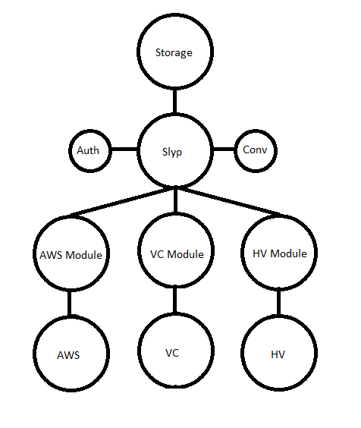

This is the overall system design diagram for Slyp. When Slyp is initiated, the user will select one of the three hypervisors to interact with. Once a hypervisor is selected, the user will choose whether they want to Get Status, Power On, Power Off, Import VM, or Export VM from that hypervisor. Authentication will take place by checking the configuration file. The module for the specified hypervisor will handle all processes with that hypervisor. If import or export are chosen, the VM image will be stored or retrieved from the shared storage on Slyp. If necessary, an image will be converted in order to be compatible with another hypervisor.

**7. Data flow diagram:**

