论文题目 | Xxxxxxxxxxxxxxxxxxx
学院名称 | 软件学院
专业名称 | 软件工程
学生姓名 | Xxxx
指导教师 | 校内 校外

二○二四年 六月

学号 |  |  | 密级

东北大学本科毕业设计（论文）

高速省际通行车辆特征抽取和可视化工具的
设计与实现

学 院 名 称： | 软件学院
专 业 名 称： | 软件工程
学 生 名 称： | 张三
指 导 教 师： | 李四 | 副教授
 | 王五 | 工程师

二○二四 年 六 月

Design and Implementation of Feature Extraction and Visualization Tools for High-Speed Inter Province Vehicles

Author: | Zhang San
Supervisor: | Li Si | Professor
Enterprise Supervisor | Wang Wu | Engineer
College: | Software College
Major: | Software Engineering  (International (English))

Northeastern University
June 20xx

高速省际通行车辆特征抽取和可视化工具的
设计与实现

作者姓名： | 张三
校内指导教师： | 李四 | 教授
校外指导教师： | 王五 | 工程师
单位名称： | 软件学院
专业名称： | 软件工程(国际(英语))

东 北 大 学
2024 年 6 月

DECLARATION

The graduation thesis submitted by me is the result of independent research work under the guidance of my supervisors. All data and images are authentic and reliable. As far as I know, the research results of this thesis do not include the content of copyright shared by others, except at references in the text. Other individuals and groups that have contributed to the research work involved in this thesis have been clearly identified. The intellectual property rights of this thesis are attributed to the training unit.

Signature: | Date:

ABSTRACT
In recent years, VoIP (Voice over IP) has been applied widely with the development of Internet. But IP network provides data transmitting service only in a “best effort” manner, it does not guarantee the quality of services to VoIP, as a real-time service. Then, QoS(Quality of Service) is becoming more and more important to VoIP, and it’s also a study focus to computer network for a long time.
This article mainly discusses the QoS architecture, the principle of VoIP and the two related protocols: H.323, SIP. And then, introduce some QoS control mechanisms: packet classification, admission control, QoS route and queue management.

Key words: VoIP; QoS; H.323; SIP; RSVP

摘 要
毕业设计（论文）是学生在校学习的最后阶段，是培养学生综合运用所学知识，发现、提出、分析和解决实际问题，锻炼实践能力的重要环节，是对学生实际工作能力的系统训练和考察过程。毕业设计（论文）是学生在教师指导下，对所从事工作和取得成果的完整表述，是学生毕业及学位资格认定的重要依据。论文的撰写是学生基本能力训练的过程，应当符合国家及有关行业（部门）指定的有关标准，符合汉语语言规范。为加强对此项工作的指导，严格把关，依据中华人民共和国《科学技术报告、学位论文和学术论文的编写格式》和东北大学论文格式制定此规范，本规范专为我院本科毕业设计（论文）撰写打印时使用。
本文主要介绍本科毕业设计（论文）的排版及打印规范，关于论文的撰写原则及内容指导请参考《本科毕业设计（论文）的撰写规范》一文。学位论文主要部分由前头部分、主体部分和结尾部分组成。前头部分主要包括：封面、中文题名页、英文题名页、郑重声明、中文摘要、英文摘要、目录。主体部分主要包括：绪论、正文、总结及展望。结尾部分包括：参考文献、致谢、附录（限必要时添加）。
希望通过本文的阐述，使同学们能够了解掌握东北大学软件学院本科毕业设计（论文）的排版及打印规范，并认真执行。

关键词：本科毕业设计；论文排版；论文打印；页面布局；段落格式

Content
ABSTRACT I
摘 要 III
Chapter 1 Introduction 1
1.1. Research Background 1
1.2. Research Significance 1
1.3. Aboard and Domestic Research Status 2
1.4. Research Contents 2
1.5. Thesis Organization 2
Chapter 2 Related Works 3
2.1. Section 1 3
2.1.1. Subsection 1 3
2.1.2. Subsection 2 3
Chapter 3 Requirement Analysis 7
Chapter 4 System Design 9
Chapter 5 System Implementation 11
Chapter 6 System Test 13
Chapter 7 Conclusions and Future Works 15
References 17
Acknowledgement 19
附录：论文内容简介 21

Introduction
请注意：本模版基于office word制作，请勿使用wps打开
With the continuous promotion of expressway information construction, the provincial toll stations have been cancelled and the expressway differentiated toll collection project is being implemented. The scale of road nodes and road network has increased sharply, which increases the difficulty of vehicle management within the jurisdiction of provincial departments and governments. Extracting the effective information from the historical vehicle traffic data, identifying the vehicle identity information and driving path, and predicting the vehicle flow direction in the province can effectively avoid the waste of resources and improve the efficiency of transportation management. After summarizing the relevant research status at home and abroad, a method of inter provincial vehicle path identification and flow prediction based on Feature Engineering and optimization algorithm is proposed.

Research Background
At the second session of the 13th National People's Congress held in 2019, the government work report proposed that "the provincial toll stations of national highways will be basically abolished within two years to realize fast toll collection without parking, reduce congestion and facilitate the masses". In order to implement the decision and deployment, a province carried out the construction of canceling the provincial main line toll station project in combination with the configuration and operation status of highway electromechanical system, set up ETC gentry system between each interchange and entrance / exit, realize the subsection charging of ETC and MTC vehicles, count and predict the direction of traffic flow. Understanding the actual driving path of high-speed vehicles and the migration of inter provincial traffic flow will help the transportation department to do a good job in traffic control and dredging, strengthen the real-time monitoring and feedback of road traffic, study and judge the early warning River dispatching command, so as to alleviate traffic congestion to the greatest extent and improve the ability to coordinate epidemic prevention & control and economic & social development.

Research Significance
At the second session of the 13th National People's Congress held in 2019, the government work report proposed that "the provincial toll stations of national highways will be basically abolished within two years to realize fast toll collection without parking, reduce congestion and facilitate the masses". In order to implement the decision and deployment, a province carried out the construction of canceling the provincial main line toll station project in combination with the configuration and operation status of highw

Aboard and Domestic Research Status
For the problem of high-speed toll path identification^{[1-2]}, Li Chengyuan introduced CUDA's shortest path algorithm into the real-time calculation scheme of large-scale highway network rate, which improved the path identification efficiency of vehicles with missing path information^{[3]}; Taking the highway in Henan Province as an example, Li Jia expounds the operation, advantages and disadvantages of ETC gantry system charging mode^{[3]};

Research Contents

Thesis Organization
- Chapter2 introduces xxxx
- Chapter3 introduces xxxx

Related Works
本小节展示本模版的一些特定用法。请注意：本模版基于office word制作，请勿使用wps打开

Section 1
Descriptions.

Subsection 1
Descriptions.

Subsection 2
Descriptions

Figure 2.1 Example Figures

【务必使用micrsoft-visio作图。字号选择五号（10.5号），字体为Tims New Roman。插入图片不可放缩】
Table 2.1 Example Table
GantryID | GantryName | PileID | Longitude | Latitude
G0001210010xx | xxx Junction-xxx Toll Station1 | K848+450 | 1xx.38705 | 4x.0749
G0001210010xx | xxx Junction-xxx Toll Station2 | K848+870 | 1xx.38971 | 4x.07832

Continued from Table 2.1 Example Table
GantryID | GantryName | PileID | Longitude | Latitude
G0001210010xx | xxx Toll Station-xxx Junction1 | K849+260 | 1xx.39245 | 4x.08179
G0001210010xx | xxx Toll Station-xxx Junction2 | K849+670 | 1xx.39564 | 4x.08470

【续表说明：续表对题注需要手工录入，并将样式更改为“题注”。续表的编号也需要手工调整，不可自动调整】

Table 2.2 Example
GantryID | GantryName | PileID | Longitude | Latitude
G0001210010xx | xxx Junction-xxx Toll Station1 | K848+450 | 1xx.38705 | 4x.0749
G0001210010xx | xxx Junction-xxx Toll Station2 | K848+870 | 1xx.38971 | 4x.07832

Figure 2.1 illustrate an example figure.

$$x=\frac{-b±\sqrt{b^{2}-4ac}}{2a}$$ | (2.1)

Equation 2.1 shows that xxx

【题注的交叉引用说明：
图：Figure
表：Table
公式：公式

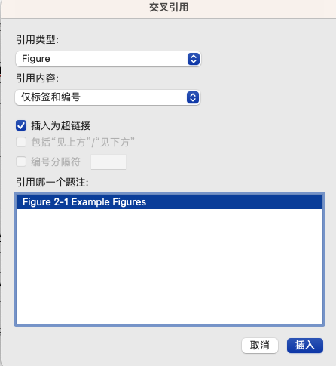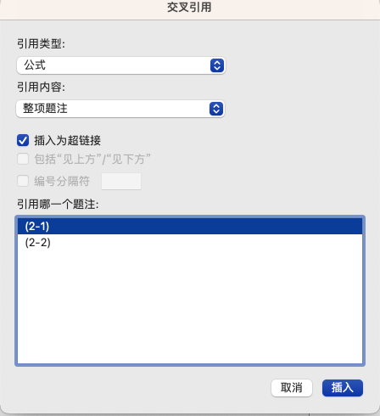

Requirement Analysis

System Design

System Implementation

System Test

Conclusions and Future Works

References
[1] 戴军, 袁惠新. 膜技术在含油废水处理中的应用[J]. 膜科学与技术, 2002, 22(2)：59-64.
[2] 毛侠, 孙云. 和谐图案的自动生成研究[A]. 第一届中国情感计算及智能交互学术会议论文集[C]. 北京: 中国科学院自动化研究所, 2003: 277-279.
[3] 王湛. 膜分离技术基础[M]. 北京: 化学工业出版社, 2000: 14-21, 30.
[4] 张志祥. 间断动力系统的随机扰动及其在守恒律方程中的应用[D]. 北京: 北京大学, 1998.
[5] World Health Organization. Factors regulating the immune response: report of WHO Scientific Group[R]. Geneva: WHO, 1970.
[6] 河北绿洲生态环境科技有限公司. 一种荒漠化地区生态植被综合培育种植方法. 中国, 01129210.5[P]. 2001-10-24.
[7] GB/T16159-1996, 汉语拼音证词法基本规则[S]. 北京, 中国标准出版社, 1996.
[8] 毛侠. 情感工学破解“舒服之谜”[N]. 光明日报, 2004-04-17(B1).
[9] 陈剑. 上博简《民之父母》“而得既塞於四海矣”句解释[EB/OL]. 简帛研究网站，http://www.bamboosilk.org/Wssf/2003/chenjian03.htm．2003-01-18

Acknowledgement
I would also like to thank my father and mother. For more than 20 years, it was their selfless love and dedication that gave me the opportunity to grow step by step. In my undergraduate study and life, I have encountered countless difficulties and troughs. It is their firm support, unconditional trust and warm encouragement that have brought me to today and put a successful end to my four years of university. Although thousands of words can't express my gratitude.

附录：论文内容简介
论文内容简介

应大于1000字，不可与摘要重复。

