School Management System - HR Recruitment Flow
This document contains a recommended HR recruitment and onboarding workflow for a School Management System (SMS). The structure is inspired by modern ATS (Applicant Tracking Systems) like BambooHR, Zoho Recruit, and Workable.

1. Recruitment Workflow
The recommended hiring flow for school staff recruitment is shown below:
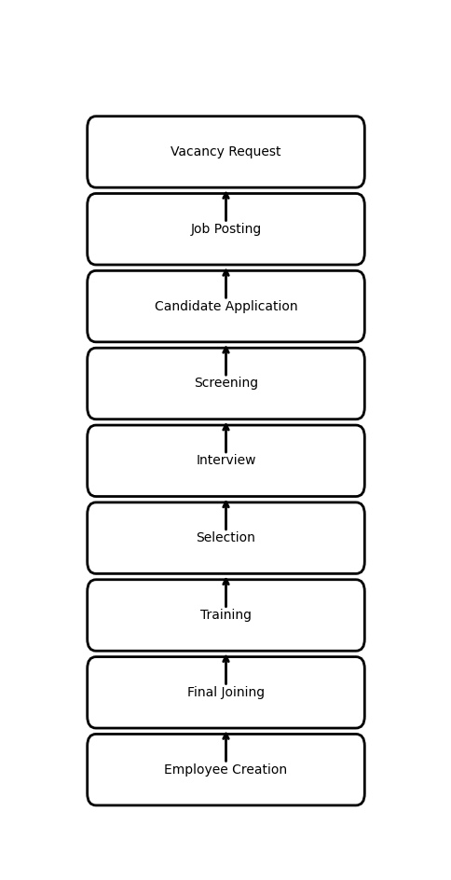

2. Recommended Modules
- Vacancy Module: Create and manage staff vacancies.
- Job Posting: Publish jobs internally or externally.
- Candidate Form: Collect candidate details and documents.
- Interview Module: Schedule and evaluate interviews.
- Selection Module: Generate offer letters and approvals.
- Training Module: Manage onboarding and orientation.
- Employee Creation: Convert selected candidate into staff.

3. Pipeline Board UI Reference
A Kanban-style recruitment pipeline is recommended for tracking candidate stages.


4. Suggested Database Tables
- vacancies
- job_posts
- candidates
- candidate_documents
- interviews
- interview_feedback
- offer_letters
- training_sessions
- employees

5. Important Features
- Resume upload and parsing
- Interview scheduling
- Offer letter generation
- Document verification
- Training checklist
- Employee login creation
- Role and department assignment
- Email/SMS notifications

6. References
• BambooHR
• Zoho Recruit
• Workable ATS
• Freshteam HRMS
• Oracle HCM

