Lucien Roberson
HW2
Chapters 5,6,7

https://github.com/Revo-Lucien/cs5600
Chapter 5:
Simulation
Q1)
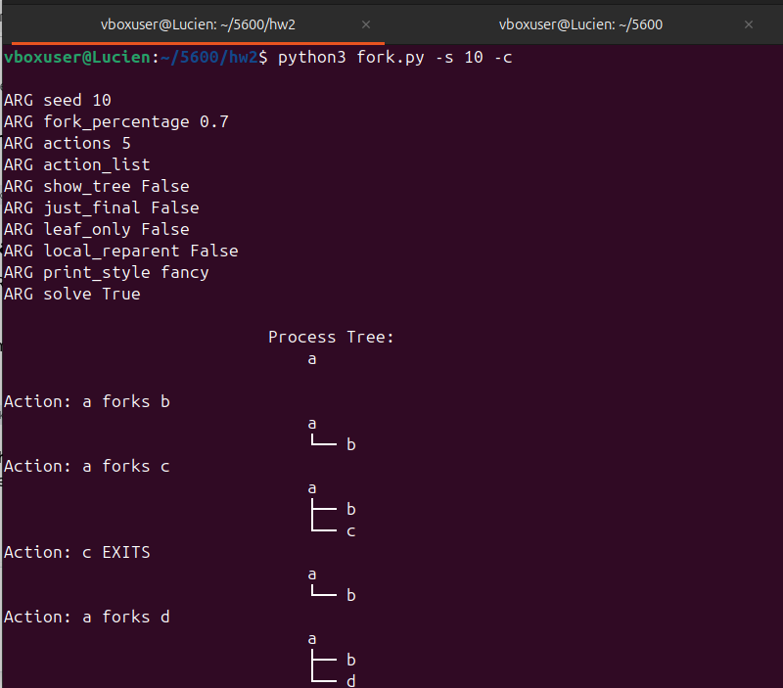
This is a random call that shows a forking several children at random.
I can predict what the tree will look like at each step.

Q2)
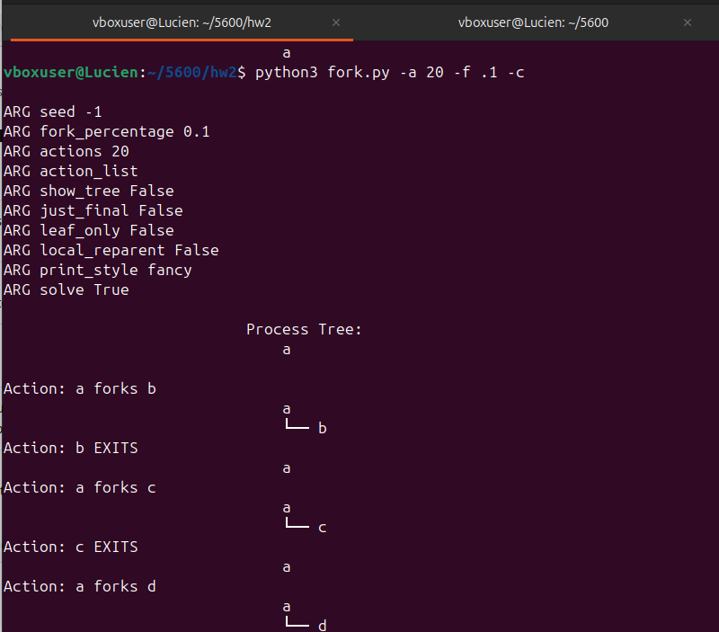
At a low fork-percentage most of the children are terminated before they call further processes, thus a shallow tree.

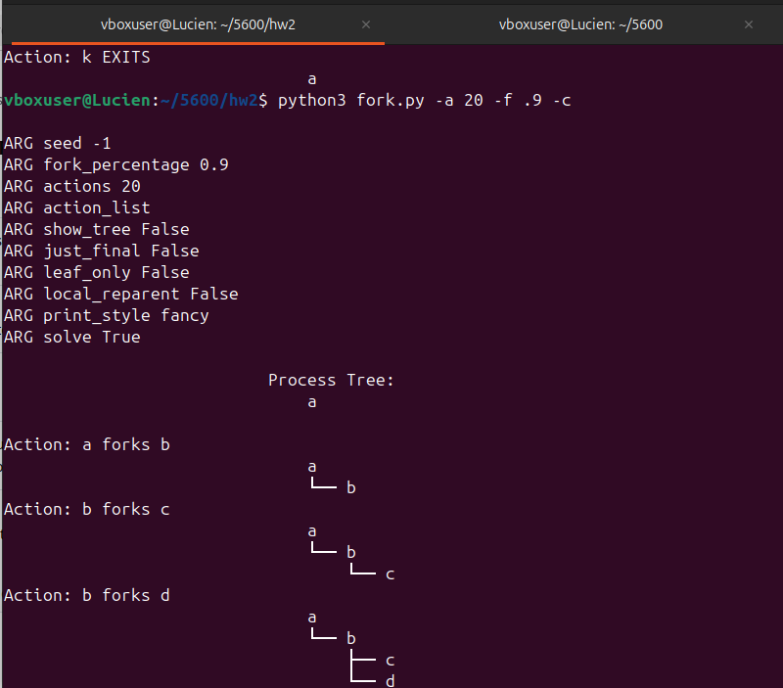
The tree gets a lot deeper as more processes are likely to call their own child before exiting.

Q3)

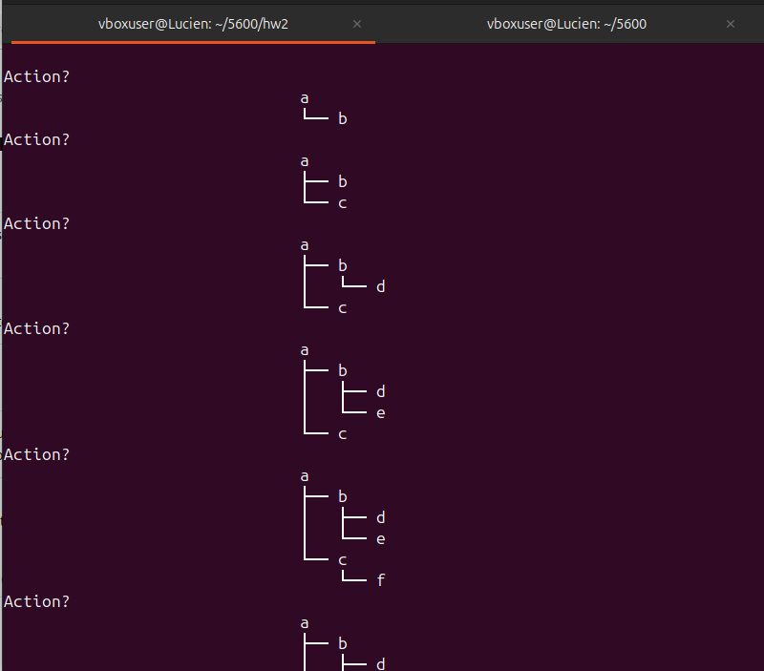
You can tell the actions taken when a child is forked underneath the parent or if a process exits.

Q4)
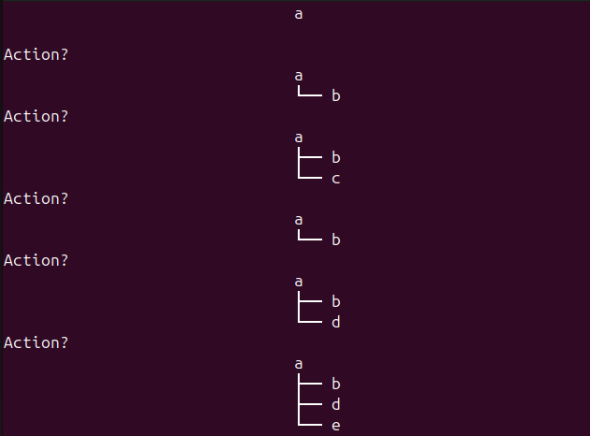
This is the output from ./fork.py -A a+b,b+c,c+d,c+e,c- . The orphaned children
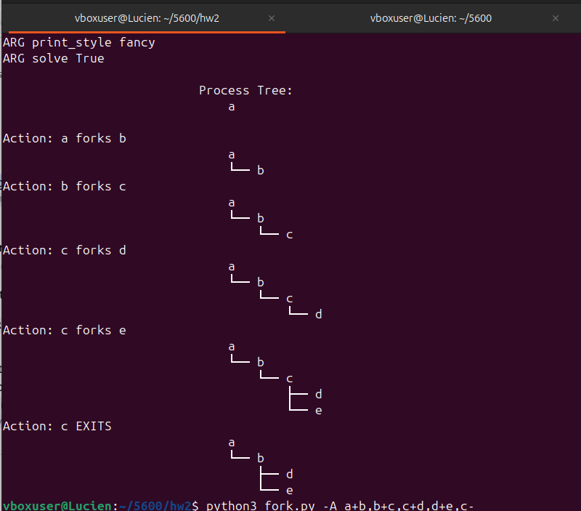
When the -R flag is included it acts more like a linked list where the parent node just gets attached immediately to the next node in the list.
After looking up how an OS manages re-parenting I found that it can choose between local and global reparenting with the -R flag.

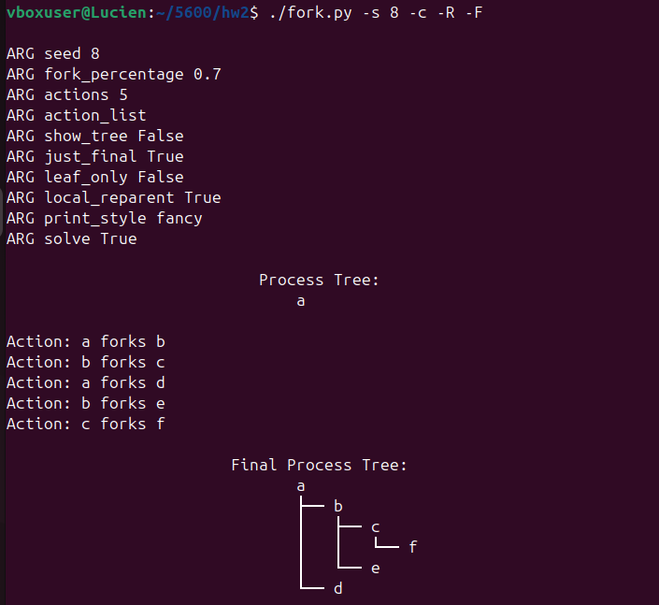
Q5)

This output matches what it said it would do.

Q6)
I ran the same command as in Q5 with the -t flag.
On the second part of the question, most of the time you wouldn’t be able to tell the actions taken unless if none of the children had returned or if there were a very limited amount of calls.

Code
Q1)
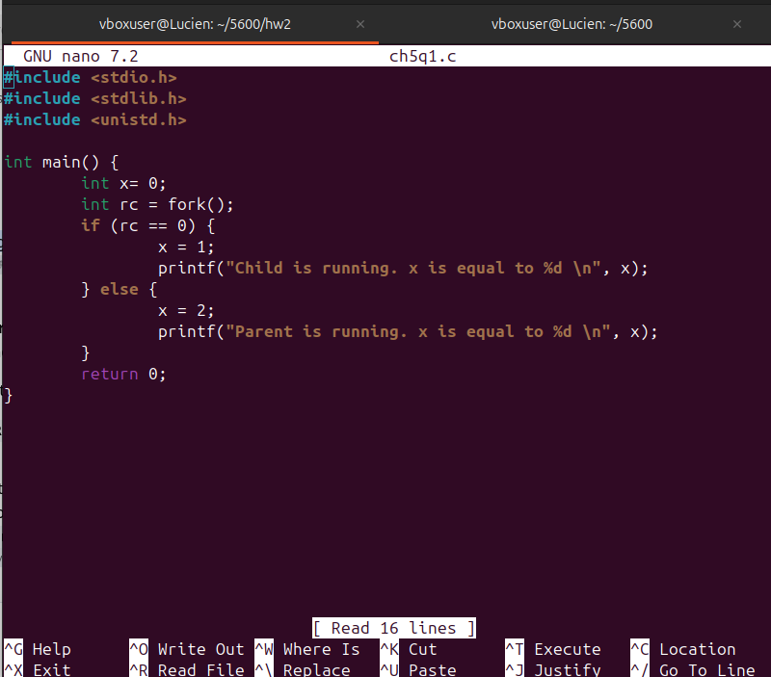
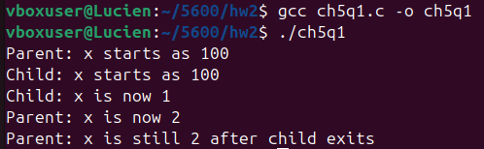

The output shows that both the child and parent have their own version of the var x and that they can change without interfering with the other’s address space.

Q2)
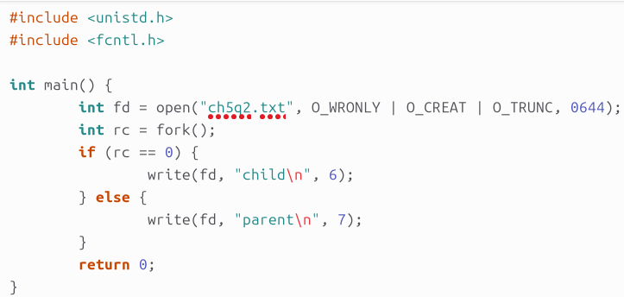

Here is the code
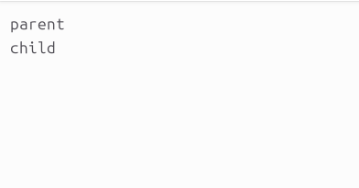

Here is the output file that it writes to. It shows that both processes were able to access and write to the file. The kernel has something called the offset that allows processes to write to a file contiguously instead of interweaving.

Q3)
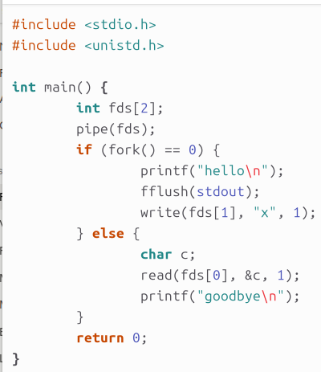
This is the code followed by the output. The parent can just write to a buffer that will wait until the child writes to it.

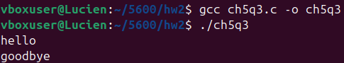

Q4)
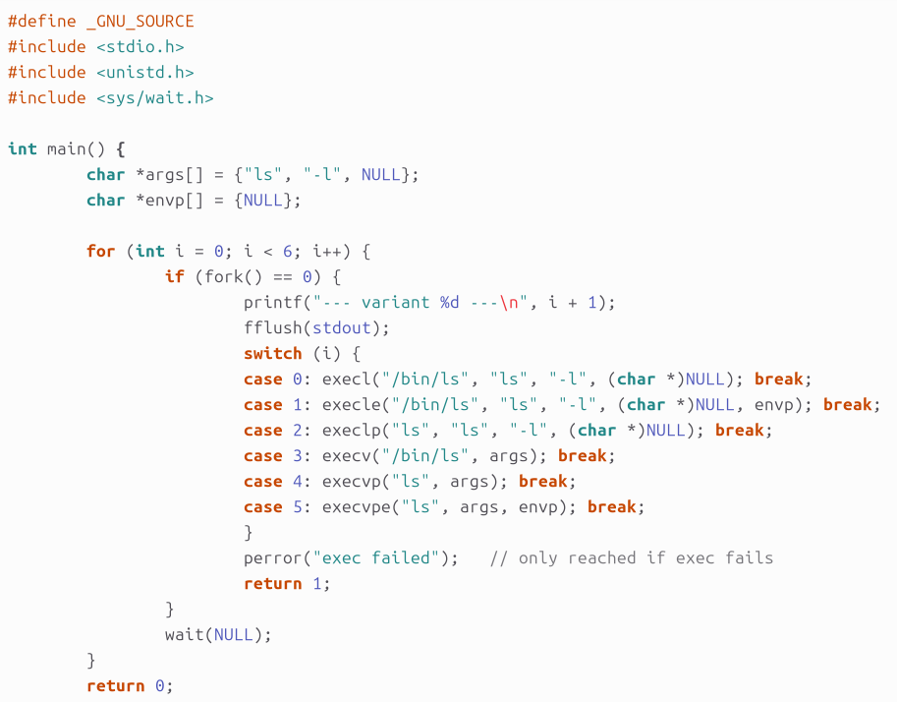
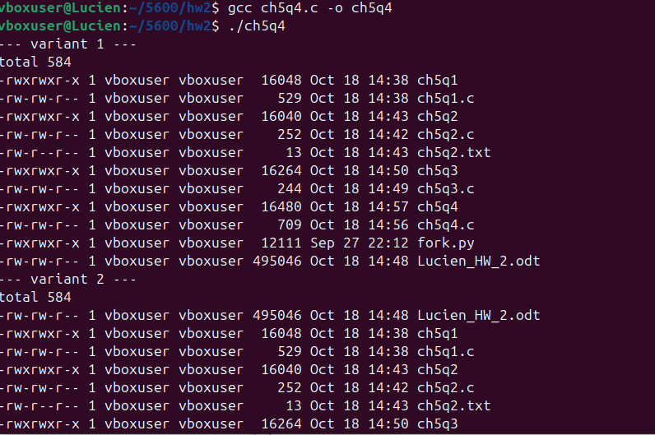
All of the variations outputted the same. There are so many variants just because the inputs are a little different merely at the sake of convenience.

Q5)
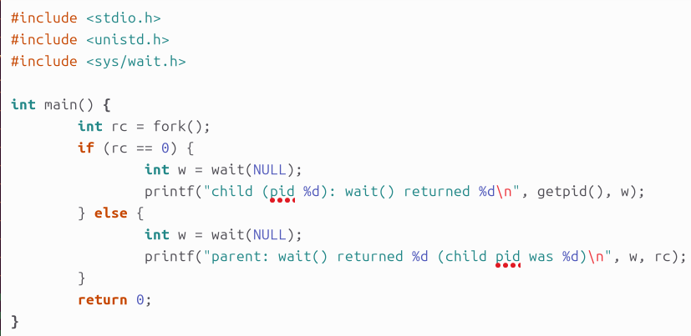
Here is my code and output.

The parent returned the PID of its child once the child had exited. Meanwhile the child returned -1 immediately because it wasn’t waiting on anything.

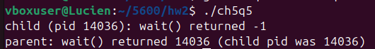

Q6)
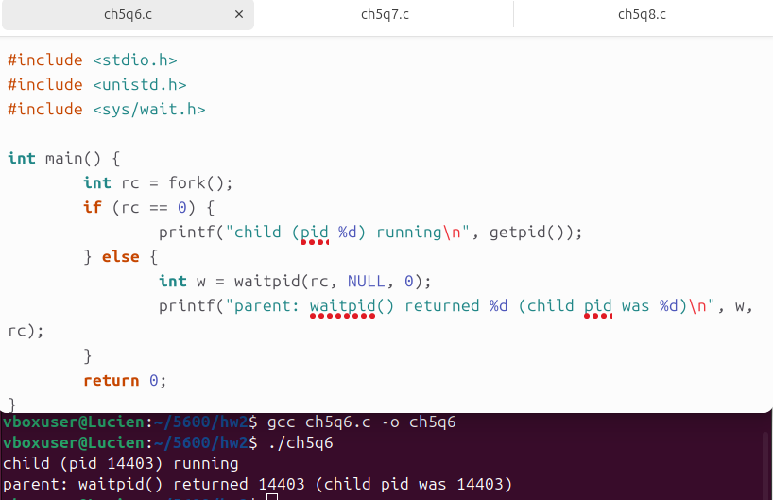
Here is the code and output for Q6. Waitpid lets the parent wait for a specific child giving the programmer more control.

Q7)
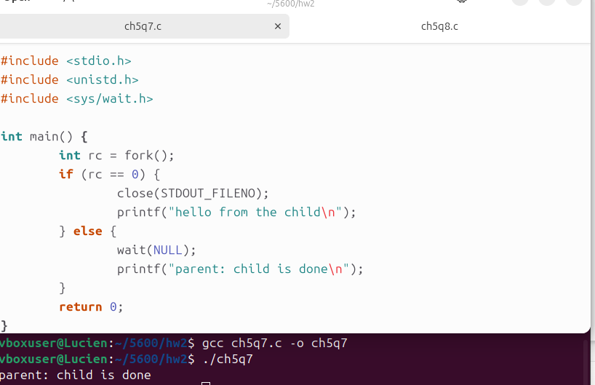
Here is the output for Q7. The child printf doesn’t output anything.

Q8)
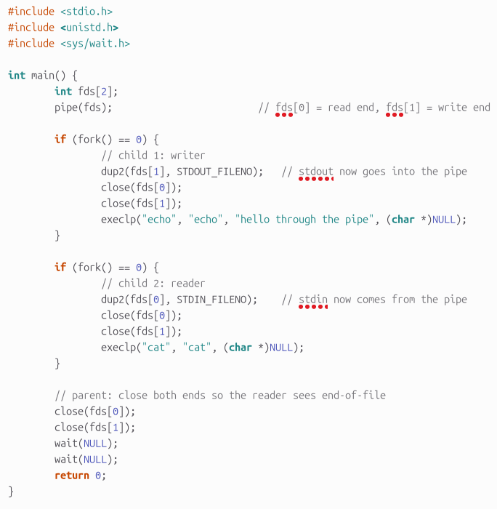
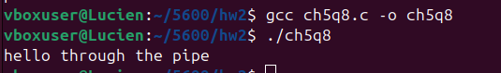

The first child piped to the pipe through stdout, the second child piped from the pipe through stdin!

Chapter 6:

There are two c programs too big to paste in this sheet, I have put them in the github. I can paste the output though:
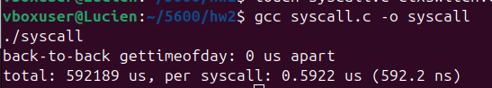

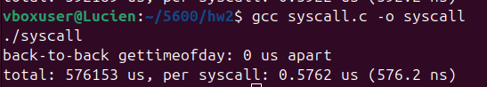

I instead called a 0-byte read() one million times and divided the total time by the iteration count. Two runs gave about 592 ns and 576 ns per system call, so I estimate the cost of a system call at roughly 580 ns. This is somewhat higher than typical bare-metal numbers, likely because I ran it in a virtual machine.

Chapter 7:

Q1:
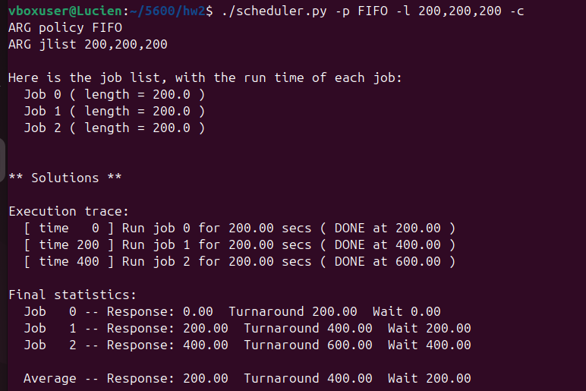

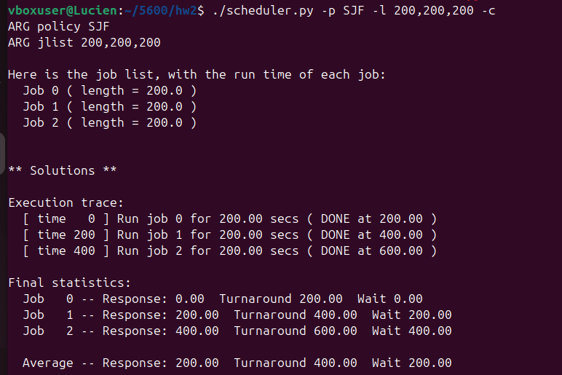
They both give the same result

Q2:
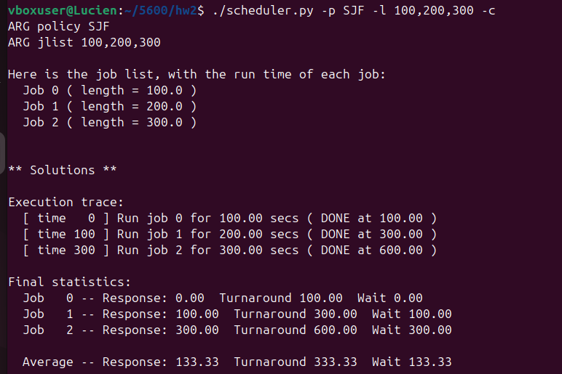
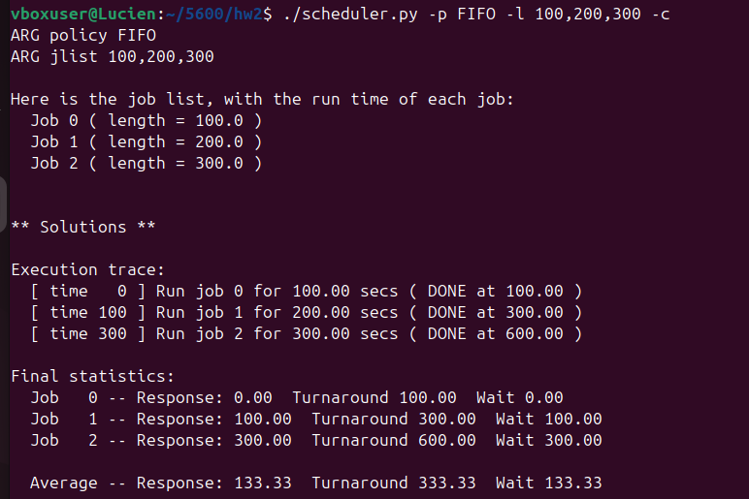
They both do the same thing.

Q3:
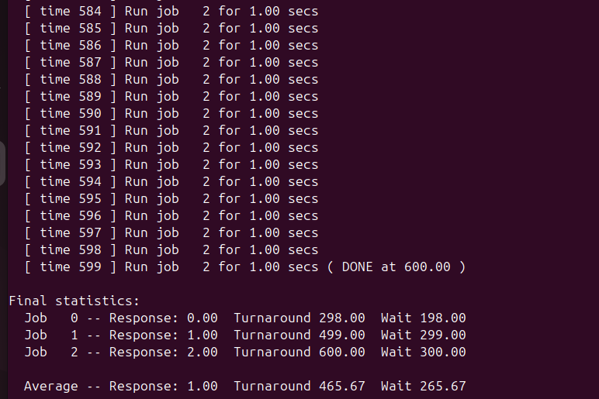
RR gives a better response time but a worse turn around time.

Q4:
When the jobs arrive in order of increasing length (shortest first), or when all jobs are the same length. In both cases FIFO’s order is already what SJF would pick.

Q5:
When the time slice is at least as long as every job and the jobs are listed shortest first. Then RR never preempts a job before it finishes, so it behaves like FIFO, which matches SJF in that order. Equal-length jobs with a quantum at least that long also work.

Q6:
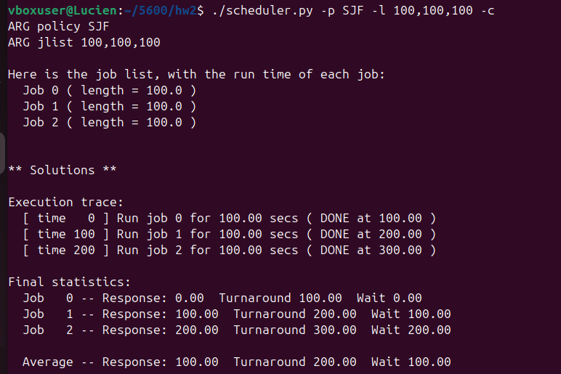
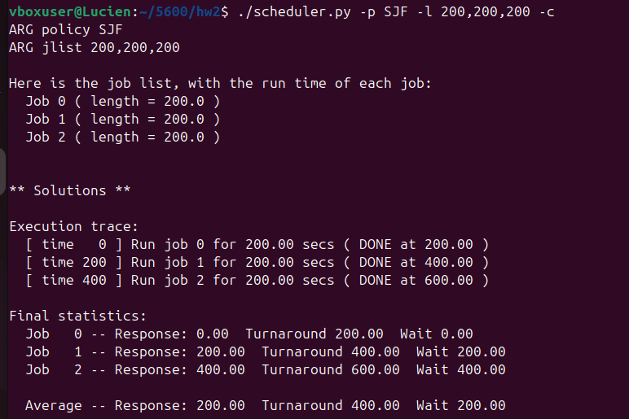
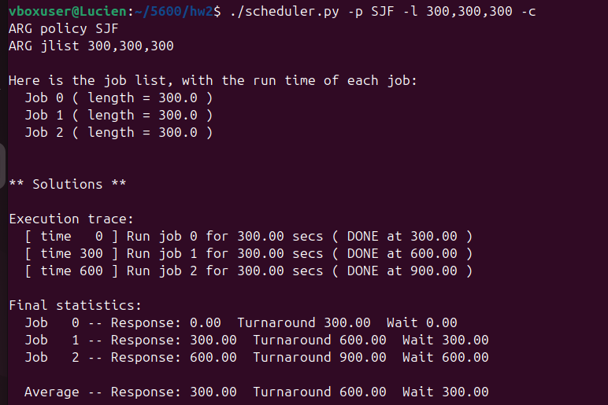
Response time grows linearly with job length. Each job’s response time is the sum of the lengths of the jobs that run before it.

Q7:
Response time increases with the quantum, because each job waits longer for the jobs ahead of it to use their full slices. Once the quantum is at least as long as the jobs, RR behaves like FIFO.
The worst-case response time for N jobs with quantum q is: (N − 1) × q

