Quiescence Search

(\* Phan trong sao la li giai them, co the bo qua khi report vi da duoc tom tat y chinh \*)

Details

Quiescence search is unlike the original heuristic search, it is an applied methods for dealing with the horizon effect. The normal search is trying to use fixed depth for each time searching for best Position that we should consider the depth is odd to reach the top for current move. However this current move doesn’t contains the information that is that the next move of it is captured move or not ? Then it could affect the whole result of a match while the rival is considered using the same or better search algorithm with higher or even equals depth in their search (some case could lead to loop in algorithm).

The main idea of this search method is trying combination of previous search method with the ability to “predict the future with some short depth”. In our method, we are trying to combine the Alpha Beta search for normal search to a fixed depth like others. The difference in here is that when that fixed depth is completed by Alpha Beta, the algorithm would check the current Position is quiet or not (is capture move or not), if it’s safe we return this move else it will run more search in quiescence search to find all the best move in further depth to ensure the right move needed to have.

Accuracy

In theory

Time complexity:

Quiescence search also use DFS

* Worst case: O(b^m)
* Ideal case: O(b^m/2)

Space complexity:

* Worst case: O(bm)
* Ideal case: O(b(m/2))

Completeness:

Quiescence is complete, definitely find solution, if exists in finite search tree

Optimality:

Optimal if both player plays optimally.

Time cost

Time is evaluation is performed on Dell Inc.Precision M4800, Intel(R) Core(TM) i7-4810MQ CPU @ 2.80GHz.

Since this algorithm depends not only on the number of Positions spawned from root but also the number of captured move each time the normal search reaches the depth equal = 0. Then we also proposed 2 methods to find the find the captured move which can improves this algorithm.

1. Naive idea: Each time searching, we list all possible move is the captured move, then if current Position not in that list, we return the move else continue with quiescence for deeper search.

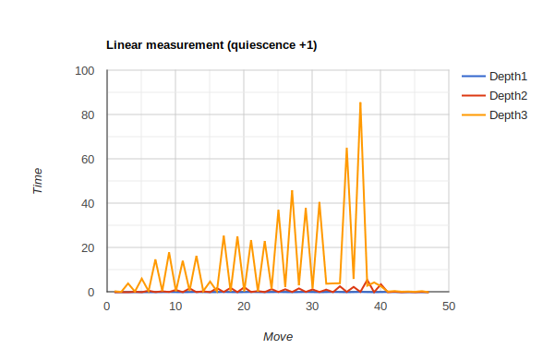

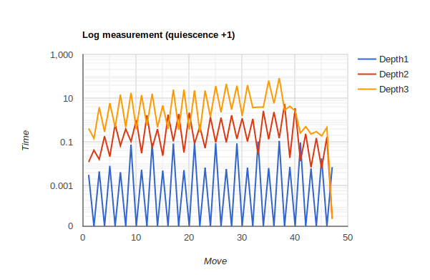

2.Improvement: Combine find captured move and en passant move and the comparison the score of board if be captured to reduce the space of the captured list.

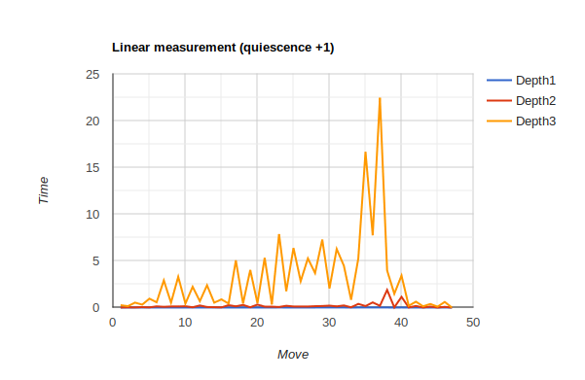

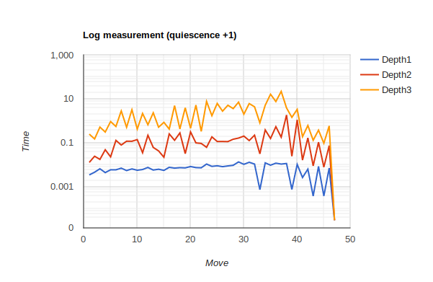

Clearly we can see the second method can reduces the time 4 times faster than the naive idea with just list all captured move. The peak of this algorithm approximately 23 seconds for depth = 3 (equals depth = 4 of fixed depth algorithm). The amount of searches increase in linear fashion as the game progresses. This means we always has benefit of score board compared with rival with same depth (since quiescence step, in our code is increasing 1 depth).

Implementation issues

This method can consider the combination of others algorithm then we need to carefully implement else this algorithms will go into loop.

Discussions

This method is the improvement for dealing with fixed path problems. We can implement many other algorithm with faster perform like negamax or null move,… for normal search to increases the performance of this algorithms.

APPENDIX

(\* The horizon effect: The horizon effect is a problem in AI which can occur when all moves from a given node in a game tree are searched to a fixed depth. Threats and opportunities beyond the search depth will remain undetected. This can result in the peculiar ploy of a program making delaying moves that degrade the position until it pushes a threat beyond the search depth or "horizon". By the time the threat must be dealt with, the position has become too degraded to be salvageable. Quiescence search attempts to mitigate this issue \* )

Real time measurement

First (direct capture)

Depth 1:

3.20e-03 4.57e-03 8.20e-03 4.23e-03 7.67e-02 5.44e-03 8.94e-02 5.00e-03 8.61e-02 5.19e-03 8.92e-02 6.85e-03 8.96e-02 5.87e-03 8.75e-02 6.84e-03 1.06e-01 6.51e-03 1.14e-01 7.34e-03 9.64e-02 6.23e-03 1.83e-02 7.30e-03 1.16e-01 7.09e-03 1.25e-01 8.29e-03 1.88e-02 8.72e-03 1.92e-02 9.23e-03 4.53e-03 1.01e-02 1.64e-01 1.02e-02 1.72e-01 8.93e-03 3.73e-03 8.16e-03 2.59e-03 5.35e-03 3.64e-04 6.51e-03 3.51e-04 5.62e-03 3.13e-05

Depth 2:

1.24e-02 4.33e-02 1.64e-02 1.88e-01 2.20e-02 6.64e-01 6.93e-02 4.02e-01 1.08e-01 1.03e+00 3.17e-02 1.71e+00 5.46e-02 4.00e-01 2.41e-02 1.81e+00 1.11e-01 1.94e+00 3.40e-02 2.24e+00 8.64e-02 5.21e-01 5.37e-02 1.40e+00 9.72e-02 1.32e+00 9.93e-02 1.69e+00 1.42e-01 1.24e+00 1.08e-01 1.17e+00 2.70e-02 2.68e+00 1.36e-01 2.40e+00 1.54e-01 5.55e+00 1.94e-02 3.57e+00 1.36e-02 2.41e-01 7.13e-03 1.55e-01 6.44e-03 1.71e-01 3.16e-05

Depth 3:

4.25e-01 1.49e-01 3.96e+00 3.01e-01 6.13e+00 4.91e-01 1.48e+01 4.96e-01 1.80e+01 4.01e-01 1.42e+01 5.90e-01 1.64e+01 4.87e-01 4.82e+00 4.05e-01 2.55e+01 3.70e-01 2.52e+01 3.78e-01 2.35e+01 2.84e-01 2.31e+01 1.44e+00 3.72e+01 2.35e+00 4.60e+01 3.13e+00 3.80e+01 1.62e+00 4.07e+01 3.83e+00 3.99e+00 4.04e+00 6.52e+01 6.01e+00 8.57e+01 2.92e+00 4.42e+00 2.69e+00 2.64e-01 5.19e-01 2.37e-01 3.04e-01 1.94e-01 4.74e-01 3.19e-05

Second (other capture + enpass move)

Depth 1:

3.57e-03 4.74e-03 6.77e-03 4.54e-03 6.10e-03 6.08e-03 7.23e-03 5.62e-03 6.69e-03 5.81e-03 6.27e-03 7.81e-03 5.93e-03 6.47e-03 5.72e-03 7.89e-03 7.25e-03 7.60e-03 7.43e-03 8.57e-03 7.66e-03 7.50e-03 1.11e-02 8.72e-03 9.29e-03 8.45e-03 9.14e-03 9.77e-03 1.39e-02 1.08e-02 1.34e-02 1.11e-02 7.64e-04 1.26e-02 9.87e-03 1.22e-02 1.11e-02 1.18e-02 7.79e-04 1.07e-02 2.72e-03 6.51e-03 3.92e-04 8.65e-03 3.93e-04 7.30e-03 3.07e-05

Depth 2:

1.32e-02 2.52e-02 1.81e-02 4.98e-02 2.36e-02 1.33e-01 8.15e-02 1.22e-01 1.21e-01 1.44e-01 3.64e-02 2.26e-01 6.33e-02 4.42e-02 2.27e-02 2.62e-01 1.34e-01 2.90e-01 3.32e-02 3.22e-01 1.02e-01 9.65e-02 6.41e-02 1.92e-01 1.18e-01 1.18e-01 1.17e-01 1.50e-01 1.69e-01 2.08e-01 1.30e-01 2.29e-01 3.26e-02 3.98e-01 1.62e-01 5.58e-01 1.86e-01 1.89e+00 2.53e-02 1.15e+00 1.68e-02 1.72e-01 9.26e-03 1.10e-01 8.09e-03 7.65e-02 3.10e-05

Depth 3:

2.56e-01 1.54e-01 5.35e-01 3.17e-01 9.55e-01 5.69e-01 2.91e+00 5.23e-01 3.30e+00 4.33e-01 2.23e+00 6.83e-01 2.39e+00 5.28e-01 8.79e-01 4.33e-01 5.06e+00 4.42e-01 4.03e+00 4.73e-01 5.33e+00 3.42e-01 7.87e+00 1.76e+00 6.39e+00 2.83e+00 5.27e+00 3.70e+00 7.29e+00 2.06e+00 6.28e+00 4.48e+00 8.38e-01 5.26e+00 1.67e+01 7.75e+00 2.25e+01 3.98e+00 1.48e+00 3.43e+00 1.95e-01 6.33e-01 1.34e-01 3.88e-01 9.81e-02 6.06e-01 3.11e-05