Alpha beta pruning algorithm

1. The details of the solution used to solve the problems
- This algorithm is the improved version of the Minimax algorithm.
- Firstly, we consider that we have a function for calculating the evaluated point in chess board after each move whose initial value is 0.
- Secondly, we consider that 2 players in chess game are maxer and miner which one tries to max the evaluated point and one tries to min that point.
- Thirdly, we initial the alpha and beta variables which initial values are -INF, INF respectively. Maxer will update alpha and miner will update beta.
- When alpha ≥ beta, we pruning the remain state of a node.
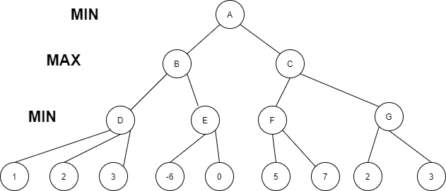

Step 1: betaD = INF, alphaD = -INF
Min(1, betaD) = 1 -> betaD = 1
Min(betaD, 2) = 1 -> betaD = 1
Min(betaD, 3) = 1 -> betaD = 1
D = 1 because min(1,2,3) = 1
Step 2:betaB = INF, alphaB = -INF
Max(D, alphaB) = 1 -> alphaB = 1
-> alphaE = 1, betaE = INF
Min(-6, betaE) = -6 -> betaE = -6 but alphaE >= betaE pruning remain state
Do like this step by step finally, at node A, alphaA = -INF, betaA = INF then best move is have score = 1 and the computer will choose this leftmost move.
2. The appropriate evaluation of the system’s performance
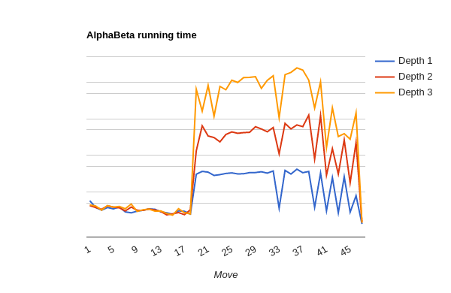Figure 1: Time with log function
3. Some improvement
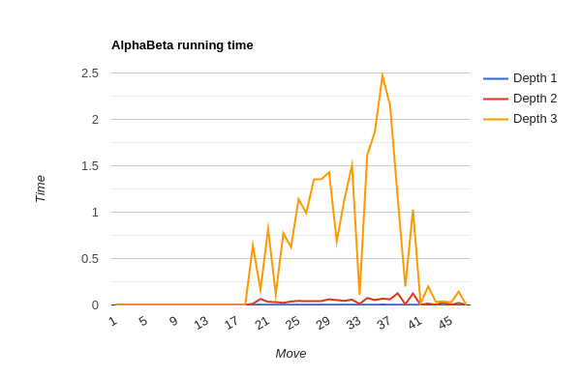Figure 2: Time with linear function
For the source code of the Alpha-Beta algorithm, I just add more condition for game ending to return point more faster. I have spent most of my time to change the index point of each piece which is the strong index for that piece.

