Artificial Intelligence: Project Report

- Overview
  - Scope of this project
    - Provide ideas and initial implementations of 5 search algorithms used in chess game: Minimax, Negamax, Alpha-Beta pruning, Quiescent Search, Null-move heuristic search.
    - Provide implementation of two simple heuristic methods, used to evaluate a chess position.
    - Provide measurement in time of each technique running on various depths to visualise time complexity over the course of a chess game.
    - Conclude, remark on measurement (if possible)
  - What this project does not cover
    - Accuracy measurement
We simply aren’t big-brained enough to construct a convincing accuracy-measuring method. There are three reasons:
      - There’s no definition of an absolutely correct move.
      - Our heuristic position evaluator is too simple, and thus:
      - Different implementations of heuristic evaluator will thrive in different types of positions (will be discussed in II.1. )

  - Third-party packages/softwares used
This project runs on python3.8.
The champion package that helped us with chess board management is python-chess (https://github.com/niklasf/python-chess).
GUI is made with Godot3.4 (https://godotengine.org) (but you probably don’t care about this).
How to install these packages/softwares is detailed in README.txt. If you don’t see that file, please email to lam.t194787@sis.hust.edu.vn and remind him that he screwed up this project.

- Details of Solutions
  - Problem Representation
The problem: Given a chess position, determine the next best move that will lead to a winning position for the side-to-move.
To solve this problem, we define the search space as a directed graph:
      - A node of the graph is a Board.
      - A Board consists of the layout of pieces on the board and the side to move.
      - A directed edge on the graph is a Move that transform one Board to another.
Board and Move are implemented by python-chess library.
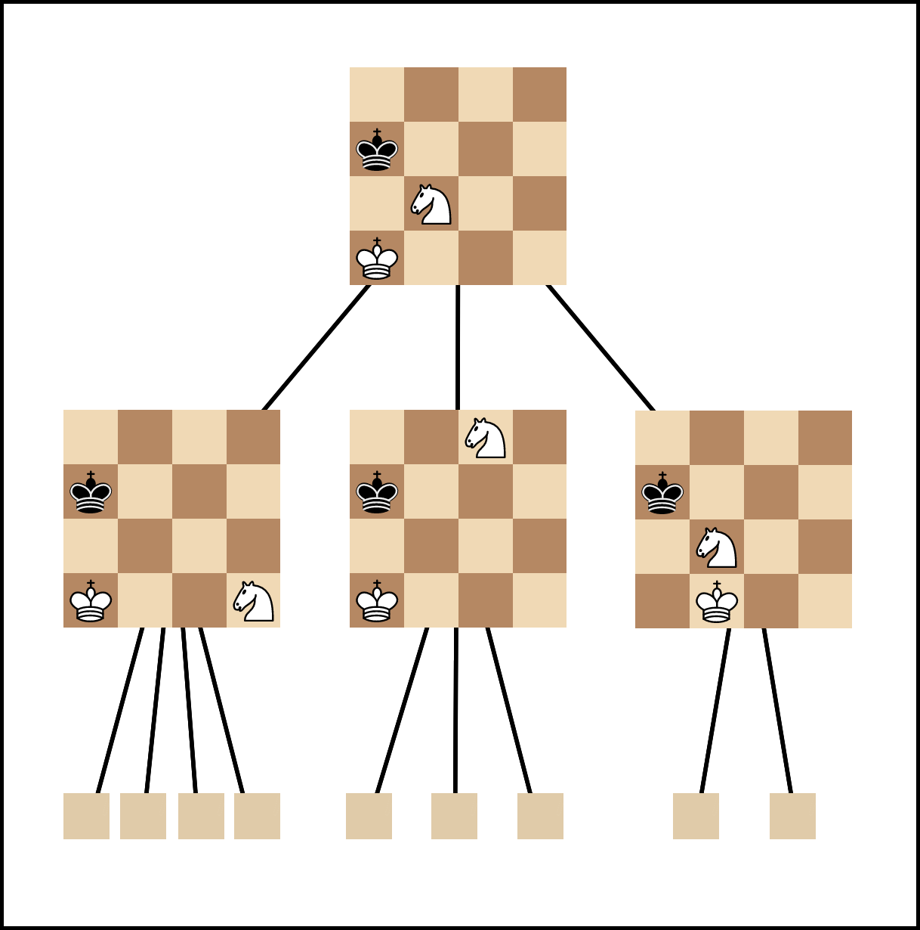
  - Measuring Method
Each search algorithm will evaluate the Evergreen game, and then output the time it takes to evaluate each position. A position should be evaluated many times and takes average to ensure the result does not bias too much from the mean. Because some algorithms are too slow, we evaluate each position 3 times. Measurement is conducted via EvergreenTimer.py. If you are curious, or want to validate the results, you can tweak and run it. Graphs are drawn by an online tool.
Again, this is time-measurement. We Do Not perform accuracy-measurement.
  - Solving Algorithms
    - Each topic in Details of Solutions will follow this structure (more or less):
      - Motivation: Why it exists, what does it do.
      - Implementation: How it works.
      - Measurement: Some plotted graphs to give you a sense of algorithm quickness.
      - Remark: Some things we noticed and explained (if possible).
      - Improvements: How it could have been better, but we didn’t have time (nor confidence) to implement it.
    - Evaluator
      - Motivation:
We need to quantify how “good” a Board is. Evaluator is the heuristic evaluation function. It takes a Board and output a number – the score estimated for a Board. Positive number indicates that white is taking the lead, and vice versa.
      - Implementation:
In our project, we have two Evaluators: EvaluatorSunfish and EvaluatorPosition. They are almost identical in working mechanism, except for King handling. Let’s talk about their common points first:
        - Each chess piece is assigned a score (also called Material Point).
        - Each chess piece has a map of position-on-board with a score.
        - The score estimated for a Board is the sum of all pieces’ score and their position score.
In EvaluatorSunfish, the King is assigned a value very big, so that it won’t trade the king for any other piece. In EvaluatorPosition, the King is not assigned any value, but still has its position-score mapping present.
We use EvaluatorPosition because it is faster than EvaluatorSunfish, and there has not been any out-of-this-world dumb move recorded when we use this Evaluator for various algorithms, and played against it.
      - Measurement:
EvaluatorSunfish takes 0.000102 second to evaluate a position. EvaluatorPosition takes 0.000082.
So, EvaluatorPosition is faster than Sunfish by 25%.
      - Remark: None
      - Improvements: Based on Ethereal chess engine evaluation criteria
Our Evaluator has a serious drawback: It is only effective in opening/middlegame phase. For example, the position-score mapping for king piece highly promotes king’s safety. It says that “The closer your king is to your home, the more advantageous it is” but this is not true in endgame phase. In endgame, your king becomes a powerful piece and must head to the battlefield itself.
Some concepts are ignored here, such as “pinning”, “isolated pawn”, “knight outpost”… which make pieces more powerful, or cool down their threat level.
Pieces with more positions to move make their presence on the board deadlier, and should also be noted.
In summary:
        - Changes position-score mapping dynamically over the game.
        - More mobility → More score
        - Integrate other chess concepts

    - Minimax/Negamax
      - Motivation
Search the whole game space for the move that lead to MAXimum advantage for self, or MINImize advantage of the opponent.
      - Implementation
Because the game space is too big to search, we implement Minimax as a Depth-limited search algorithm: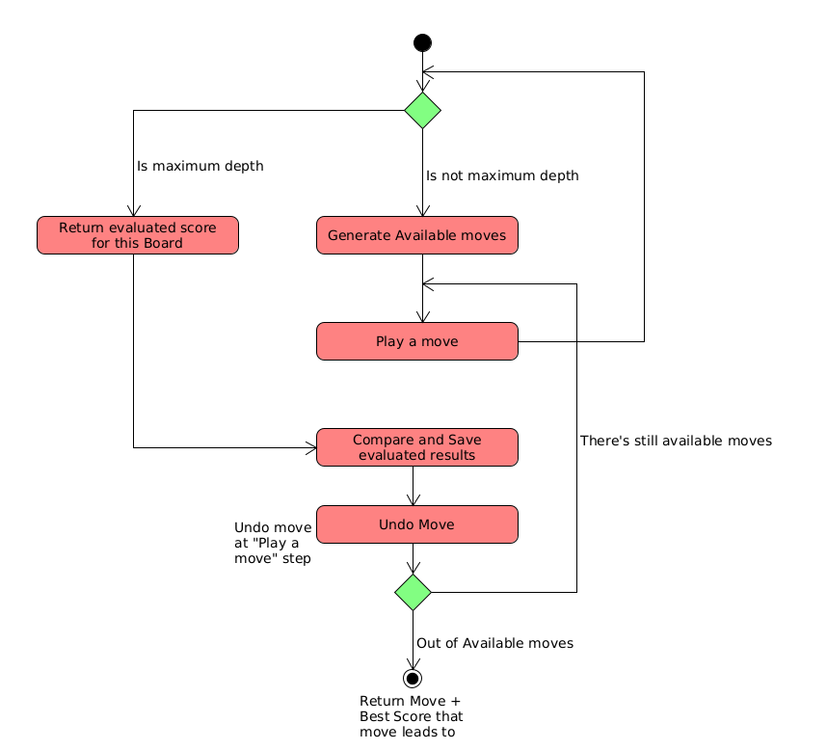
Negamax algorithm is basically Minimax algorithm but instead of having separate subroutines for finding Min and Max, we combine those two into one and passed one part as negative, one as positive as follows:
max(a, b) = -min(-a, -b)
      - Measurement
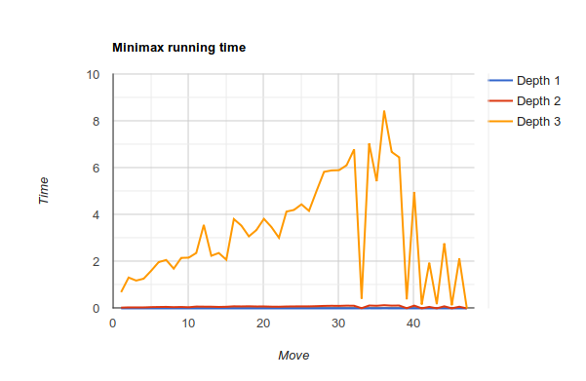Figure 1: Minimax linear measurement
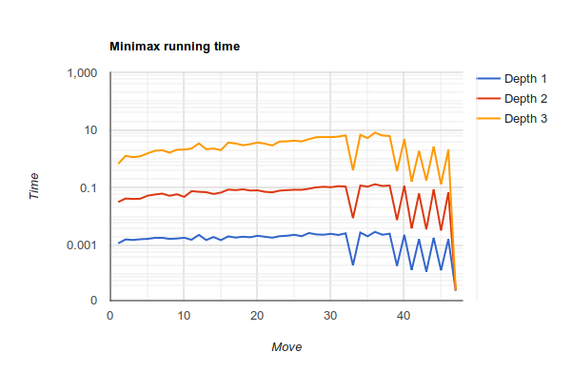Figure 2: Minimax logarithm measurement
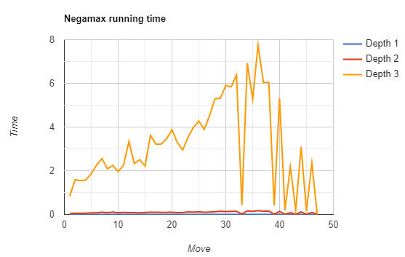Figure 3: Negamax Linear Measurement
      - Remarks
There are some sharp cuts in the graph. That’s because a king is in check in these moves. Consecutive checking cuts down the search space drastically, because it leaves the mover with very few options.
The search time rises from the start to middle of the game (half-move 30), and then go down from middle to endgame. That’s because at the middle game phase, pieces are released from their starting positions, and thus there’re more options to consider. And then at the end of the game, pieces are captured, disappear from the board, number of options reduces, so the search time go down.
In logarithm graph, the graph forms are alike. This might indicate that the proportion of search space between (any) two depths are approximately fixed.
      - Improvements:
        - Some Boards are exactly identical (move numbering excluded). But Minimax/Negamax still re-evaluate them many times. To speed up, we have an idea to use dynamic programming with hash table to store the FEN strings of traversed Board. But the problem is that the search space might overwhelm hardware memory, and caching effectiveness dies. Thus, it remains a speculation.

    - Alpha-Beta Pruning
    - Quiescent Search
    - Null-move Heuristic

Or any of my team member. They would gladly bombard him with complains, frustration, desperation, regret, anger, disappointment, 50 shades of F midterm... *shiver.
A splendid examplar of the Romantic Era of chess: https://www.chess.com/terms/evergreen-game-chess
https://www.rapidtables.com/tools/line-graph.html. Pretty neat little thing.
Adapted from Sunfish chess engine: https://github.com/thomasahle/sunfish/blob/master/sunfish.py
https://github.com/AndyGrant/Ethereal

