The search space of the problem is a tree which can be visualized as following:

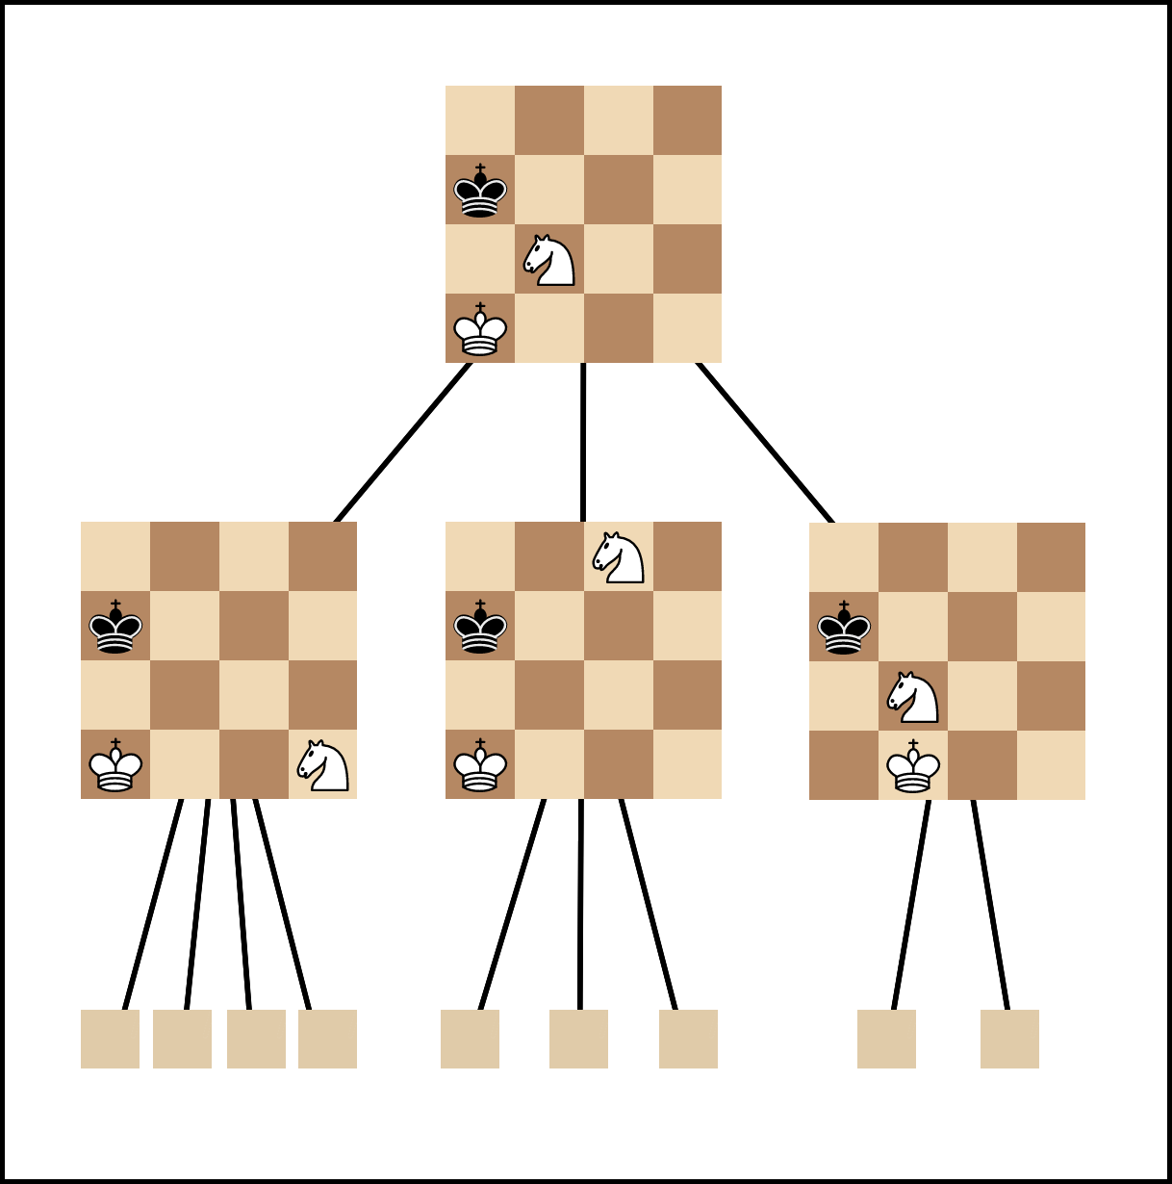Figure 1: Image source: medium.com/@SereneBiologist

where each node in a tree is a Position, and each edge represent a board Transition. In details:
Position contains the information about pieces on the board, their locations, and very importantly: Whose turn is it? Turn is a crucial factor of a Position, as the same arrangement of pieces on the board will sometimes result in vastly different interpretations of the game tide.
Transition can be simply understood as a piece move that bridges between two Positions, although it’s a little more than that. A Transition is also an undo-move, but we shouldn’t focus on that in our search algorithm, and neither should you.
For details of how we implement this tree: We don’t. The python-chess library provides us with Board class (which is what we called Position earlier), and Move class. You can add a Move to a Board to get the next position. This is the minor details of the library, let’s not dwell on this and move on to more interesting topic.

Evaluation:
Evaluation is done heuristically based on experience of the coders, chess community, and chess theory. In our project, evaluation of a Position depends on two factors:
Each piece has a score (material value). The more pieces a side has, the more that side scores.
Each cell on the board has a score value, differently for each piece type and side. By experience, there’re some cells that are considered “beautiful” for each piece. A pawn that’s one cell away from promotion will score more than a pawn that hasn’t moved, and a knight on the center of the board undisputably seizes more control over the game than one in the corner.
The King might be scored ridiculously high, or has no value and is directly, logically handled. We implemented both ways, with the former in EvaluatorSunfish and the latter in EvaluatorPosition class. You can find them in Evaluator.py file.

Performance evaluation:
We’ll use the Evergreen game (Anderssen vs Dufresne 1852) to time our algorithms. Each Position of the game will be evaluated a few times. After that, the total running time will be taken average and plotted on a line chart.

Minimax

Detail:
Minimax is an exhaustive depth-first search algorithm. It works as the baseline algorithm for a chess AI. From a root Position, it spawns all possible board Transition, and recursively search new Position results from them. After reaching a certain depth from the root, Minimax stops searching new Transition, and then directly evaluates current Position. The evaluated score will propagate back, parent Position will look at the score of all Transition, and choose the most favourable one as its score, finally propagate back until the root.

Accuracy:
Because the evaluating algorithm recognizes exactly checkmate/draw conditions, so if there’s a checkmate or draw “depth” (or less) half-moves from the root, Minimax can find out exactly. Else, Minimax accuracy is only as good as the evaluating algorithm.

Time cost:
Time evaluation performed on Dell Inc. Inspiron 3580, Intel® Core™ i7-8565U CPU @ 1.80GHz × 8:

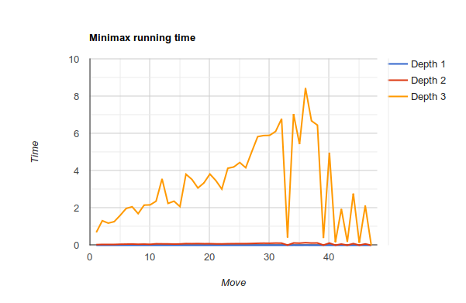Figure 2: Linear measurement
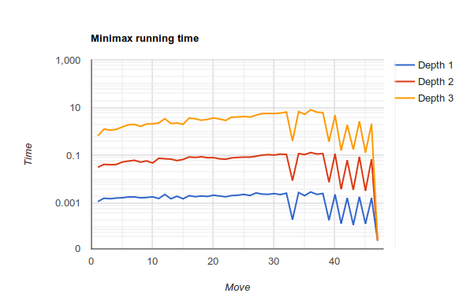Figure 3: Log measurement

Minimax algorithm search time depends on the number of Positions spawned from the root. Peaked 8.45 seconds at depth 3 move 36, the amount of searches increase in linear fashion as the game progresses. Note that linearity in search space is not a prevalent attribute of chess games, it’s for this game only.

Implementation issues:
There’s none. This is the easiest algorithm.

Discussions:
Many Positions may transits into the same Position (because of loops, or different move sequence), which means we’re re-evaluating what we’ve already known. We could use dynamic programming to pair up a Position with its score, which will help us cut off duplicate Positions. However, the search space is large, thus memory might not be sufficient to store every evaluated Positions. Look up time is also a problem when the number of Positions rises too high.

