Avatar creator - Technical documentation

This document will help you to find your way in the avatar creator project

|  |  |
| --- | --- |
| *Code* | *C# version 4* |
| *Tools* | *Visual Studio, Unity 3D 5.3.0f3* |
| *GIT* | *https://github.com/planitglobal/avatar-creator* |

1. Avatar Creator

The avatar creator is currently not used on the production website. The purpose of it (the avatar creator) is to provide to the user a easy way to build his/her own personalized avatar. The avatar will be shown in in the company scare on the explorer game.

1. Configurations

Constants are sets in the file *“/script/Config.cs”* it include the model name which is “Model”, the icons prefix, the folder path inside the ressources folder which contain icons and the API path

1. API

The avatar creator uses the API for loading and reading avatars, all calls to the api are made into the *“scripts/Database.cs”* file

**2.1 Reading**

The reading is made into the LoadAvatar function it calls the API in *"[pathToTheAPI]/users/avatar/[userID]"*

**2.1 Writing**

The reading is made into the SaveAvatar function it calls the API in *"[pathToTheAPI]/users/avatar/[userID]/edit?avatar=[BinaryFormatted string of the avatar]"*

1. Serialization

To obtain a serialized string or to unserialize a string there is a custom method in *“scripts/SerializeGameObject.cs”* which serialize all the useful information from the avatar in serializable object

1. Asset Identity

The asset identity script is used to save the values of every object of the model before any change, to get the default state of every object. The script is here :*“scripts/AssetIdentity.cs”*

1. Canvas Organisation

The canvas organisation script is the main script, it is located here : *“scripts/CanvasOrganisation.cs” ,*note that every object is strong named, so you must look at this file before renaming an item in the Unity editor to avoid any problems.

1. Model

The model is an important part of the avatar creator, the model must be placed into the *“Ressources/Mannequins”* folder, the model must be an prefab. Models must have this type of tree and this naming still

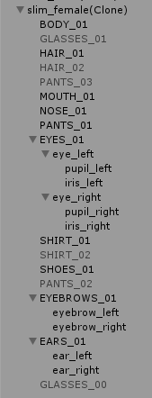

The *_00 items are made to remove an item (like the glasses). To add a body part you must : add the part to the model then set a sub-category button with the name of the part (in uppercase) in a CanvasOrganisation.OnClickSubCategoryButton(). the icon associated to the part must be named : [iconPrefix]_[nameInLowerCase]_[number]

1. Show the avatar in the game

To show the avatar in game, you can use the light avatar library. The library is a copy of all needed function from the avatar creator, so you should keep it as updated as possible.

**TO DO**

The avatar can only display loaded female style avatar, to change that you have to change the function Load() from both the avatar-creator and the light library