Restaurant Feasibility Study

Intro/Problem/Target

There are a lot of variables that go into opening any new business, but few business ventures are as likely to fail as restaurants. Some reports indicate that as many as 90% of new restaurants close their doors within the first year (<https://www.forafinancial.com/blog/industries-we-serve/reasons-new-restaurants-fail/>). One question any new business owner would have is; where do I open? That is exactly what this project strives to answer or at the very least provide insight on the current layout of the competition.

The code in our notebook could easily be adapted to compare any genre of restaurant in any location with the only adjustments being the source data. For this project we will be comparing burger restaurants in Toronto.

The Data

Location data was scraped on various neighborhoods in Toronto (<https://en.wikipedia.org/wiki/List_of_postal_codes_of_Canada:_M>, <http://cocl.us/Geospatial_data>). To get a better understanding of the neighborhood demographics we also collected population and average income data and merged it all into one table (<https://en.wikipedia.org/wiki/Demographics_of_Toronto_neighbourhoods>). Foursquare API was used to count the number of competing restaurants in the same genre and neighborhood. All the data was aggregated into a table for statistical analysis.

During the data collection process, we had collected non-pertinent columns that had to be dropped for better visual analysis. Certain columns needed to have spaces stripped off to allow us to merge tables and numbers needed to have commas removed to allow us to convert mis-interpreted object types into integers and floats for statistical analysis.

There are two problems with the data: the first is the demographic data was old (2007), and the second was that a lot of neighborhood names in the demographic data did not fully match the names in our location data. The latter can be corrected with spending some more time cleaning the data, but I feel for the scope of this project the resultant data will suffice. The Foursquare API also proved limiting as we could only retrieve 50 venues per call, so I chose a specific genre of restaurant that didn’t max out my calls yet provided me with enough data to draw conclusions.

Our feature selection of complete data consists of six neighborhoods in Toronto.

Analysis

With our table of complete data, one trend was obvious: a linear regression of poorer neighborhoods having more burger restaurants than wealthier ones.

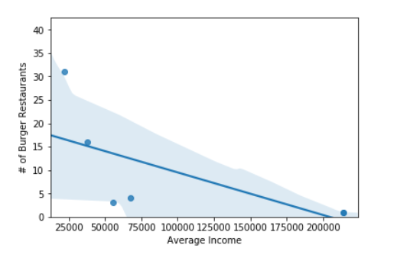

Prior to collecting the data, I predicted that population would be a good indicator of the amount of burger restaurants in an area, but as we can see here, population is not a good metric of determining the amount of burger joints in an area.

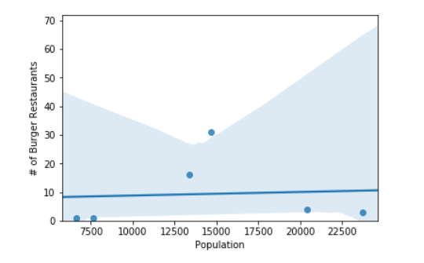

Results/Discussion

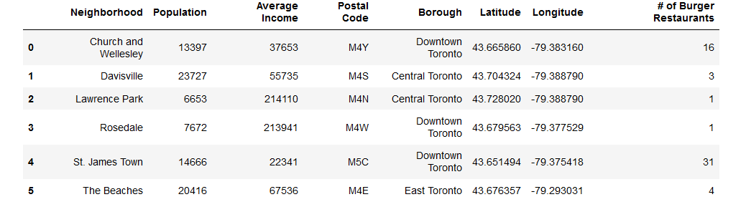

In my findings there is more competition in neighborhoods where people make less money. The reasons for this are because it’s cheaper to start a restaurant in an area where rent on your building is cheaper. Burgers are also usually sold at very moderate prices attracting clientele that does not have a great deal of disposable income. Population was not a good indicator of competition and I believe this is attributed to zoning laws. You can’t place a restaurant in the middle of a residential neighborhood.

Conclusion

We can see there is a lot of competition in neighborhoods where the average income is less than $50,000, especially St. James Town. Choosing a location is difficult and many factors must be taken into account. If you are confident in the quality of your product but do not have a lot of start-up funds it makes sense to open somewhere cheaper to keep overhead costs low. If you are able to spend a bit more and if you’re looking to create a customer experience and not just sell food it makes sense to look for areas with average incomes between $50,000-$75,000. This range of neighborhoods that includes The Beaches and Davisville also have larger population and would be my recommendation for a start-up location. From our limited data it is hard to recommend opening a burger joint in areas earning over $100,000.