**Lab1**: Model Analysis Using Teachable Machine and Python

**Objective**:  
Utilize .h5 models exported from Teachable Machine and analyze their prediction results by python or colab.

**Recommended Datasets for Classification:**

**COVID-19 Chest X-ray Image Dataset**

<https://www.kaggle.com/datasets/alifrahman/covid19-chest-xray-image-dataset>

**Bird Speciees Dataset**

<https://www.kaggle.com/datasets/rahmasleam/bird-speciees-dataset>

**Chinese MNIST**

<https://www.kaggle.com/datasets/gpreda/chinese-mnist> Image Classification Datasets

**Sign Language MNIST**

<https://www.kaggle.com/datasets/datamunge/sign-language-mnist>

**Tasks**:

1. **Train and Load Three .h5 Models**
   * **Exclude** 10 **distinct** images for testing in Task 4.
   * **Adjust** different parameters such as number of images, epochs, batch size, or learning rate.
   * **Record** the parameters used for each model.

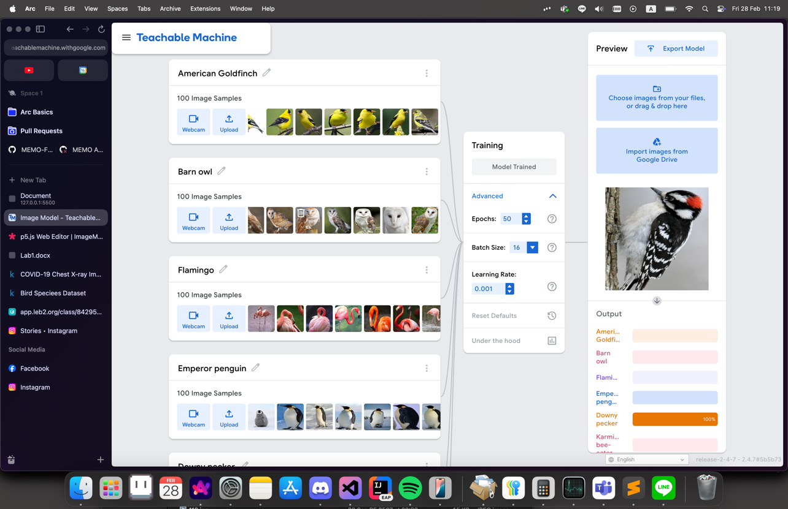

* Epochs: 50
* Batch Size :16
* Learning Rate: 0.001

1. **Test the Models on Images Categorized by Class**
   * **Organize** test images into separate folders based on their respective classes.
   * **Use** the trained models to make predictions.  
     Image categorized

1. **Analyze the Performance of Each Model**
   * **Generate** an Accuracy Table.
     + **12 Samples**

* + **Create** a Confusion Matrix.

* + **Calculate** Precision, Recall, and F1-Score for each class.

1. **Evaluate the Models on Unseen Test Images**
   * **Use** 10 images from (1.) that were not used for training and **test** them on all three models.
   * **Record** the predictions and **analyze** which classes the models misclassified.

1. **Critically Evaluate Each Model**

**จากการลองใช้ model จาก** [**https://teachablemachine.withgoogle.com/**](https://teachablemachine.withgoogle.com/) **โดยใช้ข้อมูลนก 100 (1-100.jpg) ตัวในแต่ละ category นั้นหลังจากการ train ทำให้มีความแม่นยำในการเดานกจากรูปที่ไม่ได้นำไป train ข้อมูลอย่างมาก โดยทดสอบตัวละ 2 แต่ละ category ซึ่งมีการทายที่แม่นยำและถูกต้องตาม true labels และตรวจสอบด้วยทั้ง confusion matrix, precision, recall, F1-score เพื่อวัดผลความถูกต้องด้วย Predicted label และ True label**