**Name : روان خالد علي بيومي**

**B.N: 356**

**Date : 30/5**

**Topic:** **Artificial intelligence**

**Github link :**

**Github page :**

**Application brief :**

**The term artificial intelligence (AI) to systems or devices that emulate human intelligence to perform some tasks that can automatically improve without interference in this depending on the information they collect**

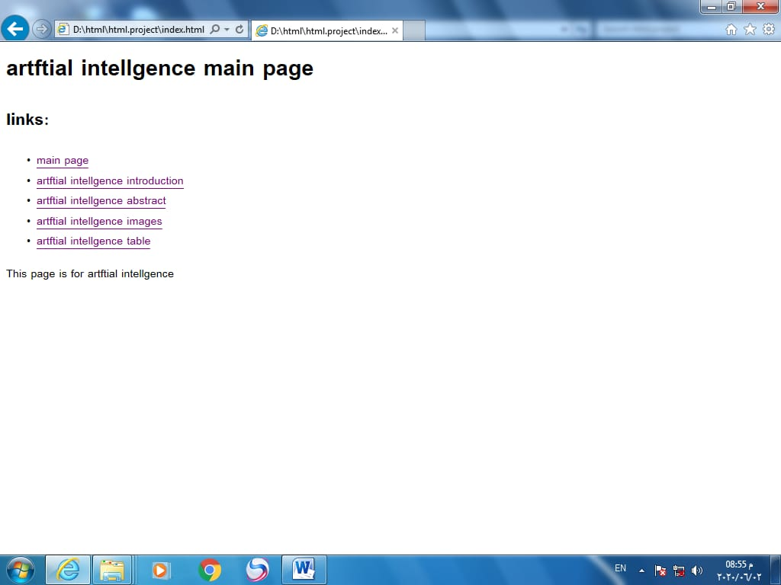**Screeshots :**

