Lab-1

Simple Shell

Name : Rewan Khaled Abdulkariem
ID : 19015677
STRUCTURE OF THE PROGRAM
The main() function sets up the environment, registers a signal handler for child process termination, and calls the shell() function to start the shell.
In the shell() function, the program repeatedly prompts the user for input, reads the input using getline(), parses the input using parse_input() function, and checks if the command is a built-in shell command or a system command. If it is a built-in command, the program executes it using shellBultin() function; otherwise, it forks a child process and executes the command using executeCommand() function.

The parse_input() function splits the input string into tokens and stores them in an array called argv that can be passed to the execvp() function later. If a token starts with $ (dollar sign), the program gets the value of the corresponding environment variable and stores its value in argv array.

The shellBultin() function implements four built-in shell commands: cd, echo, export and exit. The cd command changes the current working directory, echo command prints out the argument(s) provided, exports command sets an environment variable, and exit command terminates the shell.
The executeCommand() function forks a child process and executes the command using execvp() function. If the command ends with &, the program sets the background_flag to 1 to indicate that the command is to be run in the background.

The on_child_exit() function is registered as a signal handler for SIGCHLD signal. It is called when a child process terminates and writes a message to a log file indicating the termination of the child process.

Overall, this shell program provides a basic command-line interface that allows users to run system commands and built-in shell commands. However, it has some limitations and potential issues, such as not handling errors properly, not implementing redirection or piping, and not providing a way to interrupt a running command

SAMPLE RUN
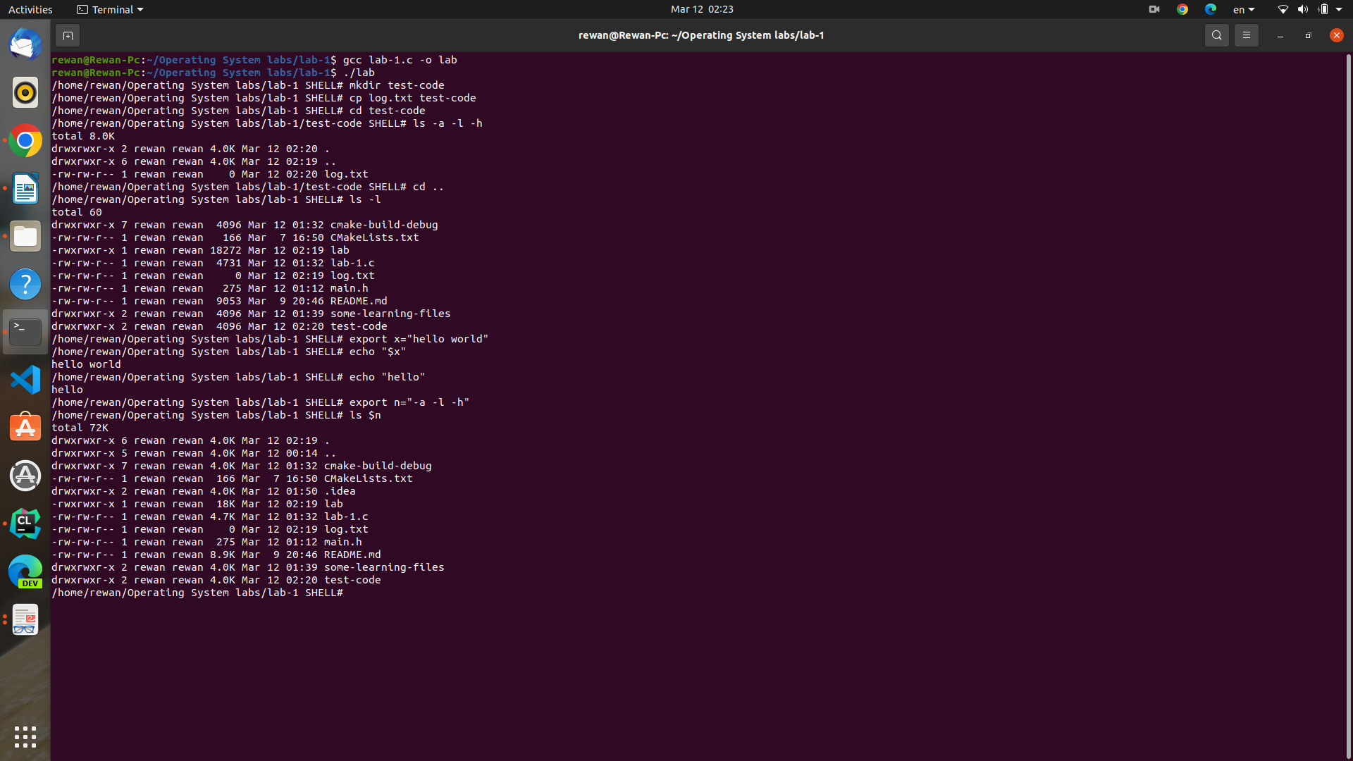
BACKGROUND EXCUTABLE
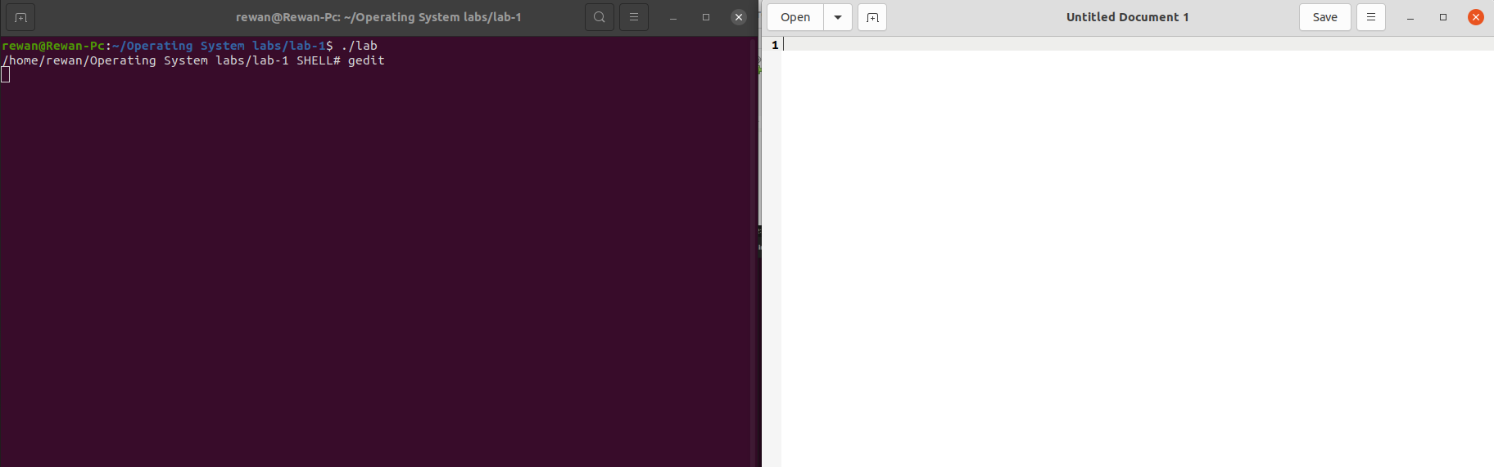
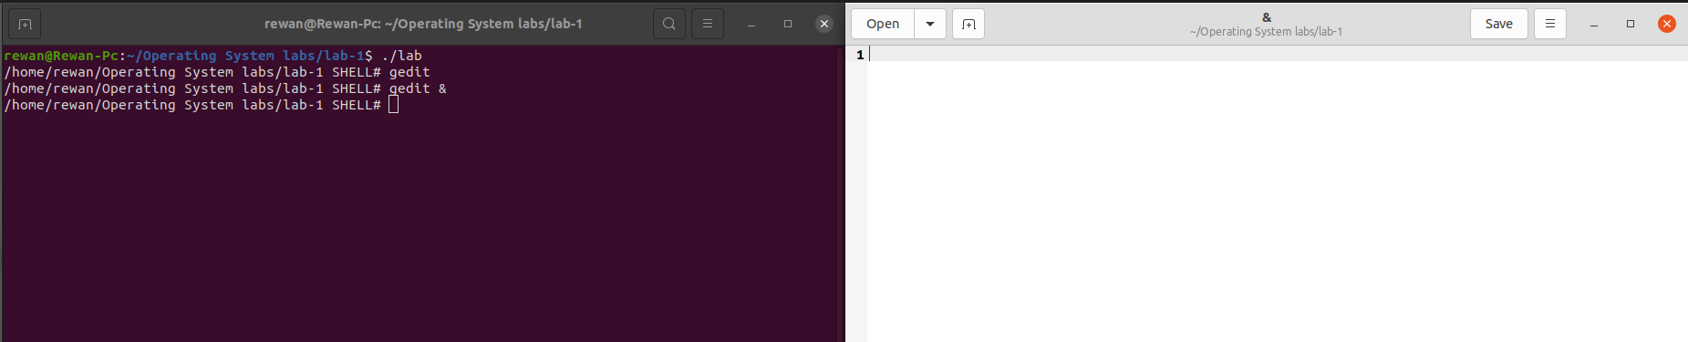
exit command-line
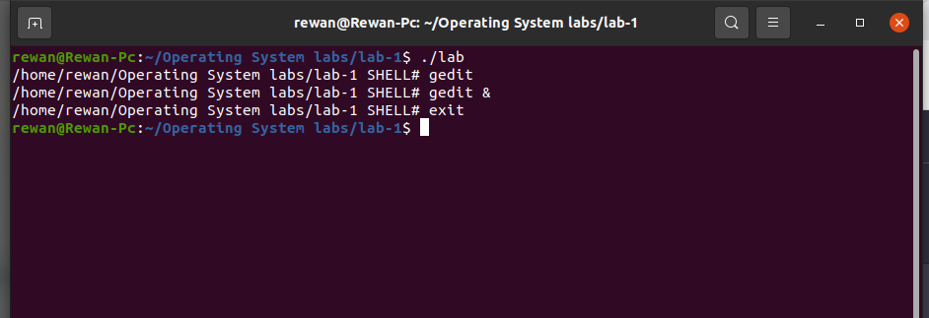
screenshots for the processes hierarchy in Ksysguard
