Lab-2

Matrix Multiplication (Multi-Threading)

Name : Rewan Khaled Abdulkariem
ID : 19015677
STRUCTURE OF THE PROGRAM
The main() function the entry of the program checks if the program was executed with enough arguments. If it was, it reads the matrices from the files specified in the arguments, stores the names of the output file, and proceeds to execute the three methods of matrix multiplication. If not, it reads the matrices from the default files "a" and "b," stores the name of the output file "c," and proceeds to execute the three methods of matrix multiplication.
The ReadMatrix() function reads a matrix from a file with the given filename a. The index parameter specifies whether the matrix should be saved to matA or matB. The function first opens the file in read mode and reads the number of rows and columns from the first line of the file. It then allocates memory for the matrix based on the number of rows and columns, and reads the matrix values from the file and saves them to the allocated memory. Finally, it saves the matrix to matA or matB based on the value of index.
The MatrixSize() function allocates memory for a 2D integer array of size rows by coloumns. It first allocates memory for an array of integer pointers with size equal to the number of rows. It then allocates memory for each row of an array of integers with size equal to the number of columns. It returns a pointer to the allocated memory.
The AllocOutMat() function allocates memory for a 2D integer array to store the result of matrix multiplication. It sets the number of rows and columns of the output matrix based on the number of rows and columns of the input matrices. It then allocates memory for the output matrix and initializes all elements to 0. It returns a pointer to the allocated memory.
The PrintArray() function writes the 2D integer array matOut to a file with the given filename. It first opens the file for writing, and writes the number of rows and columns of the matrix to the file. It then writes each element of the matrix to the file. Finally, it closes the file.
The PerMatrix() function performs matrix multiplication using the first method. It first allocates memory for the output matrix using AllocOutMat(). It then calculates the product of the input matrices and saves the result to the output matrix. Finally, it writes the output matrix to a file using PrintArray().
The per_row() function performs matrix multiplication using the second method. It first allocates memory for the output matrix using AllocOutMat(). It then creates a thread for each row of the output matrix and calculates the values of the row in parallel. Finally, it writes the output matrix to a file using PrintArray().
`The per_element() function performs matrix multiplication using the third method. It first allocates memory for the output matrix using AllocOutMat(). It then creates a thread for each element of the output matrix and calculates the value of the element in parallel. Finally, it writes the output matrix to a file using PrintArray().

Sample Output
1- first test
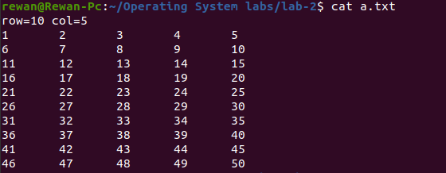

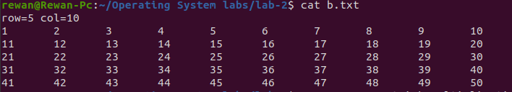

output files:
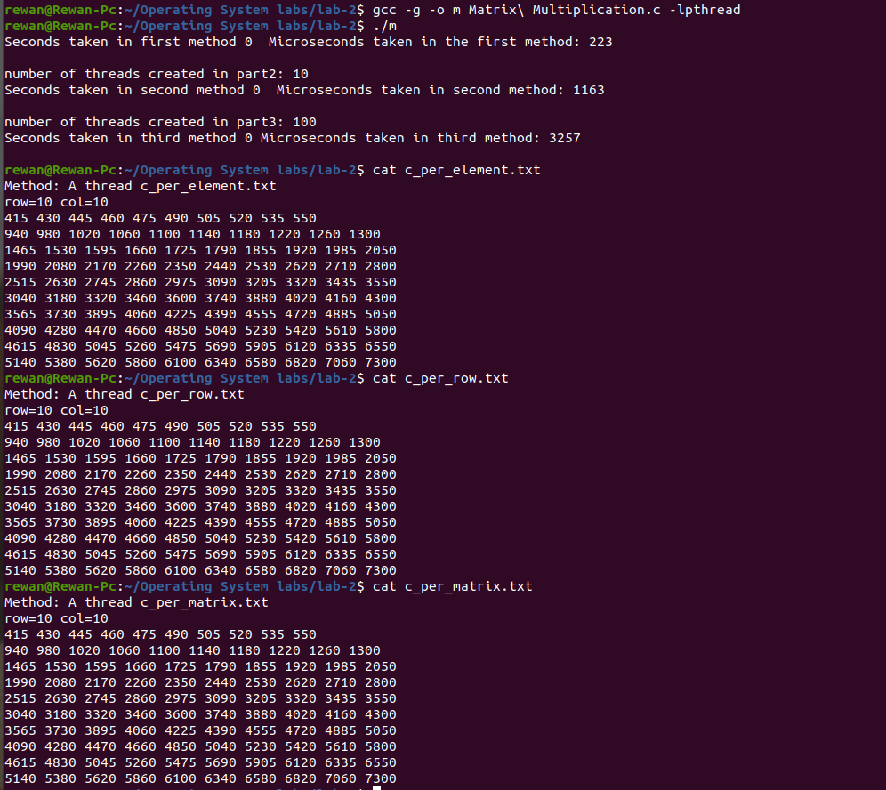
2- second test

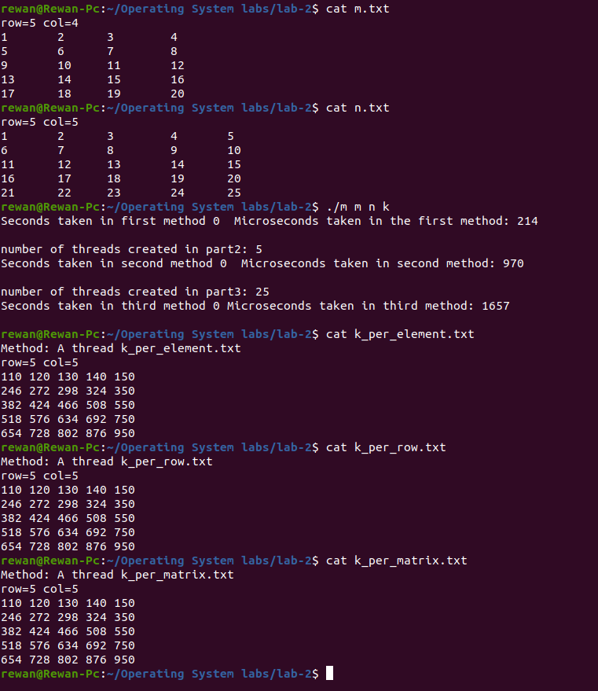
3-third test
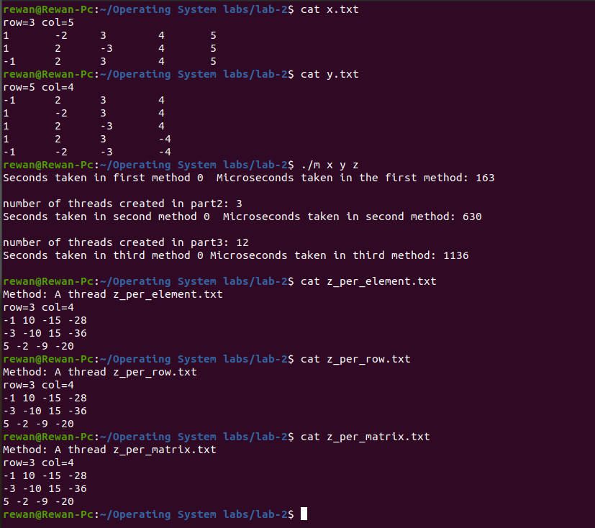
A comparison between the three methods of matrix multiplication.
First method (thread per matrix) >> Second method (thread per row) >> Third method (Thread per element)
the first method, thread per matrix, is the fastest for smaller matrices, as it involves the least overhead in terms of thread creation and synchronization. However, as the size of the matrices increases, the second method, thread per row, may become more efficient, as it can take advantage of more parallelism and reduce the amount of data transfer between threads. The third method, thread per element, may be the slowest due to the high overhead associated with creating and synchronizing a large number of threads.

