Software Engineering

Sheet

Use case diagram

1. [Business actors](https://www.uml-diagrams.org/use-case-actor.html#business-actor) are Passenger, Tour Guide, Minor (Child), Passenger with Special Needs (e.g. with disabilities), all playing **external roles** in relation to airport business.

[Business use cases](https://www.uml-diagrams.org/use-case.html#business-use-case) are Individual Check-In, Group Check-In (for groups of tourists), Security Screening, etc. - representing business functions or processes taking place in airport and serving the needs of passengers.

Business use cases Baggage Check-in and Baggage Handling extend Check-In use cases, because passenger might have no luggage, so baggage check-in and handling are optional.

1. Draw use case diagram

Answer:

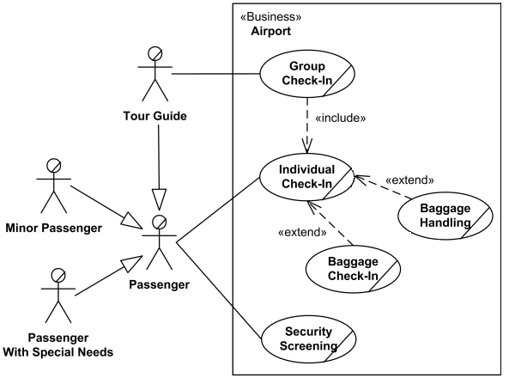

2. Draw use case diagram for Webmail System Use Case Model.

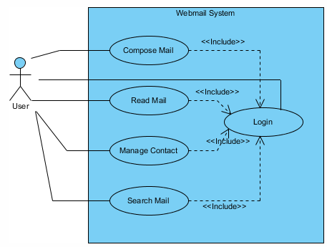

3. Draw the use case diagram and use case table for ‘Login’ to a ‘School Management System’.

Answer:

Reset password and forget password are extend function

Use case table fe mohadret el doctor

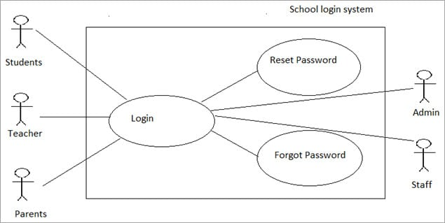

4. Draw the use case diagram for an ATM, then write use case table for two functions.

Answer:

El customer bs

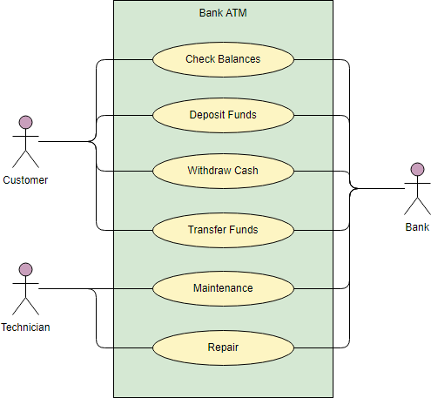

5. Web Customer actor uses some web site to make purchases online. Top level use cases are View Items, Make Purchase and Client Register. View Items use case could be used by customer as top level use case if customer only wants to find and see some products. This use case could also be used as a part of Make Purchase use case. Client Register use case allows customer to register on the web site, for example to get some coupons or be invited to private sales. Note that, Checkout use case is included use case not available by itself - checkout is part of making purchase.

