**DOCUMENTATION**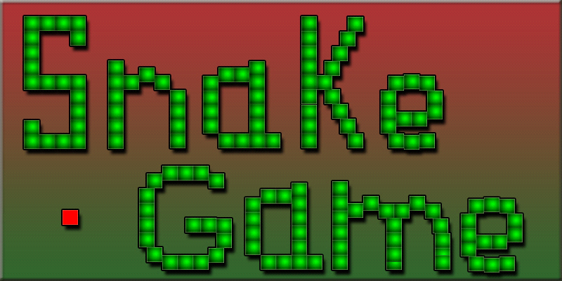

**Table of Content**:

**No.** …………………. **Content**

1 ………………… Introduction

2 ………………… Acknowledgements  
3 ………………… Game Attribute

4 .....………… System Architecture

4.1………………… Game Components

4.2………………… Game Architecture

5 ………………… Game Construction

5.1 ……………… Building the Game

5.2 ……………… Game Play

6 …………………… Development Challenges

7 …………………… Conclusion

8 …………………… Reference

**1. Introduction:**

Project documentation is concerned with describing the delivered software product, in this case the Multiplayer Snake game project. Project documentation includes user documentation which tells users how to use the software product and system documentation which is principally intended for further development and understanding.

**2.** **Acknowledgement(s):**Thank **Sapna mam** for pushing us and inspiring to build and understand a singleplayer Snake game. Thanks for the effort and giving us lectures and explaining the architecture. Thanks for helping when we were stop in the middle during the development phase. We could not have built such a challenging project without your help.

**3. Game Attributes:**

The name of the game is “Multiplayer Snake Game”. It’s a multiplayer game which can be played in the same machine. In this game we use four arrow keys and “A”,”S”,”W” & “D” to control the snake direction. And when press Enter game start and when press Space bar game become pause.

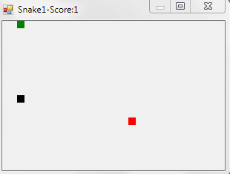

Fig:-3.2(Game Attributes)

**4. System Architecture:**

System architecture is the skeleton view behind the GUI part of a game. System architecture defines the working methodology of the game and shows the components, their relationships and how they evolve to make the game work. The system architecture of this particular game can be divided into two parts:

* Game components.
* Game architecture.

**4.1 Game Component:**

Game Components are behind the scene classes and methods which make up the game and all the functionalities. The components are mesh together and there are lot of inter relationships between them. The main components are described below:

**Main class:**  Main class is where all the components are connected and it’s the heart and mind of the game. In this game it is named “frmMain.cs”. The GUI of the game is represented in this class. The movement is also listened from here & different methods are used for different functionality.

program of snake in python-

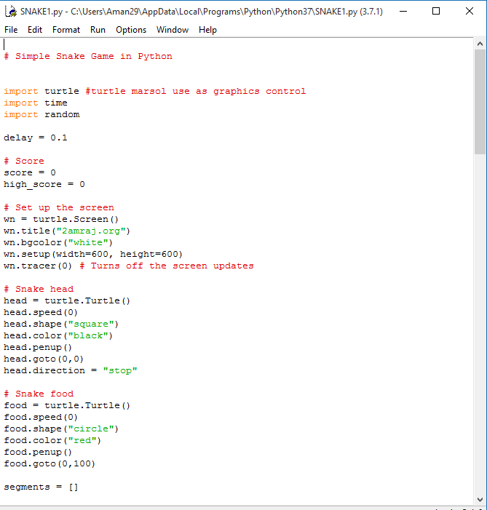

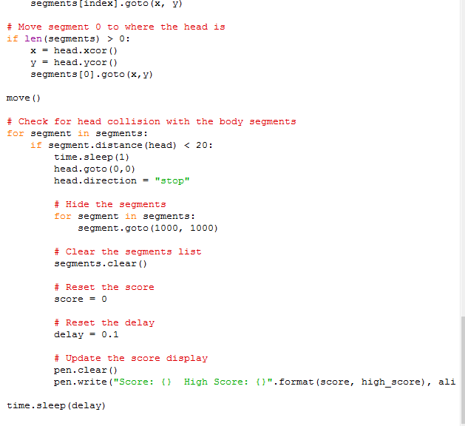

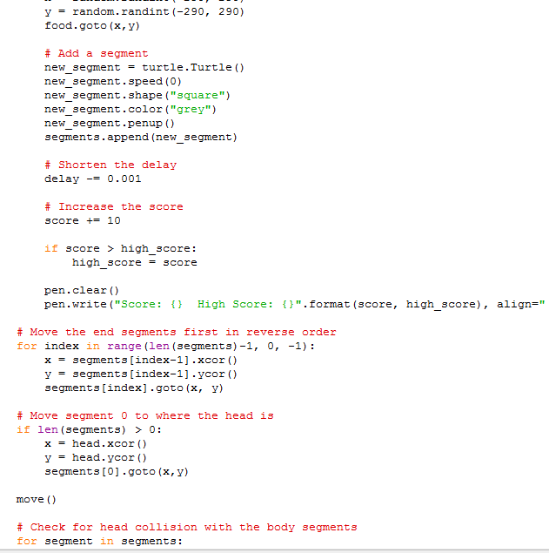

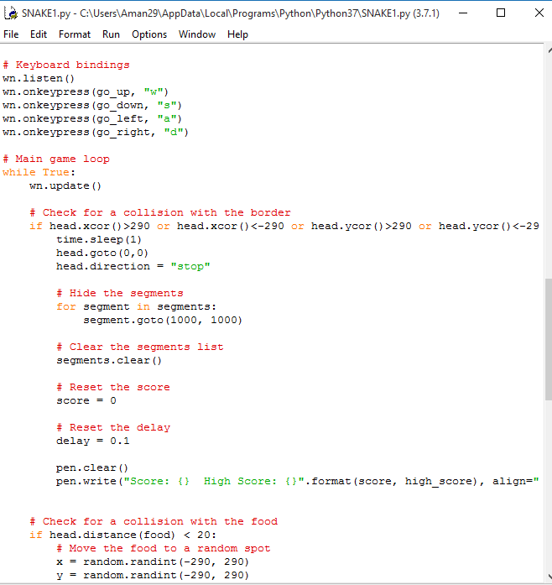

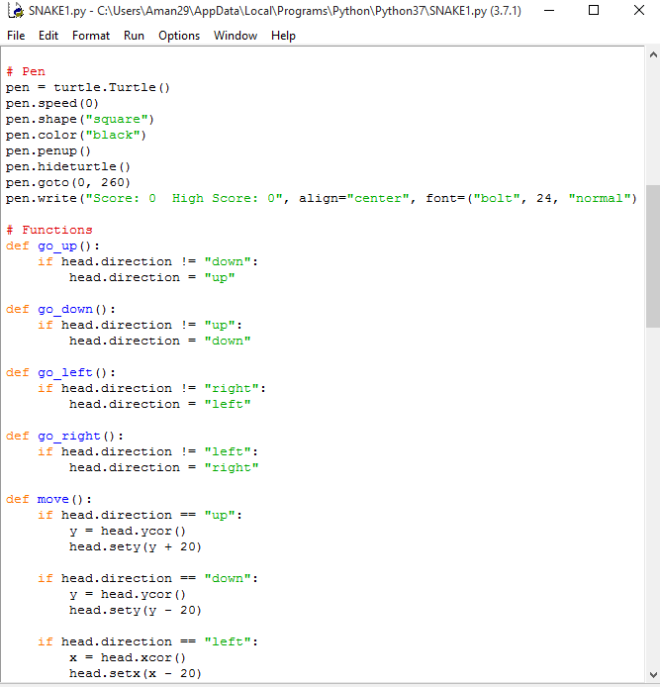

**Snake class:** Snake class is a class which is used to draw, design, control movement and define Snake behavior.

**Snake1 class:** Snake1class is a class which is used to draw, design, control movement and define Snake1 behavior.

Here are some game functions-

snake food()-for food of Snake

snake head ()-for making head of snake

screen (int direction)-for developing screen

pen ()-for showing the score of player

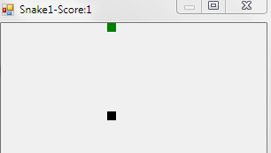

Figure ( Snake1)

**Food class:** Food class is a class which is used to draw, design food. Here food is randomly generated. When the Snake & Snake1 eat food they become grow.

Public Food (Random rand)

Public void Draw (Graphics graphics)

Public void Generate (Random rand)

x=rand.Next(0,30)*10;

y=rand.Next(0,20)*10;



Fig:-4.3(Food)

**4.2 Game Architecture*:*** The Game Architecture is the simplified graphical view of the game. It shows how the components work and the basic view of the game at action. The architectural view of the game is very important. Simply it gives an overview of the game functionality and it makes the game easy to understand.

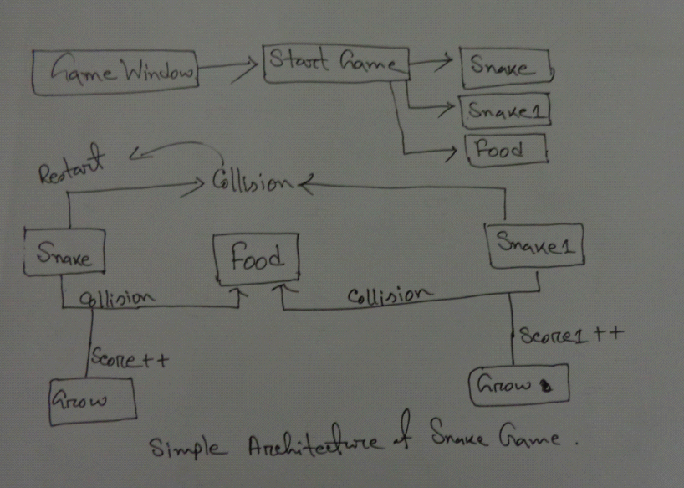

Fig:-4.4(Simple architecture of snake game)

**5. Game Construction:**

Here we develop the game and test the game and ultimately play the game. Construction phase can be divided into 2 phases:

* Building the Game
* Game play

**5.1 Building the Game:**

It’s the headrest part in all the line of process.

When we first start the game we first planning, find out the requirements, draw the architecture.

To build the game need to know programming language (this time python).

The development phases are:

* Creating a single Snake.
* Creating a Food.
* Then creating two snakes.
* Snakes collision with food.
* Snakes collision with each other body.
* Snakes don’t move two directions at a same time.

**5.2 Game Play:**

The steps of game play are given below:-

* Open the game application:

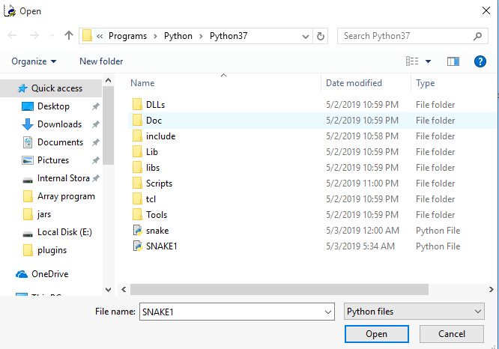

* Press any key to start

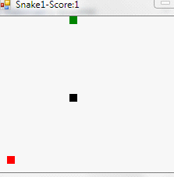

***6.* Development challenges:**

We had to face a lot of challenges during the development phase. We cannot make this game playable through network. We only developed multiplayer game in same machine that is handled by button.

**7. Conclusion:**

This project gives us more thrilling, frustrating and also gives us more pleasure. It helps us in many sectors like- planning, designing, developing, managing, programming skill, socket programming and so on.

**8. References:**

* Class lab