**GIT comments**

**# $ git <options> command <options> ....the way we type a command (there are about 137 commands)**

**# the most common commands ..(push/pull/log/merge/add/status/checkout/clone/branch/commit/rm/mv/diff/init/status)**

**# for help in commands ($ git <command> -h / $ git <command> --help / $ git help <command>)**

**# to create a git repository folder go to the directory of the project on CMD and type ...$ git init**

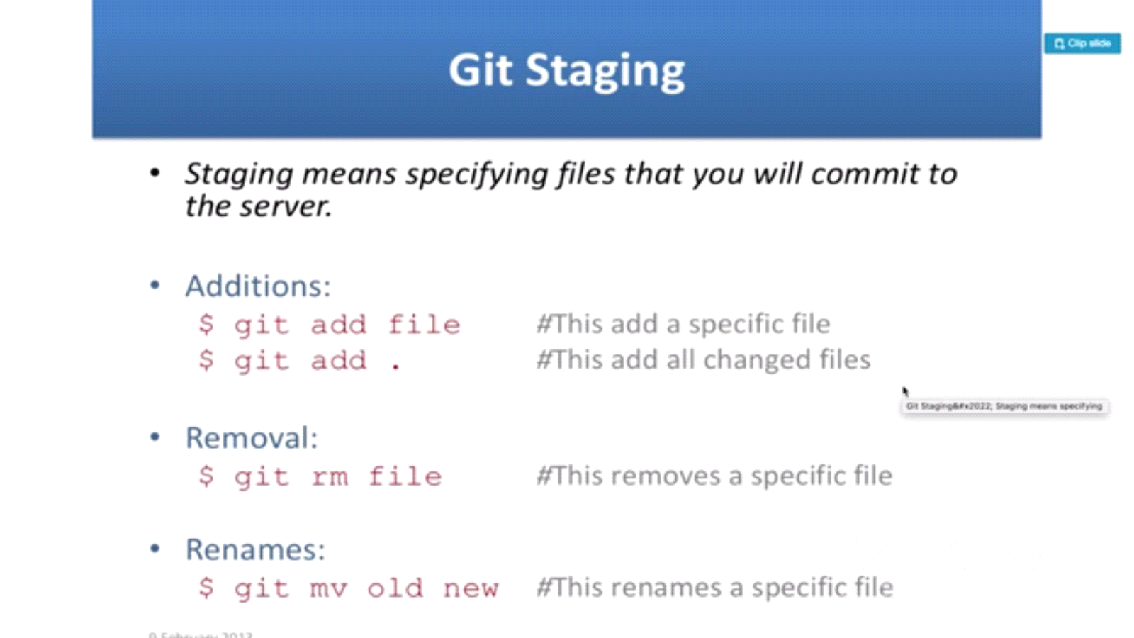

**# staging area means files that changed occurred on them will be saved it it before being saved to local repository (on the machine not the server)**

**#when typing>>> $ git status....it shows the files in staging area that ready to be put in local directory ...they will appear in green**

**# suggested commands will appear in the bash for the user to commit them**

**#We don’t make commit unless the file is added and appears as modified in green**

**#Once you committed don’t type $ git status ..again….it’s not correct**

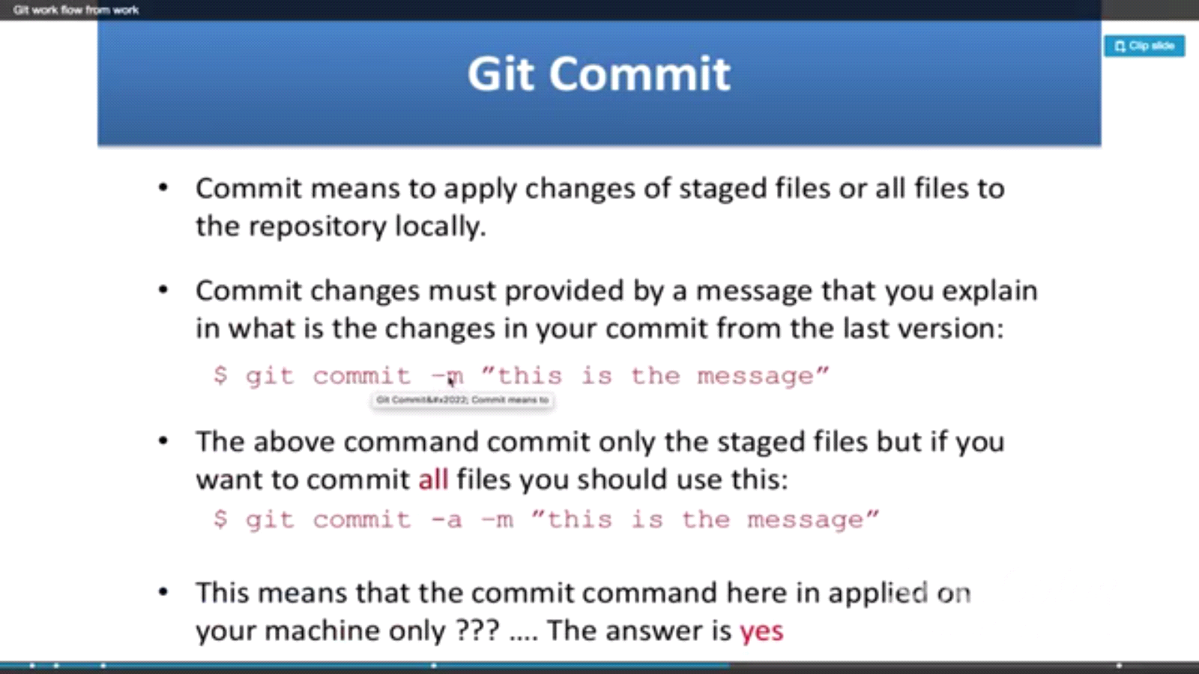

**#Tags: used in milestones and latest stable version.**

**#Branch: used in Bug fixing /for new features …and not to work on the production thread (Branch)**

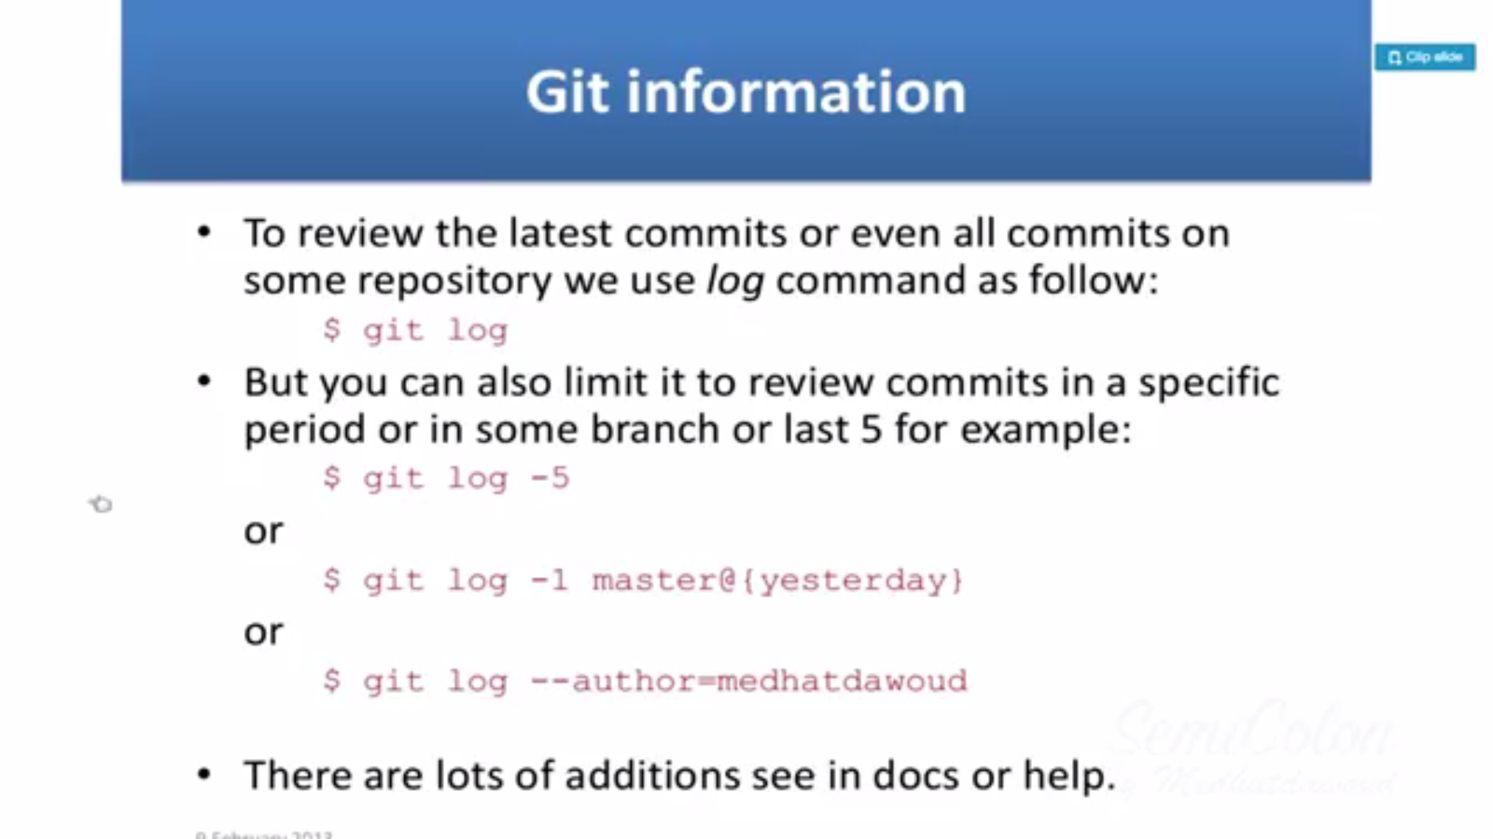

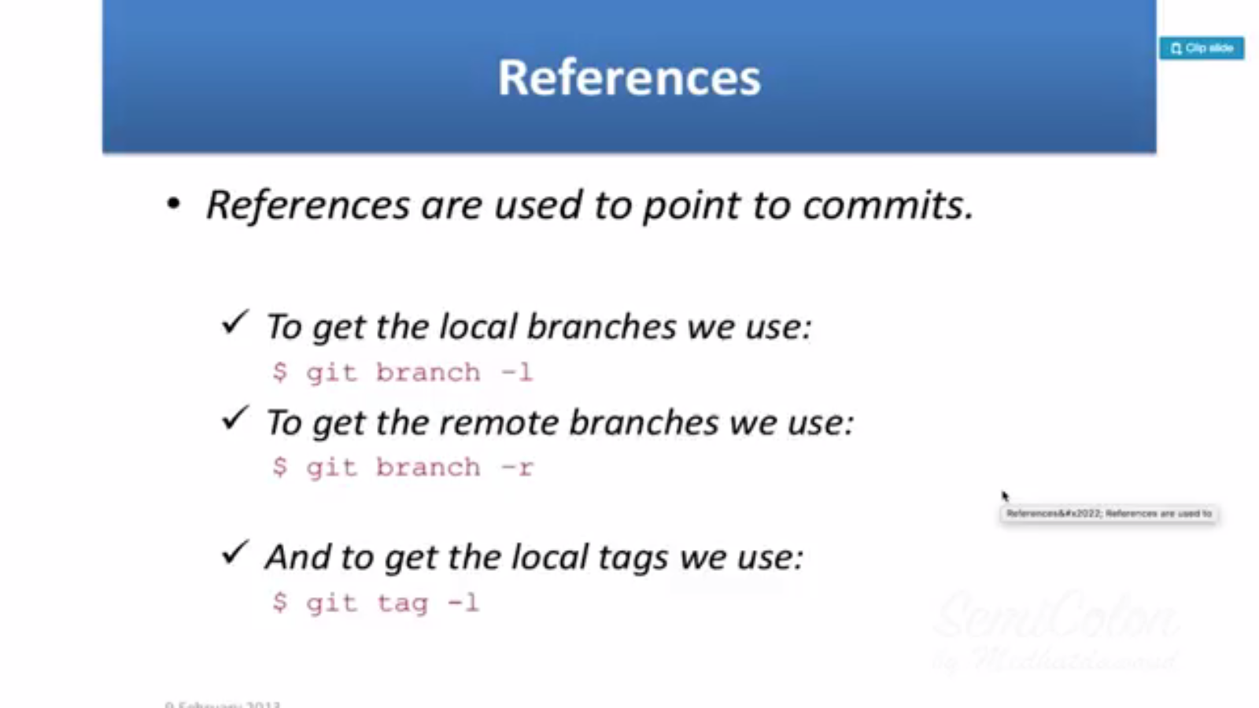

**# To create a new branch…$ git new branch Branch_Name**

**#The default main branch is “master”**

**# Switching from one branch to another …$ git checkout Branch_Name**

**#Creating and switching to that Branch …$ git checkout –b Branch2_Name**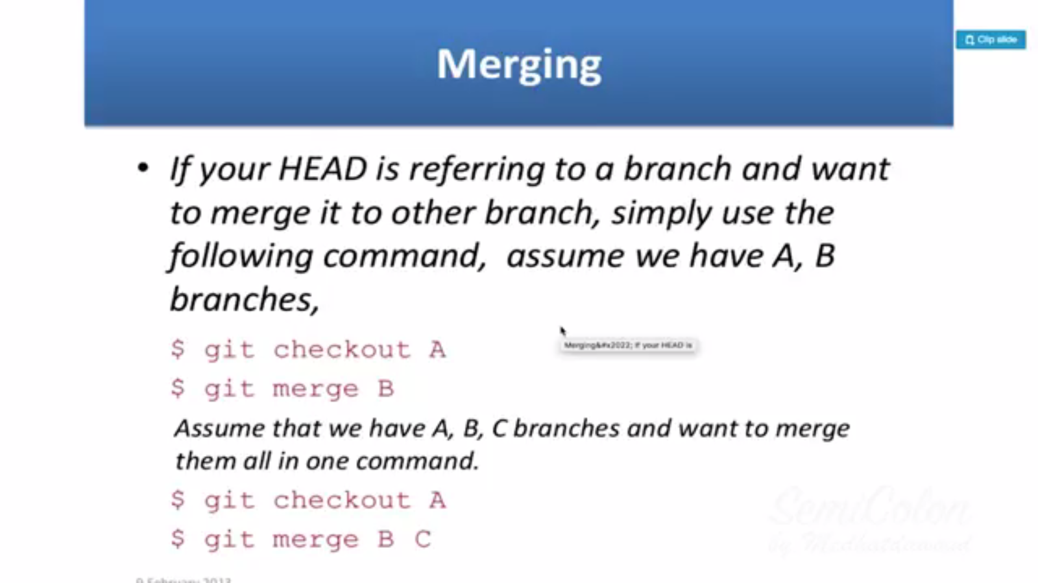

**#To merge things from one branch and merging them to another…we go to this branch using ….$ git checkout master then ….$ git merge SecondBranch**

**#We can make a remote Repo/Git on GitHub....for example.We need internet connection and we type the next commands….** 