**Optimization document**

Code optimization:

Before:

After:

Before:

After:

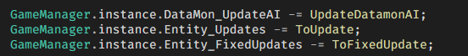

Profiler:

Before:

After:

Art optimization:

Some of our sprites were made by Moh Fey, but they used too many objects. We optimized them by turning some body parts to single sprites to reduce the space it took.

Some examples of the art optimization:

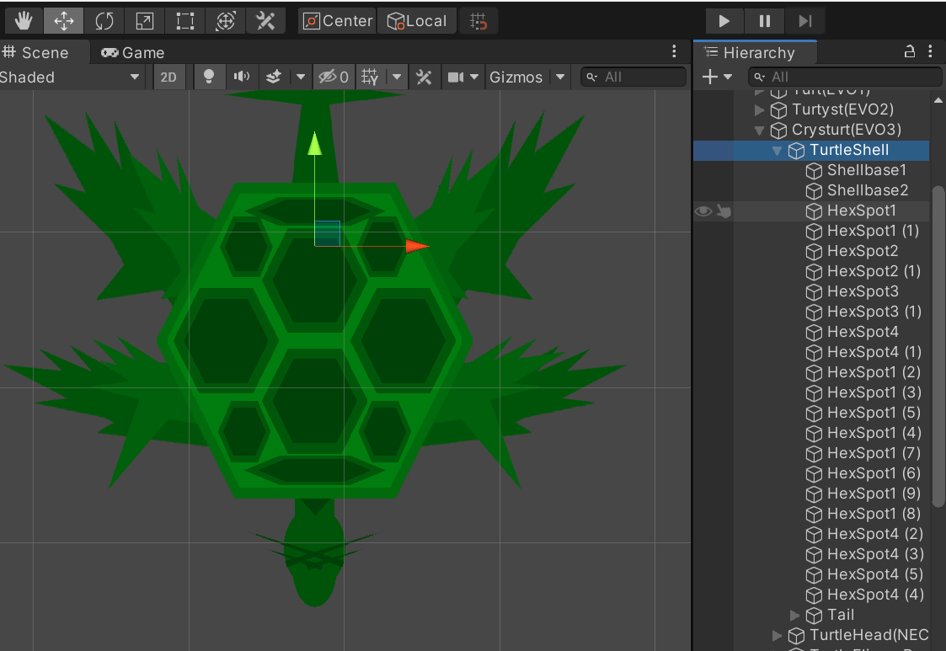Turtle before optimization:

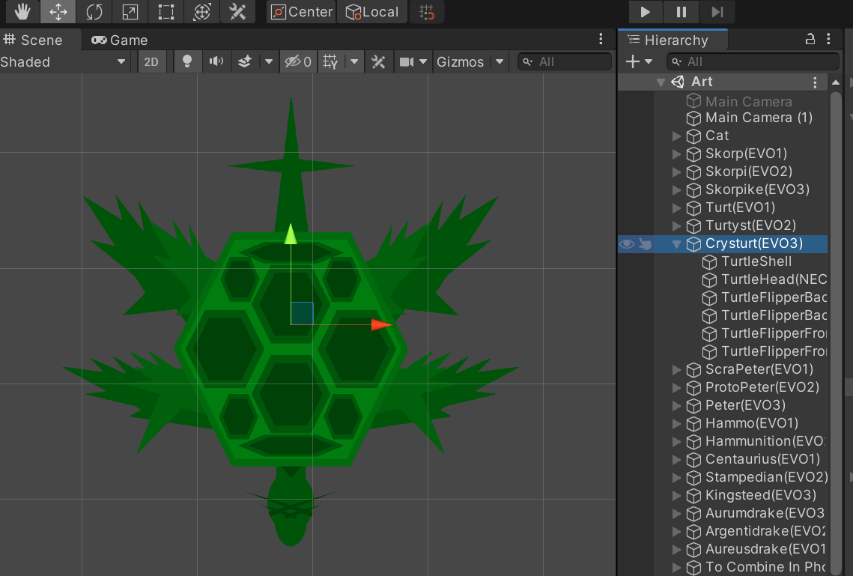Turtle after optimization:

Skorpike before optimization: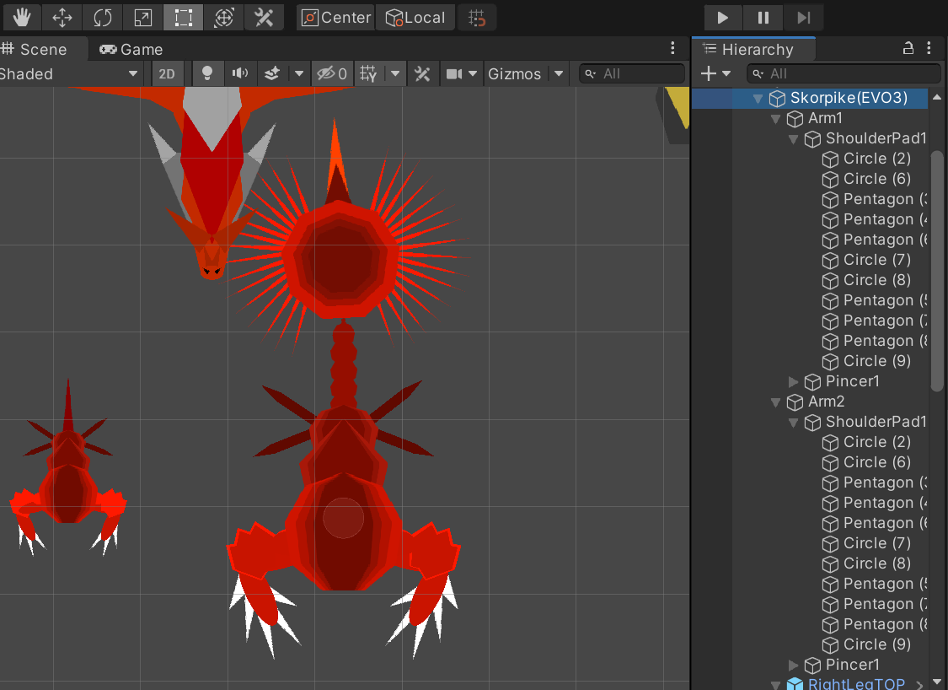

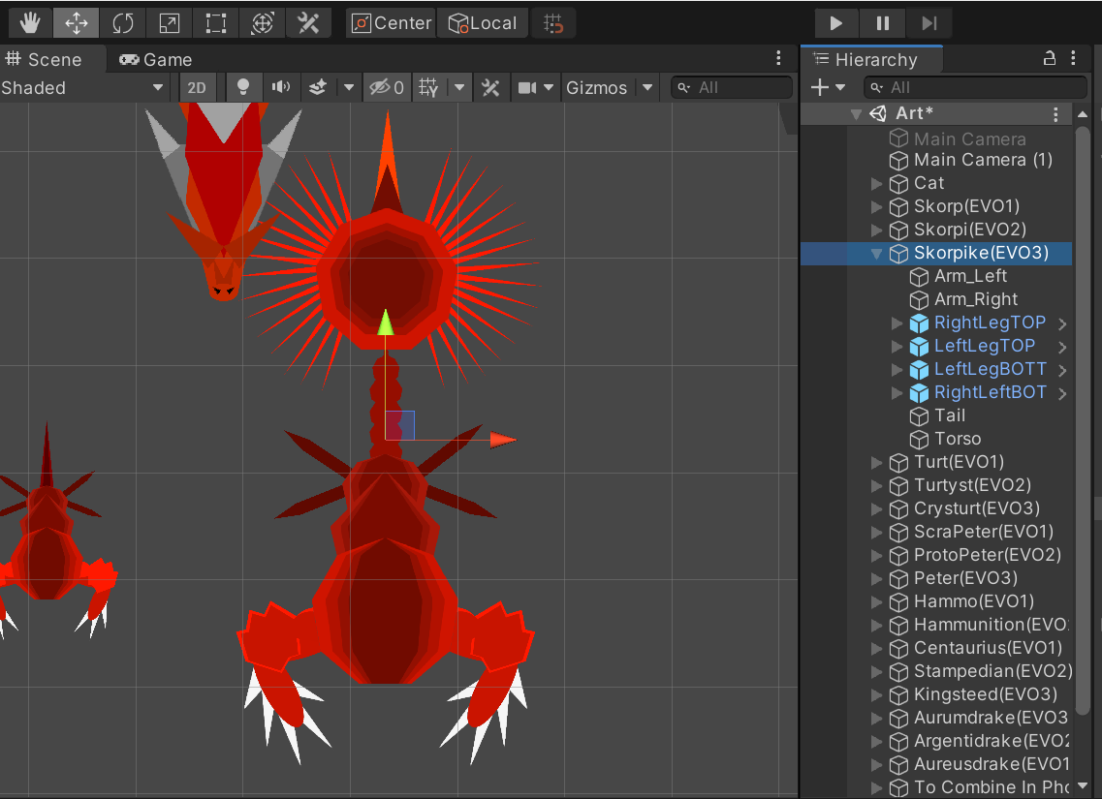Skorpike after optimization:

Peter before optimization:

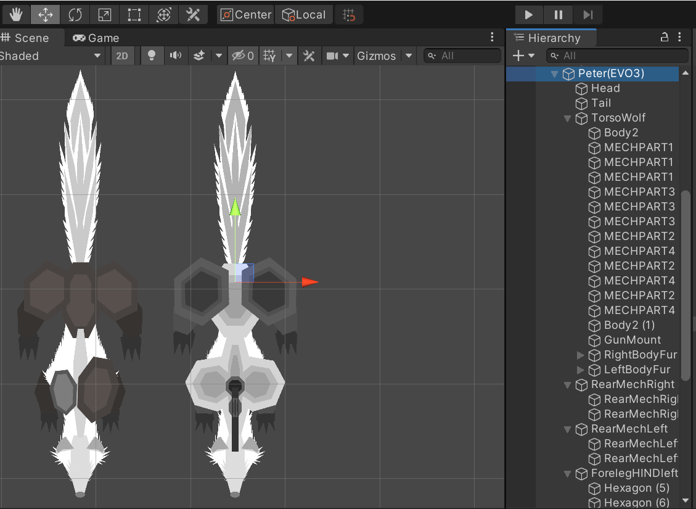

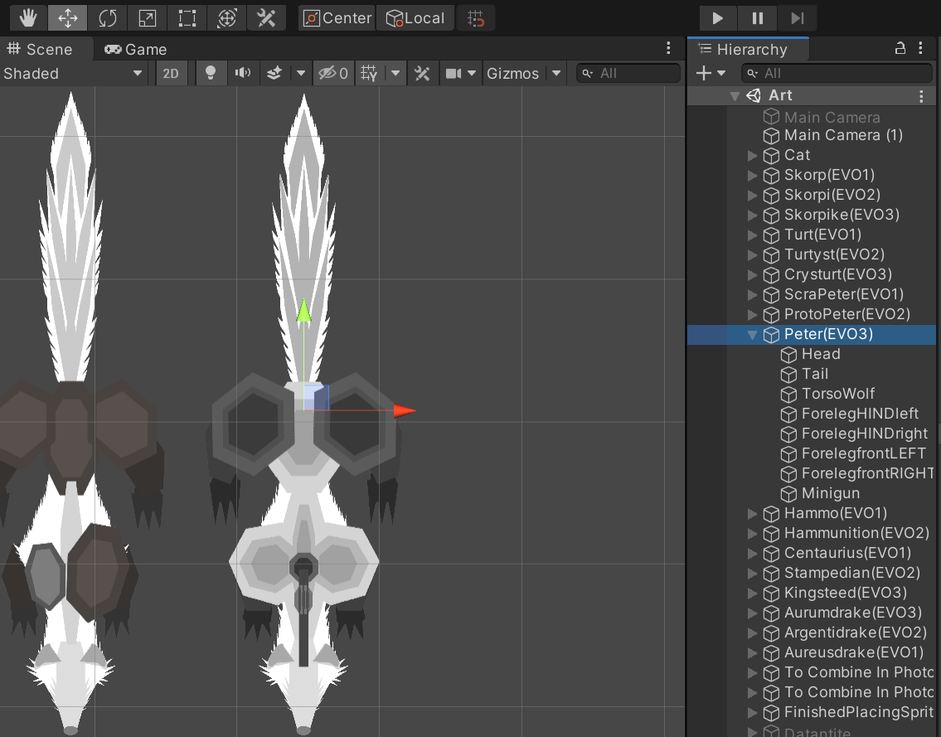Peter after optimization:

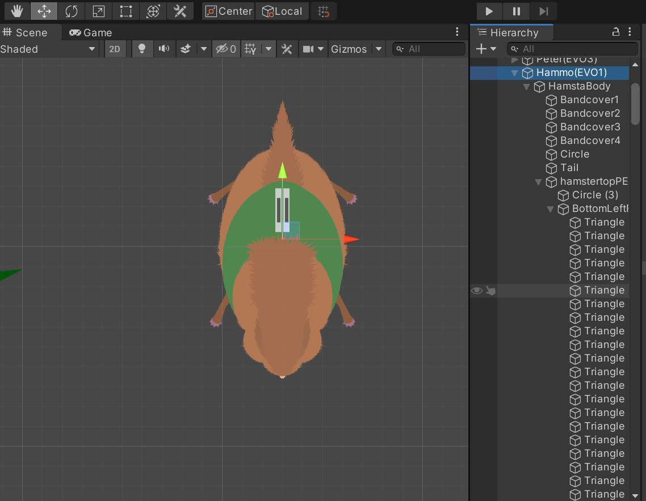Hammo before optimization:

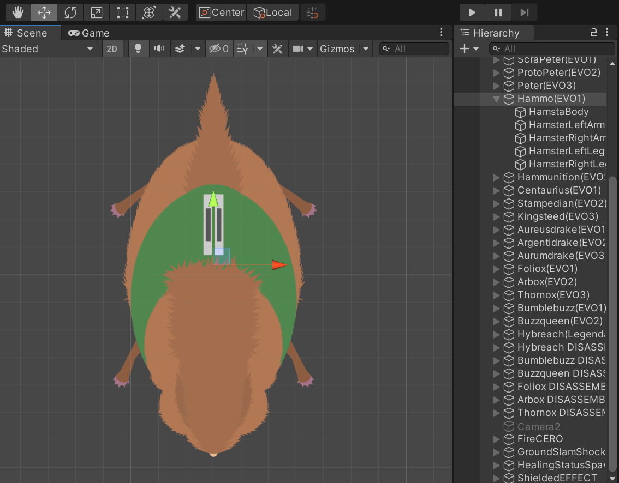Hammo after optimization:

Dragon before optimization:

Dragon after optimization:

