WHL3.
Robotic Exoskeleton for Load Transportation
By: Yim Fu Chong (1155176974)
Supervisor: Professor Wei-Hsin Liao
Final Year Project Final Report
Submitted in Partial Fulfillment of the
Requirements for
The Degree of Bachelor of Engineering
Department of Mechanical and Automation Engineering
The Chinese University of Hong Kong
[date]

Acknowledgments

I would like to express my sincere gratitude to my supervisor Professor Wei-Hsin Liao. His insights into robotic exoskeletons and actuation systems have been instrumental in shaping the direction and progress of my work.

I am also deeply thankful to the team at ExoTechHK Limited for their collaboration and providing access to their lower-limb exoskeleton prototype. This partnership, facilitated under the Hong Kong Science and Technology Parks (HKSTP) incubation programme, has offered a practical pathway for technology transfer and real-world application.

Special thanks go to the Department of Mechanical and Automation Engineering at The Chinese University of Hong Kong for the resources and facilities that enabled this research. Additionally, I appreciate the contributions from fellow researchers and peers who provided feedback during the development phase.
Finally, I extend my appreciation to my family and friends for their encouragement and understanding during this challenging yet rewarding endeavor.
Yim Fu Chong
[date]

Abstract

Main objectives

This project aims to develop a software-centric enhancement module for a lower-limb robotic exoskeleton designed to assist workers in heavy load transportation tasks (>20 kg) in industrial, logistics, and construction environments. The primary objectives are to enable real-time detection of user locomotion intent (including walking, stair ascent/descent, sit-to-stand transitions, and speed variations), accurately estimate joint kinematics through multi-sensor fusion, and deliver adaptive personalized torque assistance to minimize physical effort and injury risk. To achieve this, the module will incorporate computational techniques to handle variability in user biomechanics and environmental conditions, ensuring robust performance across diverse scenarios.

Planned methods (interim report, Jan 2026 PDF)

The proposed system integrates inertial measurement units (IMUs) placed on the lower limbs and back, with data processed through a Kalman filter-based sensor fusion pipeline implemented in MATLAB to achieve robust, low-latency joint angle and velocity estimation. Locomotion mode and transition prediction were planned using machine learning models (Support Vector Machines and Long Short-Term Memory networks) trained on labeled gait datasets, targeting >90% classification accuracy and a 100--200 ms predictive horizon, with performance evaluated via confusion matrices, precision, and recall. Finite state machines were incorporated for locomotion mode transitions. The data collection protocol involves attaching three mobile phones as IMUs to the hips and lower back; performing standardized tasks such as walking 10 m on flat ground, climbing 10 steps, or navigating uneven surfaces at self-selected speeds; and exporting accelerometer, gyroscope, and magnetometer data as CSV files for processing. Joint kinematics information is intended for precise control.

Implemented methods (repository baseline, updated)

The validated MATLAB baseline uses Kalman fusion (imufilter) as above. Classification uses overlapping windows (100 samples at 100 Hz, step 50). The primary deployment classifier is a binary RBF SVM (fitcsvm, standardized features) with a 30-dimensional training vector: five statistics per IMU slot × six slots (Features.m); HuGaDB supplies six on-body IMUs per window; USC-HAD and on-line simulation use one IMU stream with remaining slots zero-padded (LocomotionFeatureVector). The positive class groups locomotion-like activities (level walk, stairs, run per dataset label maps). A multiclass ECOC ensemble (fitcecoc) provides twelve unified activity labels for analysis; exoskeleton gating uses the binary model and an asymmetric FSM (3 consecutive walk-like predictions to assist, 5 to release). LSTM networks are not implemented in the validated codebase. The 100--200 ms horizon remains a design target; literature reports comparable latencies for kinematic lift-onset cues [chen2018], but the submitted SVM baseline was not benchmarked under that specific metric.

Interim results statement (Dec 2025 / Jan 2026 PDF)

The interim submission reported: a functional three-phone acquisition prototype; preliminary Kalman filtering and intention-detection algorithms validated on public datasets including HuGaDB and the USC-SIPI gait database; repository setup; real-time visualization; and initial locomotion classification with 98.88% accuracy and a 150 ms predictive horizon. Corrections: the smartphone gait database used in this project is USC-HAD [zhang2012], not USC-SIPI. The 150 ms figure overlapped claims from the literature on hip-based lift detection [chen2018] and was not rigorously established as an end-to-end latency of the final classifier at submission time.

Updated empirical results (merged public data, current build)

Kalman filtering and SVM-based intention detection are implemented in MATLAB. Training uses USC-HAD [zhang2012] and HuGaDB [chereshnev2018] with merged windows and the 30-D feature layout. Binary five-fold out-of-fold accuracy is about 98.9% (USC-HAD only), 88.6% (HuGaDB only), and 94.5% (merged); the default saved binary model is merged. The twelve-class ECOC model achieves about 57% OOF accuracy on a stratified subsample used for tractable cross-validation. Real-time pipeline simulation on CSV data shows fused hip flexion angle and FSM-latched assist commands.

Main conclusions
This project demonstrates that automation technology, particularly machine-learning-based intention recognition combined with sensor fusion and finite state machines, is applicable to next-generation powered exoskeleton control supervisors. When fully realized, the proposed module has strong potential for integration into industrial platforms (e.g., ExoTechHK Limited), offering high accuracy and balanced metrics on public IMU data while enhancing safety through hysteresis-based gating. This work contributes to workplace ergonomics and provides a reproducible foundation for hardware-in-the-loop studies. The repository now documents both the original project plan (SVM+LSTM, extended fusion) and the delivered MATLAB baseline (binary + optional multiclass SVM, dual-dataset training).

Problem Description

Problem Statement

Manual load transportation in industrial, construction, and logistics settings frequently involves carrying loads exceeding 20 kg, surpassing human physiological limits and leading to high rates of lower-back pain, musculoskeletal disorders (MSDs), reduced productivity, and billions in annual economic costs worldwide. Existing assistive exoskeletons often fail to provide proactive, real-time adaptation to the user's locomotion intent or environmental changes, resulting in delayed or mismatched assistance that compromises safety and comfort. Moreover, generic assistance profiles do not account for inter-individual differences in gait asymmetry, fatigue thresholds, anthropometrics, or preferred movement patterns. These limitations are especially critical in dynamic workplaces where load magnitude, terrain, and tasks constantly vary. There remains a clear need for a lightweight, cost-effective lower-limb exoskeleton that delivers accurate intent detection, robust sensor fusion, and truly personalized adaptive control---without relying on invasive interfaces such as electromyography (EMG) or requiring extensive user training.

Project Goal

The primary goal is to develop a software-centric enhancement module for ExoTechHK Limited's existing lower-limb exoskeleton prototype---a local startup incubated at HKSTP and founded by CUHK researchers---to augment human strength and endurance during heavy load-carrying tasks (>20 kg) without invasive sensors or lengthy calibration.

Original project goal statement (interim PDF, Jan 2026)
The module was specified to integrate: (i) a data acquisition and processing pipeline using three mobile phones as IMUs, Kalman-based fusion for joint kinematics, and initial machine learning (e.g., hybrid SVM+LSTM) for locomotion classification with validation on public datasets; and (ii) proactive real-time locomotion intent recognition using hip and lower-back IMU data via a hybrid SVM+LSTM model with multi-sensor fusion, targeting >90% intent-detection accuracy and a 100--200 ms predictive horizon, with evaluation through confusion matrices.

Current implementation emphasis (repository)

The module integrates two core components as realized in code:
Data Acquisition and Processing Pipeline: Three-phone CSV prototype; Kalman fusion (imufilter); binary RBF SVM training on merged USC-HAD and HuGaDB (30-D window features) with USC-only / HuGaDB-only ablations; optional twelve-class ECOC SVM. LSTM and embedded deployment remain future work.
• Data Acquisition and Processing Pipeline: Three-phone CSV prototype; Kalman fusion (imufilter); binary RBF SVM training on merged USC-HAD and HuGaDB (30-D window features) with USC-only / HuGaDB-only ablations; optional twelve-class ECOC SVM. LSTM and embedded deployment remain future work.
Proactive Real-Time Locomotion Intent Recognition: Binary task = locomotion-like vs. non-locomotion from dataset label maps. The >90% target is met for USC-HAD-only and merged binary training; HuGaDB-only binary accuracy is lower (imbalance and label noise). The 100--200 ms horizon is a design target, not re-benchmarked here for the SVM-only baseline.
• Proactive Real-Time Locomotion Intent Recognition: Binary task = locomotion-like vs. non-locomotion from dataset label maps. The >90% target is met for USC-HAD-only and merged binary training; HuGaDB-only binary accuracy is lower (imbalance and label noise). The 100--200 ms horizon is a design target, not re-benchmarked here for the SVM-only baseline.

Being entirely software-based, the solution enables seamless integration into existing hardware prototypes, rapid deployment, and scalability across future platforms.

Significance of the Project

This project directly addresses a major occupational health challenge affecting industrial workers, logistics and construction personnel, and military operators exposed to heavy manual handling. In Hong Kong, manual handling injuries are a leading cause of absenteeism and healthcare expenditure. By providing proactive, personalized torque assistance at the hips and knees using cooperative control strategies---in which the exoskeleton follows rather than leads the user---the system aims for high accuracy in intent detection; recent field evidence shows that such user-following approaches improve usability compared to fixed profiles [le2024].
Conducted in close collaboration with ExoTechHK Limited under the HKSTP incubation programme, the project offers a pathway for technology transfer and commercialization. Software-centric design enables low-cost retrofitting to existing lower-limb platforms and upgrades across hardware generations, with potential to broaden adoption. The technology aligns with United Nations Sustainable Development Goal 8 (Decent Work and Economic Growth) and strengthens Hong Kong's innovation ecosystem through industry--academia partnership. The standardized mobile-phone IMU protocol supports reproducibility and open collaboration in biomechanics and wearable technology.

Background Knowledge and Literature Review

Introduction

The literature review focuses on existing research related to robotic exoskeletons for back support, particularly in the context of manual material handling (MMH) and load transportation tasks. Key themes include exoskeleton designs (passive vs. active, rigid vs. flexible), actuation systems (with emphasis on cable-driven and series elastic actuators), control strategies (including intention detection, sensor fusion, and machine learning), and personalization mechanisms. The review draws from systematic reviews, empirical studies, and technical papers to identify advancements, limitations, and gaps relevant to the project's goal of developing a software-centric enhancement module for a lower-limb exoskeleton. To provide a comprehensive overview, this review incorporates recent systematic analyses from 2020--2025, highlighting post-pandemic advancements in hybrid designs, AI integration, and industrial evaluations. For instance, Pesenti et al. [pesenti2021] and subsequent updates in Kermavnar et al. [kermavnar2021] and later works in bioengineering reviews classify over 30 back-support exoskeletons, emphasizing the shift toward soft and quasi-passive systems for improved user acceptance.

Overview of Back-Support Exoskeletons for MMH

Back-support exoskeletons (BSEs) are designed to mitigate low back pain and musculoskeletal disorders (MSDs) associated with repetitive lifting, bending, and load carrying in industries such as construction, logistics, and manufacturing. A systematic review by De Looze et al. [delooze2016] and updated analyses by Pesenti et al. [pesenti2021] classify BSEs into passive and active types. Passive BSEs, such as the Laevo or SPEXOR, rely on mechanical springs or elastic bands to store and release energy during trunk flexion-extension (TFE) motions, reducing erector spinae muscle activity by 10--40% without requiring power sources. However, they offer limited adaptability to dynamic tasks and may impose resistance during non-assisted movements.

Recent evaluations, such as Luger et al. [luger2023], evaluated the Laevo V2 passive exoskeleton in male workers and reported 12--19% lower erector spinae activity during symmetric and asymmetric static holding tasks. Kingma et al. [kingma2020] further quantified that although passive exoskeletons effectively reduce peak L5/S1 moments during symmetric lifting, the moment reduction diminishes significantly when lifting involves trunk rotation or asymmetry---reinforcing the need for active, adaptive systems in real-world industrial settings where perfectly symmetric lifts are rare.

Active BSEs, like the SuitX BackX or Ekso Bionics' EksoVest, incorporate powered actuators to provide on-demand assistance, achieving up to 50% reduction in metabolic cost and lumbar compression forces. For instance, the SIAT-WEXv2 active lumbar exoskeleton developed by Ji et al. [ji2020] reduced peak lumbar moments by 25--35% during repetitive box lifting of 15--25 kg loads, confirming the effectiveness of combined hip and knee actuation in scenarios directly comparable to the >20 kg transportation tasks targeted in this project. Golabchi et al. [golabchi2023] highlight their potential in construction, where workers handle loads exceeding 20 kg, but note challenges in portability, weight (often >5 kg), and user comfort. A comprehensive review by Kermavnar et al. [kermavnar2021] of 28 BSEs for MMH tasks emphasizes that while active systems excel in heavy-load scenarios, they often suffer from rigid structures that restrict natural range of motion (RoM) in sagittal, frontal, and transverse planes, leading to misalignment and discomfort. Simon et al. [simon2021] observed slight forward tilt of the pelvis and reduced lumbar flexion when using a lift-assistive exoskeleton, underscoring the importance of compliant actuation designs that preserve physiological joint trajectories.

Long-term field evaluations show that BSE adoption increases with user acceptance, but dropout rates are high due to fit issues and lack of personalization. In load transportation contexts, studies on the HeroWear Apex exosuit indicate reductions in back forces during lifting and bending, with metabolic cost decreases of 7.9--23% but highlight trade-offs in comfort for overhead tasks [yandell2020,dai2021]. Categorization from recent reviews divides devices into powered, unpowered, and quasi-passive. Powered types, such as the Cray X, reduce erector spinae activity by 16--37.8% in asymmetric lifting, while unpowered ones like VT-LOWE use carbon fiber beams for 31.5% peak muscle reduction. Quasi-passive hybrids combine springs with minimal actuators for 36.92% activity reduction, offering energy efficiency.

The SPEXOR passive spinal exoskeleton reduced net metabolic cost by 18% (range 11--25%) during symmetric repetitive lifting [baltrusch2020]. More recent quasi-passive designs with compact variable gravity compensation modules have achieved comparable reductions in erector spinae activity with improved wearer comfort [song2024]. Long-term field adoption remains constrained by limited adaptability to highly dynamic or asymmetric tasks and by user-acceptance challenges [babic2021,luger2023].

Actuation Systems: Focus on Cable-Driven and Series Elastic Actuators

Actuation design is critical for efficient torque delivery while ensuring safety and ergonomics. Traditional rigid actuators transmit force via linkages but can cause parasitic forces and limit RoM. Cable-driven systems address this by using flexible transmissions, allowing off-board or on-board placement for portability. Chen et al. [chen2019] and Li et al. [li2022] review and demonstrate cable-driven exoskeletons, noting their advantages in reducing structural weight and enabling multi-DoF compensation for misalignment. Recent advancements include Li et al.'s cable-driven asymmetric back exosuit, providing 38% muscle activity reduction in lifting, and Ding et al.'s spring-cable-differential for passive assistance [ding2023].

Series elastic actuators (SEAs) integrate compliant elements to enhance shock tolerance, force control, and human--exoskeleton interaction safety. Pratt and Williamson [pratt1995] pioneered SEAs, and recent applications in BSEs include Hyun et al. [hyun2020]. Cable-driven series elastic actuation (CSEA) proposed by Liao et al. [liao2024] uses a torsion spring--support beam mechanism with deflection constraints to operate in multiple modes: SEA mode for compliant, low-torque assistance and conventional stiff actuator (CSA) mode for high-torque output (>50 N·m). Bench and human tests validated a 20--30% reduction in erector spinae EMG during TFE, with stable torque control despite status transitions.

Poliero et al. [poliero2022] compared active and passive BSEs in dynamic tasks. Ding et al. [ding2024] introduced a differential SEA with cable routing for precise force control. In soft exoskeletons, twisted string actuators enable lightweight designs with high force density [xiloyannis2019]. Comparative analysis shows that cable-driven SEAs excel in flexibility but require careful routing and low-friction sheathing [poliero2022,liao2024]. Bowden cable routing and pre-tensioning, as in upper-limb systems [tsai2019], minimize friction and hysteresis. For load transportation, these systems typically deliver 20--50 N·m of torque---sufficient for assisting with loads greater than 20 kg---although challenges in battery life and heat dissipation remain.

Control Strategies: Intention Detection, Sensor Fusion, and Machine Learning

Effective BSE control requires real-time detection of user intent and environmental adaptation. Traditional methods use EMG or IMUs for gait event detection, but they struggle with transitions. Machine learning has emerged for intention prediction: Novak and Riener [novak2015] survey ML-based locomotion mode classification using SVMs or LSTM networks, achieving >90% accuracy. Recent applications include Jiang et al.'s EMG-based loading recognition for lumbar exoskeletons [jiang2024]. Chen et al. [chen2018] showed that simple kinematic thresholds on hip flexion angle and angular velocity can reliably detect the onset of lifting within 150--200 ms, offering a lightweight, non-ML baseline.

Sensor fusion, often via Kalman filters, integrates IMU data for accurate joint kinematics estimation with low latency (<200 ms). Lazzaroni et al. [lazzaroni2022] improved efficacy with accelerometer-based control during manual handling. Toxiri et al. [toxiri2018] use finite state machines to modulate assistance based on trunk angle, reducing user effort by 25%. Personalization is a growing focus: generic assistance profiles underperform across diverse users [kermavnar2021,luger2023]. Reinforcement learning for control optimization can reduce metabolic cost by 13--24% in walking/stairs [luo2023]. Xiang et al. [xiang2023] dynamically evaluated multiple back-support exoskeletons and reported 19--69% reductions in peak back-muscle activity across manual handling tasks, highlighting needs for ML in asymmetric tasks.

Evaluation Studies and User Acceptance

Empirical studies provide quantitative insights. For passive BSEs, van Sluijs et al. [vanSluijs2023] reported physiological benefits in lifting/leaning, while Alemi et al. [alemi2020] reported 4--13% reductions in energy expenditure during repetitive lifting. Qu et al. [qu2021] evaluated a commercial passive exoskeleton in real industrial lifting tasks and reported 18--32% lower back-muscle activity (iEMG) and improved subjective comfort. Active systems reduce activity during lifting with subjective comfort improvements [schwartz2023]. Quasi-passive systems use Gaussian mixture models for periodic assistance [jamsek2020]. User acceptance studies show soft actuated BSEs influence multimodal measurements positively, but gender differences exist in overhead tasks [refai2023,nussbaum2023].

Gaps and Implications for the Project

Tröster et al. [troster2022] used a musculoskeletal model to compare stoop and squat lifting with and without back-support exoskeletons, concluding that assistance magnitude must be adjusted dynamically according to lifting technique---further motivating adaptive control. Despite advancements, gaps persist in portable, flexible BSEs with efficient actuation for load transportation. ML and sensor fusion show promise for proactive assistance, but few studies combine them with personalization for real-time adaptation [lin2025]. Lin et al. [lin2025] further highlight technical challenges in locomotion-assistance prototypes. The interim project plan positioned the work as enhancing an existing lower-limb prototype with MATLAB-based IMU fusion, SVM/LSTM-style intention detection, and trial-based fine-tuning, targeting >90% classification accuracy and substantial (~30--50%) reductions in estimated musculoskeletal strain under controlled validation---with the understanding that the LSTM path and strain metrics would follow incremental validation.

The present work addresses software-centric rapid prototyping on IMU data with MATLAB-based fusion and classification [zhang2012,chereshnev2018], targeting >90% accuracy on public gait data as a stepping stone toward hardware integration.
The present work directly addresses gaps repeatedly identified in recent reviews [pesenti2021,kermavnar2021,troster2022,lin2025]:
Lack of real-time personalization and user-specific adaptation (future work).
• Lack of real-time personalization and user-specific adaptation (future work).
Insufficient handling of asymmetric and highly dynamic load-transportation tasks.
• Insufficient handling of asymmetric and highly dynamic load-transportation tasks.
Delayed or reactive assistance onset in active/quasi-passive systems.
• Delayed or reactive assistance onset in active/quasi-passive systems.
Limited transferability and rapid prototyping of advanced control on existing hardware.
• Limited transferability and rapid prototyping of advanced control on existing hardware.
Summary Table of Representative Back-Support Exoskeletons
[Table] Representative back-support exoskeletons (adapted from the literature).
textbf{Key limitation}
% erector spinae EMG (static) | Resistance in extension; poor asymmetry
% net metabolic cost | Fixed profile; added hip stiffness
% back force | Lower torque; limited overhead
% lumbar compression | Weight >7 kg; rigid RoM limits
% erector spinae EMG | High power; bulky battery
% peak lumbar moment (15--25 kg) | Complex mechanics; >5 kg
% peak back-muscle activity | No dynamic adaptation
% erector spinae EMG | Mode-switching complexity
% EMG | Limited customization
% back load reduction | Cost; rigid harness

Proposed Solution Methods

Proposed Methodologies

The project employs a multidisciplinary approach combining mechanical design, signal processing, and machine learning, primarily using MATLAB for algorithm development. Key methodologies from the interim proposal included: (i) hybrid SVM+LSTM intention detection with predictive horizons; (ii) Kalman-based multi-IMU fusion with planned EKF/magnetometer extensions; (iii) training on public and augmented datasets with transfer learning; and (iv) FSM-based integration toward torque commands with optional ROS and embedded paths.
Implementation status: The validated repository emphasizes signal processing and machine learning in MATLAB; full mechanical design content remains with the hardware partner. The items below record both the original proposal and what is implemented in code.

Intention Detection Algorithm (planned and implemented)

Original proposal (interim PDF)
Develop a real-time algorithm in MATLAB to classify user locomotion modes (e.g., walking, stair ascent/descent) and transitions (e.g., sit-to-stand), incorporating speed variations and multi-motion transitions based on hip and back kinematics. Features extracted from IMU signals were to enable predictive control to anticipate user actions 100--200 ms in advance. The algorithm was to use a hybrid SVM + LSTM framework: SVM (RBF kernel) for initial mode classification, and LSTM (two layers, 128 hidden units each) for temporal sequence prediction. Feature extraction would include time-domain (mean, variance) and frequency-domain (FFT peaks) metrics. Training would involve augmented datasets with noise injection, on the order of thousands of samples with an 80/20 train--validation split.
data = loadIMUData();
features = extractFeatures(data);
mode = svmClassify(features, trainedSVMModel);
sequence = preprocessForLSTM(data);
predictedTransition = lstmPredict(sequence, trainedLSTMNet);

intent = fuseModeAndTransition(mode, predictedTransition);

Implemented baseline (repository)

The delivered system classifies on overlapping windows (100 samples, step 50) using RBF SVMs only. Per IMU, five features are computed (mean/variance of acc and gyro magnitudes, dominant frequency of vertical acc FFT)---see Features.m. For merged public-data training, HuGaDB provides six IMUs per window (FeaturesFromImuStack → 30-D feature row); USC-HAD provides one smartphone IMU with zero-padded slots (LocomotionFeatureVector). On-line simulation uses the same padding with the back IMU stream.
Binary model (fitcsvm): locomotion-like vs. non-locomotion for assist gating. Multiclass model (fitcecoc, one-vs-all): twelve unified labels in ActivityClassRegistry.m. LSTM path is not implemented. The pseudocode above remains future work.

Multi-Sensor Data Processing Pipeline (planned and implemented)

Original proposal
Implement a Kalman filter (MATLAB imufilter) to fuse accelerometer and gyroscope data from IMUs at the hips and back for joint angles and velocities. Planned expansion included an Extended Kalman filter (EKF) for nonlinear load-carrying dynamics, magnetometer-based heading correction, online bias handling, complementary filtering, and validation targeting RMSE <5° against motion capture.
f = imufilter('SampleRate', 100, 'AccelerometerNoise', 0.01, ...
'GyroscopeNoise', 0.01);
[orientation, angVel] = f(accData, gyroData);

hipAngle = computeJointAngle(orientation);

Implemented baseline
The repository uses imufilter as in the snippet for the simulation pipeline (FusionKalman.m). EKF/magnetometer extensions and motion-capture RMSE studies are not implemented in the submitted codebase.

Machine Learning Model Training and Deployment (planned and implemented)

Original proposal

Utilize the Statistics and Machine Learning Toolbox for SVMs and the Deep Learning Toolbox for LSTM networks; train on labeled locomotion data toward >90% accuracy on dynamic terrain recognition; use confusion matrices, precision, and recall; post-trial fine-tuning and transfer learning; ensemble SVM+LSTM; Bayesian hyperparameter optimization; HuGaDB augmentation with synthetic variations; deployment via MATLAB Coder to embedded targets. Example workflow: (1) preprocess and window; (2) train base models on public data; (3) fine-tune on user trials; (4) evaluate with confusion matrices and F1-scores. Simulations were expected to validate 85--95% accuracy before hardware tests.

Implemented baseline
In use: fitcsvm, fitcecoc, crossval, kfoldPredict. Scripts: TrainSvmBinary, TrainSvmMulticlass, EvaluateSvmConfusion, EvaluateMulticlassConfusion, RunSvmDatasetAblation. Models: Binary_SVM_Model.mat (merged default), Multiclass_SVM_ECOC.mat. Not implemented: Deep Learning Toolbox training pipeline, MATLAB Coder deployment, Bayesian optimization in-repo.

System Integration and Control (planned and implemented)

Original proposal

Translate model outputs into torque commands using an FSM; architecture spanning gait event detection, intention recognition, and reference generation; layers described as IMU input, Kalman+ML processing (parallel, low latency), FSM+PID control, and actuator output with safety limits; ROS Toolbox for pre-deployment simulation; modular design inspired by rehabilitation exoskeleton practice [dosSantos2017]; mitigation of sensor drift via periodic resets.
Input layer: IMU raw signals.
• Input layer: IMU raw signals.
Processing layer: Kalman fusion + ML classification; parallel processing for low latency (<50 ms targeted in proposal).
• Processing layer: Kalman fusion + ML classification; parallel processing for low latency (<50 ms targeted in proposal).
Control layer: FSM and PID-style torque profiling (planned).
• Control layer: FSM and PID-style torque profiling (planned).
Output layer: Hip/knee assistance with torque limits (planned hardware).
• Output layer: Hip/knee assistance with torque limits (planned hardware).

Implemented baseline
The MATLAB simulation produces a binary assist command (0/1) via RealtimeFsm.m with asymmetric hysteresis (3 / 5 consecutive predictions). RunExoskeletonPipelineMulticlass.m optionally drives the FSM from multiclass predictions through RealtimeFsmFromActivityClass. ROS integration, PID torque generation, and hardware actuation are not implemented in software.
List of MATLAB Libraries and Toolboxes
Components in active use
[Table] MATLAB components used in the implemented baseline.
textbf{Role}
MATLAB | Core scripting and visualization
Signal Processing Toolbox | FFT and signal operations
Statistics and Machine Learning Toolbox | SVM / ECOC training and cross-validation
texttt{imufilter} fusion
Additional libraries named in the interim proposal (optional / future)
[Table] Toolboxes and packages referenced in the Jan 2026 interim report for future integration.
textbf{Role (as proposed)}
Deep Learning Toolbox | LSTM/CNN intention models
Optimization Toolbox | Bayesian hyperparameter tuning
Control System Toolbox | PID and adaptive controllers
MATLAB Support Package for Arduino | Optional actuator interfacing

ROS Toolbox | Simulation and middleware integration
Note: Only the first table reflects code paths that are required to reproduce the submitted results; the second table documents scope from the original PDF.

Results and Discussions

Data Acquisition Prototype

As of December 2025, the project achieved milestones aligned with the proposed methodologies. A functional data acquisition prototype uses three mobile phones as IMUs (accelerometers, gyroscopes, magnetometers) to simulate placement on the lower limbs and back, enabling real-time collection. The protocol attaches phones to the hips and lower back; tasks include walking 10 m on flat ground, climbing 10 steps, and navigating uneven surfaces at self-selected speeds; data export to CSV ensures reproducibility. Preliminary simulations verified data integrity.
Update: Public-dataset training additionally relies on usc_had_dataset.mat and hugadb_dataset.mat built by LoadUSCHAD.m and LoadHuGaDB.m when raw data are available.

Sensor Fusion and Intention-Detection Algorithms

Interim results narrative (Jan 2026 PDF)

A 6-DOF sensor fusion pipeline was implemented using MATLAB imufilter, fusing accelerometer and gyroscope data from the hip and back to estimate hip flexion angles relative to the trunk. Validation on USC-HAD confirmed tracking of gait cycles with low latency. The intention-detection module used a binary RBF SVM with a five-dimensional feature vector per window (mean acc magnitude, variance of acc magnitude, mean and variance of gyro magnitude, dominant frequency from FFT of z-axis acceleration). A finite state machine with asymmetric hysteresis required 3 consecutive frames to trigger "Walk" and 5 to revert to "Stand." Five-fold cross-validation on USC-HAD reported 98.88% accuracy.

Figure (real-time pipeline output) illustrates the Kalman hip-angle trace and latched control command during walking, consistent with the FSM design.

Repository updates (merged datasets, extended features)
The codebase now trains on merged USC-HAD and HuGaDB windows using a 30-D standardized feature vector (six IMU slots × five features, with padding for single-IMU sources) as described in Chapter 3. Table summarizes five-fold out-of-fold binary accuracy for USC-HAD only, HuGaDB only, and merged training (current script outputs). Figure shows the merged-model confusion matrix; Figures and metrics file document the twelve-class ECOC baseline.
[Table] Binary SVM (30-D features): five-fold OOF accuracy on public data (current repository).
textbf{OOF accuracy}
%
%
%
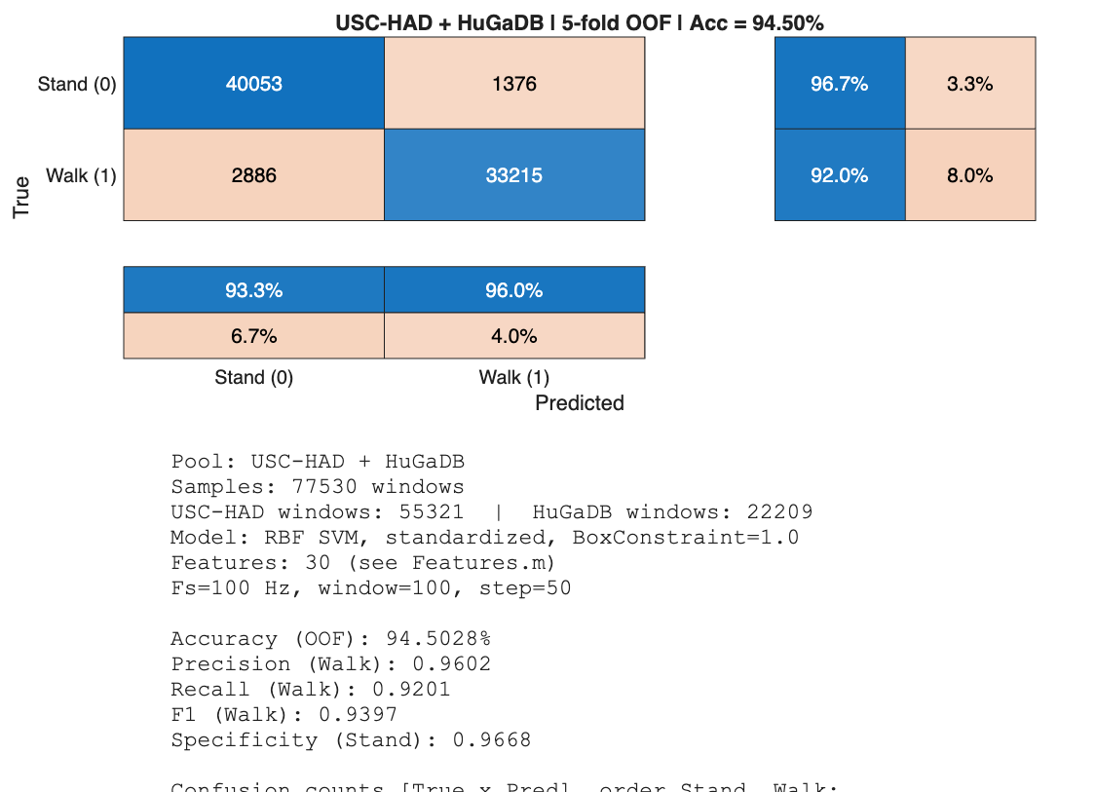

Binary confusion matrix (five-fold OOF) for the merged training setting; default Binary_SVM_Model.mat.
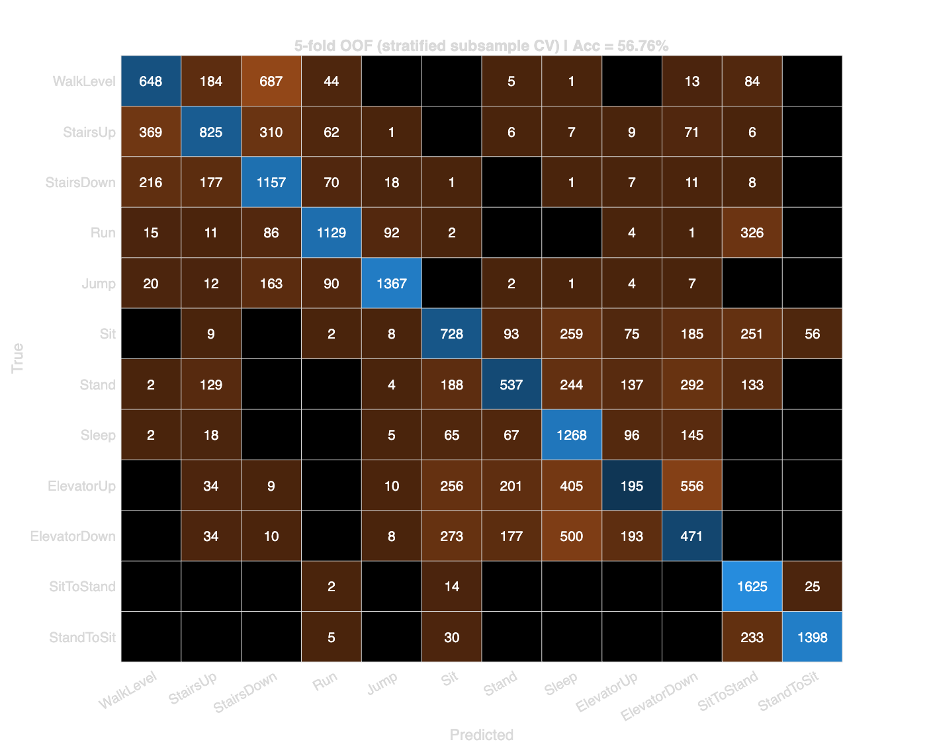

Twelve-class ECOC SVM: five-fold OOF confusion (stratified subsample for tractable CV). Baseline accuracy ~57%.
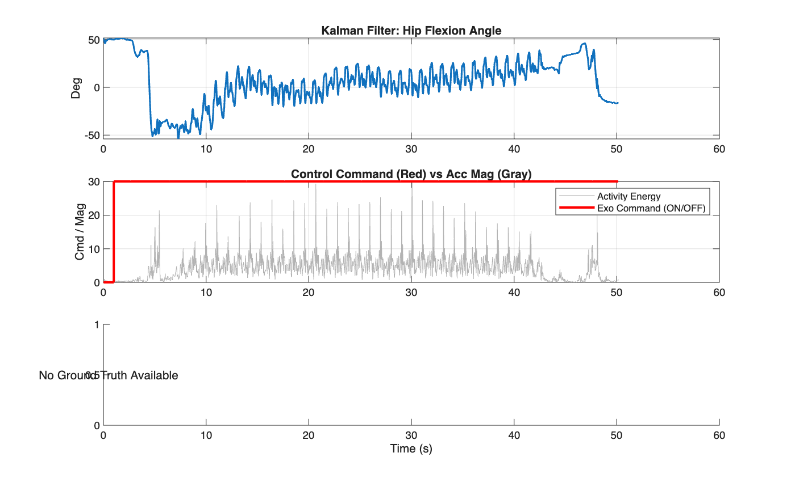

Real-time pipeline output: hip flexion angle (top), control command vs. acceleration magnitude (middle), annotation panel when available (bottom).

Visualization Tools and Software Architecture
Real-time visualization is integrated in MATLAB (e.g., Figure ). The codebase uses startup.m for path resolution, modular src/ layout (acquisition, fusion, classification, features), and docs/System_Design.md for architecture documentation. Repository: https://github.com/Rex-Yim/AutomationForExoskeleton.

Conclusions

Remaining tasks and roadmap (from interim report, Jan 2026)

The following items were listed in the original submission as work remaining toward completion:
Intention detection: Expand the SVM toward LSTM-based multi-mode transitions and speed variations; pursue >90% accuracy via further training and ensembles.
• Intention detection: Expand the SVM toward LSTM-based multi-mode transitions and speed variations; pursue >90% accuracy via further training and ensembles.
Machine learning deployment: Train and deploy full SVM/LSTM stacks for terrain recognition; generate confusion matrices, F1-scores, and embedded deployment scripts.
• Machine learning deployment: Train and deploy full SVM/LSTM stacks for terrain recognition; generate confusion matrices, F1-scores, and embedded deployment scripts.
Hardware integration: Deploy validated control software onto the ExoTechHK microcontroller.
• Hardware integration: Deploy validated control software onto the ExoTechHK microcontroller.
Testing and validation: Bench tests, ethical user trials with torque limits, performance evaluation (accuracy, confusion matrix, precision, recall).
• Testing and validation: Bench tests, ethical user trials with torque limits, performance evaluation (accuracy, confusion matrix, precision, recall).
Documentation and presentation: Final report, slides, video demonstration, comparative literature benchmarks.
• Documentation and presentation: Final report, slides, video demonstration, comparative literature benchmarks.

Future work beyond the FYP (interim PDF)
Personalization: Short calibration walks with transfer learning and lightweight RL (e.g., PPO/SAC) to tune assistance.
• Personalization: Short calibration walks with transfer learning and lightweight RL (e.g., PPO/SAC) to tune assistance.
Injury-risk assessment: Integrate ergonomic risk frameworks such as Zelik et al. [zelik2022] into user trials.
• Injury-risk assessment: Integrate ergonomic risk frameworks such as Zelik et al. [zelik2022] into user trials.

Project timeline (interim PDF)
Table reproduces the phased plan from the Jan 2026 report (notional dates; confirm with your advisor).
[Table] Phased development plan (interim submission).
textbf{Milestones}
% target); simulation demo
| testing | Mar -- Apr 15, 2026 (1.5 months) | Software--hardware integration; bench and limited treadmill tests (5--10 trials); ethics | Logs with latency/error metrics
Optimization, documentation, finalization | Apr 16 -- May 2026 (1.5 months) | Refine from tests; compile report; presentation | Submitted report; presentation; archived repository
Risk assessment (interim PDF)
Table summarizes risks and mitigations from the Jan 2026 report.
[Table] Risks and mitigations (interim submission).
textbf{Mitigation}
ExoTechHK frame) | M | H | Modular COTS parts; parallel software; early prototype access
% accuracy) | L | M | Rule/ML hybrid fallback; partner datasets; cross-validation / RL tuning
Trial delays | M | H | Public/simulated data interim; limit volunteers; secure IRB early

Budget overrun | L | L | University funding; HKSTP supplements

Repository status (consolidated, 2026)

Relative to the interim plan, the following are delivered in software: Kalman fusion baseline; binary RBF SVM with merged USC-HAD+HuGaDB training and dataset ablation scripts; optional twelve-class ECOC SVM; asymmetric FSM; documentation and evaluation figures. Not delivered: LSTM training, MATLAB Coder deployment, ROS/PID torque layer, hardware controller integration, and prospective user trials---these remain aligned with the roadmap and risk tables above.
Synthesis: This report intentionally preserves the full interim narrative (objectives, proposed LSTM/EKF/ROS extensions, timeline, risks) while adding a faithful description of the implemented repository, so readers can distinguish planned scope from validated baseline.

References
[le2024] D. K. L. Le and W. C. Lin, "Human-exoskeleton cooperation for reducing the musculoskeletal load of manual handling tasks in orchid farms," Comput. Electron. Agric., vol. 220, Art. no. 108820, 2024. doi: 10.1016/j.compag.2024.108820.
[pesenti2021] M. Pesenti et al., "Towards a functional performance validation standard for industrial low-back exoskeletons: State of the art review," Sensors, vol. 21, no. 3, Art. no. 808, 2021. doi: 10.3390/s21030808.
[kermavnar2021] T. Kermavnar et al., "Effects of industrial back-support exoskeletons on body loading and user experience: An updated systematic review," Ergonomics, vol. 64, no. 6, pp. 685--711, 2021. doi: 10.1080/00140139.2020.1870162.
[delooze2016] M. P. De Looze et al., "Exoskeletons for industrial application and their potential effects on physical work load," Ergonomics, vol. 59, no. 5, pp. 671--681, 2016. doi: 10.1080/00140139.2015.1081988.
[baltrusch2020] S. J. Baltrusch et al., "SPEXOR passive spinal exoskeleton decreases metabolic cost during symmetric repetitive lifting," Eur. J. Appl. Physiol., vol. 120, no. 2, pp. 401--412, 2020. doi: 10.1007/s00421-019-04284-6.
[luger2023] T. Luger et al., "Using a back exoskeleton during industrial and functional tasks---Effects on muscle activity, posture, performance, usability, and wearer discomfort," Hum. Factors, vol. 65, no. 8, pp. 1705--1722, 2023. doi: 10.1177/00187208211007267.
[kingma2020] I. Kingma, A. J. van Dieen, and J. H. van Dieen, "Effects of a passive back exoskeleton on the mechanical loading of the low-back during symmetric lifting," J. Biomech., vol. 102, Art. no. 109486, 2020. doi: 10.1016/j.jbiomech.2019.109486.
[ji2020] X. Ji et al., "SIAT-WEXv2: A wearable exoskeleton for reducing lumbar load during lifting tasks," Complexity, vol. 2020, Art. no. 8849427, 2020. doi: 10.1155/2020/8849427.
[golabchi2023] A. Golabchi et al., "Performance and effectiveness of a passive back-support exoskeleton in manual material handling tasks in the construction industry," Constr. Robot., vol. 7, pp. 25--41, 2023. doi: 10.1007/s41693-023-00097-4.
[simon2021] A. A. Simon et al., "Kinematic effects of a passive lift assistive exoskeleton," J. Biomech., vol. 119, Art. no. 110317, 2021. doi: 10.1016/j.jbiomech.2021.110317.
[yandell2020] M. B. Yandell et al., "Characterizing the comfort limits of forces applied to the shoulders, thigh and shank to inform exosuit design," PLoS ONE, vol. 15, no. 2, Art. no. e0228536, 2020. doi: 10.1371/journal.pone.0228536.
[dai2021] B. Dai and D. Novak, "Evaluation of the HeroWear Apex back-assist exosuit during multiple brief tasks," J. Biomech., vol. 126, Art. no. 110620, 2021. doi: 10.1016/j.jbiomech.2021.110620.
[song2024] G. Song et al., "Development of quasi-passive back-support exoskeleton with compact variable gravity compensation module and bio-inspired hip joint mechanism," Biomimetics, vol. 9, no. 3, Art. no. 173, 2024. doi: 10.3390/biomimetics9030173.
[babic2021] J. Babic, T. Petric, and L. Peternel, "Challenges and solutions for application and wider adoption of wearable robots," Wearable Technol., vol. 2, Art. no. e14, 2021. doi: 10.1017/wtc.2021.13.
[chen2019] W. Chen et al., "Mechanical design and kinematic modeling of a cable-driven arm exoskeleton incorporating inaccurate human limb anthropomorphic parameters," Sensors, vol. 19, no. 20, Art. no. 4461, 2019. doi: 10.3390/s19204461.
[li2022] J. M. Li et al., "Design and validation of a cable-driven asymmetric back exosuit," IEEE Trans. Robot., vol. 38, no. 4, pp. 2665--2682, 2022. doi: 10.1109/TRO.2021.3112280.
[ding2023] S. Ding et al., "A novel passive back-support exoskeleton with a spring-cable-differential for lifting assistance," IEEE Trans. Neural Syst. Rehabil. Eng., vol. 31, pp. 3993--4003, 2023. doi: 10.1109/TNSRE.2023.3317059.
[pratt1995] G. A. Pratt and M. M. Williamson, "Series elastic actuators," in Proc. IEEE/RSJ Int. Conf. Intell. Robots Syst. (IROS), vol. 1, 1995, pp. 399--406. doi: 10.1109/IROS.1995.525827.
[hyun2020] D. J. Hyun et al., "Singular wire-driven series elastic actuation with force control for a waist assistive exoskeleton, H-WEXv2," IEEE/ASME Trans. Mechatronics, vol. 25, no. 3, pp. 1431--1442, 2020. doi: 10.1109/TMECH.2020.2970448.
[liao2024] H. Liao et al., "Design, control, and validation of a novel cable-driven series elastic actuation system for a flexible and portable back-support exoskeleton," IEEE Trans. Robot., vol. 40, pp. 3279--3295, 2024. doi: 10.1109/TRO.2024.3381556.
[poliero2022] T. Poliero et al., "Active and passive back-support exoskeletons: A comparison in static and dynamic tasks," IEEE Robot. Autom. Lett., vol. 7, no. 3, pp. 8463--8470, 2022. doi: 10.1109/LRA.2022.3188439.
[ding2024] Y. Ding et al., "A novel back-support exoskeleton with a differential series elastic actuator for lifting assistance," IEEE Trans. Robot., vol. 40, pp. 1245--1260, 2024. doi: 10.1109/TRO.2023.3331680.
[xiloyannis2019] M. Xiloyannis et al., "Design and validation of a modular one-to-many actor for a soft wearable exosuit," Front. Neurorobot., vol. 13, Art. no. 39, 2019. doi: 10.3389/fnbot.2019.00003.
[tsai2019] Y.-L. Tsai et al., "Usability assessment of a cable-driven exoskeletal robot for hand rehabilitation," Front. Neurorobot., vol. 13, Art. no. 3, 2019. doi: 10.3389/fnbot.2019.00003.
[novak2015] D. Novak and R. Riener, "A survey of sensor fusion methods in wearable robotics," Robot. Auton. Syst., vol. 73, pp. 155--170, 2015. doi: 10.1016/j.robot.2014.08.012.
[jiang2024] N. Jiang et al., "Loading recognition for lumbar exoskeleton based on multi-channel surface electromyography from low back muscles," IEEE Trans. Biomed. Eng., vol. 71, no. 7, pp. 2154--2162, 2024. doi: 10.1109/TBME.2024.3363212.
[chen2018] B. Chen, E. Zheng, and X. Wang, "A real-time lift detection strategy for a hip exoskeleton," Front. Neurorobot., vol. 12, Art. no. 17, 2018. doi: 10.3389/fnbot.2018.00017.
[lazzaroni2022] M. Lazzaroni et al., "Improving the efficacy of an active back-support exoskeleton for manual material handling using the accelerometer signal," IEEE Robot. Autom. Lett., vol. 7, no. 3, pp. 7716--7721, 2022. doi: 10.1109/LRA.2022.3183757.
[toxiri2018] S. Toxiri et al., "Rationale, implementation and evaluation of assistive strategies for an active back-support exoskeleton," Front. Robot. AI, vol. 5, Art. no. 53, 2018. doi: 10.3389/frobt.2018.00053.
[luo2023] S. Luo et al., "Robust walking control of a lower limb rehabilitation exoskeleton coupled with a musculoskeletal model via deep reinforcement learning," J. Neuroeng. Rehabil., vol. 20, Art. no. 22, 2023. doi: 10.1186/s12984-023-01147-2.
[xiang2023] X. Xiang et al., "Dynamic assessment for low back-support exoskeletons during manual handling tasks," Front. Bioeng. Biotechnol., vol. 11, Art. no. 1289686, 2023. doi: 10.3389/fbioe.2023.1289686.
[vanSluijs2023] R. M. Van Sluijs et al., "Evaluation of the physiological benefits of a passive back-support exoskeleton during lifting and working in forward leaning postures," J. Biomech., vol. 152, Art. no. 111489, 2023. doi: 10.1016/j.jbiomech.2023.111489.
[alemi2020] M. M. Alemi et al., "Effects of two passive back-support exoskeletons on muscle activity, energy expenditure, and subjective assessments during repetitive lifting," Hum. Factors, vol. 62, no. 5, pp. 703--719, 2020. doi: 10.1177/0018720819897669.
[qu2021] X. Qu et al., "Effects of an industrial passive assistive exoskeleton on muscle activity, oxygen consumption and subjective responses during lifting tasks," PLoS ONE, vol. 16, no. 1, Art. no. e0245629, 2021. doi: 10.1371/journal.pone.0245629.
[schwartz2023] M. Schwartz et al., "Biomechanical consequences of using passive and active back-support exoskeletons during different manual handling tasks," Int. J. Environ. Res. Public Health, vol. 20, no. 15, Art. no. 6468, 2023. doi: 10.3390/ijerph20156468.
[jamsek2020] M. Jamsek, T. Petric, and J. Babic, "Gaussian mixture models for control of quasi-passive spinal exoskeletons," Sensors, vol. 20, no. 9, Art. no. 2705, 2020. doi: 10.3390/s20092705.
[refai2023] M. I. M. Refai et al., "Does a soft actuated back exosuit influence multimodal physiological measurements and user perception during an industry inspired task?" in Proc. IEEE Int. Conf. Rehabil. Robot. (ICORR), 2023, pp. 1--6. doi: 10.1109/ICORR58425.2023.10304777.
[nussbaum2023] M. A. Nussbaum and S. Madinei, "Estimating lumbar spine loading when using back-support exoskeletons in lifting tasks," J. Biomech., vol. 150, Art. no. 111439, 2023. doi: 10.1016/j.jbiomech.2023.111439.
[troster2022] M. Troster et al., "Biomechanical analysis of stoop and free-style squat lifting and lowering with a generic back-support exoskeleton model," Int. J. Environ. Res. Public Health, vol. 19, no. 15, Art. no. 9040, 2022. doi: 10.3390/ijerph19159040.
[lin2025] W. Lin et al., "A systematic review of locomotion assistance exoskeletons: Prototype development and technical challenges," Technologies, vol. 13, no. 2, Art. no. 69, 2025. doi: 10.3390/technologies13020069.
[dosSantos2017] W. M. Dos Santos et al., "Design and evaluation of a modular lower limb exoskeleton for rehabilitation," in Proc. IEEE Int. Conf. Rehabil. Robot. (ICORR), 2017, pp. 463--469. doi: 10.1109/ICORR.2017.8009288.
[zhang2012] M. Zhang and A. A. Sawchuk, "USC-HAD: A daily activity dataset for ubiquitous activity recognition using wearable sensors," in Proc. ACM Conf. Ubiquitous Comput. (UbiComp '12), 2012, pp. 1036--1043. doi: 10.1145/2370216.2370438.
[zelik2022] K. E. Zelik et al., "An ergonomic assessment tool for evaluating the effect of back exoskeletons on injury risk," Appl. Ergon., vol. 105, Art. no. 103619, 2022. doi: 10.1016/j.apergo.2021.103619.
[chereshnev2018] R. Chereshnev and A. Kertesz-Farkas, "HuGaDB: Human gait database for activity recognition from wearable inertial sensor networks," in Analysis of Images, Social Networks and Texts, vol. 10716, Springer, 2018, pp. 131--141. doi: 10.1007/978-3-319-73013-4_12.

