Plots of errors:
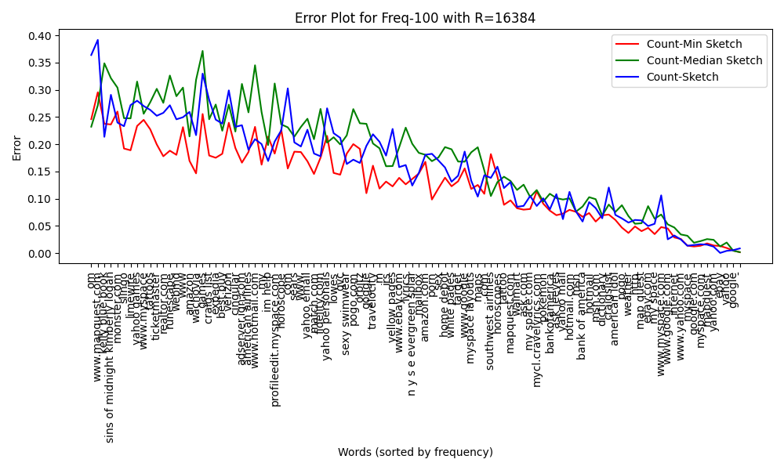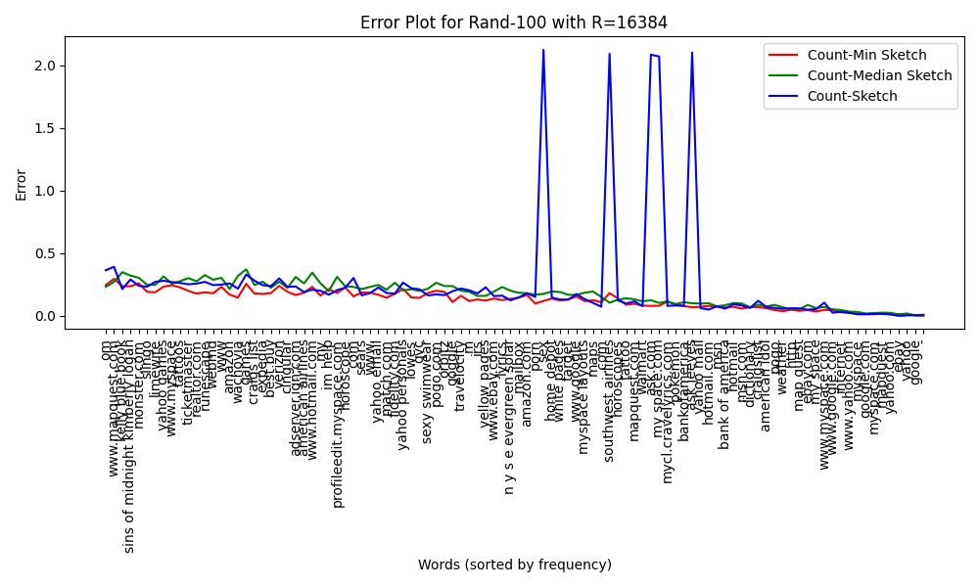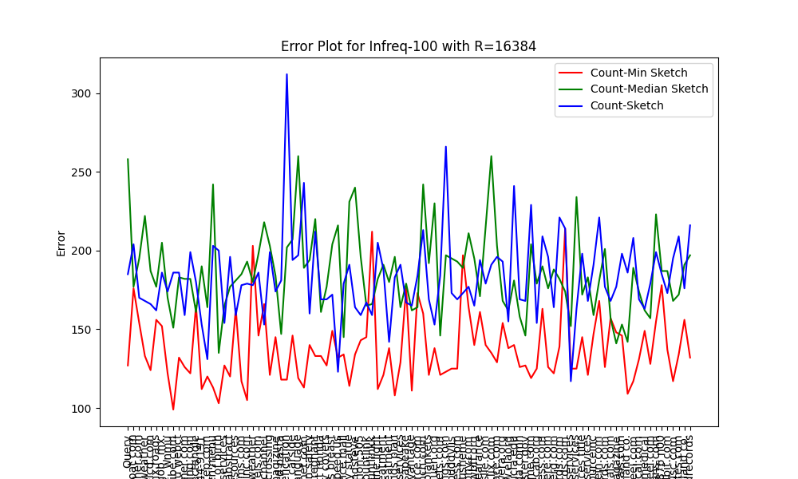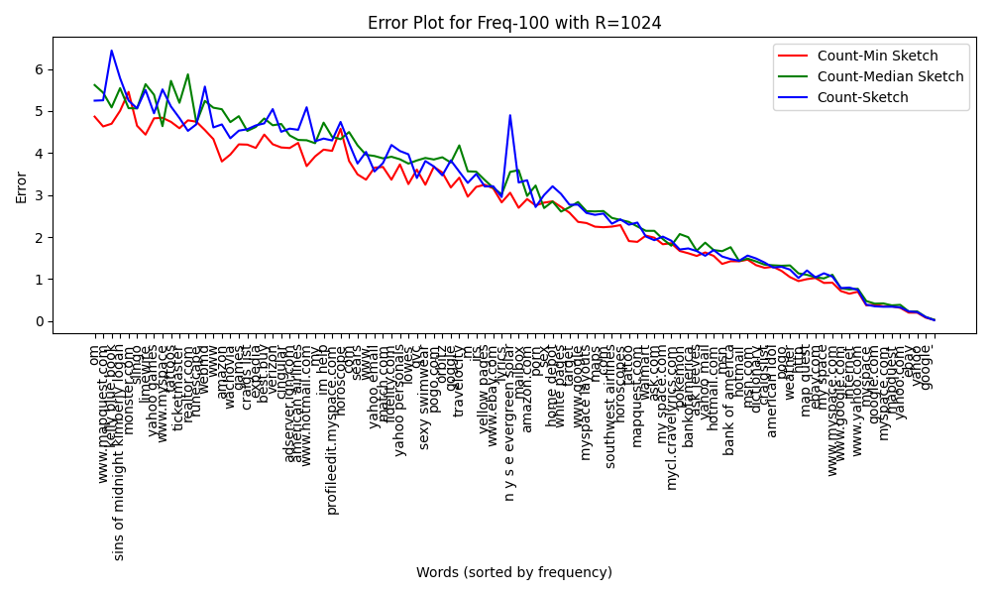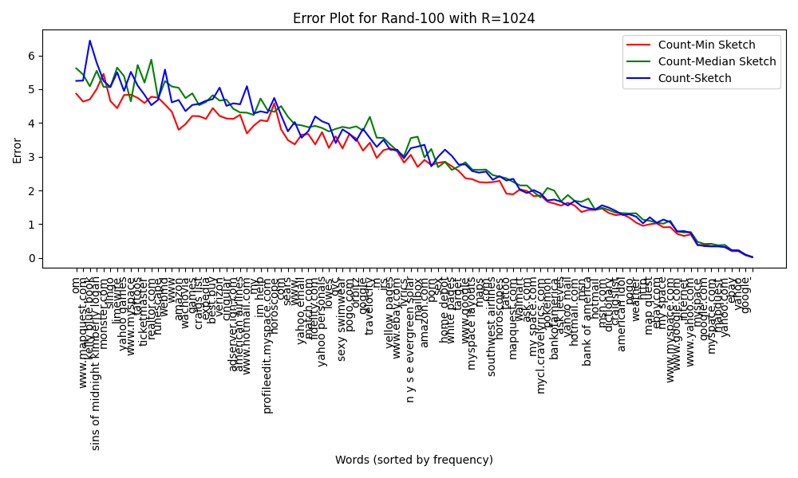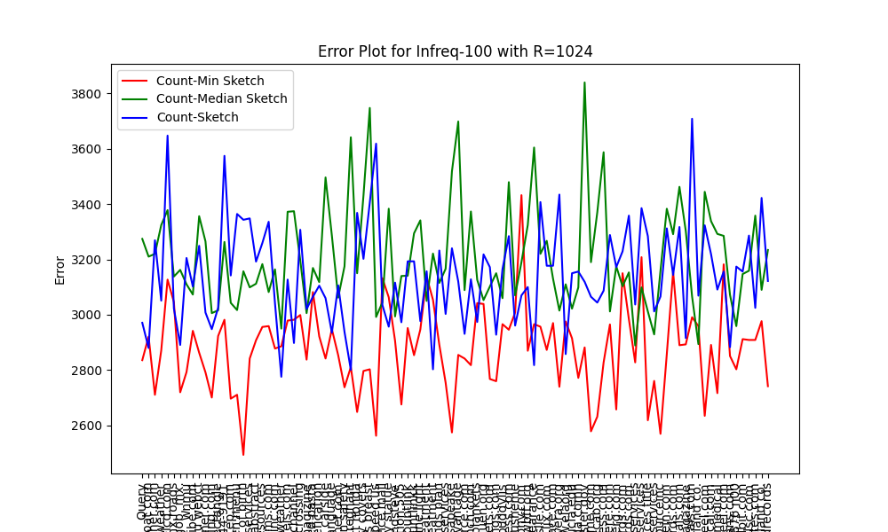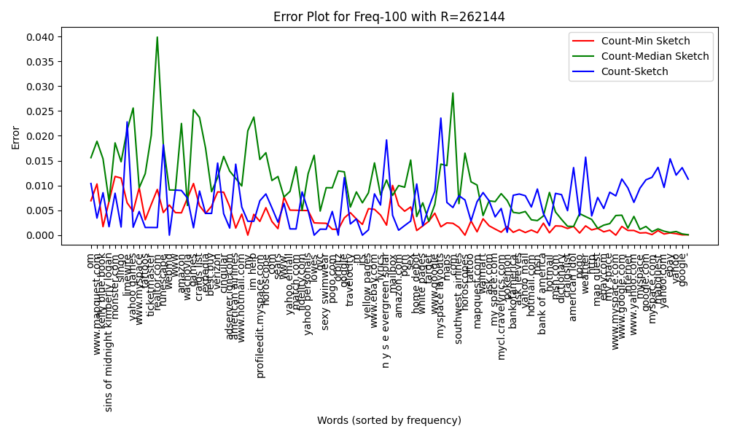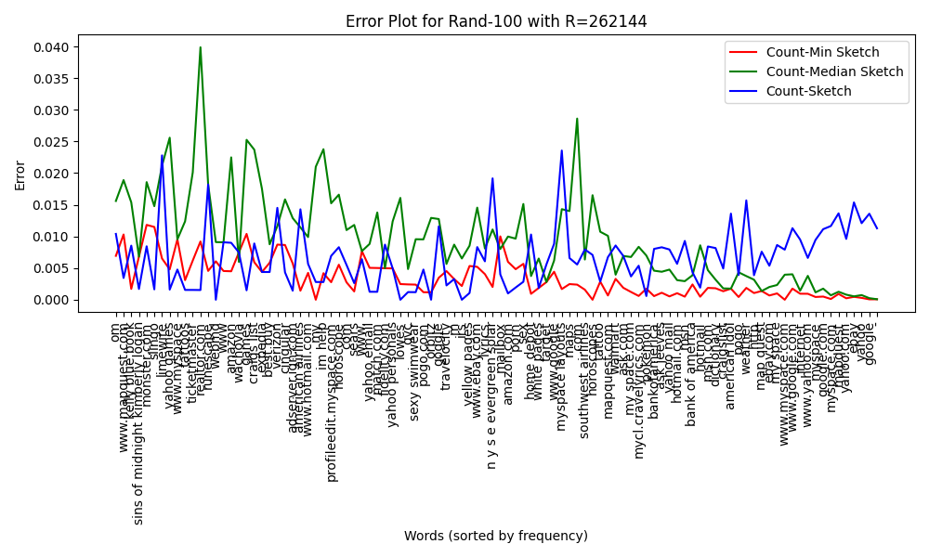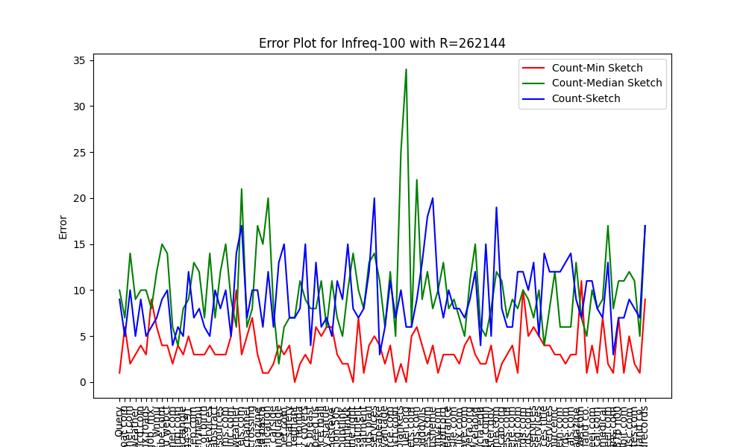

Conclusion:

This plots demonstrate that Count-Min Sketch is the best performer when frequent words are the focus, while Count-Median Sketch offers some resilience, and Count-Sketch struggles with frequent words but improves as the frequency decreases.

This plots emphasize that while Count-Min Sketch and Count-Median Sketch are both effective for estimating random word frequencies, Count-Sketch can have significant weaknesses due to its sign-based approach.

For infrequent words, Count-Min Sketch demonstrates the most consistent performance with lower error values. In contrast, Count-Median Sketch and Count-Sketch show much higher error variability, especially Count-Sketch, which struggles with infrequent words. These findings suggest that for datasets with sparse or infrequent items, Count-Min Sketch is the most reliable choice, while the other sketches, particularly Count-Sketch, may introduce significant inaccuracies.

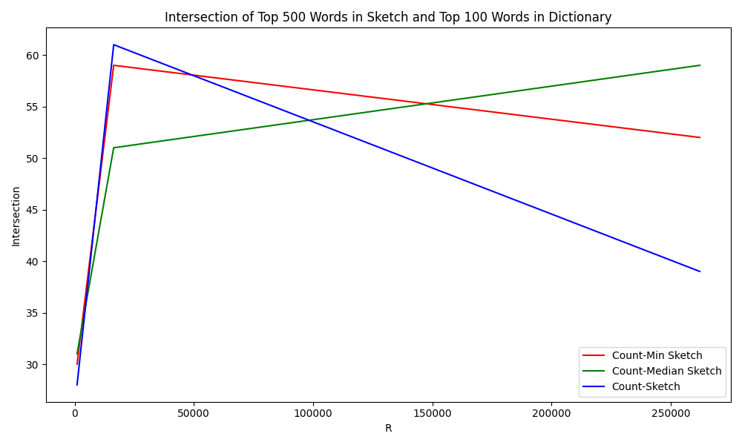
Observation:

All three sketches attain their transferring point intersection with top 500 words when R is at 16384. While the intersection goes up for count-median sketch, count-min sketch and count-sketch have lower number of intersections.

Conclusion:
Count-Median Sketch benefits the most from increasing R and has the increasing number of intersections with the actual top-100 words.

Count-Min Sketch performs well but shows diminishing returns as R increases, reaching a limit on how many frequent words it can correctly identify.

Count-Sketch, while improved with higher R, struggles to match the performance of the other two, likely due to its more complex update mechanism.

