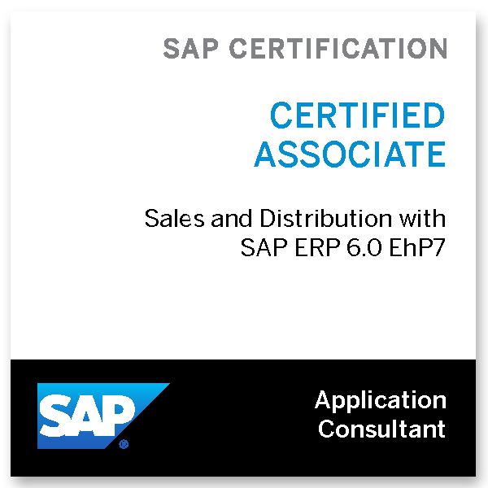
Shakir I Momin
103`Saryu,
Jangid Complex, Nr. Silver Park,
Mira Rd. (E), Thane, Mumbai.
Email: mominshakir@gmail.com
+919987137781
Certification ID: P2005023635

Objective

• A highly committed and motivated professional looking forward to work in a challenging position where my professional knowledge, experience and aptitude can be put to optimum use.

Qualifications

Master of Management Studies (M.M.S), Marketing with 70.50%, Mumbai University, 2009

Bachelor of Management Studies (B.M.S) Marketing with 63.57%, Mumbai University, 2007

Software Skills

SAP Sales & Distribution ECC 6.0 62_67 Global Certified Consultant. Proficient in components of SAP SD including Master data, Pricing, Credit management processing, Basic functions, Sales documents, Delivery documents, Billing documents, Sales Order processing, Output determination & Route Determination.
- SAP SD Organisation Structures, Sales organisations, Distribution channel, Division, Sales area, Plant, Storage locations & Warehouses.

Microsoft Office tools namely Excel, Power point, Word & other fundamentals.

Professional Experience

Eureka Forbes Ltd., Mumbai, from November 2020 – August 2021
Designation: Divisional Head – Business Development
Department: Forbes Pro Ride-on & Industrial Cleaning Machines
Key Deliverables:
- New Business Development of Ride-on & Industrial Cleaning machines like Ride-on Automatic Scrubber Driers, Sweepers, Industrial Vaccum Cleaners, Safety & Hygiene Solutions for Industrial, Logistics & Warehousing sector. Visits to various MIDCs, SEZs & Automotive hubs across India for potential clients in FMCG, Food, Pharmaeuticals & Automotive companies like Sun Pharma, Mahindra Logistics, Tata Motors, Mahindra & Mahindra, Ashok Leyland & TVS group to name a few.
- Co-ordinate the range of business activities associated with business development.
- Increasing customer-base for Industrial Cleaning Solutions in Mumbai, Thane district, Raigarh, uptill Vapi & Valsad & other business hubs.

Responsibilities: Travelling all-over India concentrating on Industrial, Warehousing & Logistics Hubs to create brand awareness & promoting the Eureka Forbes Industrial Cleaning Machines in Automotive & FMCGs generating requirements & sealing the deals & key account management.
LEAP India Pvt. Ltd., Mumbai, from October 2016 to November 2020.
Designation: Assistant Manager – Business Development
Department: Materials Handling Division & Packaging solutions
Key Deliverables:
- Key Accounts Management & New Business Development of Material handling products like Plastic & wooden pallets & Returnable Packaging solutions for Automotive sector. Visits to various MIDCs, SEZs & Automotive hubs across the India for potential clients in Automotive companies like Tata Motors, Mahindra & Mahindra, Ashok Leyland & TVS group to name a few.
- Co-ordinate the range of business activities associated in India comprising of Maharashtra, Gujarat, Madhya Pradesh, Goa & North-western Karnataka with sales & business development.
- Increasing customer-base for pallets & packaging solutions in Pune, Kolhapur, Sanand & other business hubs.

Responsibilities: Travelling all-over India concentrating on OEMs to create brand awareness & promoting for returnable packaging solutions & pallets in Automotive & FMCGs generating requirements & sealing the deals & key account management.
B. D. Industries, Mumbai, from February 2012 to September 2016.
Designation: Assistant Manager – Sales {PAN India}
Department: Materials Handling Division & Road Safety Products
Key Deliverables:
- Marketing of Material handling products like Plastic Pallets & Road safety products. Visits to various MIDCs, SEZs & excise exempted zones across India for potential clients in FMCGs, Food, Logistics, pharmaceutical companies/factories & site offices/ major infrastructure companies and product presentation.
- Increasing customer-base for Road & Highway safety products & plastic pallets PAN India

Responsibilities: While Sr. Executive – Sales, travelling in western & southern parts of India visiting NHAI & Metro Sites, Pharmaceutical & FMCG Industries & warehouses providing solutions for materials handling and road safety products like barricades & pallets.
After promotion in April 2013, Travelling all-over India to create brand awareness & promoting for Road safety products & plastic pallets in FMCGs, Logistics, Infrastructure companies, Pharmaceuticals & Food Industries, generating requirements & sealing the deals.

Nilkamal Limited, Mumbai from January 2011 to January 2012.
Designation: Executive - Sales
Department: Materials Handling Division
Key Deliverables:
- Marketing of Material handling products. Visits to various corporates and product presentation.
- Develop strategies and deliver excellent sales and after – sales services to maximize sales, customer satisfaction and retention.
.
Responsibilities: Providing solutions for materials handling like Crates, Pallets, forklifts, Storage systems etc., in Industries/Factories & Warehouses.
Fams Rubo Mould Industries, Mumbai, From July 2009 to January 2011.
Designation: Sales & Marketing Executive
Marketing Department: Sales Operations & Marketing
Key Deliverables:
- Sales & Marketing of rubber moulded dyes.
- After sales services, feed-backs and maintaining excellent rapport with the purchase managers so as to ensure future orders.
- Key contribution was in identifying the customers, meeting them, presenting the products and closing the deals, thus increasing the market share.

Responsibilities: Marketing of Rubber Molded dyes.

Corporate Projects

Reliance Industries Ltd., May 2008 to July 2008
Designation: Management Trainee
- Project on PVC Pipes and Margin Analysis
- Carry-out SWOT analysis
- Working-out End-Product Cost Analysis
Reliance Industries Ltd., April 2006 to June 2006
Designation: Management Trainee
- Study the Sales Operations

Achievements

- SAP Certified Professional in Sales & Distribution Module. Completed 3 months of professional training.
- Generated business contract from reputed commercial & pharmaceutical brands for PAN India requirements.
- Converted 65% of a reputed OEM for PAN India flows, in-ward as well as outward; for returnable packaging solutions.
- Single handedly opened-up a new region & maintained it at a sustainable position.
- Crucial role played in aggressively promoting & developing the plastic pallets business at PAN India level.
- Claimed L&T ECC Rate contract {RC 2013-14} for Road safety products PAN India Road Projects.
- Highest Achiever of the year 2014-15.
- Claimed L&T IDPL Rate contract {RC 2016-17} for Road safety products PAN India Toll Projects.

Other Details

• LANGUAGES KNOWN: English, Hindi, Marathi and Urdu.
• MMS: Mumbai Institute of Management and Research, Wadala, Mumbai.
BMS: Wilson College, Chowpatty, Mumbai.
HSC (Science): Passed with 60% from Maharashtra College, Mumbai Central, Mumbai.
SSC: Passed with 63.2% from Antonio D`Souza High School, Byculla, Mumbai.
• Birth-date: October 23rd, 1986.
• Married.

